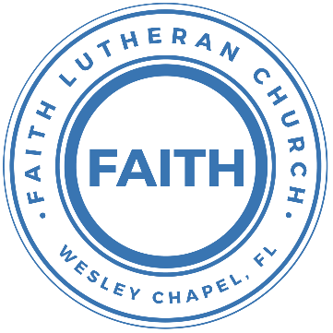

**Leading our community into a deep connection in Christ**

**Worship Service for July 5th, 2020 at 11:30 AM**

**Welcome**

**Opening Song:**Sing to the King

Sing to the King Who is coming to reign  
Glory to Jesus, the Lamb that was slain  
Life and salvation His empire shall bring  
And joy to the nations when Jesus is King

Chorus:  
Come, let us sing a song, A song declaring that we belong to Jesus  
He’s all we need  
Lift up a heart of praise. Sing now with voices raised to Jesus  
Sing to the King

For His returning we watch and we pray  
We will be ready the dawn of that day  
We'll join in singing with all the redeemed  
'Cause Satan is vanquished and Jesus is King

Chorus 2x

**Invocation**

**Confession and Forgiveness:**

P: Come into the presence of God. It is God, Himself, who bids us to come to Him in prayer, especially when we have sinned, so that we may receive His forgiveness. So, we enter His courts with confidence that if we confess our sins, He will forgive us as He promised.

(a time of silence to reflect and personally confess our sins)

C: Heavenly Father, we confess that we have sinned against you in thought, word, and deed. We have not loved you with our whole heart and have not loved our neighbor as ourselves. We are truly sorry and we humbly repent. For the sake of your Son Jesus Christ and His suffering and death on the cross, have mercy on us and forgive us; that we may delight in your will, and walk in your ways, to the glory of your Name. Amen

P: The Lord our God is merciful and gracious, longsuffering, and abounding in goodness and truth, keeping mercy for thousands, forgiving iniquity and transgression and sin. Therefore I announce unto you the grace of our Lord Jesus Christ. In His stead and by the command of my Lord Jesus Christ, I forgive you all your sins in the name of the Father and of the Son and of the Holy Spirit.

C: Amen. Praise God!

**Song of Praise and Thanksgiving:** This Is My Father’s World

This is my Father's world, and to my listening ears

all nature sings, and round me rings the music of the spheres.

This is my Father's world: I rest me in the thought

of rocks and trees, of skies and seas;

his hand the wonders wrought.

This is my Father's world, the birds their carols raise,

the morning light, the lily white, declare their maker's praise.

This is my Father's world: he shines in all that's fair;

in the rustling grass I hear him pass;

he speaks to me everywhere.

This is my Father's world. O let me ne'er forget

that though the wrong seems oft so strong, God is the ruler yet.

This is my Father's world: why should my heart be sad?

The Lord is King; let the heavens ring!

God reigns; let the earth be glad!

This is my Father's world: why should my heart be sad?

The Lord is King; let the heavens ring!

God reigns; let the earth be glad!

The Lord is King; let the heavens ring!

God reigns; let the earth be glad!

**First Reading -**Acts 24:14-23

But this I confess to you, that according to the Way, which they call a sect, I worship the God of our fathers, believing everything laid down by the Law and written in the Prophets, having a hope in God, which these men themselves accept, that there will be a resurrection of both the just and the unjust. So I always take pains to have a clear conscience toward both God and man. Now after several years I came to bring alms to my nation and to present offerings. While I was doing this, they found me purified in the temple, without any crowd or tumult. But some Jews from Asia— they ought to be here before you and to make an accusation, should they have anything against me. Or else let these men themselves say what wrongdoing they found when I stood before the council, other than this one thing that I cried out while standing among them: ‘It is with respect to the resurrection of the dead that I am on trial before you this day.’”

But Felix, having a rather accurate knowledge of the Way, put them off, saying, “When Lysias the tribune comes down, I will decide your case.” Then he gave orders to the centurion that he should be kept in custody but have some liberty, and that none of his friends should be prevented from attending to his needs.

**Gospel Reading** - Matthew 11:25–30

At that time Jesus declared, “I thank you, Father, Lord of heaven and earth, that you have hidden these things from the wise and understanding and revealed them to little children; yes, Father, for such was your gracious will. All things have been handed over to me by my Father, and no one knows the Son except the Father, and no one knows the Father except the Son and anyone to whom the Son chooses to reveal him. Come to me, all who labor and are heavy laden, and I will give you rest. Take my yoke upon you, and learn from me, for I am gentle and lowly in heart, and you will find rest for your souls. For my yoke is easy, and my burden is light.”

**Children's Message**

**Sermon Hymn***–*God of This City

Verse:

You're the God of this city, You're the King of these people

You're the Lord of this nation, You are

You’re the light in this darkness, You’re the hope to the hopeless

You’re the peace to the restless, You are

Pre-Chorus 1:

There is no one like our God, there is no one like our God

Chorus 1:

Greater things have yet to come

Greater things are still to be done in this city

Greater things have yet to come

Greater things are still to be done in this city

Verse

Pre Chorus 2:

There is no one like our God, there is no one like our God

Chorus 2:

Greater things have yet to come

Greater things are still to be done in this city

Greater things have yet to come

Greater things are still to be done In this city

Greater things have yet to come,

Greater things are still to be done here

Pre Chorus 1:

There is no one like our God, there is no one like our God

Chorus 3

Greater things have yet to come

Greater things are still to be done in this city

Greater things have yet to come

Greater things are still to be done, Oh, we believe.

We believe in You God

Greater things have yet to come

Greater things are still to be done in this city

Greater things have yet to come

Greater things are still to be done in this city

We believe. We believe in You God

Greater things have yet to come,

Greater things are still to be done here

**Sermon** - "Celebrating Freedom"

1 Corinthians 10:23-33

“All things are lawful,” but not all things are helpful. “All things are lawful,” but not all things build up. Let no one seek his own good, but the good of his neighbor. Eat whatever is sold in the meat market without raising any question on the ground of conscience. For “the earth is the Lord's, and the fullness thereof.” If one of the unbelievers invites you to dinner and you are disposed to go, eat whatever is set before you without raising any question on the ground of conscience. But if someone says to you, “This has been offered in sacrifice,” then do not eat it, for the sake of the one who informed you, and for the sake of conscience— I do not mean your conscience, but his. For why should my liberty be determined by someone else's conscience? If I partake with thankfulness, why am I denounced because of that for which I give thanks?

So, whether you eat or drink, or whatever you do, do all to the glory of God. Give no offense to Jews or to Greeks or to the church of God, just as I try to please everyone in everything I do, not seeking my own advantage, but that of many, that they may be saved.

**Apostles' Creed**

I believe in God, the Father almighty,  
maker of heaven and earth,

And in Jesus Christ, his only Son, our Lord,  
who was conceived by the Holy Spirit,  
born of the Virgin Mary,  
suffered under Pontius Pilate, was crucified, died and was buried.  
He descended into hell.  
The third day he rose again from the dead.  
He ascended into heaven and sits at the right hand of God  
the Father almighty.  
From there he will come to judge the living and the dead.

I believe in the Holy Spirit,  
the holy Christian Church,  
the communion of saints,  
the forgiveness of sins,  
the resurrection of the body,

and the life everlasting. Amen.

**Prayers**

**The Lord's Prayer**

Our Father who art in heaven, hallowed be Thy name, Thy kingdom come, Thy will be done on earth as it is in heaven.  Give us this day our daily bread; and forgive us our trespasses as we forgive those who trespass against us; and lead us not into temptation, but deliver us from evil.  For Thine is the kingdom and the power and the glory forever and ever.  Amen

**Benediction**

**Closing Song:**Joyful, Joyful, We Adore Thee

Joyful, joyful we adore Thee, God of glory, Lord of love!

Hearts unfold like flow'rs before Thee,

Praising Thee, their sun above.

Melt the clouds of sin and sadness,

Drive the gloom of doubt away.  
Giver of immortal gladness,

Fill us with the light of day.

Verse 2:

All Thy works with joy surround Thee,

Earth and heav'n reflect Thy rays,

Stars and angels sing around Thee,

Center of unbroken praise.

Field and forest, vale and mountain,

Flow’ry meadow, flashing sea,

Chanting bird, and flowing fountain

Call us to rejoice in Thee.

Verse 3:

Thou art giving and forgiving,

Ever blessing, ever blest,  
Well-spring of the joy of living,

Ocean-depth of happy rest!  
Father, Son, and Holy Spirit,

Fountainhead of love divine:  
Joyful, we Thy heav'n inherit!

Joyful, we by grace are Thine!

**Online Offering**

**Sermon Notes:**

**_______________________________________________**

**_______________________________________________**

**_______________________________________________**

**_______________________________________________**

**_______________________________________________**

**_______________________________________________**

**_______________________________________________**

**Upcoming Events**

**July 9, 7 PM - A Time of Prayer**

Facebook, YouTube, FaithWesleyChapel.com

**July 10, 7 PM - Growth Group Bible Study**

Zoom

**July 12, 11 AM - In-Person and Online Worship Resumes**

Facebook, YouTube, and FaithWesleyChapel.com

Song and Dance - Studio 4

[**www.FaithWesleyChapel.com**](http://www.FaithWesleyChapel.com)

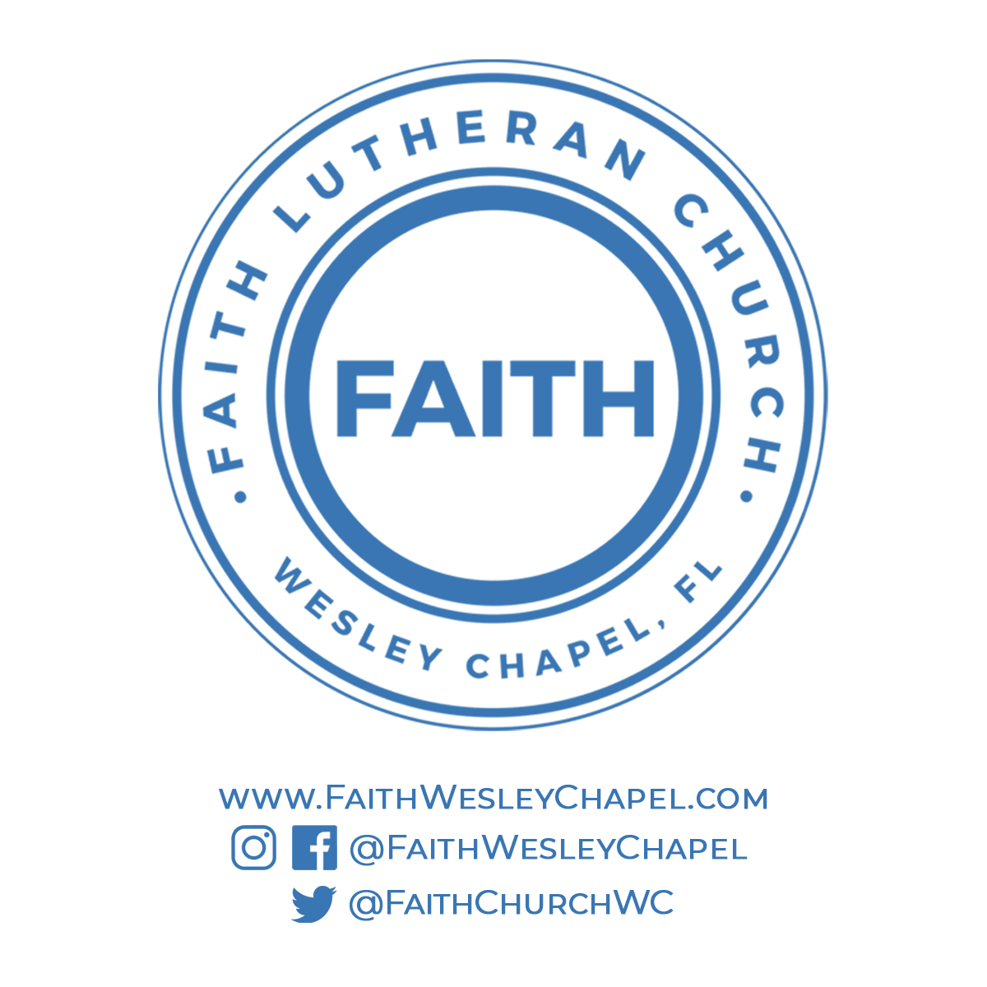[**Faith YouTube**](https://www.youtube.com/channel/UCmI-Pg2fcqf7VOJThDyJE8g/featured)

**[@FaithWesleyChapel](https://www.instagram.com/faithwesleychapel/)**

[**@FaithWesleyChapel**](https://www.facebook.com/FaithWesleyChapel/)

[**@FaithChurchWC**](https://twitter.com/FaithChurchWC)