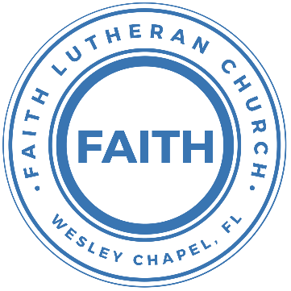

**Leading our community into a deep connection in Christ**

**Worship Service for August 2, 2020 at 11 AM**

**Welcome**

**Opening Song:**Agnus Dei

Verse:  
Alleluia  
Alleluia, for the Lord God Almighty reigns  
(repeat)  
Alleluia,

Chorus:  
Holy, Holy, Are You Lord God Almighty  
Worthy is the Lamb. Worthy is the Lamb  
You are Holy

Verse

Chorus 2:  
Holy, Holy, Are You Lord God Almighty  
Worthy is the Lamb. Worthy is the Lamb  
You are Holy, Holy, Are You Lord God Almighty  
  
Worthy is the Lamb. Worthy is the Lamb  
Worthy is the Lamb. Worthy is the Lamb

Amen

**Invocation**

**Confession and Forgiveness:**

**P:** Our Heavenly Father asks us to come into His presence.  
**C:** But we are sinful and unworthy.

**P:** Yes, all have sinned and fall short of the glory of God, but Jesus Christ died on the cross that we may be forgiven and washed clean of all our sins by His blood spilled on the cross.  
**C:** Lord, if You wash us, we will certainly be clean and pure.

**P:** We take a moment to bow before the His cross and silently reflect on our lives and confess our sins.

(Time of silence for reflection and confession)

**P:** Let us confess, together, our sins to God our Father.  
**C:** Heavenly Father, we confess that we are sinners.  We have sinned against you and our neighbors. We have not loved you with our whole heart and we have not loved our neighbors as ourselves. We have not lived out our faith out in our community. We justly deserve Your punishment.  For the sake of Your Son, Jesus Christ, have mercy on us.  Forgive us, renew us, and lead us, so that we may delight in Your will and walk in Your ways to the glory of Your holy name.  Amen.

**P:** Almighty God in His mercy has given His Son to die for you and for His sake forgives you all your sins.  As a called and ordained servant of Christ, and by His authority, I, therefore, forgive you all your sins in the name of the Father and of the Son and of the Holy Spirit.

**C:** Amen  
**P:** Give thanks to the Lord, for he is good,  
**C:** for his steadfast love endures forever.  
**P:** Give thanks to the God of gods,  
**C:** for his steadfast love endures forever.  
**P:** Give thanks to the Lord of lords,  
**C:** for his steadfast love endures forever.  
**P:** to him who alone does great wonders,  
**C:** for his steadfast love endures forever.  
**P:** to him who by understanding made the heavens,  
**C:** for his steadfast love endures forever.  
**P:** to him who spread out the earth above the waters,  
**C:** for his steadfast love endures forever.  
**P:** to him who made the great lights,  
**C:** for his steadfast love endures forever.  
**P:** the sun to rule over the day,  
**C:** for his steadfast love endures forever.  
**P:** the moon and stars to rule over the night,  
**C:** for his steadfast love endures forever.

**Song of Praise and Thanksgiving:** The Steadfast Love

The steadfast love of the Lord never ceases

His mercies never come to an end

They are new every morning

New every morning

Great is Thy faith-fulness, O Lord

Great is Thy faith-fulness

**Epistle or Old Testament Reading -**Isaiah 55:1-5

“Come, everyone who thirsts, come to the waters; and he who has no money, come, buy and eat! Come, buy wine and milk without money and without price. Why do you spend your money for that which is not bread, and your labor for that which does not satisfy? Listen diligently to me, and eat what is good, and delight yourselves in rich food.

Incline your ear, and come to me; hear, that your soul may live; and I will make with you an everlasting covenant, my steadfast, sure love for David. Behold, I made him a witness to the peoples, a leader and commander for the peoples. Behold, you shall call a nation that you do not know, and a nation that did not know you shall run to you, because of the Lord your God, and of the Holy One of Israel, for he has glorified you.

**Epistle Reading** - Romans 9:1-13

I speak the truth in Christ—I am not lying, my conscience confirms it through the Holy Spirit— I have great sorrow and unceasing anguish in my heart. For I could wish that I myself were cursed and cut off from Christ for the sake of my people, those of my own race, the people of Israel. Theirs is the adoption to sonship; theirs the divine glory, the covenants, the receiving of the law, the temple worship and the promises. Theirs are the patriarchs, and from them is traced the human ancestry of the Messiah, who is God over all, forever praised! Amen.

It is not as though God’s word had failed. For not all who are descended from Israel are Israel. Nor because they are his descendants are they all Abraham’s children. On the contrary, “It is through Isaac that your offspring will be reckoned.” In other words, it is not the children by physical descent who are God’s children, but it is the children of the promise who are regarded as Abraham’s offspring. For this was how the promise was stated: “At the appointed time I will return, and Sarah will have a son.”

Not only that, but Rebekah’s children were conceived at the same time by our father Isaac. Yet, before the twins were born or had done anything good or bad—in order that God’s purpose in election might stand: not by works but by him who calls—she was told, “The older will serve the younger.” Just as it is written: “Jacob I loved, but Esau I hated.”

**Children's Message** *(Children dismissed to Children's Church)*

**Sermon Hymn***–*Come Thou Fount  
Verse 1:

Come Thou Fount of every blessing, tune my heart to sing Thy grace;

Steams of mercy, never ceasing, Call for songs of loudest praise.

Teach me some melodious sonnet, sung by flaming tongues above;

Praise the mount! I’m fixed upon it, mount of Thy redeeming love.

Verse 2:

Here I raise my “Ebenezer” Hither by Thy help I come.

And I hope, by Thy good pleasure, safely to arrive at home.

Jesus sought me when a stranger, wandering from the fold of God;

He, to rescue me from danger, interposed His precious blood.

Verse 3:

Oh, to grace how great to debtor, Daily I’m con-strained to be!

Let Thy goodness, like a fetter, Bind my wand’ring heart to Thee.

Prone to wan-der, Lord, I feel it, Prone to leave the God I love;

Here’s my heart, Lord, take and seal it, Seal it for Thy courts above.

Prone to wan-der, Lord, I feel it, Prone to leave the God I love;

Here’s my heart, Lord, take and seal it, Seal it for Thy courts above.

Here’s my heart, Lord, take and seal it, Seal it for Thy courts above.

**Sermon** - "Eat and Be satisfied"

Matthew 14:13-21

When Jesus heard what had happened, he withdrew by boat privately to a solitary place. Hearing of this, the crowds followed him on foot from the towns. When Jesus landed and saw a large crowd, he had compassion on them and healed their sick.

As evening approached, the disciples came to him and said, “This is a remote place, and it’s already getting late. Send the crowds away, so they can go to the villages and buy themselves some food.” Jesus replied, “They do not need to go away. You give them something to eat.” “We have here only five loaves of bread and two fish,” they answered.

“Bring them here to me,” he said. And he directed the people to sit down on the grass. Taking the five loaves and the two fish and looking up to heaven, he gave thanks and broke the loaves. Then he gave them to the disciples, and the disciples gave them to the people. They all ate and were satisfied, and the disciples picked up twelve basketfuls of broken pieces that were left over. The number of those who ate was about five thousand men, besides women and children.

**Apostles' Creed**

I believe in God, the Father almighty,  
maker of heaven and earth,

And in Jesus Christ, his only Son, our Lord,  
who was conceived by the Holy Spirit,  
born of the Virgin Mary,  
suffered under Pontius Pilate,  
was crucified, died and was buried.  
He descended into hell.  
The third day he rose again from the dead.  
He ascended into heaven and sits at the right hand of God  
the Father almighty.  
From there he will come to judge the living and the dead.

I believe in the Holy Spirit,  
the holy Christian Church,  
the communion of saints,  
the forgiveness of sins,  
the resurrection of the body,

and the life everlasting. Amen.

**Prayers**

**The Lord's Prayer**

Our Father who art in heaven, hallowed be Thy name, Thy kingdom come, Thy will be done on earth as it is in heaven.  Give us this day our daily bread; and forgive us our trespasses as we forgive those who trespass against us; and lead us not into temptation, but deliver us from evil.  For Thine is the kingdom and the power and the glory forever and ever.  Amen

**Benediction**

**Closing Song:**How Great Thou Art

O Lord my God when I in awesome wonder,

Consider all the works thy hand has made

I see the stars, I hear the rolling thunder,

Your power throughout the universe displayed

Chorus:

Then sings my soul, my savior God to thee,

How great thou art, how great thou art

Then sings my soul, my savior God to thee,

How great thou art, how great thou art (repeat last line)

Verse 2:

When through the woods, and forest glades I wander,

And hear the birds sing sweetly in the trees.

When I look down, from lofty mountain grandeur,

And see the brook, and feel the gentle breeze.

Chorus

Verse 3:

And when I think, that God, His Son not sparing;

Sent Him to die, I scarce can take it in;

That on the Cross, my burden gladly bearing,

He bled and died to take away my sin.

Chorus

Verse 4:

When Christ shall come, with shout of acclamation,

And take me home, what joy shall fill my heart.

Then I shall bow, in humble adoration,

And then proclaim: "My God, how great Thou art!"

Chorus

**Offering**

**Sermon Notes:**

**_______________________________________________**

**_______________________________________________**

**_______________________________________________**

**_______________________________________________**

**_______________________________________________**

**Upcoming Events**

**Today – Blessing Bags**

Sunday – Noon – Handing out blessing bags

**Aug 6, 7 PM - A Time of Prayer**

Facebook, YouTube, FaithWesleyChapel.com

**Aug 7, 7 PM – Growth Group Bible Study**

Zoom

**Aug 9, 11 AM - In-Person and Online Worship**

Facebook, YouTube, and FaithWesleyChapel.com

Song and Dance - Studio 4

[**www.FaithWesleyChapel.com**](http://www.FaithWesleyChapel.com)

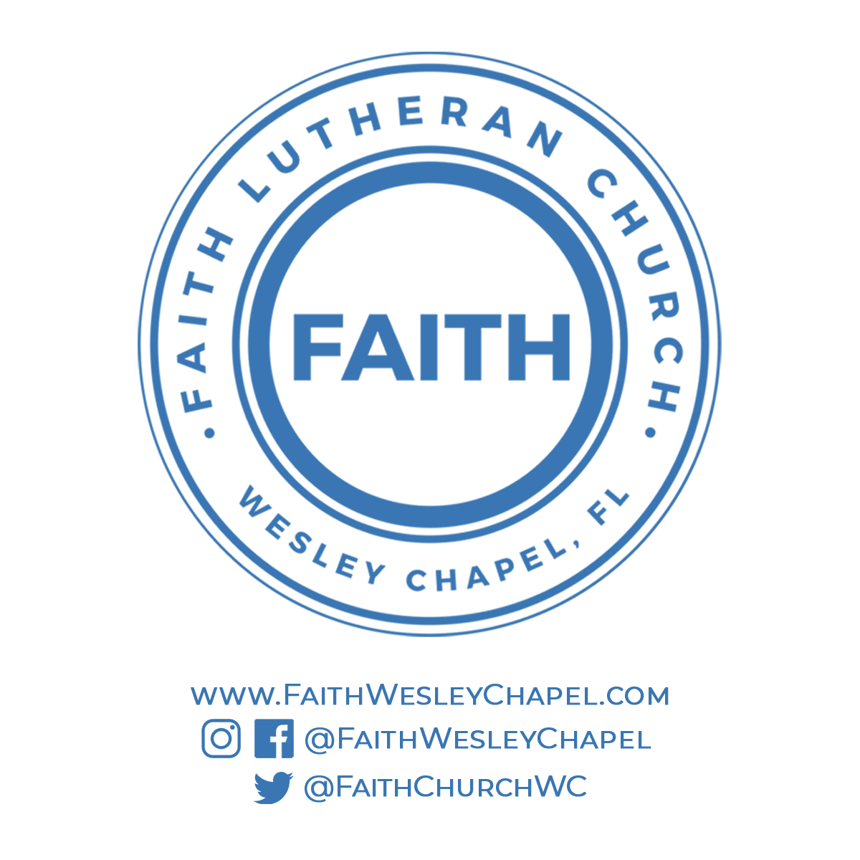[**Faith YouTube**](https://www.youtube.com/channel/UCmI-Pg2fcqf7VOJThDyJE8g/featured)

[**@FaithWesleyChapel**](https://www.instagram.com/faithwesleychapel/)

[**@FaithWesleyChapel**](https://www.facebook.com/FaithWesleyChapel/)

[**@FaithChurchWC**](https://twitter.com/FaithChurchWC)