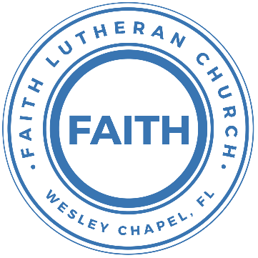

**Leading our community into a deep connection in Christ**

**Worship Service for August 9, 2020 at 11 AM**

**Welcome**

**Opening Song:**King of Kings

In the darkness We were waiting Without hope Without light  
Till from heaven You came running There was mercy in Your eyes  
To fulfil the law and prophets To a virgin came the word  
From a throne of endless glory To a cradle in the dirt

Chorus:  
Praise the Father Praise the Son Praise the Spirit Three in one  
God of glory, Majesty. Praise forever to the King of Kings

Verse 2:  
To reveal the kingdom coming And to reconcile the lost  
To redeem the whole creation You did not despise the cross  
For even in your suffering You saw to the other side  
Knowing this was our salvation Jesus for our sake you died

Chorus

Verse 3:  
And the morning that You rose All of heaven held its breath  
Till that stone was moved for good For the Lamb had conquered death  
And the dead rose from their tombs And the angels stood in awe  
For the souls of all who'd come To the Father are restored  
And the church of Christ was born. Then the Spirit lit the flame  
Now this gospel truth of old Shall not kneel, Shall not faint  
By His blood and in His name In His freedom I am free  
For the love of Jesus Christ Who has resurrected me

Chorus (2x):  
Praise the Father Praise the Son Praise the Spirit Three in one  
God of glory, Majesty. Praise forever to the King of Kings

**Invocation**

**Confession and Forgiveness:**

P: Come into the presence of the Lord our God.  
C: Have mercy, O Lord. If you, Lord, kept a record of sins, Lord, who could stand?  
P: If we say we have no sin, we deceive ourselves, and the truth is not in us.  
C: If we confess our sins, he is faithful and just to forgive us our sins and to cleanse us from all unrighteousness.

*(a time of silence to reflect and personally confess our sins)*

P: I said, "I will confess my transgressions to the LORD." And you forgave the guilt of my sin. Let us confess our sin before the Lord.  
C: Heavenly Father, we confess that we are sinners.  We have sinned against you and our neighbors. We have not loved you with our whole heart and we have not loved our neighbors as ourselves. We justly deserve Your punishment.  For the sake of Your Son, Jesus Christ, have mercy on us.  Forgive us, renew us, and lead us, so that we may delight in Your will and walk in Your ways to the glory of Your holy name.  Amen.  
P: The Lord is gracious and merciful. He promises to forgive our sins. Therefore, upon this, your confession, as a called and ordained servant of the Lord, in the stead and by the command of my Lord, Jesus Christ, I forgive you all your sins in the name of the Father and of the Son and of the Holy Spirit.  
C: Amen.

**Song of Praise:** Praise God from Whom All Blessings Flow

Praise God from Whom all blessings flow.  
Praise Him all creatures here below.  
Praise Him above, ye heavenly hosts.  
Praise Father, Son and Holy Ghost.  
Amen

**Peace**

**P:** The peace of the Lord be with you all.

**C:** And also with you.

**P:** We greet each other in the peace of Christ.  
*(Waive and greet from a distance, please)*

**Epistle Reading -**Romans 10:14-17

How then will they call on him in whom they have not believed? And how are they to believe in him of whom they have never heard? And how are they to hear without someone preaching? And how are they to preach unless they are sent? As it is written, “How beautiful are the feet of those who preach the good news!” But they have not all obeyed the gospel. For Isaiah says, “Lord, who has believed what he has heard from us?” So faith comes from hearing, and hearing through the word of Christ.

**Gospel Reading** - Matthew 14:22-33

Immediately he made the disciples get into the boat and go before him to the other side, while he dismissed the crowds. And after he had dismissed the crowds, he went up on the mountain by himself to pray. When evening came, he was there alone, but the boat by this time was a long way from the land, beaten by the waves, for the wind was against them. And in the fourth watch of the night he came to them, walking on the sea. But when the disciples saw him walking on the sea, they were terrified, and said, “It is a ghost!” and they cried out in fear. But immediately Jesus spoke to them, saying, “Take heart; it is I. Do not be afraid.”

And Peter answered him, “Lord, if it is you, command me to come to you on the water.” He said, “Come.” So Peter got out of the boat and walked on the water and came to Jesus. But when he saw the wind, he was afraid, and beginning to sink he cried out, “Lord, save me.” Jesus immediately reached out his hand and took hold of him, saying to him, “O you of little faith, why did you doubt?” And when they got into the boat, the wind ceased. And those in the boat worshiped him, saying, “Truly you are the Son of God.”

**Children's Message**

**Sermon Hymn***–*Indescribable

Verse 1:  
From the highest of heights to the depths of the sea  
Creation's revealing Your majesty  
From the colors of fall to the fragrance of spring  
Every creature unique in the song that it sings  
All exclaiming

Chorus:

Indescribable, uncontainable,

You placed the stars in the sky and You know them by name.

You are amazing God

All powerful, untamable,

Awestruck we fall to our knees as we humbly proclaim

You are amazing God

Verse 2:  
Who has told every lightning bolt where it should go

Or seen heavenly storehouses laden with snow

Who imagined the sun and gives source to its light

Yet conceals it to bring us the coolness of night

None can fathom

Chorus 2X:

**Sermon** - "Fear and Confidence"

Job 38:4-18

“Where were you when I laid the foundation of the earth? Tell me, if you have understanding. Who determined its measurements—surely you know! Or who stretched the line upon it? On what were its bases sunk, or who laid its cornerstone, when the morning stars sang together and all the sons of God shouted for joy?

“Or who shut in the sea with doors when it burst out from the womb, when I made clouds its garment and thick darkness its swaddling band, and prescribed limits for it and set bars and doors, and said, ‘Thus far shall you come, and no farther, and here shall your proud waves be stayed’?

“Have you commanded the morning since your days began, and caused the dawn to know its place, that it might take hold of the skirts of the earth, and the wicked be shaken out of it? It is changed like clay under the seal, and its features stand out like a garment. From the wicked their light is withheld, and their uplifted arm is broken.

“Have you entered into the springs of the sea, or walked in the recesses of the deep? Have the gates of death been revealed to you, or have you seen the gates of deep darkness? Have you comprehended the expanse of the earth? Declare, if you know all this.

**Apostles' Creed**

I believe in God, the Father almighty,  
maker of heaven and earth,

And in Jesus Christ, his only Son, our Lord,  
who was conceived by the Holy Spirit,  
born of the Virgin Mary,  
suffered under Pontius Pilate,  
was crucified, died and was buried.  
He descended into hell.  
The third day he rose again from the dead.  
He ascended into heaven and sits at the right hand of God  
the Father almighty.  
From there he will come to judge the living and the dead.

I believe in the Holy Spirit,  
the holy Christian Church,  
the communion of saints,  
the forgiveness of sins,  
the resurrection of the body,

and the life everlasting. Amen.

**Prayers**

**The Lord's Prayer**

Our Father who art in heaven, hallowed be Thy name, Thy kingdom come, Thy will be done on earth as it is in heaven.  Give us this day our daily bread; and forgive us our trespasses as we forgive those who trespass against us; and lead us not into temptation, but deliver us from evil.  For Thine is the kingdom and the power and the glory forever and ever.  Amen

**Benediction**

**Closing Song:**Whom Shall I Fear (God of Angel Armies)

You hear me when I call. You are my morning song  
Though darkness fills the night, It cannot hide the light. Whom shall I fear

You crush the enemy Underneath my feetYou are my sword and shield, though troubles linger still**.** Whom shall I fear

Chorus:  
I know who goes before me. I know who stands behind  
The God of angel armies Is always by my side  
The One who reigns forever He is a friend of mine  
The God of angel armies Is always by my side

My strength is in Your name For You alone can save  
You will deliver me. Yours is the victory. Whom shall I fear? Whom shall I fear?

Chorus:  
I know who goes before me. I know who stands behind  
The God of angel armies Is always by my side  
The One who reigns forever He is a friend of mine  
The God of angel armies Is always by my side

And nothing formed against me shall stand  
You hold the whole world in Your hands  
I'm holding on to Your promises. You are faithful, You are faithful   
*(Repeat)*

You are faithful

Chorus:  
I know who goes before me. I know who stands behind  
The God of angel armies Is always by my side  
The One who reigns forever He is a friend of mine  
The God of angel armies Is always by my side

(Repeat)

The God of angel armies Is always by my side

**Offering**

**Sermon Notes:**

**______________________________________________________________________________****_________________________________________________________________________________________________________________________________________________________________________________________________________________________________________________________________________****_________________________________________________________________________________________________________________________________________________________________________________________________________________________________________________________________________________________**

**Upcoming Events**

**August 11, 7 PM - Church Council Meeting**

Zoom

**August 13, 7 PM - A Time of Prayer**

Facebook, YouTube, FaithWesleyChapel.com

**August 14, 7 PM - Growth Group Bible Study**

Zoom

**www.FaithWesleyChapel.com**

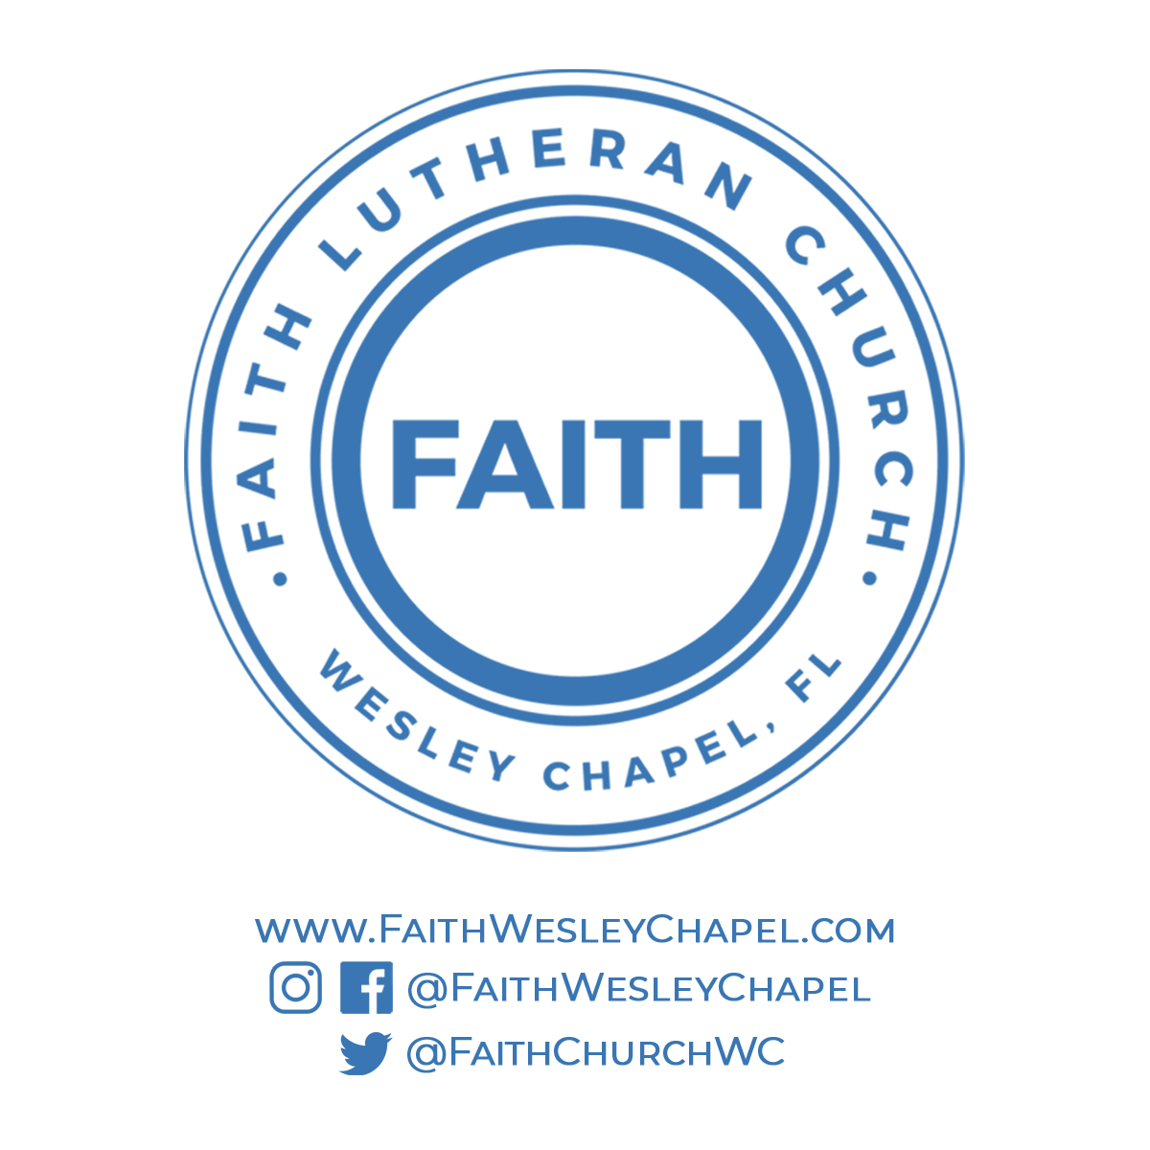**Faith YouTube**

**@FaithWesleyChapel**

**@FaithWesleyChapel**

**@FaithChurchWC**