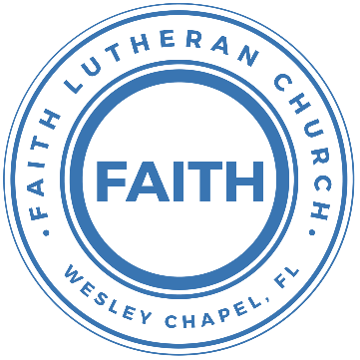

**Leading our community into a deep connection in Christ**

**Worship Service for September 13, 2020 at 11 AM**

**Welcome**

**Opening Song: I Know That My Redeemer Lives**

I know that my Redeemer lives;  
What comfort this sweet sentence gives!  
He lives, He lives, who once was dead;  
He lives, my ever-living head.

He lives triumphant from the grave;  
He lives eternally to save;  
He lives all-glorious in the sky;  
He lives exalted there on high.

He lives and grants me daily breath;  
He lives, and I shall conquer death;  
He lives my mansion to prepare;  
He lives to bring me safely there.

He lives, all glory to His name!  
He lives, my Jesus, still the same;  
Oh, the sweet joy this sentence gives;  
I know that my Redeemer lives!

**Invocation**

**Confession and Forgiveness:**

**P:** Our Heavenly Father asks us to come into His presence.

**C:** But we are sinful and unworthy.

**P:** Yes, all have sinned and fall short of the glory of God, but Jesus Christ died on the cross that we may be forgiven and washed clean of all our sins by His blood spilled on the cross.

**C:** Lord, if You wash us, we will certainly be clean and pure.

**P:** We take a moment to bow before the His cross and silently reflect on our lives and confess our sins.

(Time of silence for reflection and confession)

**P:** Let us confess, together, our sins to God our Father.

**C:** Heavenly Father, we confess that we are sinners.  We have sinned against you and our neighbors. We have not loved you with our whole heart and we have not loved our neighbors as ourselves. We have not lived out our faith out in our community. We justly deserve Your punishment.  For the sake of Your Son, Jesus Christ, have mercy on us.  Forgive us, renew us, and lead us, so that we may delight in Your will and walk in Your ways to the glory of Your holy name.  Amen.

**P:** Almighty God in His mercy has given His Son to die for you and for His sake forgives you all your sins.  As a called and ordained servant of Christ, and by His authority, I, therefore, forgive you all your sins in the name of the Father and of the Son and of the Holy Spirit.

**C:** Amen

**Song of Praise and Thanksgiving:** O Praise the Name (Anástasis)

I cast my mind to Calvary  
Where Jesus bled and died for me

I see His wounds, His hands, His feet.   
My Savior on that cursed tree

His body bound and drenched in tears.   
They laid Him down in Joseph's tomb

The entrance sealed by heavy stone.   
Messiah still and all alone

Chorus:  
O praise the Name of the Lord our God.   
O praise His Name forevermore

For endless days, we will sing Your praise.

Oh Lord, oh Lord our God

Then on the third, at break of dawn  
The Son of heaven rose a - gain

O trampled death, where is your sting.   
The angels roar for Christ the King

Chorus

He shall return in robes of white.

The blazing sun shall pierce the night

And I will rise among the saints,

My gaze transfixed on Jesus' face

Chorus 2x

Oh Lord, oh Lord our God

**Epistle Reading -**Romans 14:1–4

As for the one who is weak in faith, welcome him, but not to quarrel over opinions. One person believes he may eat anything, while the weak person eats only vegetables. Let not the one who eats despise the one who abstains, and let not the one who abstains pass judgment on the one who eats, for God has welcomed him. Who are you to pass judgment on the servant of another? It is before his own master that he stands or falls. And he will be upheld, for the Lord is able to make him stand.

**Gospel Reading** - Matthew 18:21–35

Then Peter came up and said to him, “Lord, how often will my brother sin against me, and I forgive him? As many as seven times?” Jesus said to him, “I do not say to you seven times, but seventy-seven times.

“Therefore the kingdom of heaven may be compared to a king who wished to settle accounts with his servants. When he began to settle, one was brought to him who owed him ten thousand talents. And since he could not pay, his master ordered him to be sold, with his wife and children and all that he had, and payment to be made. So the servant fell on his knees, imploring him, ‘Have patience with me, and I will pay you everything.’ And out of pity for him, the master of that servant released him and forgave him the debt. But when that same servant went out, he found one of his fellow servants who owed him a hundred denarii, and seizing him, he began to choke him, saying, ‘Pay what you owe.’ So his fellow servant fell down and pleaded with him, ‘Have patience with me, and I will pay you.’ He refused and went and put him in prison until he should pay the debt. When his fellow servants saw what had taken place, they were greatly distressed, and they went and reported to their master all that had taken place. Then his master summoned him and said to him, ‘You wicked servant! I forgave you all that debt because you pleaded with me. And should not you have had mercy on your fellow servant, as I had mercy on you?’ And in anger his master delivered him to the jailers, until he should pay all his debt. So also my heavenly Father will do to every one of you, if you do not forgive your brother from your heart.”

**Children's Message** *(Children dismissed to Children's Church)*

**Sermon Hymn***–*They’ll Know We Are Christians By Our Love

We are one in the Spirit; we are one in the Lord;

We are one in the Spirit; we are one in the Lord;

And we pray that all unity will one day be restored.

Chorus:

And they'll know we are Christians by our love, by our love,

yes, they'll know we are Christians by our love.

We will walk with each other; we will walk hand in hand;

We will walk with each other; we will walk hand in hand;  
And together we'll spread the news that God is in our land.

Chorus

We Will work with each other; we will work side by side;

We will work with each other; we will work side by side;

And we'll guard each one's dignity and save each other's pride.

Chorus

**Sermon** - "The Power of Forgiveness"

Genesis 50:15-21

When Joseph's brothers saw that their father was dead, they said, “It may be that Joseph will hate us and pay us back for all the evil that we did to him.” So they sent a message to Joseph, saying, “Your father gave this command before he died: ‘Say to Joseph, “Please forgive the transgression of your brothers and their sin, because they did evil to you.”’ And now, please forgive the transgression of the servants of the God of your father.” Joseph wept when they spoke to him. His brothers also came and fell down before him and said, “Behold, we are your servants.” But Joseph said to them, “Do not fear, for am I in the place of God? As for you, you meant evil against me, but God meant it for good, to bring it about that many people should be kept alive, as they are today. So do not fear; I will provide for you and your little ones.” Thus he comforted them and spoke kindly to them.

**Prayers**

**Apostles' Creed**

I believe in God, the Father almighty,  
maker of heaven and earth,

And in Jesus Christ, his only Son, our Lord,  
who was conceived by the Holy Spirit,  
born of the Virgin Mary,  
suffered under Pontius Pilate,  
was crucified, died and was buried.  
He descended into hell.  
The third day he rose again from the dead.  
He ascended into heaven and sits at the right hand of God  
the Father almighty.  
From there he will come to judge the living and the dead.

I believe in the Holy Spirit,  
the holy Christian Church,  
the communion of saints,  
the forgiveness of sins,  
the resurrection of the body,

and the life everlasting. Amen.

**The Lord's Prayer**

Our Father who art in heaven, hallowed be Thy name, Thy kingdom come, Thy will be done on earth as it is in heaven.  Give us this day our daily bread; and forgive us our trespasses as we forgive those who trespass against us; and lead us not into temptation, but deliver us from evil.  For Thine is the kingdom and the power and the glory forever and ever.  Amen

**Words of Institution**

**Peace**

P: The peace of the Lord be with you all.

C: And also with you.

P: We greet each other in the peace of Christ.

**Distribution**

**Prayer**

**Benediction**

**Closing Song:**I Will Follow

Where You go, I’ll go Where You stay, I’ll stay  
When You move, I’ll move I will follow…  
All Your ways are good   
All Your ways are sure  
I will trust in You alone  
Higher than my sight   
High above my life  
I will trust in You alone

Chorus:  
Where You go, I’ll go, Where You stay, I’ll stay  
When You move, I’ll move   
I will follow You  
Who You love, I'll love   
How You serve I'll serve  
If this life I lose, I will follow You, Yeah.  
I will follow You

Light unto the world, Light unto my life  
I will live for You alone  
You're the one I seek, Knowing I will find  
All I need in You alone, in You alone

Chorus

In You there's life everlasting  
In You there's freedom for my soul  
In You there's joy, unending joy and I will follow

Chorus 2x

**Offering**

**Sermon Notes:**

**____________________________________________________________________________________________________________________________________________________________________________________________________________________________________________________________________________________________________________________________________**

**Upcoming Events**

**September 13, Noon – Drive Up Communion**

Song and Dance

**September 17, 7 PM - A Time of Prayer**

Facebook, YouTube, FaithWesleyChapel.com

**September 18, 7 PM - Growth Group Bible Study**

Zoom

**www.FaithWesleyChapel.com**

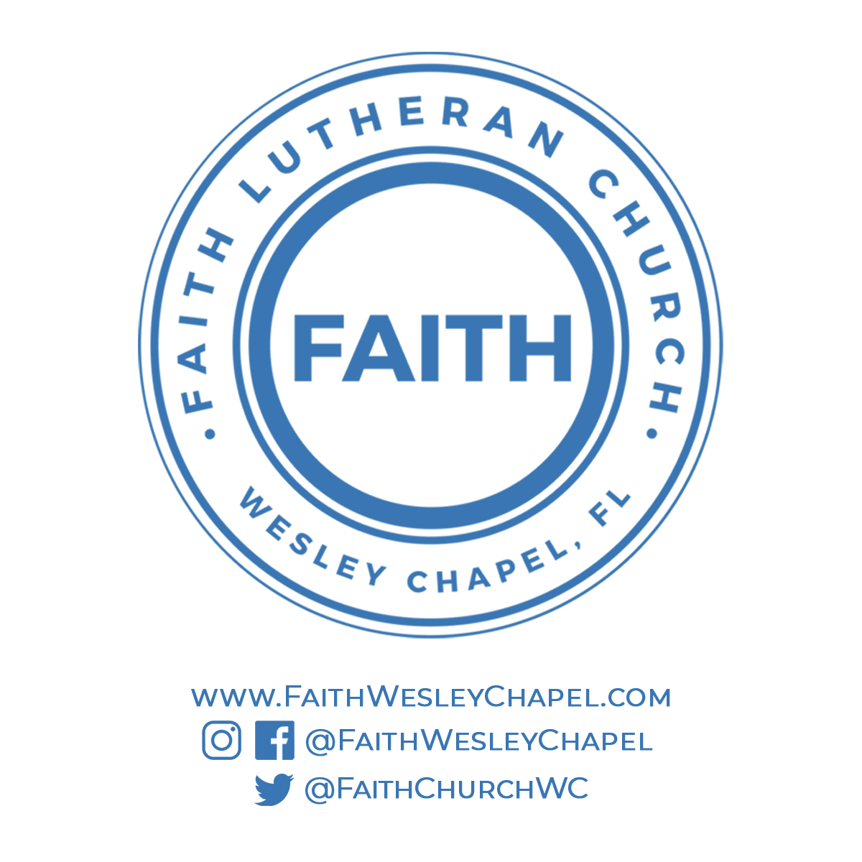**Faith YouTube**

**@FaithWesleyChapel**

**@FaithWesleyChapel**

**@FaithChurchWC**