**Mordecai**

“Served God and Helped Others Where God Had Put Him”

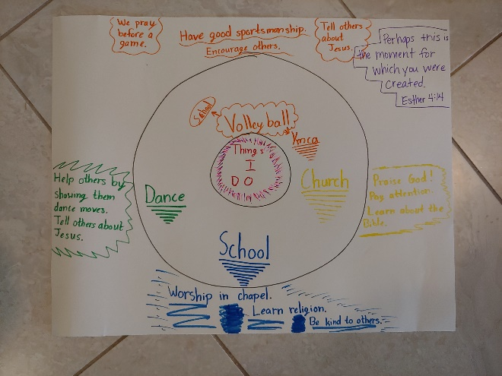

**Making a Circle Map**

Supplies:

* Printer paper or poster board
* Markers or Crayons

Directions:

1. 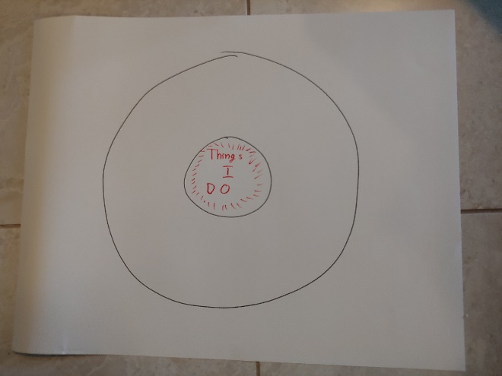Draw a circle in the middle of the paper or poster board and write “Things I do” in the center of the circle. You can also replace “I” with your child’s name if you want.
2. Draw another much larger circle around the first circle so it looks like a donut. Make sure you leave a little room on the outside of the larger circle.
3. 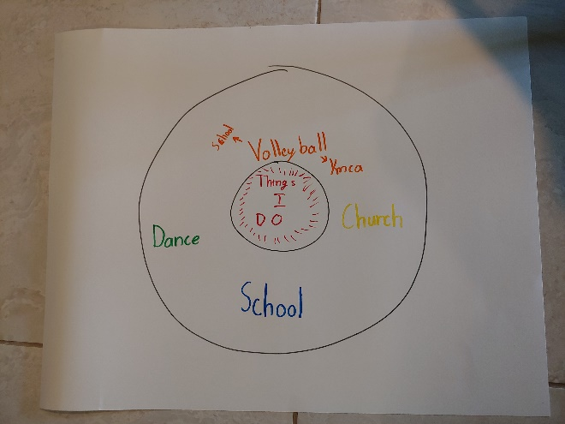Inside the larger circle, write things you are involved in. These may be things like, school, volleyball, soccer, church, family, etc. Use different colors for each activity you do.
4. 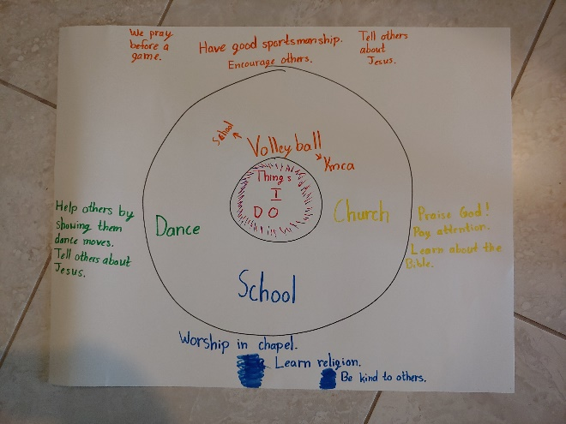Go through one thing inside the larger circle at a time and write some ways you can serve God or help the people in that thing. Write your ideas outside the large circle. Parents, use this as an opportunity to let your kids think about how they can serve God and help others in various aspects of their lives and discuss it with them. You may need to help them come up with some ideas as well.
5. In an open space of the paper or poster board, write out the Bible verse “Perhaps this is the moment for which you have been created.” - Esther 4:14
6. Add other decorations, if you’d like.