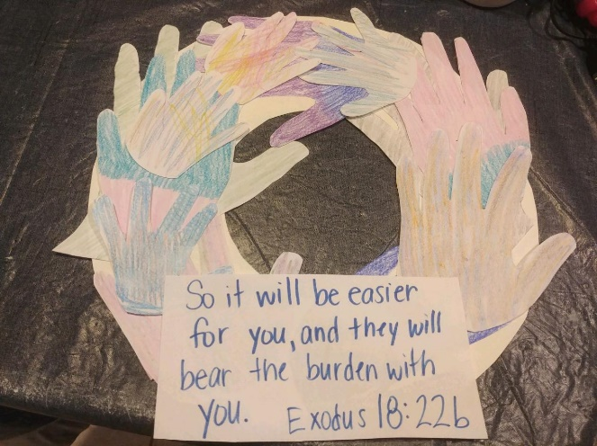
Helping Hands Wreath

Supplies:
- Printer paper or construction paper
- Poster board (If you don’t have poster board, you can use cardstock, construction paper, or even cardboard.
- Scissors
- Glue stick
- Markers or crayons
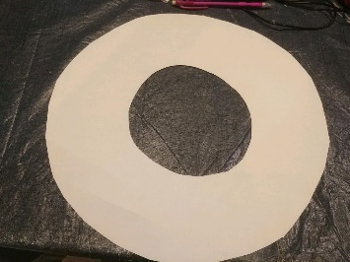
Directions:
- Cut a large circle from the poster board.

- Cut a smaller circle out from the middle so you are left with a wreath shape, or donut.
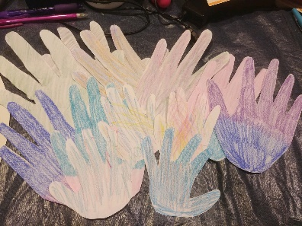
- Trace the hands of family members. Color them and then cut them out. We have four people in our family. The adults traced their hands twice and the kids traced their hands 4 times. If your wreath is big, you might need more, if it is smaller, you will need less.

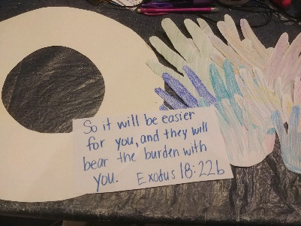
- Once you have all the handprints colored and cut out, lay them on the wreath to see how you want them glued on.

- We wrote out the Bible verse – Exodus 18:22b to add to our wreath and remind us to work together and help each other. “So it will be easier for you, and they will bear the burden with you”
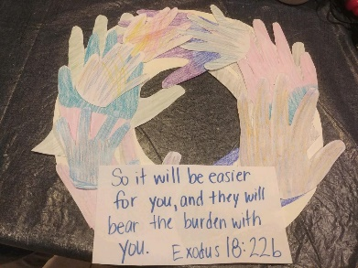
- Glue the handprints around the wreath and add the verse if you want.

