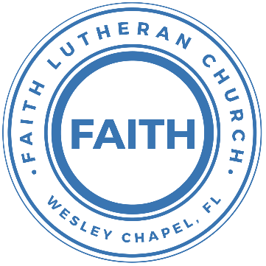

**Leading our community into a deep connection in Christ**

**Worship Service for November 8, 2020 at 11 AM**

**Welcome**

**Pray for the Food** - **People get food**

**Invocation**

**Confession and Forgiveness:**

P: As we gather, today, let us cleanse our hearts and our consciences by confessing our sin to God.

(Time of silence for reflection and confession)

C: Heavenly Father, we confess that we are sinful and unclean. We have sinned against you and against our neighbor in our thoughts, words, and actions.  We are truly sorry for our sins and sincerely repent of them. We ask for Your mercy. For the sake of Jesus Christ's bitter suffering and death, please forgive us and renew us that we may walk in Your Spirit to the glory of Your holy name.

P: The Lord has heard your confession. Therefore, as a called and ordained servant of the Lord, in the stead and by the command of my Lord, Jesus Christ, I forgive you all your sins in the name of the Father and of the Son and of the Holy Spirit.

C: Amen

**Songs of Praise and Thanksgiving:** God So Loved

*Intro:* Oooo, Ooooo, Ooooo

*Verse 1:*

Come all you weary, Come all you thirsty

Come to the well that Never runs dry

Drink of the Water, Come and thirst no more

*Verse 2:*

Come all you sinners, Come find His mercy

Come to the table, He Will satisfy

Taste of His goodness, Find what you’re looking for

*Chorus 1:*

For God so loved the World that He gave us His

One and only Son to save us

Whoever believes in Him will live forever

*Interlude:* Oooo, Ooooo, Ooooo

*Verse 3:*

Bring all your failures, Bring your addictions

Come lay them down at the Foot of the cross

Jesus is waiting There with open arms

*(Chorus)*

*Chorus 2:*

The power of Hell forever defeated

Now it is well, I’m Walking in freedom

For God so loved, God so loved the world

Bridge:

Praise God, praise God, From whom all blessings flow

Praise Him, praise Him for the Wonders of His love

(Repeat)

*(Chorus)*

*(Chorus 2)*

*(Verse 3 – Outro)*

**First Reading:**Acts 2:42-47

And they devoted themselves to the apostles' teaching and the fellowship, to the breaking of bread and the prayers. And awe came upon every soul, and many wonders and signs were being done through the apostles. And all who believed were together and had all things in common. And they were selling their possessions and belongings and distributing the proceeds to all, as any had need. And day by day, attending the temple together and breaking bread in their homes, they received their food with glad and generous hearts, praising God and having favor with all the people. And the Lord added to their number day by day those who were being saved.

**Gospel Reading:**Matthew 16:13-19

Now when Jesus came into the district of Caesarea Philippi, he asked his disciples, “Who do people say that the Son of Man is?” And they said, “Some say John the Baptist, others say Elijah, and others Jeremiah or one of the prophets.” He said to them, “But who do you say that I am?” Simon Peter replied, “You are the Christ, the Son of the living God.” And Jesus answered him, “Blessed are you, Simon Bar-Jonah! For flesh and blood has not revealed this to you, but my Father who is in heaven. And I tell you, you are Peter, and on this rock I will build my church, and the gates of hell shall not prevail against it. I will give you the keys of the kingdom of heaven, and whatever you bind on earth shall be bound in heaven, and whatever you loose on earth shall be loosed in heaven.”

**Sermon Hymn***–*The Church’s One Foundation

The church's one foundation is Jesus Christ, her Lord;

she is his new creation by water and the Word:

from heav'n he came and sought her to be his holy bride;

with his own blood he bought her, and for her life he died.

Elect from ev'ry nation, yet one o'er all the earth,

her charter of salvation one Lord, one faith, one birth;

one holy name she blesses, partakes one holy food,

and to one hope she presses, with ev'ry grace endued.

Yet she on earth hath union with God the Three in One,

and mystic sweet communion with those whose rest is won:

O blessed heav'nly chorus! Lord, save us by Your grace,

that we, like saints before us, may see You face to face.

**Sermon** – Series: Households of Faith

Week 5: "How the Church Supports Households of Faith"

Hebrews 10:19-25

Therefore, brothers, since we have confidence to enter the holy places by the blood of Jesus, by the new and living way that he opened for us through the curtain, that is, through his flesh, and since we have a great priest over the house of God, let us draw near with a true heart in full assurance of faith, with our hearts sprinkled clean from an evil conscience and our bodies washed with pure water. Let us hold fast the confession of our hope without wavering, for he who promised is faithful. And let us consider how to stir up one another to love and good works, not neglecting to meet together, as is the habit of some, but encouraging one another, and all the more as you see the Day drawing near.

**Sermon Notes:**

**______________________________________________________________________________**

**______________________________________________________________________________**

**______________________________________________________________________________**

**______________________________________________________________________________**

**______________________________________________________________________________**

**______________________________________________________________________________**

**______________________________________________________________________________**

**______________________________________________________________________________**

**______________________________________________________________________________**

**______________________________________________________________________________**

**Prayers**

**Apostles' Creed**

I believe in God, the Father almighty, maker of heaven and earth,  
And in Jesus Christ, his only Son, our Lord,  
who was conceived by the Holy Spirit,  
born of the Virgin Mary, suffered under Pontius Pilate,  
was crucified, died and was buried. He descended into hell.  
The third day he rose again from the dead.  
He ascended into heaven and sits at the right hand of God  
the Father almighty.  
From there he will come to judge the living and the dead.  
I believe in the Holy Spirit, the holy Christian Church,  
the communion of saints, the forgiveness of sins,  
the resurrection of the body, and the life everlasting. Amen.

**The Lord's Prayer**

Our Father who art in heaven, hallowed be Thy name, Thy kingdom come, Thy will be done on earth as it is in heaven.  Give us this day our daily bread; and forgive us our trespasses as we forgive those who trespass against us; and lead us not into temptation, but deliver us from evil.  For Thine is the kingdom and the power and the glory forever and ever.  Amen

**Words of Institution**

**Distribution**

**Prayer**

**Benediction**

**Closing Song:**The Blessing

*Verse:*

The Lord bless you and keep you

Make His face shine upon you and be gracious to you

The Lord turn His face toward you And give you peace

*Chorus:*

Amen. Amen. Amen

*(Repeat)*

*(Verse)*

*(Chorus)*

*Bridge:*

May His favor be upon you And a thousand generations

And your family and your children

And their children and their children

*(Repeat)*

*Bridge 2:*

May His presence go before you And behind you and beside you

All around you and within you. He is with you. He is with you

In the morning, in the evening. In your coming and your going

In your weeping and rejoicing He is with you. He is with you

He is for you. He is for you. He is for you. He is for you.

He is for you He is for you

*(Chorus)*

*(Bridge 2)*

**Thanksgiving Prayer Service – Sunday, November 22**

On the Sunday before Thanksgiving, we are going to have a prayer service. The service will be a little like our Good Friday Tenebrae service, where we have several readings followed by a short message and a prayer. Each section would be focused on thanking God for something specific He has done or a specific part of our lives.

Terrell had a great idea that we could have volunteers for both the readings and the prayers. I’d like to ask each of you to consider volunteering for one of the prayers. The prayers can be done individually or as a team.

You would be able to pray on the theme of your section and include any personal prayers of praise and thanksgiving. If you would like help with what to say for the prayer, I would be more than happy to help.

Below are the verses and themes for the prayers.

* Chronicles 16:23-26 - Thanksgiving for Forgiveness and Salvation
* Luke: 4:18-19; 1 Peter 2:16-17 - Thanksgiving for Freedom, America, etc.
* Psalm 23 - Thanksgiving for Health and wellbeing
* Psalm 145:15-19 - Thanksgiving for Provision, Home, Food, Work, etc.
* Ecclesiastes 4:9-11 - Thanksgiving for Family and friends
* Philippians 4:6-7 - Thanksgiving for Peace and comfort
* Colossians 3:15-17 - Thanksgiving for Prayer, God’s Word, Church, etc.

Please select which you would like to do and let me know or go to our signup genius list and sign up for one of the prayers.

https://www.signupgenius.com/go/10C0D48A9AF2FA3F9CF8-thanksgiving

Thanks!

**Upcoming Events**

**Offering**

**November 10, 7 PM Church Council Meeting**

Zoom

**November 12, 7 PM - A Time of Prayer – Planning Meeting**

Zoom

**November 22, 11 AM – Thanksgiving Prayer Service**

Song and Dance, Facebook, YouTube, and FaithWesleyChapel.com

[**www.FaithWesleyChapel.com**](http://www.FaithWesleyChapel.com)

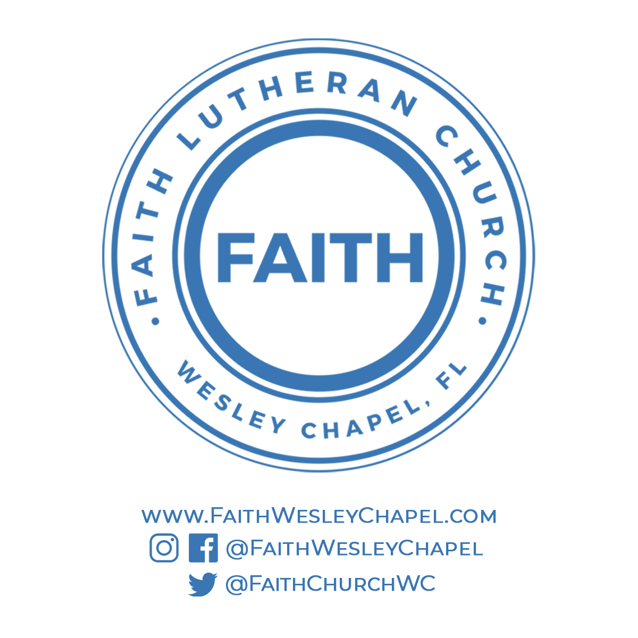**Faith YouTube**

**@FaithWesleyChapel**

**@FaithWesleyChapel**

**@FaithChurchWC**