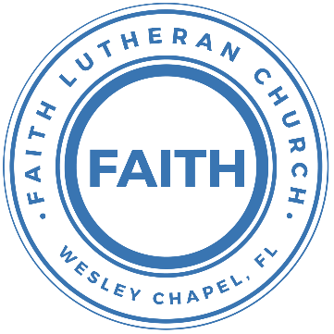

**Leading our community into a deep connection in Christ**

**Worship Service for November 29, 2020 at 11 AM**

**Welcome**

**Opening Song:**Arise and Shine in Splendor  
Arise and shine in splendor, let night to day surrender;  
Your light is drawing near. Above, the night sky is beaming,  
In matchless beauty gleaming; the glory of the Lord is here.

See earth in darkness lying, the heathen nations dying  
In hopeless gloom and night. To you the Lord of heaven,  
Your light, your hope, his given great glory, honor, and delight.

The world’s remotest races, upon whose weary faces  
The sun looks from the sky, shall run with zeal untiring,  
With joy your light desiring that breaks upon them from on high.

Lift up your eyes in wonder; see, nations yonder,  
They all come to be free. The world has heard your story,  
Your sons come to your glory,   
and daughters haste your light to see.

**Invocation**

**Confession and Forgiveness:**

P: Come into the presence of God. It is God, Himself, who bids us to come to Him in prayer, especially when we have sinned, so that we may receive His forgiveness. So, we enter His courts with confidence that if we confess our sins, He will forgive us as He promised.

*(a time of silence to reflect and personally confess our sins)*

C: Heavenly Father, we confess that we have sinned against you in thought, word, and deed. We have not loved you with our whole heart and have not loved our neighbor as ourselves. We are truly sorry and we humbly repent. For the sake of your Son Jesus Christ and His suffering and death on the cross, have mercy on us and forgive us; that we may delight in your will, and walk in your ways, to the glory of your Name. Amen

P: The Lord our God is merciful and gracious, longsuffering, and abounding in goodness and truth, keeping mercy for thousands, forgiving iniquity and transgression and sin. Therefore, I announce unto you the grace of our Lord Jesus Christ. In His stead and by the command of my Lord Jesus Christ, I forgive you all your sins in the name of the Father and of the Son and of the Holy Spirit.

C: Amen. Praise God!

**Song of Praise and Thanksgiving:** Savior of the Nations, Come

Savior of the nations, come, Virgin’s Son, make here Thy home!  
Marvel now O heaven and earth, That the Lord chose such a birth.

Not by human flesh and blood, by the Spirit of our God,  
Was the Word of God made flesh, Woman’s offspring, pure and fresh.

From the Father forth He came and returneth to the same,  
Captive leading death and hell, High the song of triumph swell!

Praise to God the Father sing, Praise to God the Son, our King,  
Praise to God the Spirit be Ever and eternally.

**Epistle Reading -**1 Corinthians 1:3-9

Grace to you and peace from God our Father and the Lord Jesus Christ. I give thanks to my God always for you because of the grace of God that was given you in Christ Jesus, that in every way you were enriched in him in all speech and all knowledge— even as the testimony about Christ was confirmed among you— so that you are not lacking in any gift, as you wait for the revealing of our Lord Jesus Christ, who will sustain you to the end, guiltless in the day of our Lord Jesus Christ. God is faithful, by whom you were called into the fellowship of his Son, Jesus Christ our Lord.

**Gospel Reading** - Mark 11:1-10

Now when they drew near to Jerusalem, to Bethphage and Bethany, at the Mount of Olives, Jesus sent two of his disciples and said to them, “Go into the village in front of you, and immediately as you enter it you will find a colt tied, on which no one has ever sat. Untie it and bring it. If anyone says to you, ‘Why are you doing this?’ say, ‘The Lord has need of it and will send it back here immediately.’” And they went away and found a colt tied at a door outside in the street, and they untied it. And some of those standing there said to them, “What are you doing, untying the colt?” And they told them what Jesus had said, and they let them go. And they brought the colt to Jesus and threw their cloaks on it, and he sat on it. And many spread their cloaks on the road, and others spread leafy branches that they had cut from the fields. And those who went before and those who followed were shouting, “Hosanna! Blessed is he who comes in the name of the Lord! Blessed is the coming kingdom of our father David! Hosanna in the highest!”

**Children's Message**

**Sermon Hymn***–*God of Wonders  
Lord of all creation of water, earth, and sky  
The heavens are Your tabernacle, Glory to the Lord on high

Chorus 1:  
God of wonders beyond our galaxy You are holy, holy  
The universe declares Your majesty You are holy, holy  
Lord of heaven and earth Lord of heaven and earth

Early in the morning, I will celebrate the light  
When I stumble in the darkness, I will call Your Name by night  
*Chorus 1*

Hallelujah to the Lord of heaven and earth (3x)  
You are holy, holy You are holy, holy, holy, holy

God of wonders beyond our galaxy You are holy, holy  
Precious Lord, reveal your heart to me You are holy, holy  
The universe declares Your majesty You are holy, holy  
Lord of heaven and earth Lord of heaven and earth

**Sermon** - "The Lord Comes...As Creator"

Isaiah 64:1-9

Oh, that you would rend the heavens and come down, that the mountains might quake at your presence, as when fire kindles brushwood and the fire causes water to boil, to make your name known to your adversaries, and that the nations might tremble at your presence! When you did awesome things that we did not look for, you came down, the mountains quaked at your presence. From of old no one has heard or perceived by the ear, no eye has seen a God besides you, who acts for those who wait for him. You meet him who joyfully works righteousness, those who remember you in your ways. Behold, you were angry, and we sinned; in our sins we have been a long time, and shall we be saved? We have all become like one who is unclean, and all our righteous deeds are like a polluted garment. We all fade like a leaf, and our iniquities, like the wind, take us away. There is no one who calls upon your name, who rouses himself to take hold of you; for you have hidden your face from us, and have made us melt in the hand of our iniquities.

But now, O Lord, you are our Father; we are the clay, and you are our potter; we are all the work of your hand. Be not so terribly angry, O Lord, and remember not iniquity forever. Behold, please look, we are all your people.

**Prayers**

**Apostles' Creed**

I believe in God, the Father almighty,  
maker of heaven and earth,  
And in Jesus Christ, his only Son, our Lord,  
who was conceived by the Holy Spirit,  
born of the Virgin Mary,  
suffered under Pontius Pilate,  
was crucified, died and was buried.  
He descended into hell.  
The third day he rose again from the dead.  
He ascended into heaven and sits at the right hand of God  
the Father almighty.  
From there he will come to judge the living and the dead.  
I believe in the Holy Spirit,  
the holy Christian Church,  
the communion of saints,  
the forgiveness of sins,  
the resurrection of the body,  
and the life everlasting. Amen.

**The Lord's Prayer**

Our Father who art in heaven, hallowed be Thy name, Thy kingdom come, Thy will be done on earth as it is in heaven.  Give us this day our daily bread; and forgive us our trespasses as we forgive those who trespass against us; and lead us not into temptation, but deliver us from evil.  For Thine is the kingdom and the power and the glory forever and ever.  Amen

**Words of Institution**

**Peace**  
P: The peace of the Lord be with you all.  
C: And also with you.  
P: We greet each other in the peace of Christ.

**Distribution**

**Prayer**

**Benediction**

**Closing Song:**Way MakerYou are here Moving in our midst. I worship you. I worship you

You are here Moving in this place. I worship you. I worship you

(Repeat)

*Chorus:*

Way maker, miracle worker Promise keeper, light in the darkness,

My God, that is who you are

*(Repeat)*

You are here Touching every heart. I worship you. I worship you

You are here Healing every heart. I worship you. I worship you

You are here Turning lives around. I worship you. I worship you

You are here Mending every heart. I worship you. I worship you

*(Chorus)*

That is who You are. That is who You are.

That is who You are. That is who You are.

Even when I don't see it, You're working

Even when I don't feel it, You're working

You never stop, You never stop working (*Repeat line)*

*(Repeat Bridge)*

That is who You are. That is who You are.

That is who You are. That is who You are.

**Offering**

**Upcoming Events**

**December 13, After Service – Top Golf**

**December 18, 6pm – Christmas in the Park**

Wesley Chapel District Park

**December 20, 11am – Dinner Service**

Song and Dance Studio

**December 24, 6pm – Christmas Eve Candlelight Service**

Song and Dance Studio

**[www.FaithWesleyChapel.com](http://www.FaithWesleyChapel.com)**

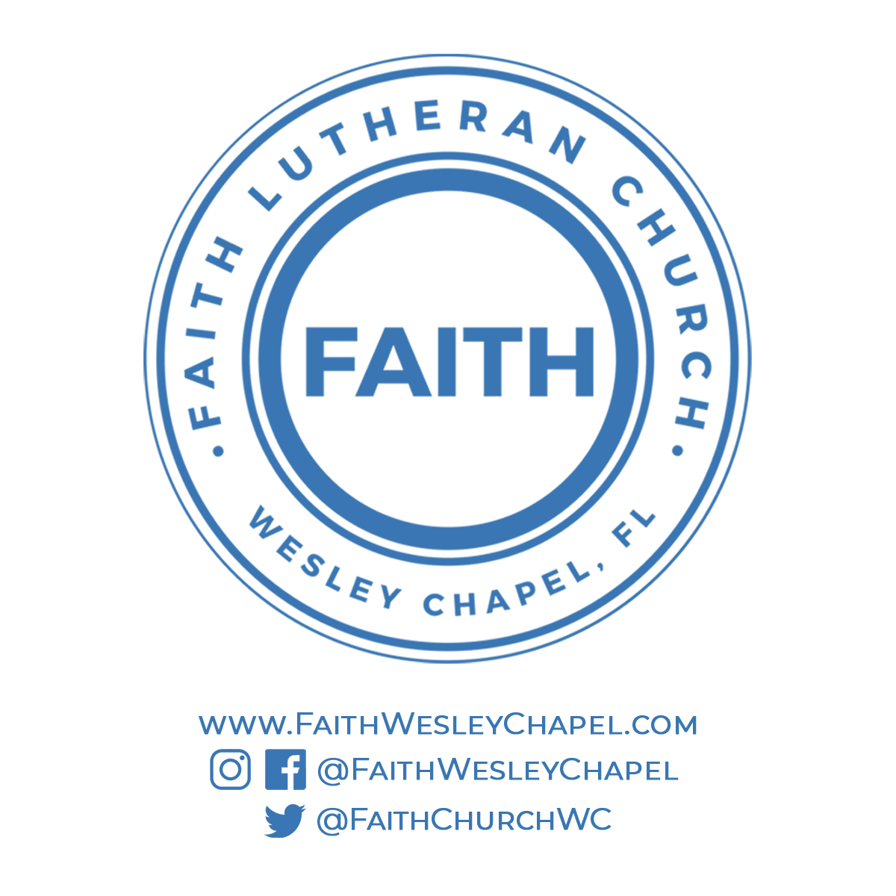**Faith YouTube**

**@FaithWesleyChapel**

**@FaithWesleyChapel**

**@FaithChurchWC**