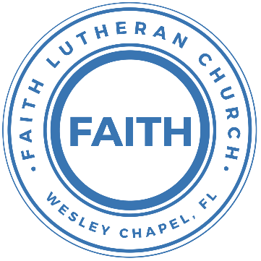

**Leading our community into a deep connection in Christ**

**Worship Service for December 6, 2020 at 11 AM**

**Welcome**

**Opening Song:**Come, Thou Long Expected Jesus

Come thou long-expected Jesus, Born to set thy people free  
From our fears and sins release us; let us find our rest in thee.  
Israel’s strength and consolation, Hope of all the earth thou art,  
Dear desire of ev’ry nation, joy of every longing heart.

Come to earth to taste our sadness, He whose glories knew no end;   
by His life He brings us gladness, Our redeemer, Shepherd, Friend.  
Leaving riches without number, born within a cattle stall;  
This the ever - lasting wonder, Christ was born the Lord of all!

Born thy people to deliver, Born a child and yet a king  
born to reign in us forever, Now thy gracious kingdom bring.  
By thine own eternal spirit; rule in all our hearts alone  
By thine all sufficient merit, Raise us to thy glorious throne

**Invocation**

**Confession and Forgiveness:**

P: We have come here today to worship the Lord.  In worship we hear the Word of God, we receive God's blessings, and respond with thanks and praise.  We begin by seeking God's blessing of forgiveness.  He has promised to remove the guilt and shame of our sin through the sacrifice of Jesus Christ on the cross.

P: Let us confess our sins to the Lord.

*(a time of silence to reflect and personally confess our sins)*

P: Heavenly Father,

P: I have done things that were wrong.

P: I have been mean to others.

P: I have not obeyed my parents.

P: I have not obeyed You, God.

P: But I am very sorry.

P: Please forgive me.

P: I love You very much.

P: And I know You love me, too.

C: Heavenly Father,

C: I have done things that were wrong.   
C: I have been mean to others.

C: I have not obeyed my parents.   
C: I have not obeyed You, God.   
C: But I am very sorry.   
C: Please forgive me.   
C: I love You very much.   
C: And I know You love me, too.

P: God has heard your apology.  He loves you very much.  God has told us that when we believe and trust in Him, He makes us His children.  As far as the east is from the west, so far does he remove our sins from us. He has told me to tell you that you are forgiven.  So, as His servant, I forgive you in the name of the Father and of the Son and of the Holy Spirit.

C: Amen.

**Song:**MessiahLong awaited, precious promise.  
Son of God and son of man  
Heaven's glory in a manger.  
Has come to us in Bethlehem. Oh – Oh

Chorus:  
Messiah, Messiah. Baby born to save us all  
Messiah, Messiah. On our knees we fall

All we longed for, all we needed,  
Shining in this child's eyes  
Hope forever, death defeated.  
Because of this one holy night (Chorus)

O come let us adore him, O come let us adore him  
O come let us adore him, Christ, the Lord

Long awaited, precious promise, Coming back again

Chorus 2:  
Messiah, Messiah. Baby born to save us all  
Messiah, Messiah. On our knees we fall  
On our knees we fall

**First Reading -**Mark 1:1–3

The beginning of the gospel of Jesus Christ, the Son of God. As it is written in Isaiah the prophet,

“Behold, I send my messenger before your face, who will prepare your way, the voice of one crying in the wilderness:

‘Prepare the way of the Lord, make his paths straight,’”

**Children's Message**"What Is a Prophet"

**Second** **Song:**This Is the Day

This is the day (This is the day)  
That the Lord hath made (That the Lord hath made)  
Let us rejoice (Let us rejoice)  
And be glad in it. (And be glad in it.)

This is the day that the Lord hath made  
Let us rejoice and be glad in it.  
This is the day (This is the day)  
That the Lord hath made

**Second Reading -**Mark 1:4-8

John appeared, baptizing in the wilderness and proclaiming a baptism of repentance for the forgiveness of sins. And all the country of Judea and all Jerusalem were going out to him and were being baptized by him in the river Jordan, confessing their sins. Now John was clothed with camel's hair and wore a leather belt around his waist and ate locusts and wild honey. And he preached, saying, “After me comes he who is mightier than I, the strap of whose sandals I am not worthy to stoop down and untie. I have baptized you with water, but he will baptize you with the Holy Spirit.”

**Children's Message**"Prepare the Way!"

**Children’s Song:** Jesus Loves Me

Jesus loves me this I know, For the Bible tells me so.  
Little ones to Him belong, They are weak, but He is strong.

Chorus:  
Yes, Jesus loves me, Yes, Jesus loves me,  
Yes, Jesus loves me, The Bible tells me so.

Jesus loves me, He who died. Heaven's gates to open wide.  
He will wash away my sin, Let His little child come in. (Chorus)

**Sermon Hymn:** What Child Is This

What child is this, who, laid to rest, On Mary’s lap is sleeping?  
Whom angels greet with anthems sweet While shepherds watch are keeping?  
This, this is Christ the king, Whom shepherds guard and angels sing;  
Haste, haste to bring him laud, The babe, the son of Mary!  
Why lies he in such mean estate Where ox and lamb are feeding?

Good Christian, fear; for sinners here The silent Word is pleading.  
Nails, spear shall pierce him through, The cross be borne for me, for you;  
Hail, hail the Word made flesh, The babe, the son of Mary!

**Sermon –**“The Lord Comes...As Prophet”

Isaiah 40:1-11

Comfort, comfort my people, says your God.

Speak tenderly to Jerusalem,

and cry to her

that her warfare is ended,

that her iniquity is pardoned,

that she has received from the Lord's hand

double for all her sins.

A voice cries:

“In the wilderness prepare the way of the Lord;

make straight in the desert a highway for our God.

Every valley shall be lifted up,

and every mountain and hill be made low;

the uneven ground shall become level,

and the rough places a plain.

And the glory of the Lord shall be revealed,

and all flesh shall see it together,

for the mouth of the Lord has spoken.”

A voice says, “Cry!”

And I said, “What shall I cry?”

All flesh is grass,

and all its beauty is like the flower of the field.

The grass withers, the flower fades

when the breath of the Lord blows on it;

surely the people are grass.

The grass withers, the flower fades,

but the word of our God will stand forever.

Go on up to a high mountain,

O Zion, herald of good news;

lift up your voice with strength,

O Jerusalem, herald of good news;

lift it up, fear not;

say to the cities of Judah,

“Behold your God!”

Behold, the Lord God comes with might,

and his arm rules for him;

behold, his reward is with him,

and his recompense before him.

He will tend his flock like a shepherd;

he will gather the lambs in his arms;

he will carry them in his bosom,

and gently lead those that are with young.

**Prayers**

**The Lord's Prayer**

Our Father who art in heaven, hallowed be Thy name, Thy kingdom come, Thy will be done on earth as it is in heaven.  Give us this day our daily bread; and forgive us our trespasses as we forgive those who trespass against us; and lead us not into temptation, but deliver us from evil.  For Thine is the kingdom and the power and the glory forever and ever.  Amen

**Words of Institution**

**Peace**

P: The peace of the Lord be with you all.

C: And also, with you.

P: We greet each other in the peace of Christ.

**Distribution**

**Prayer**

**Benediction**

**Closing Song –**Go Tell It On the Mountain

Go tell it on the mountain, over the hills and everywhere;  
Go tell it on the mountain that Jesus Christ is born.

Verse 1:  
While shepherds kept their watching o'er silent flocks by night,  
Behold throughout the heavens there shone a Holy Light.

Chorus

Verse 2:  
The shepherds feared and trembled when lo! Above the earth,  
Rang out the angel chorus that hailed our Savior’s birth.

Chorus

Verse 3:  
Down in a lowly manger, the humble Christ was born  
And brought us God's salvation that blessed Christmas morn!

Chorus

**Offering**

**Sermon Notes:**

**_______________________________________________**

**_______________________________________________**

**_______________________________________________**

**_______________________________________________**

**_______________________________________________**

**_______________________________________________**

**_______________________________________________**

**Upcoming Events**

**December 13, After Service – Top Golf**

**December 18, 6pm – Christmas in the Park**

Wesley Chapel District Park

**December 20, 11am – Dinner Service**

Song and Dance Studio

**December 24, 6pm – Christmas Eve Candlelight Service**

Song and Dance Studio

**www.FaithWesleyChapel.com**

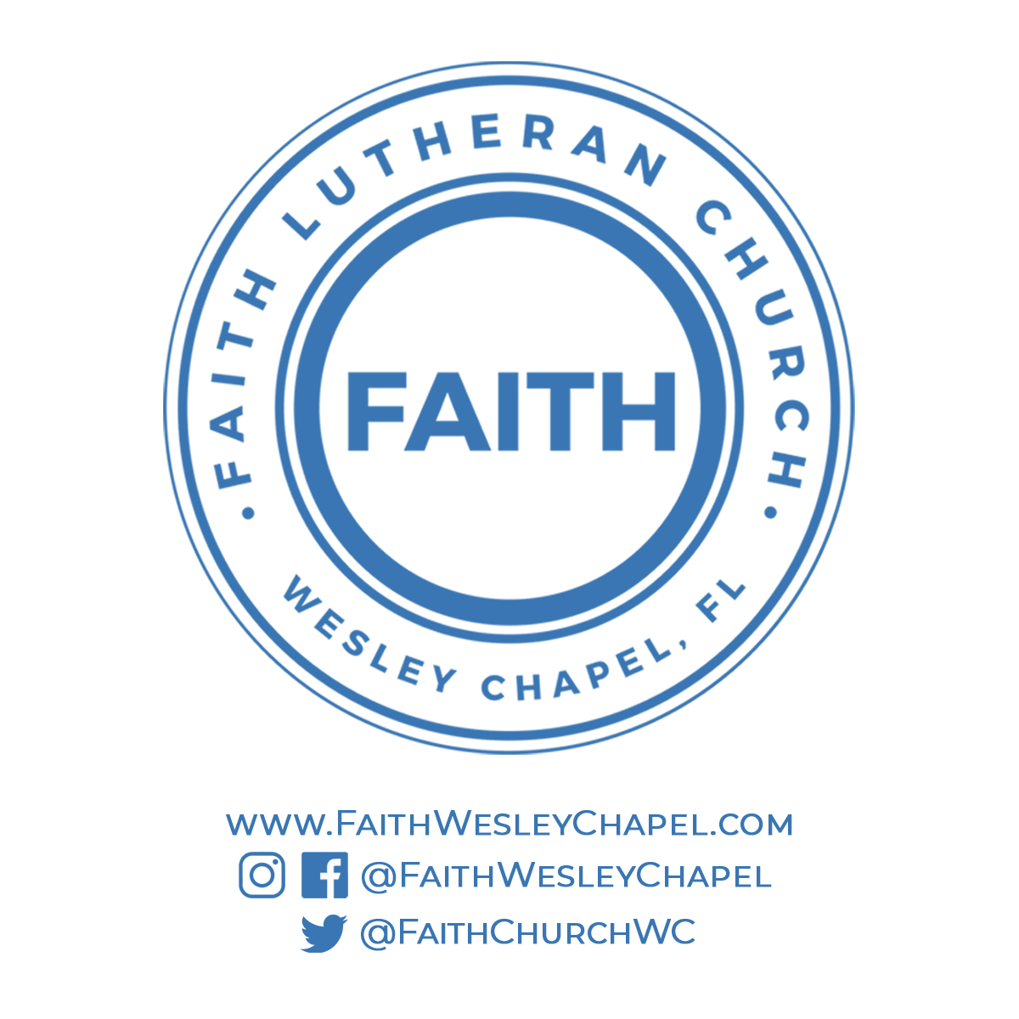**Faith YouTube**

**@FaithWesleyChapel**

**@FaithWesleyChapel**

**@FaithChurchWC**