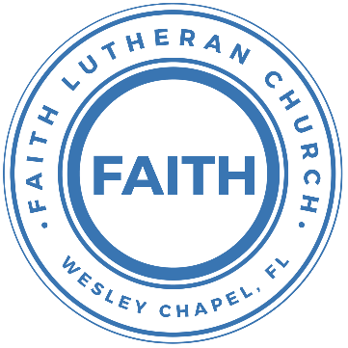

**Leading our community into a deep connection in Christ**

**Worship Service for January 17, 2020 at 11 AM**

**Welcome**

**Opening Song:**God So Loved

Come all you weary, Come all you thirsty  
Come to the well that Never runs dry  
Drink of the Water, Come and thirst no more

Come all you sinners, Come find His mercy  
Come to the table, He Will satisfy  
Taste of His goodness, Find what you’re looking for

Chorus 1:  
For God so loved the World that He gave us His  
One and only Son to save us  
Whoever believes in Him will live forever

Bring all your failures, Bring your addictions  
Come lay them down at the Foot of the cross  
Jesus is waiting There with open arms

Chorus 1

Chorus 2:  
The power of Hell forever defeated  
Now it is well, I’m Walking in freedom  
For God so loved, God so loved the world

Praise God, praise God, From whom all blessings flow  
Praise Him, praise Him for the Wonders of His love  
(Repeat)

His amazing love  
For God so loved the world that He gave us His one and only Son to save

Chorus 1:  
For God so loved the World that He gave us His one and only Son to save us whoever believes in Him will live forever

Chorus 2:  
The power of Hell forever defeated  
Now it is well, I’m Walking in freedom  
For God so loved, God so loved the world

Bring all your failures. Bring your addictions  
Come lay them down at the foot of the cross  
Jesus is waiting. God so loved the world

**Invocation**

**Confession and Forgiveness:**

**P:** Our Heavenly Father asks us to come into His presence.  
**C:** But we are sinful and unworthy.   
**P:** Yes, all have sinned and fall short of the glory of God, but Jesus Christ died on the cross that we may be forgiven and washed clean of all our sins by His blood spilled on the cross. We take a moment to bow before the His cross and silently reflect on our lives and confess our sins.

(Time of silence for reflection and confession)

**P:** Let us confess, together, our sins to God our Father.  
**C:** Heavenly Father, we confess that we are sinners.  We have sinned against you and our neighbors. We have not loved you with our whole heart and we have not loved our neighbors as ourselves. We have not lived out our faith out in our community. We justly deserve Your punishment.  For the sake of Your Son, Jesus Christ, have mercy on us.  Forgive us, renew us, and lead us, so that we may delight in Your will and walk in Your ways to the glory of Your holy name.  Amen.

**P:** Almighty God in His mercy has given His Son to die for you and for His sake forgives you all your sins.  As a called and ordained servant of Christ, and by His authority, I, therefore, forgive you all your sins in the name of the Father and of the Son and of the Holy Spirit.  
**C:** Amen

**Song of Praise and Thanksgiving:** Christ Is Risen

Let no one caught in sin remain Inside the lie of inward shame  
We fix our eyes upon the cross and run to Him who showed great love  
And bled for us. Freely You've bled for us

Chorus:  
Christ is risen from the dead, trampling over death by death  
Come awake, come awake, come and rise up from the grave  
Christ is risen from the dead, we are one with Him again  
Come awake, come awake, come and rise up from the grave

Beneath the weight of all our sin You bowed to none but Heaven's will  
No scheme of Hell, no scoffer's crown,   
No burden great can hold You down  
In strength You reign. Forever let Your church pro-claim

Chorus

O death, where is your sting? O hell, where is your victory?  
O church, come stand in the light.  
The glory of God has defeated the night!  
O death, where is your sting? O hell, where is your victory?  
O church, come stand in the light.  
Our God is not dead. He is alive! He is alive!

Chorus

**Epistle Reading -**1 Corinthians 6:12-20

“All things are lawful for me,” but not all things are helpful. “All things are lawful for me,” but I will not be dominated by anything. “Food is meant for the stomach and the stomach for food”—and God will destroy both one and the other. The body is not meant for sexual immorality, but for the Lord, and the Lord for the body. And God raised the Lord and will also raise us up by his power.

Do you not know that your bodies are members of Christ? Shall I then take the members of Christ and make them members of a prostitute? Never! Or do you not know that he who is joined to a prostitute becomes one body with her?

For, as it is written, “The two will become one flesh.” But he who is joined to the Lord becomes one spirit with him. Flee from sexual immorality. Every other sin a person commits is outside the body, but the sexually immoral person sins against his own body. Or do you not know that your body is a temple of the Holy Spirit within you, whom you have from God? You are not your own, for you were bought with a price. So glorify God in your body.

**Gospel Reading** - John 1:43–51

The next day Jesus decided to go to Galilee. He found Philip and said to him, “Follow me.” Now Philip was from Bethsaida, the city of Andrew and Peter. Philip found Nathanael and said to him, “We have found him of whom Moses in the Law and also the prophets wrote, Jesus of Nazareth, the son of Joseph.” Nathanael said to him, “Can anything good come out of Nazareth?” Philip said to him, “Come and see.”

Jesus saw Nathanael coming toward him and said of him, “Behold, an Israelite indeed, in whom there is no deceit!” Nathanael said to him, “How do you know me?” Jesus answered him, “Before Philip called you, when you were under the fig tree, I saw you.” Nathanael answered him, “Rabbi, you are the Son of God! You are the King of Israel!” Jesus answered him, “Because I said to you, ‘I saw you under the fig tree,’ do you believe? You will see greater things than these.” And he said to him, “Truly, truly, I say to you, you will see heaven opened, and the angels of God ascending and descending on the Son of Man.”

**Children's Message**

**Sermon Hymn***–*Speak, O Lord, Your Servant Listens

Newborn life and spirit give me, let each promise still my fear.  
Death's dread pow'r, its inward strife, Wars against Your Word of life;  
Fill me, Lord, with love's strong fervor That I cling to You forever!

Oh, what blessing to be near You And to listen to Your voice;  
Let me ever love and hear You, let Your Word be now my choice!  
Many hardened sinners, Lord, flee in terror at Your Word;  
But to all who feel sin's burden You give words of peace and pardon.

Lord, Your words are waters living when my thirsting spirit pleads.  
Lord, Your words are bread life-giving; on Your words my spirit feeds.  
Lord, Your words will be my light through death's cold and dreary night;  
Yes, they are my sword prevailing and my cup of joy unfailing!

As I pray, dear Jesus, hear me; Let Your words in me take root.  
May Your Spirit e'er be near me That I bear abundant fruit.  
May I daily sing Your praise, From my heart glad anthems raise,  
Till my highest praise is given In the endless joy of heaven.

**Sermon** - "But He Did Not Know YAHWEH"

1 Samuel 3:1-10

Now the boy Samuel was ministering to the Lord in the presence of Eli. And the word of the Lord was rare in those days; there was no frequent vision. At that time Eli, whose eyesight had begun to grow dim so that he could not see, was lying down in his own place. The lamp of God had not yet gone out, and Samuel was lying down in the temple of the Lord, where the ark of God was.

Then the Lord called Samuel, and he said, “Here I am!” and ran to Eli and said, “Here I am, for you called me.” But he said, “I did not call; lie down again.” So he went and lay down. And the Lord called again, “Samuel!” and Samuel arose and went to Eli and said, “Here I am, for you called me.” But he said, “I did not call, my son; lie down again.” Now Samuel did not yet know the Lord, and the word of the Lord had not yet been revealed to him.

And the Lord called Samuel again the third time. And he arose and went to Eli and said, “Here I am, for you called me.” Then Eli perceived that the Lord was calling the boy. Therefore, Eli said to Samuel, “Go, lie down, and if he calls you, you shall say, ‘Speak, Lord, for your servant hears.’” So, Samuel went and lay down in his place. And the Lord came and stood, calling as at other times, “Samuel! Samuel!” And Samuel said, “Speak, for your servant hears.”

**Prayers**

**Apostles' Creed**

I believe in God, the Father almighty, maker of heaven and earth,  
And in Jesus Christ, his only Son, our Lord, who was conceived by the Holy Spirit, born of the Virgin Mary, suffered under Pontius Pilate, was crucified, died and was buried.  
He descended into hell. The third day he rose again from the dead. He ascended into heaven and sits at the right hand of God the Father almighty. From there he will come to judge the living and the dead. I believe in the Holy Spirit, the holy Christian Church, the communion of saints, the forgiveness of sins, the resurrection of the body, and the life everlasting. Amen.

**The Lord's Prayer**

Our Father who art in heaven, hallowed be Thy name, Thy kingdom come, Thy will be done on earth as it is in heaven.  Give us this day our daily bread; and forgive us our trespasses as we forgive those who trespass against us; and lead us not into temptation, but deliver us from evil.  For Thine is the kingdom and the power and the glory forever and ever.  Amen

**Words of Institution**

**Peace**

P: The peace of the Lord be with you all.

C: And also with you.

P: We greet each other in the peace of Christ.

**Distribution**

**Prayer**

**Benediction**

**Closing Song:**All The People Said, Amen

You are not alone, if you are lonely  
When you feel afraid, you're not the only  
We are all the same, in need of mercy  
To be forgiven and be free  
It's all you got to lean on but thank God it's all you need

Chorus:  
And all the people said Amen, woah  
And all the people said Amen  
Give thanks to the Lord for His love never ends  
And all the people said Amen (Last line repeated on last chorus)

If you're rich or poor, well it don't matter  
Weak or strong, you know love is what we're after  
We're all broken, but we're all in this together  
God knows we stumble and fall  
And He so loved the world, He sent His son to save us all

Chorus

Blessed are the poor in spirit who are torn apart  
Blessed are the persecuted and the pure in heart  
Blessed are the people hungry for another start  
For this is the kingdom, the kingdom of God

Chorus 2x

**Offering**

**Sermon Notes:**

________________________________________________________________________________________________________________________________________________________________________________________________________________________________________________________________________________________________________________________________________________________________________________________________________________________________________________

**Upcoming Events**

**January 21, 7 PM – Thursday Evening Prayers**Online – [Facebook](https://www.facebook.com/FaithWesleyChapel/), [YouTube](https://www.youtube.com/channel/UCmI-Pg2fcqf7VOJThDyJE8g/featured), [FaithWesleyChapel.com](http://FaithWesleyChapel.com)

**January 24, Immediately After the Service – Voter Meeting**Vote on Delaying the LCMS ConventionSong and Dance, Zoom

**January 24, After the Service (1 PM) – Youth Bowling**Pin Chasers East Pasco

**January 31, After the Service – Voter Assembly**“The State of the Church”Song and Dance, Zoom

**www.FaithWesleyChapel.com**

**Faith YouTube**

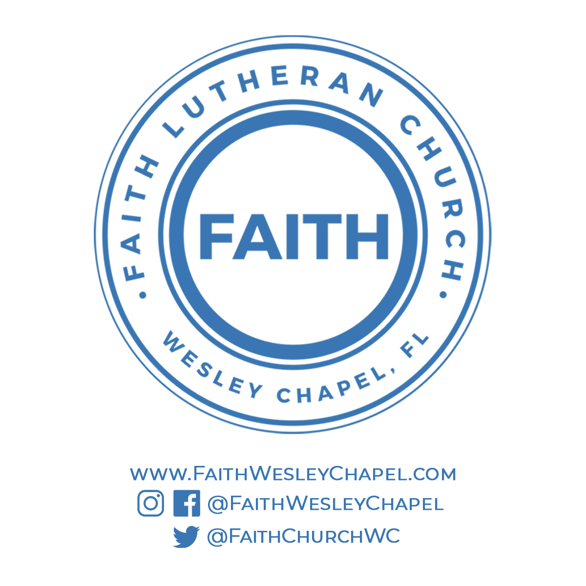**@FaithWesleyChapel**

**@FaithWesleyChapel**

**@FaithChurchWC**