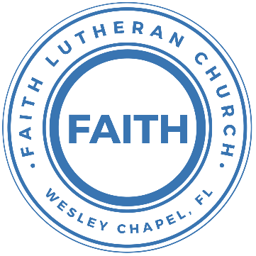

**Leading our community into a deep connection in Christ**

**Worship Service for January 31, 2021 at 11 AM**

**Welcome**

**Opening Song:**Goodness of God

I love you, Lord, For your mercy never fails me.  
All my days, I’ve been held in your hands  
From the moment that I wake up, Till I lay my head  
I will sing of the goodness of God

Chorus:  
All my life you have been faithful.  
All my life you have been so, so good  
With every breath that I am able  
I will sing of the goodness of God

I love your voice. You have led me through the fire  
In darkest night you are close like no other.  
I’ve known you as a father. I’ve known you as a friend  
I have lived in the goodness of God

Chorus

Your goodness is running after, It’s running after me  
Your goodness is running after, It’s running after me  
With my life laid down, I’m surrendered now  
I give you everything  
Your goodness is running after, It’s running after me

Your goodness is running after, It’s running after me  
Your goodness is running after, It’s running after me  
With my life laid down, I’m surrendered now  
I give you everything  
Your goodness is running after, It’s running after me

Chorus:  
All my life you have been faithful.  
All my life you have been so, so good  
With every breath that I am able  
I will sing of the goodness of God

**Invocation**

**Confession and Forgiveness:**

P: Come into the presence of God. It is God, Himself, who bids us to come to Him in prayer, especially when we have sinned, so that we may receive His forgiveness. So, we enter His courts with confidence that if we confess our sins, He will forgive us as He promised.

(a time of silence to reflect and personally confess our sins)

C: Heavenly Father, we confess that we have sinned against you in thought, word, and deed. We have not loved you with our whole heart and have not loved our neighbor as ourselves. We are truly sorry and we humbly repent. For the sake of your Son Jesus Christ and His suffering and death on the cross, have mercy on us and forgive us; that we may delight in your will, and walk in your ways, to the glory of your Name. Amen

P: The Lord our God is merciful and gracious, longsuffering, and abounding in goodness and truth, keeping mercy for thousands, forgiving iniquity and transgression and sin. Therefore I announce unto you the grace of our Lord Jesus Christ. In His stead and by the command of my Lord Jesus Christ, I forgive you all your sins in the name of the Father and of the Son and of the Holy Spirit.

C: Amen.

**Song of Praise and Thanksgiving:** How Deep the Father’s Love For Us

How deep the Father's love for us, how vast beyond all measure  
That He should give His only Son, to make a wretch His treasure  
How great the pain of searing loss, the Father turned His face away  
As wounds which mar the Chosen One, bring many sons to glory

Behold the Man upon a cross, my sin upon His shoulders  
Ashamed, I hear my mocking voice call out among the scoffers  
It was my sin that held Him there until it was accomplished  
His dying breath has brought me life; I know that it is finished

I will not boast in anything: no gifts, no power, no wisdom  
But I will boast in Jesus Christ; his death and resurrection  
Why should I gain from His reward? I cannot give an answer  
But this I know with all my heart: His wounds have paid my ransom  
But this I know with all my heart: His wounds have paid my ransom

**Old Testament Reading -**Psalm 111

Praise the Lord!

I will give thanks to the Lord with my whole heart,

in the company of the upright, in the congregation.

Great are the works of the Lord,

studied by all who delight in them.

Full of splendor and majesty is his work,

and his righteousness endures forever.

He has caused his wondrous works to be remembered;

the Lord is gracious and merciful.

He provides food for those who fear him;

he remembers his covenant forever.

He has shown his people the power of his works,

in giving them the inheritance of the nations.

The works of his hands are faithful and just;

all his precepts are trustworthy;

they are established forever and ever,

to be performed with faithfulness and uprightness.

He sent redemption to his people;

he has commanded his covenant forever.

Holy and awesome is his name!

The fear of the Lord is the beginning of wisdom;

all those who practice it have a good understanding.

His praise endures forever!

**Gospel Reading** - Mark 1:21–28

And they went into Capernaum, and immediately on the Sabbath he entered the synagogue and was teaching. And they were astonished at his teaching, for he taught them as one who had authority, and not as the scribes. And immediately there was in their synagogue a man with an unclean spirit. And he cried out, “What have you to do with us, Jesus of Nazareth? Have you come to destroy us? I know who you are—the Holy One of God.” But Jesus rebuked him, saying, “Be silent, and come out of him!” And the unclean spirit, convulsing him and crying out with a loud voice, came out of him. And they were all amazed, so that they questioned among themselves, saying, “What is this? A new teaching with authority! He commands even the unclean spirits, and they obey him.” And at once his fame spread everywhere throughout all the surrounding region of Galilee.

**Children's Message**

**Sermon Hymn***–*I Surrender All

All to Jesus I surrender. All to Him I freely give  
I will ever love and trust Him. In His presence daily live

Chorus:  
I surrender all. I surrender all  
All to Thee my blessed Savior.  
I surrender all

All to Jesus I surrender, Humbly at His feet I bow  
Worldly pleasures all forsaken,  
Take me, Jesus, take me now

Chorus

All to Jesus I surrender. Lord, I give my-self to Thee  
Fill me with Thy love and power. Let Thy blessing fall on me

Chorus 2x

**Sermon** - "Knowledge Puffs Up, But Love Builds Up"

1 Corinthians 8:1–13

Now concerning food offered to idols: we know that “all of us possess knowledge.” This “knowledge” puffs up, but love builds up. If anyone imagines that he knows something, he does not yet know as he ought to know. But if anyone loves God, he is known by God.

Therefore, as to the eating of food offered to idols, we know that “an idol has no real existence,” and that “there is no God but one.” For although there may be so-called gods in heaven or on earth—as indeed there are many “gods” and many “lords”— yet for us there is one God, the Father, from whom are all things and for whom we exist, and one Lord, Jesus Christ, through whom are all things and through whom we exist.

However, not all possess this knowledge. But some, through former association with idols, eat food as really offered to an idol, and their conscience, being weak, is defiled. Food will not commend us to God. We are no worse off if we do not eat, and no better off if we do. But take care that this right of yours does not somehow become a stumbling block to the weak. For if anyone sees you who have knowledge eating in an idol's temple, will he not be encouraged, if his conscience is weak, to eat food offered to idols? And so by your knowledge this weak person is destroyed, the brother for whom Christ died. Thus, sinning against your brothers and wounding their conscience when it is weak, you sin against Christ. Therefore, if food makes my brother stumble, I will never eat meat, lest I make my brother stumble.

**Offering**

**Prayers**

**Apostles' Creed**

I believe in God, the Father almighty,  
maker of heaven and earth,

And in Jesus Christ, his only Son, our Lord,  
who was conceived by the Holy Spirit,  
born of the Virgin Mary,  
suffered under Pontius Pilate,  
was crucified, died and was buried.  
He descended into hell.  
The third day he rose again from the dead.  
He ascended into heaven and sits at the right hand of God  
the Father almighty.  
From there he will come to judge the living and the dead.

I believe in the Holy Spirit,  
the holy Christian Church,  
the communion of saints,  
the forgiveness of sins,  
the resurrection of the body,

and the life everlasting. Amen.

**The Lord's Prayer**

Our Father who art in heaven, hallowed be Thy name, Thy kingdom come, Thy will be done on earth as it is in heaven.  Give us this day our daily bread; and forgive us our trespasses as we forgive those who trespass against us; and lead us not into temptation, but deliver us from evil.  For Thine is the kingdom and the power and the glory forever and ever.  Amen

**Words of Institution**

**Peace**

P: The peace of the Lord be with you all.

C: And also with you.

P: We greet each other in the peace of Christ.

**Distribution**

**Prayer**

**Benediction**

**Closing Song:**Joy of the Lord

Though the tears may fall my song will rise, my song will rise to You  
Though my heart may fail my song will rise, my song will rise to You  
While there's breath in my lungs, I will praise You Lord  
In the dead of night I’ll lift my eyes, I’ll lift my eyes to You  
Though the waters rise I’ll lift my eyes, I’ll lift my eyes to You  
While there's hope in this heart, I will praise You Lord

Chorus:  
The joy of the Lord is my strength   
The joy of the Lord is my strength  
In the darkness I’ll dance, in the shadows I’ll sing  
(stop)  
The joy of the Lord is my strength

When I cannot see You with my eyes, let faith arise to You  
When I cannot feel Your hand in mine, let faith arise to You  
God of mercy and love, I will praise You Lord  
How You shine with glory Lord of light, I feel alive with You  
In Your presence now I come alive, I am alive with You  
There is strength when I say "I will praise You Lord"

When sorrow comes my way, You are the shield around me  
Always You remain my courage in the fight  
I hear You call my name, Jesus I am coming  
Walking on the waves, reaching for Your light

**Offering**

**Sermon Notes:**

________________________________________________________________________________________________________________________________________________________________________________________________________________________________________________________________________________________________________________________________________________________________________________________________________________________________________________

**Upcoming Events**

**January 31, Immediately After the Service – Voter Meeting**Vote on Delaying the LCMS Convention **After the Voter Meeting – Voter Assembly**“The State of the Church”Song and Dance, Zoom

**February 4, 7 PM – Thursday Evening Prayers**Online – [Facebook](https://www.facebook.com/FaithWesleyChapel/), [YouTube](https://www.youtube.com/channel/UCmI-Pg2fcqf7VOJThDyJE8g/featured), [FaithWesleyChapel.com](http://FaithWesleyChapel.com)

**www.FaithWesleyChapel.com**

**Faith YouTube**

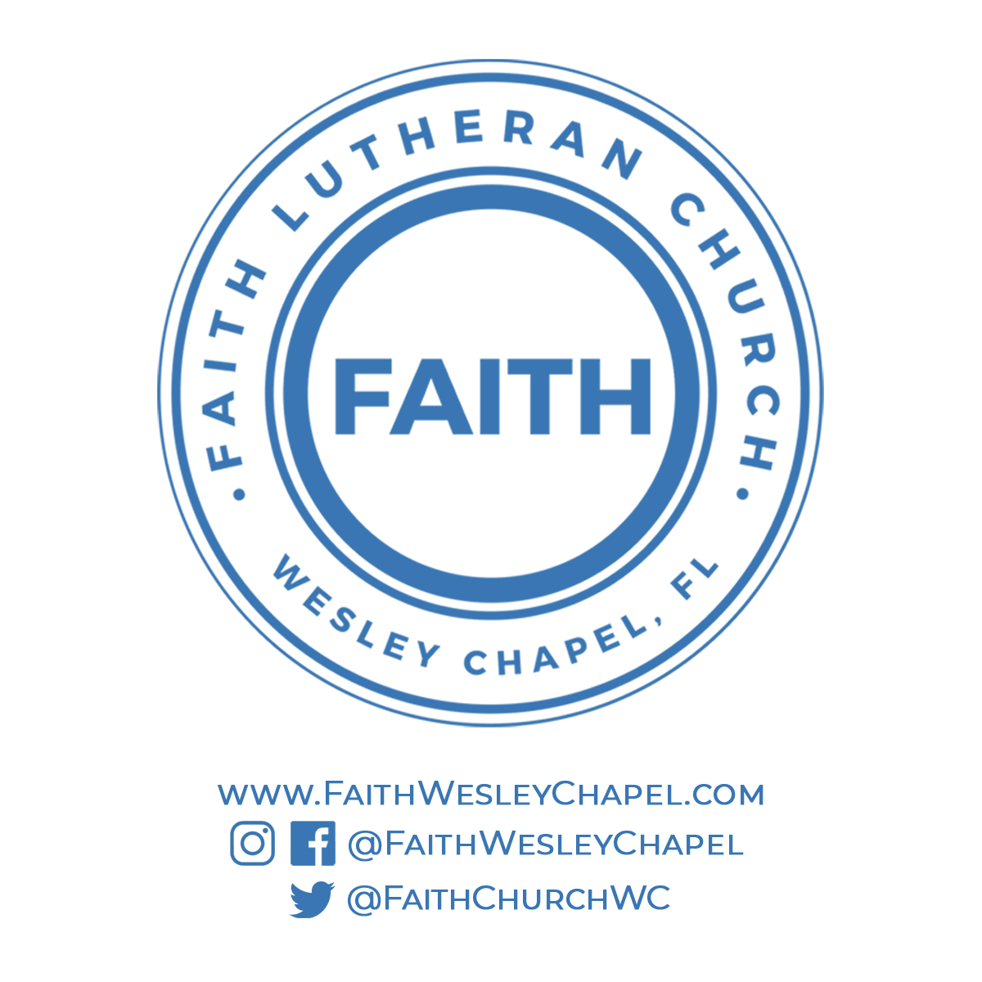**@FaithWesleyChapel**

**@FaithWesleyChapel**

**@FaithChurchWC**