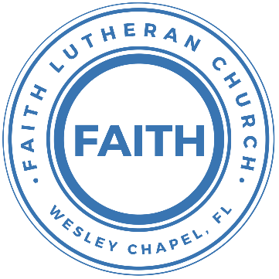

**Leading our community into a deep connection in Christ**

**Worship Service for February 14, 2021 at 11 AM**

**Welcome**

**Invocation**

**Confession and Forgiveness:**

P: Come into the presence of God. It is God, Himself, who bids us to come to Him in prayer, especially when we have sinned, so that we may receive His forgiveness. So, we enter His courts with confidence that if we confess our sins, He will forgive us as He promised.

(a time of silence to reflect and personally confess our sins)

C: Heavenly Father, we confess that we have sinned against you in thought, word, and deed. We have not loved you with our whole heart and have not loved our neighbor as ourselves. We are truly sorry and we humbly repent. For the sake of your Son Jesus Christ and His suffering and death on the cross, have mercy on us and forgive us; that we may delight in your will, and walk in your ways, to the glory of your Name. Amen

P: The Lord our God is merciful and gracious, longsuffering, and abounding in goodness and truth, keeping mercy for thousands, forgiving iniquity and transgression and sin. Therefore I announce unto you the grace of our Lord Jesus Christ. In His stead and by the command of my Lord Jesus Christ, I forgive you all your sins in the name of the Father and of the Son and of the Holy Spirit.

C: Amen.

**Song of Praise and Thanksgiving:** All Glory, Laud, and Honor

Refrain:  
All glory, laud, and honor to You, Redeemer, King,  
To whom the lips of children made sweet hosannas ring.

You are the King of Israel And David’s royal Son,  
Now in the Lord’s Name coming, our King and Blessed One.

Refrain

The multitude of pilgrims with palms before You went:  
Our praise and prayers and anthems Before You we present.

Refrain

To you before Your passion they sang their hymns of praise;  
To You, now high exalted, our melody we raise.

Refrain

**Epistle Reading -**2 Corinthians 3:12-4:6

Since we have such a hope, we are very bold, not like Moses, who would put a veil over his face so that the Israelites might not gaze at the outcome of what was being brought to an end. But their minds were hardened. For to this day, when they read the old covenant, that same veil remains unlifted, because only through Christ is it taken away. Yes, to this day whenever Moses is read a veil lies over their hearts. But when one turns to the Lord, the veil is removed. Now the Lord is the Spirit, and where the Spirit of the Lord is, there is freedom. And we all, with unveiled face, beholding the glory of the Lord, are being transformed into the same image from one degree of glory to another. For this comes from the Lord who is the Spirit.

Therefore, having this ministry by the mercy of God, we do not lose heart. But we have renounced disgraceful, underhanded ways. We refuse to practice cunning or to tamper with God's word, but by the open statement of the truth we would commend ourselves to everyone's conscience in the sight of God. And even if our gospel is veiled, it is veiled to those who are perishing. In their case the god of this world has blinded the minds of the unbelievers, to keep them from seeing the light of the gospel of the glory of Christ, who is the image of God. For what we proclaim is not ourselves, but Jesus Christ as Lord, with ourselves as your servants for Jesus' sake. For God, who said, “Let light shine out of darkness,” has shone in our hearts to give the light of the knowledge of the glory of God in the face of Jesus Christ.

**Gospel Reading** - Mark 9:2–9

And after six days Jesus took with him Peter and James and John, and led them up a high mountain by themselves. And he was transfigured before them, and his clothes became radiant, intensely white, as no one on earth could bleach them. And there appeared to them Elijah with Moses, and they were talking with Jesus. And Peter said to Jesus, “Rabbi, it is good that we are here. Let us make three tents, one for you and one for Moses and one for Elijah.” For he did not know what to say, for they were terrified. And a cloud overshadowed them, and a voice came out of the cloud, “This is my beloved Son; listen to him.” And suddenly, looking around, they no longer saw anyone with them but Jesus only. And as they were coming down the mountain, he charged them to tell no one what they had seen, until the Son of Man had risen from the dead.

**Children's Message**

**Sermon Hymn***–*Goodness of God

I love you, Lord, For your mercy never fails me.  
All my days, I’ve been held in your hands  
From the moment that I wake up, Till I lay my head  
I will sing of the goodness of God

Chorus:  
All my life you have been faithful.   
All my life you have been so, so good  
With every breath that I am able  
I will sing of the goodness of God

I love your voice. You have led me through the fire  
In darkest night you are close like no other.  
I’ve known you as a father. I’ve known you as a friend  
I have lived in the goodness of God

Chorus

Your goodness is running after, it’s running after me  
Your goodness is running after, it’s running after me  
With my life laid down, I’m surrendered now I give you everything  
Your goodness is running after, it’s running after me

Repeat

With my life laid down, I’m surrendered now I give you everything  
Your goodness is running after, it’s running after me

Repeat

Chorus

**Sermon** - "Removing the Veil"

**Prayers**

**Apostles' Creed**

I believe in God, the Father almighty,  
maker of heaven and earth,

And in Jesus Christ, his only Son, our Lord,  
who was conceived by the Holy Spirit,  
born of the Virgin Mary,  
suffered under Pontius Pilate,  
was crucified, died and was buried.  
He descended into hell.  
The third day he rose again from the dead.  
He ascended into heaven and sits at the right hand of God  
the Father almighty.  
From there he will come to judge the living and the dead.

I believe in the Holy Spirit,  
the holy Christian Church,  
the communion of saints,  
the forgiveness of sins,  
the resurrection of the body,

and the life everlasting. Amen.

**The Lord's Prayer**

Our Father who art in heaven, hallowed be Thy name, Thy kingdom come, Thy will be done on earth as it is in heaven.  Give us this day our daily bread; and forgive us our trespasses as we forgive those who trespass against us; and lead us not into temptation, but deliver us from evil.  For Thine is the kingdom and the power and the glory forever and ever.  Amen

**Benediction**

**Closing Song:**We Are

Every secret, every shame, every fear, every pain  
Live inside the dark, but that’s not who we are  
We are children of the day

Pre-Chorus:  
So wake up sleeper, lift your head.   
We were meant for more than this  
Fight the shadows conquer death.  
Make the most of the time we have left

Chorus:  
We are the light of the world. We are the city on a hill   
We are the light of the world  
We gotta, we gotta, we gotta let the light shine

Repeat

Let the light shine, let the light shine

We are called to the spread the news.  
Tell the world the simple truth  
Jesus came to save, there’s freedom in His Name  
So let it all break through

Pre-Chorus

Chorus

We are the light we are the light we are the light  
So let your light shine brighter  
We the light we are the light we are the light… Jesus  
You are the light you are the light you are the light.  
We will lift you high and Shine, shine, shine

Chorus (2x)

**Offering**

**Sermon Notes:**

____________________________________________________________________________________________________________________________________________________________________________________________________________________________________________________________________________________________________________________________________________________________________________________________________________________________________________________________________________________________________________________________________________________________________________________________________________________________________________________________________________________________________________________________________________________________________________________________________________________________________________________________________________________________________________________________________________________________________________________________________________________________________________________________________________________________________________________________________________________________________________________________________________________________________

**Upcoming Events**

**February 18, 7 AM and 7 PM Tampa Lutherans Pray Launch**

Online on the Tampa Lutherans Pray YouTube Channel

TampaLutheransPray.com

**www.FaithWesleyChapel.com**

**Faith YouTube**

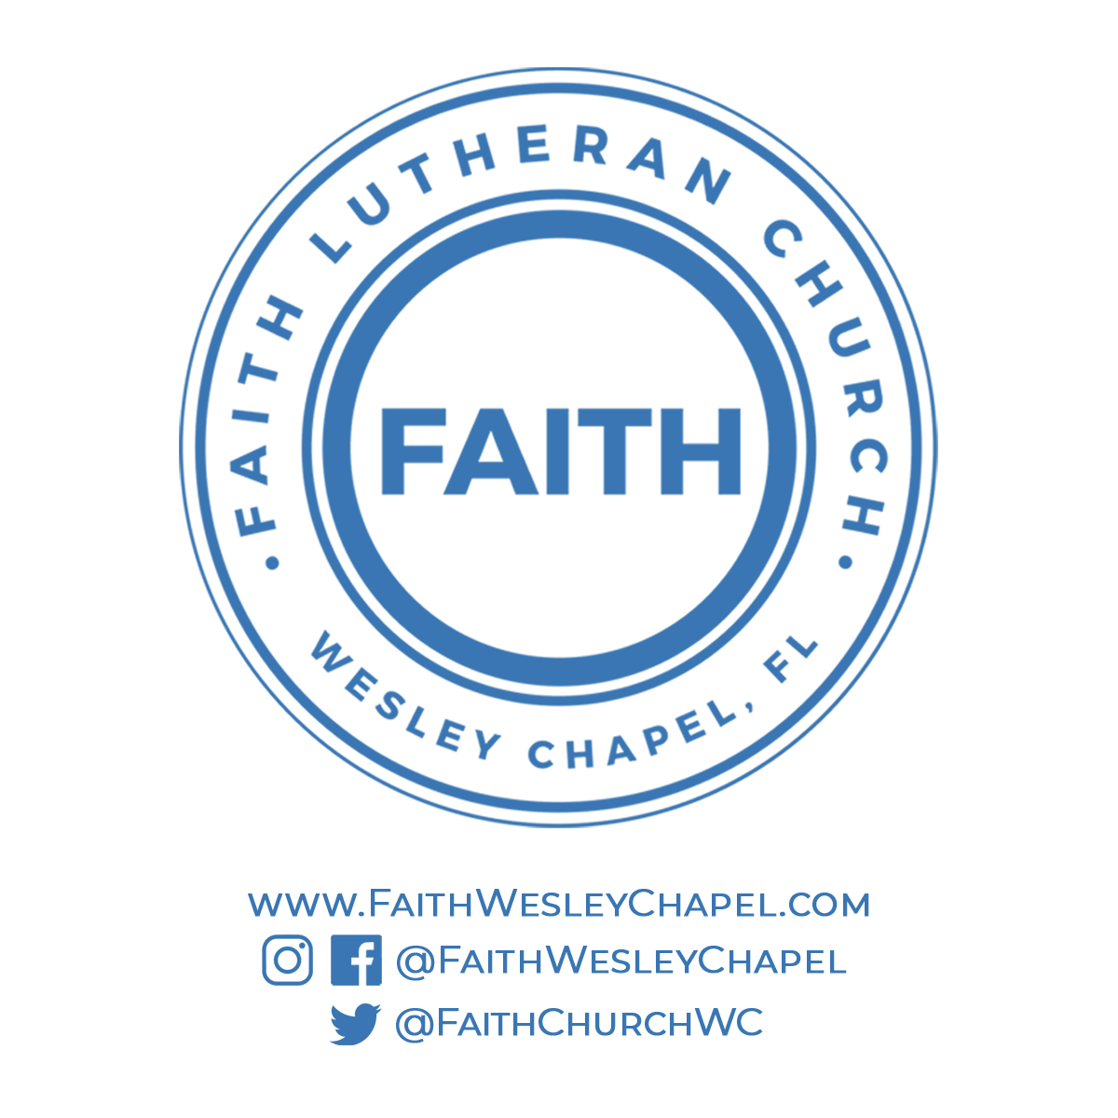**@FaithWesleyChapel**

**@FaithWesleyChapel**

**@FaithChurchWC**