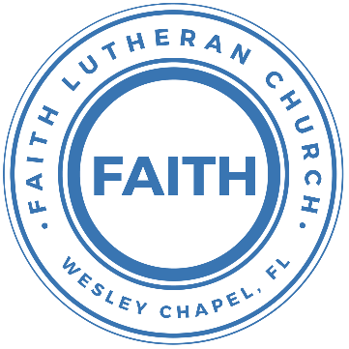

**Leading our community into a deep connection in Christ**

**Worship Service for March 14, 2021 at 11 AM**

**Welcome**

**Invocation**

**Confession and Forgiveness:**

P: As we gather, today, let us cleanse our hearts and our consciences by confessing our sin to God.

(Time of silence for reflection and confession)

C: Heavenly Father, we confess that we are sinful and unclean. We have sinned against you and against our neighbor in our thoughts, words, and actions.  We are truly sorry for our sins and sincerely repent of them. We ask for Your mercy. For the sake of Jesus Christ's bitter suffering and death, please forgive us and renew us that we may walk in Your Spirit to the glory of Your holy name.

P: The Lord has heard your confession. Therefore, as a called and ordained servant of the Lord, in the stead and by the command of my Lord, Jesus Christ, I forgive you all your sins in the name of the Father and of the Son and of the Holy Spirit.

C: Amen

**Song of Praise and Thanksgiving:** In Christ Alone

In Christ alone my hope is found.   
He is my light, my strength, my song  
This Cornerstone, this solid ground.   
Firm through the fiercest drought and storm  
What heights of love, what depths of peace  
When fears are stilled, when strivings cease  
My Comforter, my All in All. Here in the love of Christ I stand

In Christ alone, who took on flesh, Fullness of God in helpless babe  
This gift of love and righteousness, scorned by the ones He came to save  
‘til on that cross as Jesus died, The wrath of God was satisfied  
For every sin on Him was laid, Here in the death of Christ I live

There in the ground His body lay, Light of the world by darkness slain  
Then bursting forth in glorious Day, up from the grave He rose again  
And as He stands in victory, Sin’s curse has lost its grip on me  
For I am His and He is mine, Bought with the precious blood of Christ

No guilt in life, no fear in death, this is the power of Christ in me  
From life’s first cry to final breath, Jesus commands my destiny  
No power of hell, no scheme of man, Can ever pluck me from His hand  
‘til He returns or calls me home, Here in the power of Christ I’ll stand  
No power of hell, no scheme of man, Can ever pluck me from His hand  
‘til He returns or calls me home, Here in the power of Christ I’ll stand

**Old Testament Reading:**Numbers 21:4-9

From Mount Hor they set out by the way to the Red Sea, to go around the land of Edom. And the people became impatient on the way. And the people spoke against God and against Moses, “Why have you brought us up out of Egypt to die in the wilderness? For there is no food and no water, and we loathe this worthless food.” Then the Lord sent fiery serpents among the people, and they bit the people, so that many people of Israel died. And the people came to Moses and said, “We have sinned, for we have spoken against the Lord and against you. Pray to the Lord, that he take away the serpents from us.” So Moses prayed for the people. And the Lord said to Moses, “Make a fiery serpent and set it on a pole, and everyone who is bitten, when he sees it, shall live.” So Moses made a bronze serpent and set it on a pole. And if a serpent bit anyone, he would look at the bronze serpent and live.

**Epistle Reading:**Ephesians 2:1-10

And you were dead in the trespasses and sins in which you once walked, following the course of this world, following the prince of the power of the air, the spirit that is now at work in the sons of disobedience— among whom we all once lived in the passions of our flesh, carrying out the desires of the body and the mind, and were by nature children of wrath, like the rest of mankind. But God, being rich in mercy, because of the great love with which he loved us, even when we were dead in our trespasses, made us alive together with Christ—by grace you have been saved— and raised us up with him and seated us with him in the heavenly places in Christ Jesus, so that in the coming ages he might show the immeasurable riches of his grace in kindness toward us in Christ Jesus. For by grace you have been saved through faith. And this is not your own doing; it is the gift of God, not a result of works, so that no one may boast. For we are his workmanship, created in Christ Jesus for good works, which God prepared beforehand, that we should walk in them.

**Gospel Reading:**John 3:14-21

And as Moses lifted up the serpent in the wilderness, so must the Son of Man be lifted up, that whoever believes in him may have eternal life.

“For God so loved the world, that he gave his only Son, that whoever believes in him should not perish but have eternal life. For God did not send his Son into the world to condemn the world, but in order that the world might be saved through him. Whoever believes in him is not condemned, but whoever does not believe is condemned already, because he has not believed in the name of the only Son of God. And this is the judgment: the light has come into the world, and people loved the darkness rather than the light because their works were evil. For everyone who does wicked things hates the light and does not come to the light, lest his works should be exposed. But whoever does what is true comes to the light, so that it may be clearly seen that his works have been carried out in God.”

**Sermon Song:** O Praise The Name (Anástasis)

I cast my mind to Calvary where Jesus bled and died for me  
I see His wounds, His hands, His feet.   
My Savior on that cursed tree

His body bound and drenched in tears.   
They laid Him down in Joseph's tomb  
The entrance sealed by heavy stone  
Messiah still and all alone

Chorus:  
O praise the Name of the Lord our God   
O praise His Name forevermore  
For endless days, we will sing Your praise  
Oh Lord, oh Lord our God

Then on the third, at break of dawn   
The Son of heaven rose again  
O trampled death, where is your sting.   
The angels roar for Christ the King

Chorus

He shall return in robes of white.   
The blazing sun shall pierce the night  
And I will rise among the saints,   
My gaze transfixed on Jesus' face

Chorus 2x

Oh Lord, oh Lord, our God

**Sermon** – What It’s All About

**Prayers**

**Apostles' Creed**

I believe in God, the Father almighty, maker of heaven and earth,  
And in Jesus Christ, his only Son, our Lord,  
who was conceived by the Holy Spirit,  
born of the Virgin Mary, suffered under Pontius Pilate,  
was crucified, died and was buried. He descended into hell.  
The third day he rose again from the dead.  
He ascended into heaven and sits at the right hand of God  
the Father almighty.  
From there he will come to judge the living and the dead.  
I believe in the Holy Spirit, the holy Christian Church,  
the communion of saints, the forgiveness of sins,  
the resurrection of the body, and the life everlasting. Amen.

**The Lord's Prayer**

Our Father who art in heaven, hallowed be Thy name, Thy kingdom come, Thy will be done on earth as it is in heaven.  Give us this day our daily bread; and forgive us our trespasses as we forgive those who trespass against us; and lead us not into temptation, but deliver us from evil.  For Thine is the kingdom and the power and the glory forever and ever.  Amen

**Benediction**

**Closing Song:** God So Loved

Come all you weary, come all you thirsty  
Come to the well that never runs dry  
Drink of the water, come and thirst no more

Come all you sinners, come find His mercy  
Come to the table, He will satisfy  
Taste of His goodness, find what you’re looking for

Chorus 1:  
For God so loved the world that He gave us His  
one and only son to save us  
whoever believes in Him will live forever

Bring all your failures, bring your addictions  
Come lay them down at the foot of the cross  
Jesus is waiting there with open arms

Chorus 1

Chorus 2:  
The power of Hell forever defeated  
Now it is well, I’m Walking in freedom  
For God so loved, God so loved the world

Praise God, praise God, from whom all blessings flow  
Praise Him, praise Him for the Wonders of His love

(Repeat)

His amazing love

Chorus 1:  
For God so loved the world that He gave us His  
one and only son to save us  
whoever believes in Him will live forever

Chorus 2:  
The power of Hell forever defeated  
Now it is well, I’m Walking in freedom  
For God so loved, God so loved the world

Bring all your failures. Bring your addictions  
Come lay them down at the foot of the cross

Jesus is waiting. God so loved the world

**Offering**

[*You can give by clicking here. You will be taken to https://faithwesleychapel.com/give/*](https://faithwesleychapel.com/give/)

**Upcoming Events**

**Sunday, March 14, Noon - New Members Class**

Song and Dance

**Wednesday, March 17 - Mid-Week Lent Devotional Service**Online – Facebook, YouTube, FaithWesleyChapel.com

**Thursday, March 18, 7am & 7pm - Tamp Lutherans Pray**  
TampaLutheransPray.com  
Submit prayer requests on the site by Wednesday

**Friday, April 2, 7pm – Good Friday Service** *(Not definite, yet)*Song and Dance &  
Online – Facebook, YouTube, FaithWesleyChapel.com

**Sunday, April 4, 11am – Easter Sunday Service**Song and Dance &  
Online – Facebook, YouTube, FaithWesleyChapel.com

[**www.FaithWesleyChapel.com**](http://www.FaithWesleyChapel.com)

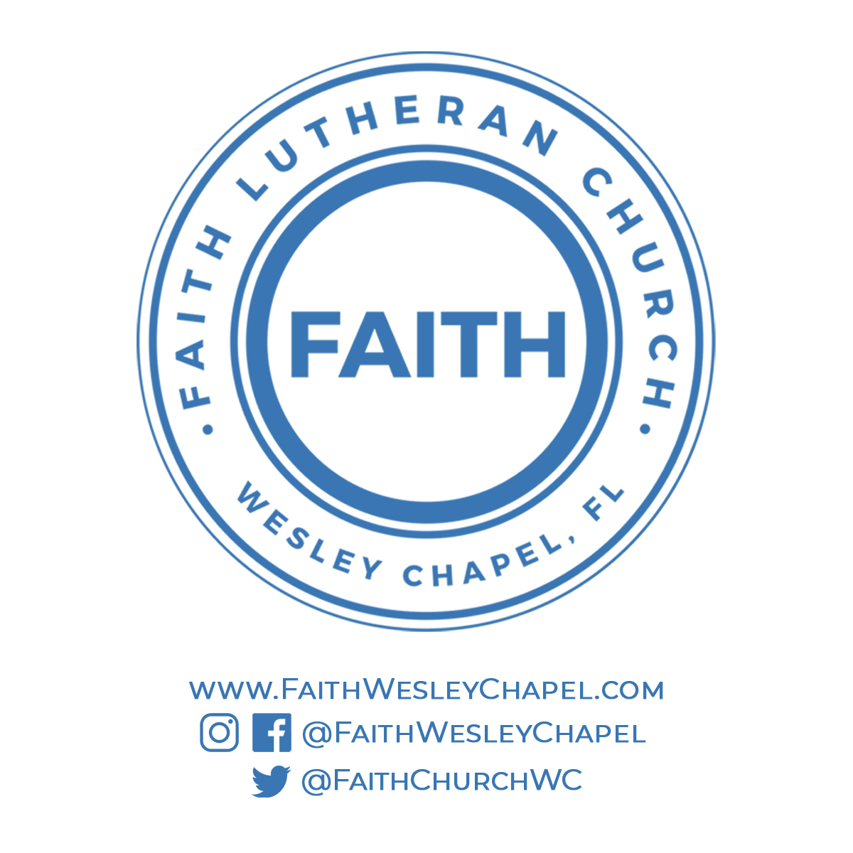**Faith YouTube**

**@FaithWesleyChapel**

**@FaithWesleyChapel**

**@FaithChurchWC**