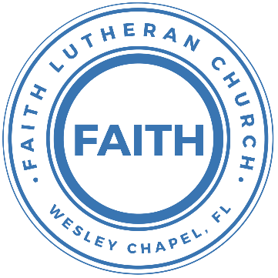

**Leading our community into a deep connection in Christ**

**Worship Service for March 28, 2021 at 11 AM**

**Palm Sunday - New Member Sunday**

**Welcome**

**Opening Song:**Hosanna (Praise Is Rising)

Praise is rising, eyes are turning to You  
We turn to You  
Hope is stirring, hearts are yearning for You  
We long for You

Pre-Chorus:  
When we see You we find strength to face the day  
In Your presence all our fears are washed away, washed away

Chorus:  
Hosanna, hosanna  
You are the God who saves us, worthy of all our praises  
Hosanna, hosanna  
Come have Your way among us  
We welcome You here Lord Jesus

Hear the sound of hearts returning to You  
we turn to You  
In Your Kingdom broken lives are made new  
You make all things new

Pre-Chorus  
Chorus

**Invocation**

**Confession and Forgiveness:**P: Come into the presence of the Lord our God.  
**C: Have mercy, O Lord. If you, Lord, kept a record of sins, Lord, who could stand?**P: If we say we have no sin, we deceive ourselves, and the truth is not in us. **C: If we confess our sins, he is faithful and just to forgive us our sins and to cleanse us from all unrighteousness.**

(a time of silence to reflect and personally confess our sins)

P: I said, "I will confess my transgressions to the LORD." And you forgave the guilt of my sin. Let us confess our sin before the Lord.

**C: Heavenly Father, we confess that we are sinners.  We have sinned against you and our neighbors. We have not loved you with our whole heart and we have not loved our neighbors as ourselves. We justly deserve Your punishment.  For the sake of Your Son, Jesus Christ, have mercy on us.  Forgive us, renew us, and lead us, so that we may delight in Your will and walk in Your ways to the glory of Your holy name.  Amen.**

P: The Lord is gracious and merciful. He promises to forgive our sins. Therefore, upon this, your confession, as a called and ordained servant of the Lord, in the stead and by the command of my Lord, Jesus Christ, I forgive you all your sins in the name of the Father and of the Son and of the Holy Spirit.

**C: Amen.**  
P: This is the day that the Lord has made;  
**C: let us rejoice and be glad in it.**  
P: Blessed is he who comes in the name of the Lord!  
**C: We bless you from the house of the Lord.**  
P: The Lord is God,  
**C: and he has made his light to shine upon us.**  
P: You are my God, and I will give thanks to you;  
**C: you are my God; I will extol you.**  
P: Oh give thanks to the Lord, for he is good;  
**C: for his steadfast love endures forever!**

**Song of Praise and Thanksgiving:** All Glory, Laud, and Honor

Refrain:  
All glory, laud, and honor To You, Redeemer, King,  
To whom the lips of children Made sweet hosannas ring.

You are the King of Israel And David’s royal Son,  
Now in the Lord’s Name coming, Our King and Blessed One.

Refrain

The multitude of pilgrims with palms before You went:  
Our praise and prayers and anthems before You we present.

Refrain

To you before Your passion they sang their hymns of praise;  
To You, now high exalted, our melody we raise.

Refrain:  
All glory, laud, and honor To You, Redeemer, King,  
To whom the lips of children Made sweet hosannas ring.

**Epistle Reading -**Philippians 2:5-11

Have this mind among yourselves, which is yours in Christ Jesus, who, though he was in the form of God, did not count equality with God a thing to be grasped, but emptied himself, by taking the form of a servant, being born in the likeness of men. And being found in human form, he humbled himself by becoming obedient to the point of death, even death on a cross. Therefore God has highly exalted him and bestowed on him the name that is above every name, so that at the name of Jesus every knee should bow, in heaven and on earth and under the earth, and every tongue confess that Jesus Christ is Lord, to the glory of God the Father.

**Gospel Reading** - John 12:12–28

The next day the great crowd that had come for the festival heard that Jesus was on his way to Jerusalem. They took palm branches and went out to meet him, shouting,

“Hosanna!” “Blessed is he who comes in the name of the Lord!”  
“Blessed is the king of Israel!”  
Jesus found a young donkey and sat on it, as it is written:  
“Do not be afraid, Daughter Zion; see, your king is coming, seated on a donkey’s colt.”

At first his disciples did not understand all this. Only after Jesus was glorified did they realize that these things had been written about him and that these things had been done to him.

Now the crowd that was with him when he called Lazarus from the tomb and raised him from the dead continued to spread the word. Many people, because they had heard that he had performed this sign, went out to meet him. So the Pharisees said to one another, “See, this is getting us nowhere. Look how the whole world has gone after him!”

Now there were some Greeks among those who went up to worship at the festival. They came to Philip, who was from Bethsaida in Galilee, with a request. “Sir,” they said, “we would like to see Jesus.” Philip went to tell Andrew; Andrew and Philip in turn told Jesus.

Jesus replied, “The hour has come for the Son of Man to be glorified. Very truly I tell you, unless a kernel of wheat falls to the ground and dies, it remains only a single seed. But if it dies, it produces many seeds. Anyone who loves their life will lose it, while anyone who hates their life in this world will keep it for eternal life. Whoever serves me must follow me; and where I am, my servant also will be. My Father will honor the one who serves me.

“Now my soul is troubled, and what shall I say? ‘Father, save me from this hour’? No, it was for this very reason I came to this hour. Father, glorify your name!”

Then a voice came from heaven, “I have glorified it, and will glorify it again.”

**Children's Message**

**Sermon Hymn***–*Hosanna, Loud Hosanna

Hosanna, loud hosanna, the little children sang;  
Through pillared court and temple the lovely anthem rang.  
To Jesus, who had blessed them, close folded to His breast,  
The children sang their praises, the simplest and the best.

From Olivet they followed mid an exultant crowd,  
The victor palm branch waving and chanting clear and loud.  
The Lord of earth and heaven rode on in lowly state  
Nor scorned that little children should on His bidding wait.

"Hosanna in the highest!" that ancient song we sing;  
For Christ is our Redeemer, the Lord of heav'n our King.  
Oh, may we ever praise Him with heart and life and voice  
And in His blissful presence eternally rejoice!

**Sermon** - "Jesus in Our Schools"

Zechariah 9:9-12

Rejoice greatly, O daughter of Zion! Shout aloud, O daughter of Jerusalem! Behold, your king is coming to you; righteous and having salvation is he, humble and mounted on a donkey, on a colt, the foal of a donkey. I will cut off the chariot from Ephraim and the war horse from Jerusalem; and the battle bow shall be cut off, and he shall speak peace to the nations; his rule shall be from sea to sea, and from the River to the ends of the earth. As for you also, because of the blood of my covenant with you, I will set your prisoners free from the waterless pit. Return to your stronghold, O prisoners of hope; today I declare that I will restore to you double.

**Welcoming of New Members**

**Prayers**

**Apostles' Creed**

I believe in one God, the Father Almighty, maker of heaven and earth and of all things visible and invisible.

And in one Lord Jesus Christ, the only-begotten Son of God, begotten of His Father before all worlds, God of God, Light of Light, very God of very God, begotten, not made, being of one substance with the Father, by whom all things were made; who for us men and for our salvation came down from heaven and was incarnate by the Holy Spirit of the virgin Mary and was made man; and was crucified also for us under Pontius Pilate. He suffered and was buried. And the third day He rose again according to the Scriptures and ascended into heaven and sits at the right hand of the Father. And He will come again with glory to judge both the living and the dead, whose kingdom will have no end.

And I believe in the Holy Spirit, the Lord and Giver of Life, who proceeds from the Father and the Son, who with the Father and the Son together is worshiped and glorified, who spoke by the prophets. And I believe in one holy Christian and apostolic Church, I acknowledge one Baptism for the remission of sins, and I look for the resurrection of the dead and the life of the world to come. Amen.

**The Lord's Prayer**

Our Father who art in heaven, hallowed be Thy name, Thy kingdom come, Thy will be done on earth as it is in heaven.  Give us this day our daily bread; and forgive us our trespasses as we forgive those who trespass against us; and lead us not into temptation, but deliver us from evil.  For Thine is the kingdom and the power and the glory forever and ever.  Amen

**Words of Institution**

**Peace**

P: The peace of the Lord be with you all.  
**C: And also with you.**  
P: We greet each other in the peace of Christ.

**Distribution**

**Prayer**

**Benediction**

**Closing Song:**Forever Reign

You are good, You are good when there's nothing good in me  
You are love, You are love on display for all to see  
You are light, You are light when the darkness closes in  
You are hope, You are hope You have covered all my sin

You are peace, You are peace when my fear is crippling  
You are true, You are true even in my wandering  
You are joy, You are joy You’re the reason that I sing  
You are life, You are life, in You death has lost its sting

Chorus:  
Oh, I’m running to Your arms, I’m running to Your arms  
The riches of Your love will always be enough  
Nothing com-pares to Your embrace  
Light of the world, forever reign

You are more, You are more than my words will ever say  
You are Lord, You are Lord all creation will proclaim  
You are here, You are here in your presence I'm made whole  
You are God, You are God of all else I'm letting go

Chorus

My heart will sing, no other name Jesus, Jesus  
Repeat 4 times

Chorus

**Offering**

**Upcoming Events**

**Thursday, April 1, 7am - Tamp Lutherans Pray (no evening prayer)**  
TampaLutheransPray.com  
Submit prayer requests on the site by Wednesday

**Thursday, April 1, 6:30pm – Maundy Thursday In-Person Service**  
The Chmiel’s Home  
29708 Weybridge Way, Wesley Chapel, FL 33545  
Gate Code: #8419 Home Phone: 813-994-1983  
Fellowship and Refreshments at 6:30pm. Service at 7pm

**Thursday, April 1, 7pm – Maundy Thursday Online Service**  
Online – Facebook, YouTube, FaithWesleyChapel.com  
*(Note: Because it’s online, there will be no Communion)*

**Friday, April 2, 7pm – Good Friday Service**Song and Dance & Online  
Facebook, YouTube, FaithWesleyChapel.com

**Sunday, April 4, 11am – Easter Sunday Service**Song and Dance & Online  
Facebook, YouTube, FaithWesleyChapel.com

**Sunday, April 11, Noon – Fellowship and Games**Song and Dance

**Sunday, April 11, 3pm – Youth Beach Trip**Sand Key Beach

[**www.FaithWesleyChapel.com**](http://www.FaithWesleyChapel.com)

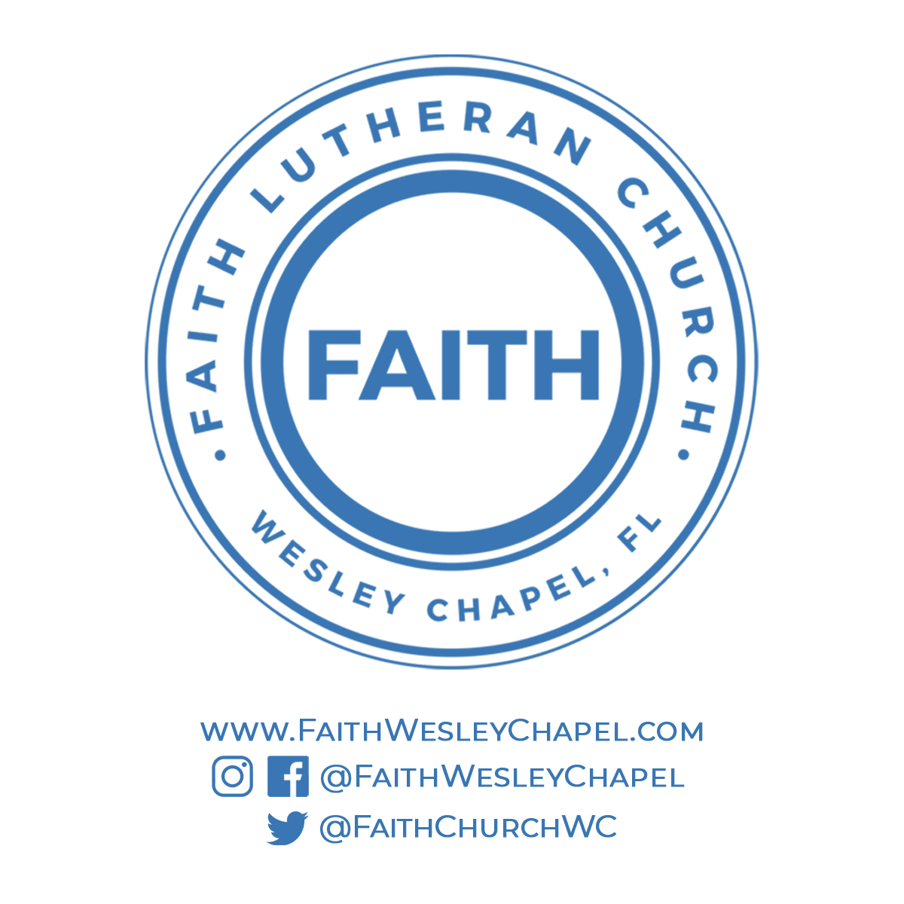**Faith YouTube**

**@FaithWesleyChapel**

**@FaithWesleyChapel**

**@FaithChurchWC**