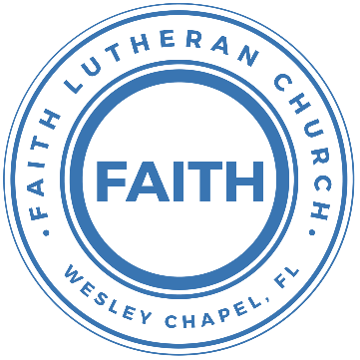

**Leading our community into a deep connection in Christ**

**Worship Service for April 18, 2021 at 11 AM**

**Welcome**

**Opening Song:**The Wonderful Cross

When I survey the wondrous cross,   
On which the prince of glory died,  
My richest gain I count but loss,   
And pour contempt on all my pride.

Forbid it, Lord, that I should boast,   
Save in the death of Christ my God.  
All the vain things that charm me most,   
I sacrifice them to His blood

Chorus:  
O the wonderful cross, O the wonderful cross  
Bids me come and die and find that I may truly live.  
O the wonderful cross, O the wonderful cross  
All who gather here   
By grace draw near and bless your name.

See from his head, His hands, His feet,  
Sorrow and love flow mingled down.  
Did e’er such love and sorrow meet,   
Or thorns compose so rich a crown

Chorus

**Invocation**

**Confession and Forgiveness:**

**P:** Our Heavenly Father asks us to come into His presence.

**C:** But we are sinful and unworthy.

**P:** Yes, all have sinned and fall short of the glory of God, but Jesus Christ died on the cross that we may be forgiven and washed clean of all our sins by His blood spilled on the cross.

**C:** Lord, if You wash us, we will certainly be clean and pure.

**P:** We take a moment to bow before the His cross and silently reflect on our lives and confess our sins.

(Time of silence for reflection and confession)

**P:** Let us confess, together, our sins to God our Father.

**C:** Heavenly Father, we confess that we are sinners.  We have sinned against you and our neighbors. We have not loved you with our whole heart and we have not loved our neighbors as ourselves. We have not lived out our faith out in our community. We justly deserve Your punishment.  For the sake of Your Son, Jesus Christ, have mercy on us.  Forgive us, renew us, and lead us, so that we may delight in Your will and walk in Your ways to the glory of Your holy name.  Amen.

**P:** Almighty God in His mercy has given His Son to die for you and for His sake forgives you all your sins.  As a called and ordained servant of Christ, and by His authority, I, therefore, forgive you all your sins in the name of the Father and of the Son and of the Holy Spirit.

**C:** Amen

**Song of Praise and Thanksgiving:** Doxology

Praise God from Whom all blessings flow.  
Praise Him all creatures here below.  
Praise Him above, ye heavenly hosts.  
Praise Father, Son and Holy Ghost.

*Repeat*

Amen, Amen, Amen, Amen

**First Reading -**Acts 3:11–21

While he clung to Peter and John, all the people, utterly astounded, ran together to them in the portico called Solomon's. And when Peter saw it he addressed the people: “Men of Israel, why do you wonder at this, or why do you stare at us, as though by our own power or piety we have made him walk? The God of Abraham, the God of Isaac, and the God of Jacob, the God of our fathers, glorified his servant Jesus, whom you delivered over and denied in the presence of Pilate, when he had decided to release him. But you denied the Holy and Righteous One, and asked for a murderer to be granted to you, and you killed the Author of life, whom God raised from the dead. To this we are witnesses. And his name—by faith in his name—has made this man strong whom you see and know, and the faith that is through Jesus has given the man this perfect health in the presence of you all.

“And now, brothers, I know that you acted in ignorance, as did also your rulers. But what God foretold by the mouth of all the prophets, that his Christ would suffer, he thus fulfilled. Repent therefore, and turn back, that your sins may be blotted out, that times of refreshing may come from the presence of the Lord, and that he may send the Christ appointed for you, Jesus, whom heaven must receive until the time for restoring all the things about which God spoke by the mouth of his holy prophets long ago.

**Reader:** This is the Word of the Lord.

**C:** Thanks be to God.

**Second Reading** - 1 John 3:1–7

See what kind of love the Father has given to us, that we should be called children of God; and so we are. The reason why the world does not know us is that it did not know him. Beloved, we are God's children now, and what we will be has not yet appeared; but we know that when he appears we shall be like him, because we shall see him as he is. And everyone who thus hopes in him purifies himself as he is pure.

Everyone who makes a practice of sinning also practices lawlessness; sin is lawlessness. You know that he appeared in order to take away sins, and in him there is no sin. No one who abides in him keeps on sinning; no one who keeps on sinning has either seen him or known him. Little children, let no one deceive you. Whoever practices righteousness is righteous, as he is righteous.

**Reader:** This is the Word of the Lord.

**C:** Thanks be to God.

**Children's Message** *(Children dismissed to Children's Church)*

**Sermon Hymn***–*10,000 Reasons (Bless the Lord)

Chorus:  
Bless the Lord, O my soul, O my soul,  
Worship His holy name.  
Sing like never before, 0 my soul.  
I'll worship Your holy name.

The sun comes up, it's a new day dawning;  
It's time to sing Your song again.  
Whatever may pass, and whatever lies before me,  
Let me be singing when the evening comes.

Chorus

You're rich in love, and You're slow to anger.  
Your name is great, and Your heart is kind.  
For all Your goodness, I will keep on singing;  
Ten thousand reasons for my heart to find.

Chorus:  
Bless the Lord, O my soul, O my soul,  
Worship His holy name.  
Sing like never before, 0 my soul.  
I'll worship Your holy name.

And on that day when my strength is failing,  
The end draws near, and my time has come;  
Still my soul will sing Your praise unending:  
Ten thousand years and then forevermore! Forevermore!

Chorus

I'll worship Your holy name. Yes, I'll worship Your holy name.

**Sermon** – Series: The Church "Opening Our Minds to the Scriptures"  
Luke 24:36–49

As they were talking about these things, Jesus himself stood among them, and said to them, “Peace to you!” But they were startled and frightened and thought they saw a spirit. And he said to them, “Why are you troubled, and why do doubts arise in your hearts? See my hands and my feet, that it is I myself. Touch me, and see. For a spirit does not have flesh and bones as you see that I have.” And when he had said this, he showed them his hands and his feet. And while they still disbelieved for joy and were marveling, he said to them, “Have you anything here to eat?” They gave him a piece of broiled fish, and he took it and ate before them.

Then he said to them, “These are my words that I spoke to you while I was still with you, that everything written about me in the Law of Moses and the Prophets and the Psalms must be fulfilled.” Then he opened their minds to understand the Scriptures, and said to them, “Thus it is written, that the Christ should suffer and on the third day rise from the dead, and that repentance for the forgiveness of sins should be proclaimed in his name to all nations, beginning from Jerusalem. You are witnesses of these things. And behold, I am sending the promise of my Father upon you. But stay in the city until you are clothed with power from on high.”

**P:** This is the Gospel of the Lord

**C:** Praise be to You, o Christ.

**Special Song:** Word of God Speak

I'm finding myself at a loss for words   
And the funny thing is it's okay  
The last thing I need is to be heard,   
But to hear what You would say

Chorus:  
Word of God speak. Would You pour down like rain  
Washing my eyes to see Your majesty  
To be still and know That You're in this place  
Please let me stay and rest In Your holiness   
Word of God speak

I'm finding myself in the midst of You,   
Beyond the music, beyond the noise  
All that I need is to be with You   
And in the quiet hear Your voice

Chorus 2x

**Nicene Creed**

I believe in one God, the Father Almighty, maker of heaven and earth and of all things visible and invisible.

And in one Lord Jesus Christ, the only-begotten Son of God, begotten of His Father before all worlds, God of God, Light of Light, very God of very God, begotten, not made, being of one substance with the Father, by whom all things were made; who for us men and for our salvation came down from heaven and was incarnate by the Holy Spirit of the virgin Mary and was made man; and was crucified also for us under Pontius Pilate. He suffered and was buried. And the third day He rose again according to the Scriptures and ascended into heaven and sits at the right hand of the Father. And He will come again with glory to judge both the living and the dead, whose kingdom will have no end.

And I believe in the Holy Spirit, the Lord and Giver of Life, who proceeds from the Father and the Son, who with the Father and the Son together is worshiped and glorified, who spoke by the prophets. And I believe in one holy Christian and apostolic Church, I acknowledge one Baptism for the remission of sins, and I look for the resurrection of the dead and the life of the world to come. Amen.

**Prayers**

**The Lord's Prayer**

Our Father who art in heaven, hallowed be Thy name, Thy kingdom come, Thy will be done on earth as it is in heaven.  Give us this day our daily bread; and forgive us our trespasses as we forgive those who trespass against us; and lead us not into temptation, but deliver us from evil.  For Thine is the kingdom and the power and the glory forever and ever.  Amen

**Words of Institution**

**Peace**

P: The peace of the Lord be with you all.  
C: And also with you.  
P: We greet each other in the peace of Christ.

**Distribution**

**Prayer**

**Benediction**

**Closing Song:**All Hail the Power of Jesus Name

All hail the pow'r of Jesus' name! Let angels prostrate fall;  
Bring forth the royal diadem And crown Him Lord of all.  
Bring forth the royal diadem And crown Him Lord of all.

Ye seed of Israel's chosen race, Ye ransomed from the fall,  
Hail Him who saves you by His grace And crown Him Lord of all.  
Hail Him who saves you by His grace And crown Him Lord of all.

Hail Him, ye heirs of David's line, Whom David Lord did call,  
The God incarnate, man divine, And crown Him Lord of all.  
The God incarnate, Man divine, And crown Him Lord of all.

Sinners, whose love can ne'er forget The wormwood and the gall,  
Go, spread your trophies at His feet And crown Him Lord of all.  
Go, spread your trophies at His feet And crown Him Lord of all.

Let ev'ry kindred, ev'ry tribe, On this terrestrial ball  
To Him all majesty ascribe And crown Him Lord of all.  
To Him all majesty ascribe And crown Him Lord of all.

**Offering**

**Upcoming Events**

**April 25, After the Service – Voter Meeting**

Song and Dance

[**www.FaithWesleyChapel.com**](http://www.FaithWesleyChapel.com)

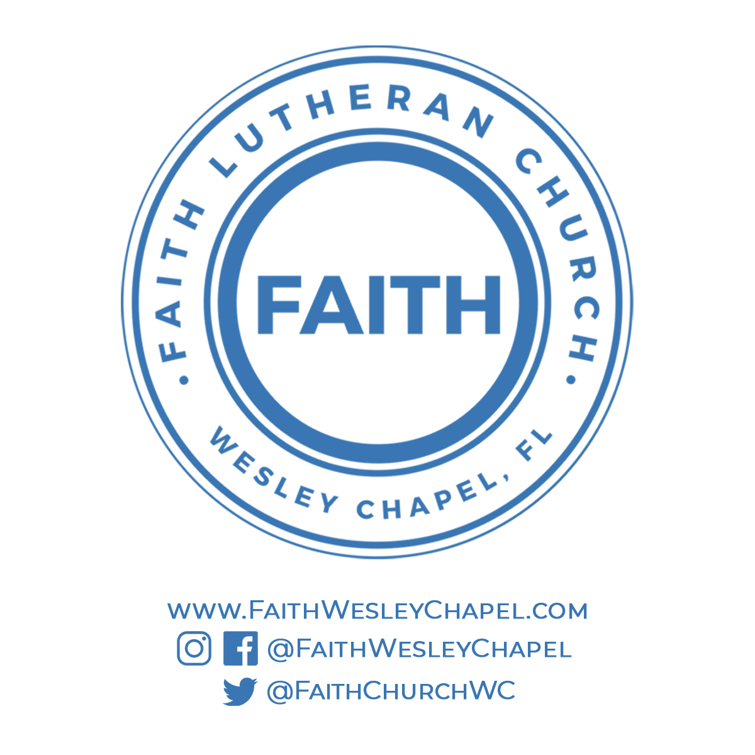**Faith YouTube**

**@FaithWesleyChapel**

**@FaithWesleyChapel**

**@FaithChurchWC**