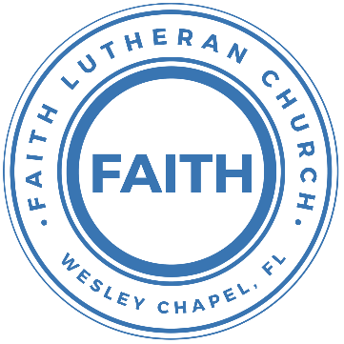

**Leading our community into a deep connection in Christ**

**Worship Service for April 25, 2021 at 11 AM**

**Welcome**

**Opening Song:**God So Loved

Come all you weary, come all you thirsty  
Come to the well that never runs dry  
Drink of the water, come and thirst no more

Come all you sinners, come find His mercy  
Come to the table, He will satisfy  
Taste of His goodness, find what you’re looking for

Chorus 1:  
For God so loved the world that He gave us His  
One and only son to save us  
Whoever believes in Him will live forever

Bring all your failures, bring your addictions  
Come lay them down at the Foot of the cross  
Jesus is waiting there with open arms

Chorus 1

Chorus 2:  
The power of Hell forever defeated  
Now it is well, I’m walking in freedom  
For God so loved, God so loved the world

Bridge:  
Praise God, praise God, from whom all blessings flow  
Praise Him, praise Him for the wonders of His love

Repeat

His amazing love

Chorus 1:  
For God so loved the World that He gave us His  
One and only son to save us  
Whoever believes in Him will live forever

Chorus 2:  
The power of Hell forever defeated  
Now it is well, I’m walking in freedom  
For God so loved, God so loved the world

Bring all your failures. Bring your addictions  
Come lay them down at the foot of the cross  
Jesus is waiting. God so loved the world

**Invocation**

**Confession and Forgiveness:**

P: As we gather, today, let us cleanse our hearts and our consciences by confessing our sin to God.

(Time of silence for reflection and confession)

P: Today, we confess our sins by singing the son, “Lord, I Need You.”

**Song of Confession:** Lord, I Need You

Lord I come, I confess. Bowing here I find my rest  
Without You, I fall apart. You're the one that guides my heart

Chorus:  
Lord, I need You, oh I need You. Every hour I need You  
My one defense, my righteousness, Oh God, how I need You

Where sin runs deep, Your grace is more.  
Where grace is found is where You are  
And where You are Lord I am free. Holiness is Christ in me

Chorus:  
Lord, I need You, oh I need You. Every hour I need You  
My one defense, my righteousness, Oh God, how I need You

So teach my song to rise to You When temptation comes my way  
And when I cannot stand I'll fall on You.   
Jesus You're my hope and stay

Chorus

Lord, I need You, oh I need You. Every hour I need You  
My one defense, my righteousness, Oh God, how I need You  
My one defense, my righteousness, Oh God, how I need You  
My one defense, my righteousness, Oh God, how I need You

P: The Lord has heard your confession. Therefore, as a called and ordained servant of the Lord, in the stead and by the command of my Lord, Jesus Christ, I forgive you all your sins in the name of the Father and of the Son and of the Holy Spirit.

C: Amen

**First Reading:** Acts 4:1–12

And as they were speaking to the people, the priests and the captain of the temple and the Sadducees came upon them, greatly annoyed because they were teaching the people and proclaiming in Jesus the resurrection from the dead. And they arrested them and put them in custody until the next day, for it was already evening. But many of those who had heard the word believed, and the number of the men came to about five thousand.

On the next day their rulers and elders and scribes gathered together in Jerusalem, with Annas the high priest and Caiaphas and John and Alexander, and all who were of the high-priestly family. And when they had set them in the midst, they inquired,

“By what power or by what name did you do this?” Then Peter, filled with the Holy Spirit, said to them, “Rulers of the people and elders, if we are being examined today concerning a good deed done to a crippled man, by what means this man has been healed, let it be known to all of you and to all the people of Israel that by the name of Jesus Christ of Nazareth, whom you crucified, whom God raised from the dead—by him this man is standing before you well. This Jesus is the stone that was rejected by you, the builders, which has become the cornerstone. And there is salvation in no one else, for there is no other name under heaven given among men by which we must be saved.”

**Gospel Reading:** John 10:11–18

I am the good shepherd. The good shepherd lays down his life for the sheep. He who is a hired hand and not a shepherd, who does not own the sheep, sees the wolf coming and leaves the sheep and flees, and the wolf snatches them and scatters them. He flees because he is a hired hand and cares nothing for the sheep. I am the good shepherd. I know my own and my own know me, just as the Father knows me and I know the Father; and I lay down my life for the sheep. And I have other sheep that are not of this fold. I must bring them also, and they will listen to my voice. So there will be one flock, one shepherd. For this reason the Father loves me, because I lay down my life that I may take it up again. No one takes it from me, but I lay it down of my own accord. I have authority to lay it down, and I have authority to take it up again. This charge I have received from my Father.”

**Children's Message**

**Sermon Hymn***–*How Deep The Father's Love For Us

How deep the Father's love for us, how vast beyond all measure  
That He should give His only Son, to make a wretch His treasure  
How great the pain of searing loss, the Father turned His face away  
As wounds which mar the Chosen One, bring many sons to glory

Behold the Man upon a cross, my sin upon His shoulders  
Ashamed, I hear my mocking voice call out among the scoffers  
It was my sin that held Him there until it was accomplished  
His dying breath has brought me life; I know that it is finished

I will not boast in anything: no gifts, no power, no wisdom  
But I will boast in Jesus Christ; his death and resurrection  
Why should I gain from His reward? I cannot give an answer  
But this I know with all my heart: His wounds have paid my ransom  
But this I know with all my heart: His wounds have paid my ransom

**Sermon Series:** The Church "Loving One Another"

Sermon Text: 1 John 3:16–24

By this we know love, that he laid down his life for us, and we ought to lay down our lives for the brothers. But if anyone has the world's goods and sees his brother in need, yet closes his heart against him, how does God's love abide in him? Little children, let us not love in word or talk but indeed and in truth.

By this we shall know that we are of the truth and reassure our heart before him; for whenever our heart condemns us, God is greater than our heart, and he knows everything. Beloved, if our heart does not condemn us, we have confidence before God; and whatever we ask we receive from him, because we keep his commandments and do what pleases him. And this is his commandment, that we believe in the name of his Son Jesus Christ and love one another, just as he has commanded us. Whoever keeps his commandments abides in God, and God in him. And by this we know that he abides in us, by the Spirit whom he has given us.

**Prayers**

**Apostles' Creed**

I believe in God, the Father almighty,  
maker of heaven and earth,  
And in Jesus Christ, his only Son, our Lord,  
who was conceived by the Holy Spirit,  
born of the Virgin Mary,  
suffered under Pontius Pilate,  
was crucified, died and was buried.  
He descended into hell.  
The third day he rose again from the dead.  
He ascended into heaven and sits at the right hand of God  
the Father almighty.  
From there he will come to judge the living and the dead.  
I believe in the Holy Spirit,  
the holy Christian Church,  
the communion of saints,  
the forgiveness of sins,  
the resurrection of the body,  
and the life everlasting. Amen.

**The Lord's Prayer**

Our Father who art in heaven, hallowed be Thy name, Thy kingdom come, Thy will be done on earth as it is in heaven.  Give us this day our daily bread; and forgive us our trespasses as we forgive those who trespass against us; and lead us not into temptation, but deliver us from evil.  For Thine is the kingdom and the power and the glory forever and ever.  Amen

**Words of Institution**

**Peace**

P: The peace of the Lord be with you all.  
C: And also with you.  
P: We greet each other in the peace of Christ.

**Distribution**

**Prayer**

**Benediction**

**Closing Song:**I Will Follow

Where You go, I’ll go  
Where You stay, I’ll stay  
When You move, I’ll move  
I will follow…

All Your ways are good, all Your ways are sure  
I will trust in You alone  
Higher than my sight, high above my life  
I will trust in You alone

Chorus:  
Where You go, I’ll go  
Where You stay, I’ll stay  
When You move, I’ll move  
I will follow You

Who You love, I'll love  
How You serve I'll serve  
If this life I lose, I will follow You, Yeah, I will follow You

Light unto the world, light unto my life  
I will live for You alone  
You're the one I seek knowing I will find  
All I need in You alone, in You alone

Chorus:  
In You there's life everlasting  
In You there's freedom for my soul  
In You there's joy, unending joy and I will follow

Chorus 2x

**Offering**

**Sermon Notes:**

**_______________________________________________**

**_______________________________________________**

**_______________________________________________**

**_______________________________________________**

**_______________________________________________**

**_______________________________________________**

**_______________________________________________**

**_______________________________________________**

**Upcoming Events**

**Today, After the Service – Voter Meeting**Song and Dance

**May 8 – Aquatica “End of the School Year Trip”**  
$29 per person. For details and to sign up, go to:  
<https://faithwesleychapel.com/aquatica/>

**May 26 at 7 PM – Council Meeting**Zoom

**www.FaithWesleyChapel.com**

**Faith YouTube**

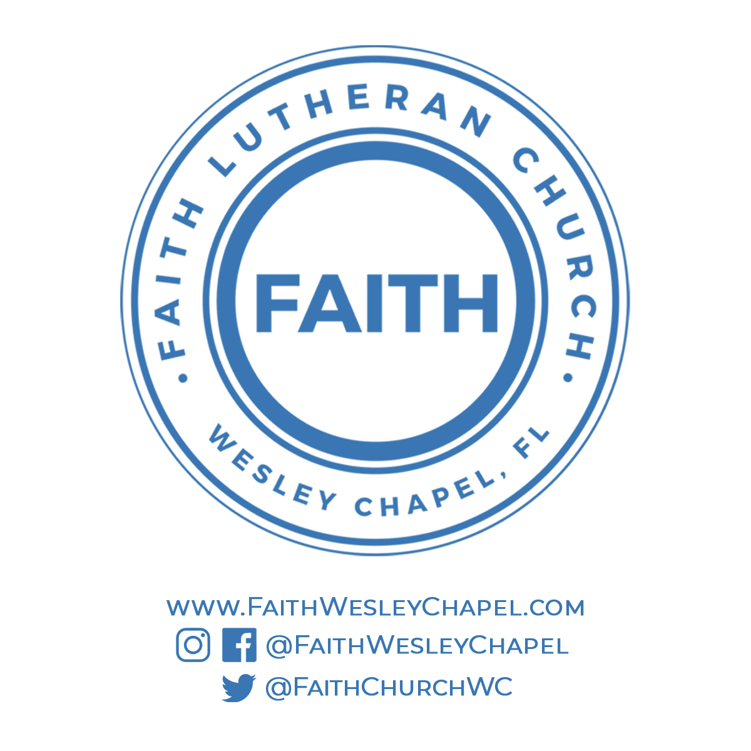**@FaithWesleyChapel**

**@FaithWesleyChapel**

**@FaithChurchWC**