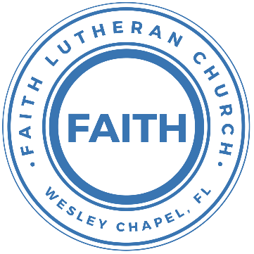

**Leading our community into a deep connection in Christ**

**Worship Service for May 2, 2021 at 11 AM**

**Welcome**

**Opening Song:**Praise Ye the Lord, Hallelujah

Side 1: Hallelu, hallelu, hallelu, hallelujah,

Side 2: Praise ye the Lord.

Side 1: Hallelu, hallelu, hallelu, hallelujah,

Side 2: Praise ye the Lord.

Side 2: Praise ye the Lord.

Side 1: Hallelujah,

Side 2: Praise ye the Lord.

Side 1: Hallelujah,

Side 2: Praise ye the Lord.

Side 1: Hallelujah,

All: Praise ye the Lord.

(Repeat all)

**Invocation**

**Confession and Forgiveness:**

P: We have come here today to worship the Lord.  In worship we hear the Word of God, we receive God's blessings, and respond with thanks and praise.  We begin by seeking God's blessing of forgiveness.  He has promised to remove the guilt and shame of our sin through the sacrifice of Jesus Christ on the cross.

P: Let us confess our sins to the Lord.

*(a time of silence to reflect and personally confess our sins)*

P: Heavenly Father,  
C: Heavenly Father,

P: I have done things that were wrong.  
C: I have done things that were wrong.

P: I have been mean to others.  
C: I have been mean to others.

P: I have not obeyed my parents.  
C: I have not obeyed my parents.

P: I have not obeyed You, God.  
C: I have not obeyed You, God.

P: But I am very sorry.  
C: But I am very sorry.

P: Please forgive me.  
C: Please forgive me.

P: I love You very much.  
C: I love You very much.

P: And I know You love me, too.  
C: And I know You love me, too.

P: God has heard your apology.  He loves you very much.  God has told us that when we believe and trust in Him, He makes us His children.  As far as the east is from the west, so far does he remove our sins from us. He has told me to tell you that you are forgiven.  So, as His servant, I forgive you in the name of the Father and of the Son and of the Holy Spirit.

C: Amen.

**Song:**Jesus Loves the Little Children

Jesus loves the little children,  
All the children of the world,  
Red and yellow, black and white,  
They are precious in His sight.  
Jesus loves the little children of the world.

Jesus died for all the children,  
All the children of the world,  
Red and yellow, black and white,  
They are precious in His sight.  
Jesus died for all the children of the world.

**First Reading -**2 Timothy 4:7-8

I have fought the good fight, I have finished the race, I have kept the faith. Henceforth there is laid up for me the crown of righteousness, which the Lord, the righteous judge, will award to me on that day, and not only to me but also to all who have loved his appearing.

**Children's Message**"Receiving the Crown"

**Second Song: Song Title**

I was buried beneath my shame   
Who could carry that kind of weight?  
It was my tomb 'Till I met You  
I was breathing but not alive   
All my failures I tried to hide  
It was my tomb 'Till I met You   
You called my name and I ran out of that grave

Chorus:  
Out of the darkness into Your glorious day  
You called my name and I ran out of that grave  
Out of the darkness into Your glorious day

Now Your mercy has saved my soul   
Now Your freedom is all that I know  
The old made new, Jesus, when I met You  
You called my name and I ran out of that grave

Chorus

I need rescue, my sin is heavy   
But chains break at the weight of Your glory  
I needed shelter, I was an orphan   
Now You call me a citizen of Heaven  
When I was broken, You were my healing  
Now Your love is the air that I'm breathing  
I have a future, my eyes are open  
'Cause when You called my name   
I ran out of that grave

Chorus

**Second Reading -**2 Timothy 4:7-8

I have fought the good fight, I have finished the race, I have kept the faith. Henceforth there is laid up for me the crown of righteousness, which the Lord, the righteous judge, will award to me on that day, and not only to me but also to all who have loved his appearing.

**Children's Message**"Running the Race"

**Sermon Hymn*–*Song Title**

What is the world to me with all its vaunted pleasure  
When You, and You alone, Lord Jesus, are my Treasure!  
You only, dearest Lord, my soul's Delight shall be;  
You are my Peace, my Rest, what is the world to me!

The world seeks to be praised and honored by the mighty,  
Yet never once reflects That they are frail and flighty.  
But what I truly prize above all things is He,  
My Jesus, He alone, what is the world to me!

What is the world to me! My Jesus is my Treasure,  
My Life, my Health, my Wealth, My Friend, my Love, my Pleasure,  
My Joy, my Crown, my All, My Bliss eternally.  
Once more, then, I declare: What is the world to me!

**Sermon –**"Getting More Racers"

Sermon Text: Mark 16:14-20

Afterward he appeared to the eleven themselves as they were reclining at table, and he rebuked them for their unbelief and hardness of heart, because they had not believed those who saw him after he had risen. And he said to them, “Go into all the world and proclaim the gospel to the whole creation. Whoever believes and is baptized will be saved, but whoever does not believe will be condemned. And these signs will accompany those who believe: in my name they will cast out demons; they will speak in new tongues; they will pick up serpents with their hands; and if they drink any deadly poison, it will not hurt them; they will lay their hands on the sick, and they will recover.”

So then the Lord Jesus, after he had spoken to them, was taken up into heaven and sat down at the right hand of God. And they went out and preached everywhere, while the Lord worked with them and confirmed the message by accompanying signs.

**Special Song:** How Beautiful

How beautiful, the hands that served.   
The wine and the bread, and the sons of the earth.  
How beautiful, the feet that walked.  
The long dusty roads, and the hill to the cross.

Chorus:  
How beautiful, how beautiful, how beautiful, is the body of Christ.

How beautiful, the heart that bled.  
That took all my sin and bore it instead.   
How beautiful, the tender eyes.  
That choose to forgive and never despise.

Chorus:  
How beautiful, how beautiful, how beautiful, is the body of Christ

And as He laid down His life. We offer this sacrifice.   
That we will live, just as He died.   
Willing to pay the price. Willing to pay the price.

How beautiful, the radiant bride.  
Who waits for her Groom with His light in her eyes.   
How beautiful, when humble hearts give.  
The fruit of pure lives so that others may live.

Chorus:  
How beautiful, how beautiful, how beautiful, is the body of Christ.

How beautiful, the feet that bring.   
The sound of good news, and the love of the King.   
How beautiful, the hands that serve.  
The wine and the bread, and the sons of the earth.

Chorus:  
How beautiful, how beautiful, how beautiful, is the body of Christ.

**Prayers:** *(Text in prayer requests to 813-602-1104)*

**The Lord's Prayer**

Our Father who art in heaven, hallowed be Thy name, Thy kingdom come, Thy will be done on earth as it is in heaven.  Give us this day our daily bread; and forgive us our trespasses as we forgive those who trespass against us; and lead us not into temptation, but deliver us from evil.  For Thine is the kingdom and the power and the glory forever and ever.  Amen

**Words of Institution**

**Peace**

P: The peace of the Lord be with you all.  
C: And also, with you.  
P: We greet each other in the peace of Christ.

**Distribution**

**Prayer**

**Benediction**

**Closing Song – Song Title**

Stand up, stand up for Jesus, Ye soldiers of the cross.  
Lift high His royal banner; It must not suffer loss.  
From vict'ry unto vict'ry His army He shall lead  
Till ev'ry foe is vanquished, And Christ is Lord in - deed.

Stand up, stand up for Jesus; The strife will not be long;  
This day the din of battle, The next the victor's song.  
The soldiers, overcoming, Their crown of life shall see  
And with the King of Glory Shall reign eternally.

**Offering**

**Sermon Notes:**

**_______________________________________________**

**_______________________________________________**

**_______________________________________________**

**_______________________________________________**

**_______________________________________________**

**_______________________________________________**

**_______________________________________________**

**_______________________________________________**

**_______________________________________________**

**_______________________________________________**

**_______________________________________________**

**_______________________________________________**

**Upcoming Events**

**May 8 – Aquatica “End of the School Year Trip”**

$29 per person. For details and to sign up, go to:

<https://faithwesleychapel.com/aquatica/>

**May 26 at 7 PM – Council Meeting**

Zoom

**www.FaithWesleyChapel.com**

**Faith YouTube**

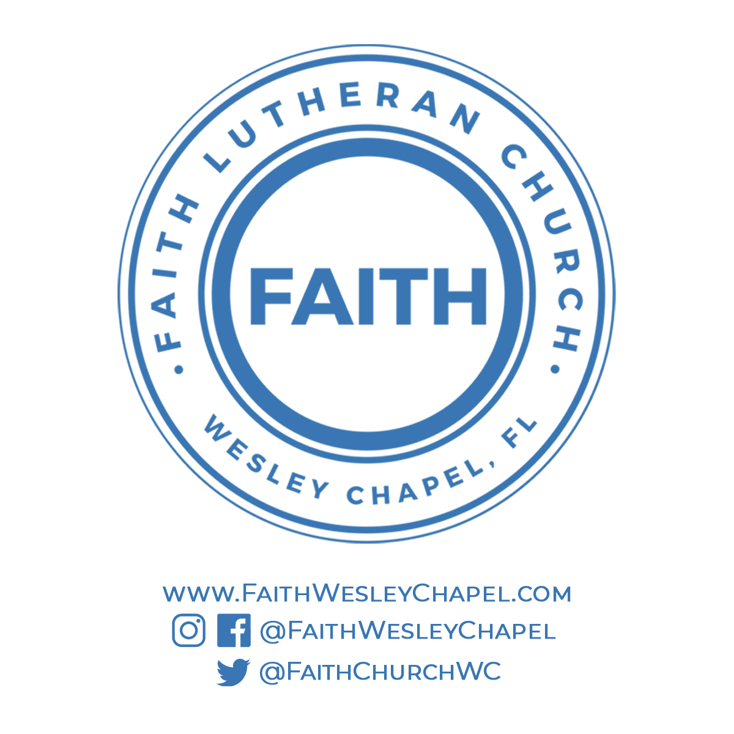**@FaithWesleyChapel**

**@FaithWesleyChapel**

**@FaithChurchWC**