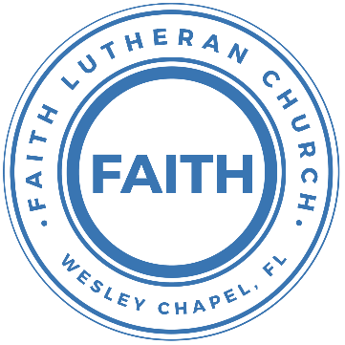

**Leading our community into a deep connection in Christ**

**Worship Service for June 6, 2021 at 11 AM**

**Welcome**

**Opening Song: Father Abraham**

Father Abraham had many sons  
Many sons had Father Abraham  
I am one of them and so are you  
So let's just praise the Lord

Right arm  
Left arm  
Right foot  
Left foot  
Chin up  
Turn around  
Sit down

**Invocation**

**Confession and Forgiveness:**

P: We have come here today to worship the Lord.  In worship we hear the Word of God, we receive God's blessings, and respond with thanks and praise.  We begin by seeking God's blessing of forgiveness.  He has promised to remove the guilt and shame of our sin through the sacrifice of Jesus Christ on the cross.

P: Let us confess our sins to the Lord.

*(a time of silence to reflect and personally confess our sins)*

P: Heavenly Father,  
C: Heavenly Father,

P: I have done things that were wrong.  
C: I have done things that were wrong.

P: I have been mean to others.  
C: I have been mean to others.

P: I have not obeyed my parents.  
C: I have not obeyed my parents.

P: I have not obeyed You, God.  
C: I have not obeyed You, God.

P: But I am very sorry.  
C: But I am very sorry.

P: Please forgive me.  
C: Please forgive me.

P: I love You very much.  
C: I love You very much.

P: And I know You love me, too.    
C: And I know You love me, too.

P: God has heard your apology.  He loves you very much.  God has told us that when we believe and trust in Him, He makes us His children.  As far as the east is from the west, so far does he remove our sins from us. He has told me to tell you that you are forgiven.  So, as His servant, I forgive you in the name of the Father and of the Son and of the Holy Spirit.

C: Amen.

**Song: Way Maker**

You are here Moving in our midst. I worship you. I worship you  
You are here Moving in this place. I worship you. I worship you  
You are here Moving in our midst. I worship you. I worship you  
You are here Moving in this place. I worship you. I worship you

Chorus:  
Way maker, miracle worker  
Promise keeper, light in the darkness,  
My God, that is who you are  
*(Repeat)*

You are here Touching every heart. I worship you. I worship you  
You are here Healing every heart. I worship you. I worship you  
You are here Turning lives around. I worship you. I worship you  
You are here Mending every heart. I worship you. I worship you

Chorus

That is who You are. That is who You are.  
That is who You are. That is who You are.

Bridge:  
Even when I don't see it, You're working  
Even when I don't feel it, You're working  
You never stop, You never stop working  
You never stop, You never stop working  
*(Repeat)*

Chorus

**First Reading - Genesis 3:8-11**

And they heard the sound of the Lord God walking in the garden in the cool of the day, and the man and his wife hid themselves from the presence of the Lord God among the trees of the garden. But the Lord God called to the man and said to him, “Where are you?” And he said, “I heard the sound of you in the garden, and I was afraid, because I was naked, and I hid myself.” He said, “Who told you that you were naked? Have you eaten of the tree of which I commanded you not to eat?”

**Children's Message "Running From God"**

**Second Song: God Is So Good**

God is so good. God is so good.

God is so good. He's so good to me.

He answers prayer. He answers prayer.  
He answers prayer. He's so good to me.

He loves me so. He loves me so.  
He loves me so. He's so good to me.

**Second Reading -   Genesis 3:12-13**

The man said, “The woman whom you gave to be with me, she gave me fruit of the tree, and I ate.” Then the Lord God said to the woman, “What is this that you have done?” The woman said, “The serpent deceived me, and I ate.”

**Children's Message "Blaming Others"**

**Sermon Hymn*–*Just As I Am**

Just as I am, without one plea,  
But that Thy blood was shed for me,  
And that Thou bidd'st me come to Thee,   
O Lamb of God, I come! I come!

Verse 2:  
Just as I am, and waiting not,  
To rid my soul of one dark blot,  
To Thee whose blood can clease each spot,  
O Lamb of God, I come! I come!

Verse 3:  
Just as I am, though tossed about,  
With many a conflict, many a doubt,  
Fightings and fears within, without,  
Lamb of God, I come! I come!

Verse 4:

Just as I am, Thou wilt receive,  
Wilt welcome, pardon, cleanse, relieve,  
Because Thy promise I believe,  
O Lamb of God, I come! I come!

**Sermon – "The Effects of the Fall"**

Sermon Text: Genesis 3:14-24

The Lord God said to the serpent,  
“Because you have done this,  
 cursed are you above all livestock  
 and above all beasts of the field;  
on your belly you shall go,  
 and dust you shall eat  
 all the days of your life.

I will put enmity between you and the woman,  
 and between your offspring and her offspring;  
he shall bruise your head,  
 and you shall bruise his heel.”

To the woman he said,  
“I will surely multiply your pain in childbearing;  
 in pain you shall bring forth children.  
Your desire shall be contrary to your husband,  
 but he shall rule over you.”

And to Adam he said,  
“Because you have listened to the voice of your wife  
 and have eaten of the tree  
of which I commanded you,  
 ‘You shall not eat of it,’  
cursed is the ground because of you;  
 in pain you shall eat of it all the days of your life;  
thorns and thistles it shall bring forth for you;  
 and you shall eat the plants of the field.

By the sweat of your face  
 you shall eat bread,  
till you return to the ground,  
 for out of it you were taken;  
for you are dust,  
 and to dust you shall return.”

The man called his wife's name Eve, because she was the mother of all living. And the Lord God made for Adam and for his wife garments of skins and clothed them.

Then the Lord God said, “Behold, the man has become like one of us in knowing good and evil. Now, lest he reach out his hand and take also of the tree of life and eat, and live forever—” therefore the Lord God sent him out from the garden of Eden to work the ground from which he was taken. He drove out the man, and at the east of the garden of Eden he placed the cherubim and a flaming sword that turned every way to guard the way to the tree of life.

**Prayers:** *(Text in prayer requests to 813-602-1104‬)*

**The Lord's Prayer**

Our Father who art in heaven, hallowed be Thy name, Thy kingdom come, Thy will be done on earth as it is in heaven.  Give us this day our daily bread; and forgive us our trespasses as we forgive those who trespass against us; and lead us not into temptation, but deliver us from evil.  For Thine is the kingdom and the power and the glory forever and ever.  Amen

**Words of Institution**

**Peace**

P: The peace of the Lord be with you all.  
C: And also, with you.  
P: We greet each other in the peace of Christ.

**Distribution**

**Prayer**

**Benediction**

**Closing Song – Jesus Messiah**

He became sin, Who knew no sin  
That we might become His Righteousness   
He humbled himself and carried the cross   
Love so amazing, Love so amazing

Chorus:  
Jesus Messiah, Name above all names,  
Blessed Redeemer, Emmanuel   
The rescue for sinners. The ransom from Heaven.   
Jesus Messiah, Lord of all.

His body the bread, His blood the wine,  
Broken and poured out all for love  
The whole earth trembled And the veil was torn   
Love so amazing, Love so amazing

Chorus:  
Jesus Messiah, Name above all names,  
Blessed Redeemer, Emmanuel   
The rescue for sinners. The ransom from Heaven.   
Jesus Messiah, Lord of all.

All our hope is in You. All our hope is in You.  
All the glory to You, God, The light of the world

Chorus:  
Jesus Messiah, Name above all names,   
Blessed Redeemer, Emmanuel   
The rescue for sinners. The ransom from Heaven.   
Jesus Messiah, Lord of all.  
Jesus Messiah, Lord of all. He is the Lord of all! Lord of all.

**Offering**

**Upcoming Events**

**March 3, 7 PM Church Council Meeting**At Beef O’Brady’s on SR 56

**March 8, 4pm Potluck Service**

**March 13, 7pm Bible study**Location TBA

**www.FaithWesleyChapel.com**

**Faith YouTube**

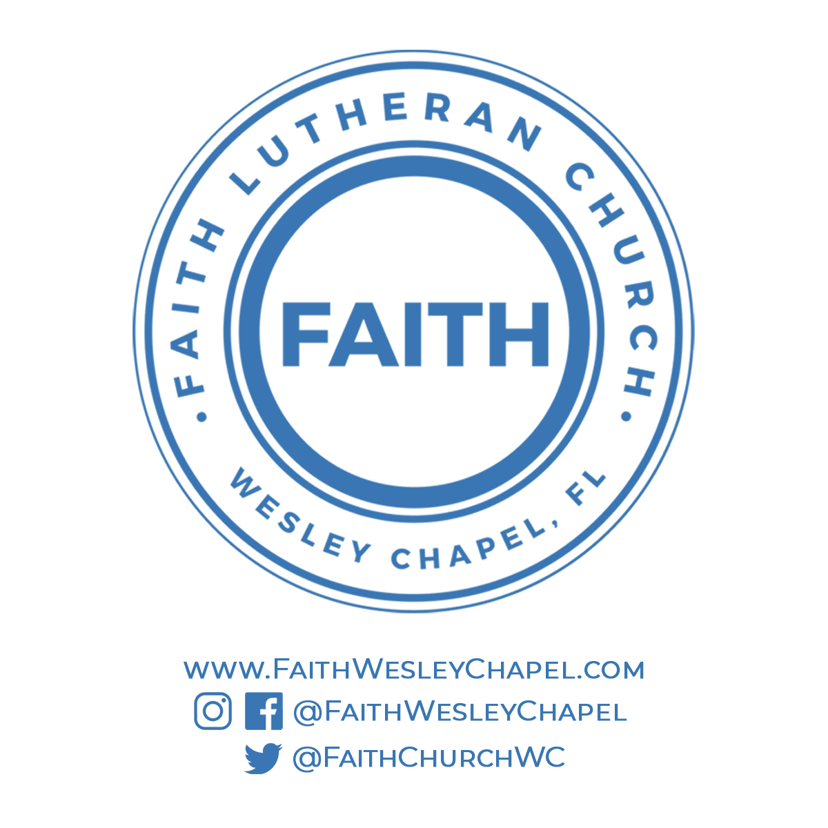**@FaithWesleyChapel**

**@FaithWesleyChapel**

**@FaithChurchWC**