

**Leading our community into a deep connection in Christ**

**Worship Service for July 18, 2021 at 11 AM**

**Welcome**

**Opening Song:**Everlasting God

Strength will rise as we wait upon the Lord,  
we will wait upon the Lord  
we will wait upon the Lord (repeat)

Pre-Chorus:  
Our God You reign forever  
Our hope Our strong deliverer

Chorus:  
You are the everlasting God  
the everlasting God  
You do not faint You won't grow weary  
and You're the defender of the weak  
You comfort those in need  
You lift us up on wings like eagles

Verse  
Pre-Chorus  
Chorus

**Invocation**

**Confession and Forgiveness:**

P: Come into the presence of God. It is God, Himself, who bids us to come to Him in prayer, especially when we have sinned, so that we may receive His forgiveness. So, we enter His courts with confidence that if we confess our sins, He will forgive us as He promised.

(a time of silence to reflect and personally confess our sins)

C: Heavenly Father, we confess that we have sinned against you in thought, word, and deed. We have not loved you with our whole heart and have not loved our neighbor as ourselves. We are truly sorry and we humbly repent. For the sake of your Son Jesus Christ and His suffering and death on the cross, have mercy on us and forgive us; that we may delight in your will, and walk in your ways, to the glory of your Name. Amen

P: The Lord our God is merciful and gracious, longsuffering, and abounding in goodness and truth, keeping mercy for thousands, forgiving iniquity and transgression and sin. Therefore, I announce unto you the grace of our Lord Jesus Christ. In His stead and by the command of my Lord Jesus Christ, I forgive you all your sins in the name of the Father and of the Son and of the Holy Spirit.

C: Amen.

**Song of Praise and Thanksgiving:** Beautiful Savior

Beautiful Savior, King of creation,  
Son of God and Son of man.  
Truly I’d love Thee, Truly I’d serve Thee  
Light of my soul, my joy, my crown.

Fair are the meadows. Fair is the woodlands  
Robed in the flow’rs of blooming spring  
Jesus is fairer. Jesus is purer.   
He makes our sorrowing spirit sing

Beautiful Savior, Lord of the nations,  
Son of God and Son of man.  
Glory and honor, praise adoration,  
Now and forever more be Thine!

**Old Testament Reading -**Jeremiah 23:1–6

“Woe to the shepherds who destroy and scatter the sheep of my pasture!” declares the Lord. Therefore, thus says the Lord, the God of Israel, concerning the shepherds who care for my people: “You have scattered my flock and have driven them away, and you have not attended to them. Behold, I will attend to you for your evil deeds, declares the Lord. Then I will gather the remnant of my flock out of all the countries where I have driven them, and I will bring them back to their fold, and they shall be fruitful and multiply. I will set shepherds over them who will care for them, and they shall fear no more, nor be dismayed, neither shall any be missing, declares the Lord.

“Behold, the days are coming, declares the Lord, when I will raise up for David a righteous Branch, and he shall reign as king and deal wisely, and shall execute justice and righteousness in the land. In his days Judah will be saved, and Israel will dwell securely. And this is the name by which he will be called: ‘The Lord is our righteousness.’

Reader: This is the Word of the Lord.

C: Thanks be to God.

**Gospel Reading** - Mark 6:30–44

The apostles returned to Jesus and told him all that they had done and taught. And he said to them, “Come away by yourselves to a desolate place and rest a while.” For many were coming and going, and they had no leisure even to eat. And they went away in the boat to a desolate place by themselves. Now many saw them going and recognized them, and they ran there on foot from all the towns and got there ahead of them. When he went ashore, he saw a great crowd, and he had compassion on them, because they were like sheep without a shepherd. And he began to teach them many things. And when it grew late, his disciples came to him and said, “This is a desolate place, and the hour is now late. Send them away to go into the surrounding countryside and villages and buy themselves something to eat.” But he answered them, “You give them something to eat.” And they said to him, “Shall we go and buy two hundred denarii worth of bread and give it to them to eat?” And he said to them, “How many loaves do you have? Go and see.” And when they had found out, they said, “Five, and two fish.” Then he commanded them all to sit down in groups on the green grass. So, they sat down in groups, by hundreds and by fifties. And taking the five loaves and the two fish, he looked up to heaven and said a blessing and broke the loaves and gave them to the disciples to set before the people. And he divided the two fish among them all. And they all ate and were satisfied. And they took up twelve baskets full of broken pieces and of the fish. And those who ate the loaves were five thousand men.

P: This is the Gospel of the Lord.

C: Praise be to You, o Christ.

**Children's Message**

**Sermon Hymn***–*They'll Know We Are Christians By Our Love

We are one in the Spirit, we are one in the Lord;  
We are one in the Spirit, we are one in the Lord;  
And we pray that all unity will one day be restored.

Chorus:  
And they'll know we are Christians by our love, by our love,  
yes, they'll know we are Christians by our love.

We will walk with each other, we will walk hand in hand;  
We will walk with each other, we will walk hand in hand;  
And together we'll spread the news that God is in our land.

Chorus:  
And they'll know we are Christians by our love, by our love,  
yes, they'll know we are Christians by our love.

We Will work with each other, we will work side by side;  
We will work with each other, we will work side by side;  
And we'll guard each one's dignity and save each other's pride.

Chorus

**Sermon** - "One In Christ"

Ephesians 2:11–22

Therefore, remember that at one time you Gentiles in the flesh, called “the uncircumcision” by what is called the circumcision, which is made in the flesh by hands— remember that you were at that time separated from Christ, alienated from the commonwealth of Israel and strangers to the covenants of promise, having no hope and without God in the world. But now in Christ Jesus you who once were far off have been brought near by the blood of Christ. For he himself is our peace, who has made us both one and has broken down in his flesh the dividing wall of hostility by abolishing the law of commandments expressed in ordinances, that he might create in himself one new man in place of the two, so making peace, and might reconcile us both to God in one body through the cross, thereby killing the hostility. And he came and preached peace to you who were far off and peace to those who were near. For through him we both have access in one Spirit to the Father. So, then you are no longer strangers and aliens, but you are fellow citizens with the saints and members of the household of God, built on the foundation of the apostles and prophets, Christ Jesus himself being the cornerstone, in whom the whole structure, being joined together, grows into a holy temple in the Lord. In him you also are being built together into a dwelling place for God by the Spirit.

Reader: This is the Word of the Lord.

C: Thanks be to God.

**Apostles' Creed**

I believe in God, the Father almighty,  
maker of heaven and earth,

And in Jesus Christ, his only Son, our Lord,  
who was conceived by the Holy Spirit,  
born of the Virgin Mary,  
suffered under Pontius Pilate,  
was crucified, died and was buried.  
He descended into hell.  
The third day he rose again from the dead.  
He ascended into heaven and sits at the right hand of God  
the Father almighty.  
From there he will come to judge the living and the dead.

I believe in the Holy Spirit,  
the holy Christian Church,  
the communion of saints,  
the forgiveness of sins,  
the resurrection of the body,

and the life everlasting. Amen.

**Prayers**

**The Lord's Prayer**

Our Father who art in heaven, hallowed be Thy name, Thy kingdom come, Thy will be done on earth as it is in heaven.  Give us this day our daily bread; and forgive us our trespasses as we forgive those who trespass against us; and lead us not into temptation, but deliver us from evil.  For Thine is the kingdom and the power and the glory forever and ever.  Amen

**Benediction**

**Closing Song:**What A Friend

Everybody has trials and temptations  
Everybody knows heart break, isolation

Pre-Chorus:  
But we can lay our burdens down, Lay our burdens down

Chorus:  
What a friend we have in Jesus. East to west my sins are gone  
I see grace on every horizon. And forever and ever His heart is my home

Everybody has fears, everybody got worries  
Everybody knows sorrow, devastation

Pre-Chorus

Chorus

No more betrayal, for He is faithful  
He fills me up and my cup runneth over  
No more betrayal, for He is faithful.   
How He has proven it over and over  
No more betrayal, for He is faithful  
He fills me up and my cup runneth over  
No more betrayal, for He is faithful  
How He has proven it over and over, over and over

Chorus 2x

Forever and ever His heart is my home

**Offering**

**Sermon Notes:**

**_______________________________________________**

**_______________________________________________**

**_______________________________________________**

**_______________________________________________**

**_______________________________________________**

**_______________________________________________**

**_______________________________________________**

**Upcoming Events**

**July 24, Time: TBD – Laser Tag**

Location - TBD

**August 1, Noon – Facility Vision Meeting – “Goals of the Facility”**

Song and Dance (Immediately after the worship service)

**August 8, 11 AM – Faith and Food Worship Service**

Song and Dance (normal service time)

**August 8, Noon-2pm – Congregational Game Day**

Song and Dance (Immediately after the worship service)

Bring a game to share

**www.FaithWesleyChapel.com**

**Faith YouTube**

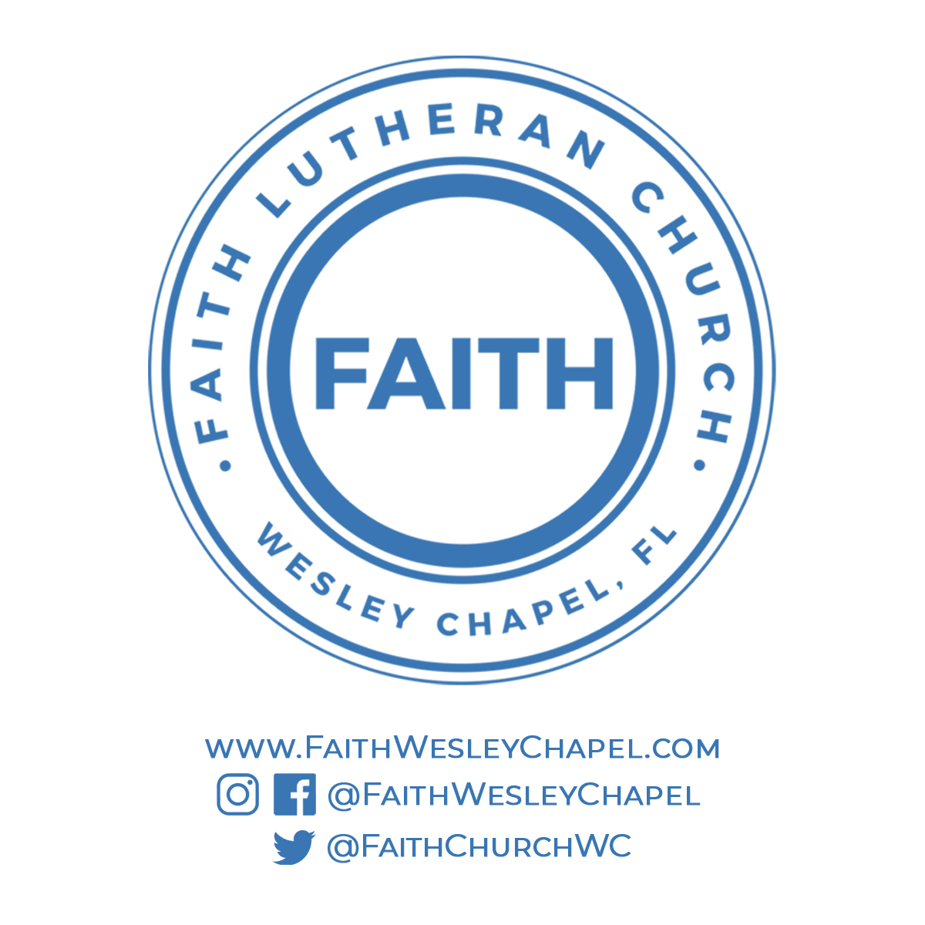**@FaithWesleyChapel**

**@FaithWesleyChapel**

**@FaithChurchWC**