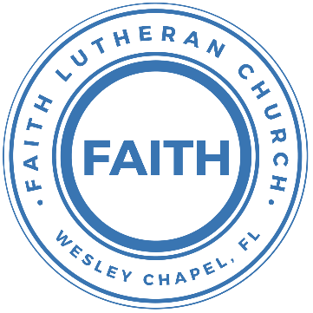

**Leading our community into a deep connection in Christ**

**Worship Service for July 25, 2021 at 11 AM**

**Welcome**

**Opening Song:**Praise to The Lord, The Almighty

Praise to the Lord the Almighty, the King of creation  
O my soul, praise Him for He is your health and salvation  
Let all who hear, Now to His temple draw near  
Joining in glad adoration

Praise to the Lord Who o’er all things is wondrously reigning  
And as on wings of an eagle, uplifting, sustaining  
have you not seen, all that is needful has been  
Sent by His gracious ordaining?

Praise to the Lord Who has fearfully, wondrously made you.  
Health has bestowed and, when heedlessly falling, has stayed you.  
What need or grief ever has failed of relief?  
Wings of His mercy did shade you.

Praise to the Lord who will prosper your work and defend you  
Surely His goodness and Mercy shall daily attend you  
Ponder anew what the Almighty can do  
As with His love He befriends you

Praise to the Lord! O let all that is in me adore Him  
All that has life and breath Come now with praises before Him  
Let the Amen sound from His people again gladly forever adore Him

**Invocation**

**Confession and Forgiveness:**

P: When we come into the presence of God we cannot help but see our sinfulness. God does not require us to cleanse our own sin and be perfect of our own power for, surely, we could never achieve this. Instead, He tells us to come as we are and receive His great mercy.

**Song: Come As You Are**

Verse 1:  
Come out of sadness, from wherever you've been  
Come broken hearted, let rescue begin  
Come find your mercy, oh sinner come kneel  
Earth has no sorrow that Heaven can't heal  
Earth has no sorrow that Heaven can't heal

Chorus:  
So lay down your burdens, lay down your shame  
All who are broken, lift up your face  
Oh wanderer come home, You're not too far  
So lay down your hurt, lay down your heart,  
Come as you are

Verse 2:  
There's hope for the hopeless, and all those who've strayed  
Come sit at the table, come taste of the grace  
There's rest for the weary, rest that endures  
Earth has no sorrow that Heaven can't cure

Chorus

Bridge:  
Come as you are. Fall in his arms. Come as you are.

*(a time of silence to reflect and personally confess our sins)*

C: Heavenly Father, we confess that we have sinned against you and each other. We are truly sorry and we humbly repent. For the sake of your Son Jesus Christ and His suffering and death on the cross, please forgive us and help us to live according to Your ways. Amen

Verse 3:  
There's joy for the morning, oh sinner be still  
Earth has no sorrow that Heaven can't heal  
Earth has no sorrow that Heaven can't heal

Chorus:  
So lay down your burdens, lay down your shame  
All who are broken, lift up your face  
Oh wanderer come home, you’re not too far  
So lay down your hurt, lay down your heart,  
Come as you are

P: The Lord our God is merciful and gracious, longsuffering, and abounding in goodness and truth, keeping mercy for thousands, forgiving iniquity and transgression and sin. Therefore, I announce unto you the grace of our Lord Jesus Christ. In His stead and by the command of my Lord Jesus Christ, I forgive you all your sins in the name of the Father and of the Son and of the Holy Spirit.  
C: Amen.

**Old Testament Reading - Genesis 9:8–17**

Then God said to Noah and to his sons with him, “Behold, I establish my covenant with you and your offspring after you, and with every living creature that is with you, the birds, the livestock, and every beast of the earth with you, as many as came out of the ark; it is for every beast of the earth. I establish my covenant with you, that never again shall all flesh be cut off by the waters of the flood, and never again shall there be a flood to destroy the earth.” And God said, “This is the sign of the covenant that I make between me and you and every living creature that is with you, for all future generations: I have set my bow in the cloud, and it shall be a sign of the covenant between me and the earth. When I bring clouds over the earth and the bow is seen in the clouds, I will remember my covenant that is between me and you and every living creature of all flesh. And the waters shall never again become a flood to destroy all flesh. When the bow is in the clouds, I will see it and remember the everlasting covenant between God and every living creature of all flesh that is on the earth.” God said to Noah, “This is the sign of the covenant that I have established between me and all flesh that is on the earth.”

Reader: This is the Word of the Lord.  
C: Thanks be to God.

**Epistle Reading - Ephesians 3:14–21**

For this reason I bow my knees before the Father, from whom every family in heaven and on earth is named, that according to the riches of his glory he may grant you to be strengthened with power through his Spirit in your inner being, so that Christ may dwell in your hearts through faith—that you, being rooted and grounded in love, may have strength to comprehend with all the saints what is the breadth and length and height and depth, and to know the love of Christ that surpasses knowledge, that you may be filled with all the fullness of God.

Now to him who is able to do far more abundantly than all that we ask or think, according to the power at work within us, to him be glory in the church and in Christ Jesus throughout all generations, forever and ever. Amen.

Reader: This is the Word of the Lord.  
C: Thanks be to God.

**Children's Message**

**Sermon Hymn***–*I Can’t Believe

In the fall you were there Grace began before I was aware  
The shame to great for me to hide  
Covered now because of Jesus Christ

Chorus:  
I can't believe the price you paid for me  
What you did not owe so that I could know you  
How can it be You chose someone like me  
To declare your praise for the glory of your name

To the one who gave it all I belong with all my heart and soul

And every gain I count as loss  
When I survey the wonder of the cross

Chorus

You gave your life upon a cross, woooh  
To make your home within my heart  
Oh what a faithful God you are, woooh  
Your praise forever in my heart

Chorus 2x

**Sermon** - "Oh Ye of Little Faith” Mark 6:45–56

Immediately he made his disciples get into the boat and go before him to the other side, to Bethsaida, while he dismissed the crowd. And after he had taken leave of them, he went up on the mountain to pray. And when evening came, the boat was out on the sea, and he was alone on the land. And he saw that they were making headway painfully, for the wind was against them. And about the fourth watch of the night, he came to them, walking on the sea. He meant to pass by them, but when they saw him walking on the sea, they thought it was a ghost, and cried out, for they all saw him and were terrified. But immediately he spoke to them and said, “Take heart; it is I. Do not be afraid.” And he got into the boat with them, and the wind ceased. And they were utterly astounded, for they did not understand about the loaves, but their hearts were hardened.

When they had crossed over, they came to land at Gennesaret and moored to the shore. And when they got out of the boat, the people immediately recognized him and ran about the whole region and began to bring the sick people on their beds to wherever they heard he was. And wherever he came, in villages, cities, or countryside, they laid the sick in the marketplaces and implored him that they might touch even the fringe of his garment. And as many as touched it were made well.

P: This is the Gospel of the Lord.  
C: Praise be to You, o Christ.

**Prayers (***Text in prayer requests to 813-602-1104)*

**Apostles' Creed**

I believe in God, the Father almighty,  
maker of heaven and earth,

And in Jesus Christ, his only Son, our Lord,  
who was conceived by the Holy Spirit,  
born of the Virgin Mary, suffered under Pontius Pilate,  
was crucified, died and was buried.  
He descended into hell.  
The third day he rose again from the dead.  
He ascended into heaven and sits at the right hand of God  
the Father almighty.  
From there he will come to judge the living and the dead.

I believe in the Holy Spirit,  
the holy Christian Church,  
the communion of saints,  
the forgiveness of sins,  
the resurrection of the body,

and the life everlasting. Amen.

**The Lord's Prayer**

Our Father who art in heaven, hallowed be Thy name, Thy kingdom come, Thy will be done on earth as it is in heaven.  Give us this day our daily bread; and forgive us our trespasses as we forgive those who trespass against us; and lead us not into temptation, but deliver us from evil.  For Thine is the kingdom and the power and the glory forever and ever.  Amen

**Words of Institution**

**Peace**

P: The peace of the Lord be with you all.  
C: And also with you.  
P: We greet each other in the peace of Christ.

**Distribution**

**Prayer**

**Benediction**

**Closing Song:**Your Grace Is Enough

Great is Your faithfulness oh God.   
You wrestle with the sinner's restless heart   
You lead us by still waters into mercy,  
And nothing can keep us apart

Pre-chorus:  
So remember Your people. Remember Your children  
Remember Your promise, Oh God

Chorus:  
Your grace is enough. Your grace is enough  
Your grace is enough for me  
Great is Your love and justice God of Jacob.  
You use the weak to lead the strong

You lead us in the song of Your salvation  
And all Your people sing along

Pre-chorus  
Chorus 2x

**Sermon Notes:**

**________________________________________________________________________________________________________________________________________________________________________________________________________________________________________________________________________________________________________________________________________________________________________________________________________________________________________________________________________________________________________________________________________________________________________________________________________________________________________________**

**Upcoming Events**

**August 1, Noon – Facility Vision Meeting – “Goals of the Facility”**

Song and Dance (Immediately after the worship service)

**August 8, 11 AM – Faith and Food Worship Service**

Song and Dance (normal service time)

**August 8, Noon-2pm – Congregational Game Day**

Song and Dance (Immediately after the worship service)

Bring a game to share

[**www.FaithWesleyChapel.com**](http://www.FaithWesleyChapel.com)

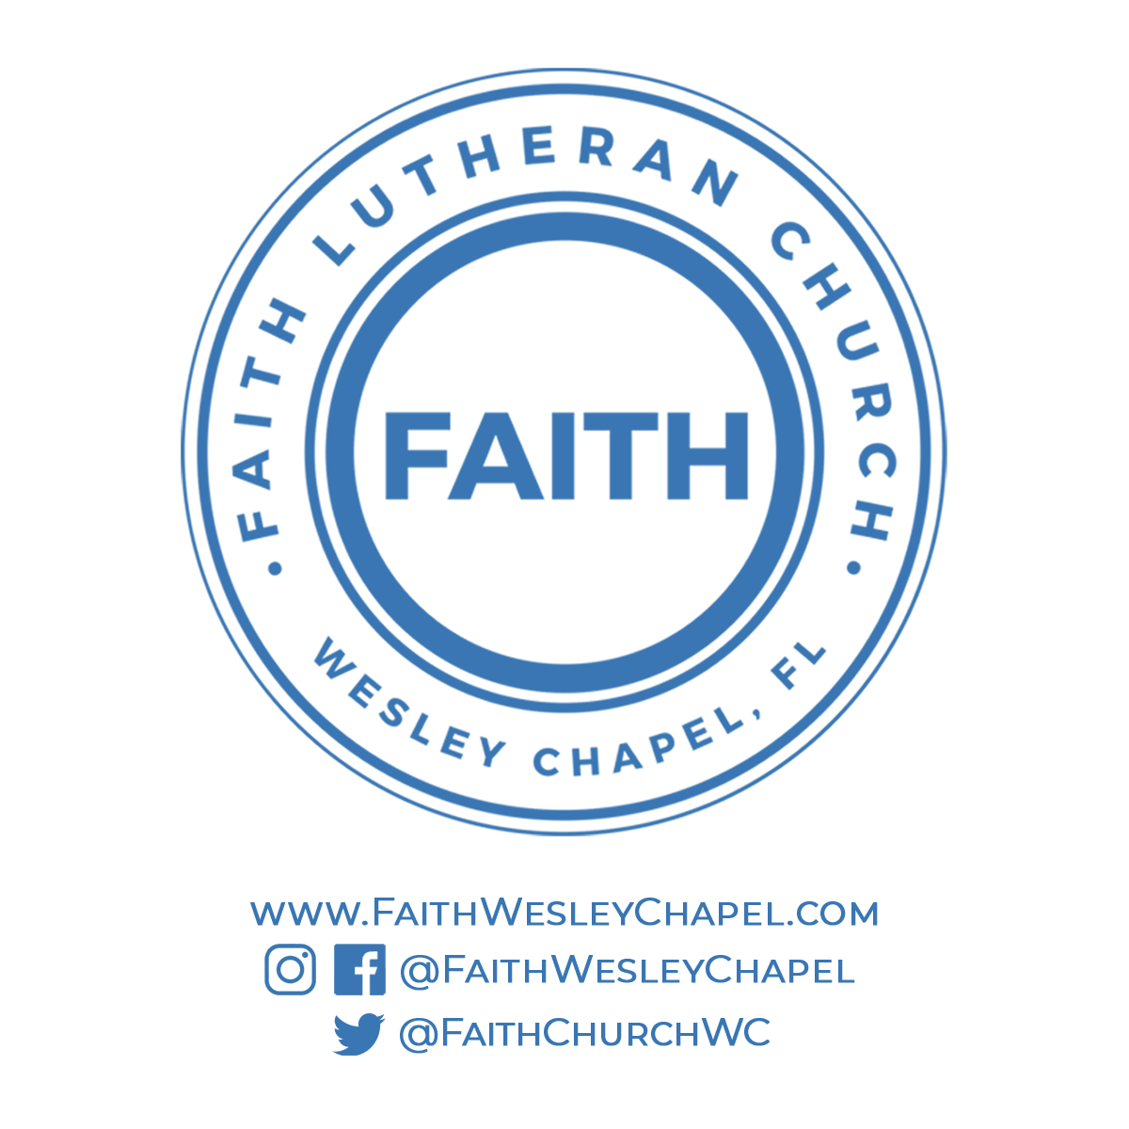**Faith YouTube**

**@FaithWesleyChapel**

**@FaithWesleyChapel**

**@FaithChurchWC**