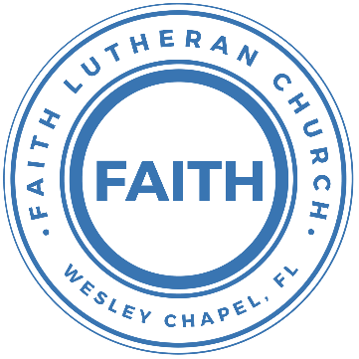

**Leading our community into a deep connection in Christ**

**Worship Service for August 8, 2021 at 11 AM**

**Welcome**

**Invocation**

**Confession and Forgiveness:**

P: As we gather, today, let us cleanse our hearts and our consciences by confessing our sin to God.

(Time of silence for reflection and confession)

C: Heavenly Father, we confess that we are sinful and unclean. We have sinned against you and against our neighbor in our thoughts, words, and actions.  We are truly sorry for our sins and sincerely repent of them. We ask for Your mercy. For the sake of Jesus Christ's bitter suffering and death, please forgive us and renew us that we may walk in Your Spirit to the glory of Your holy name.

P: The Lord has heard your confession. Therefore, as a called and ordained servant of the Lord, in the stead and by the command of my Lord, Jesus Christ, I forgive you all your sins in the name of the Father and of the Son and of the Holy Spirit.

C: Amen

**Song of Praise and Thanksgiving:** This Is Amazing Grace

Who breaks the power of sin and darkness   
Whose love is mighty and so much stronger  
The King of Glory, the King above all kings   
Who shakes the whole earth with holy thunder   
Who leaves us breathless in awe and wonder   
The King of Glory, the King above all kings

Chorus:  
This is amazing grace  
This is unfailing love  
That You would take my place  
That You would bear my cross  
You would lay down Your life  
That I would be set free

Jesus, I sing for  
All that You've done for me

Chorus

Who brings our chaos back into order  
Who makes the orphan a son and daughter  
The King of Glory, The King of Glory  
Who rules the nations with truth and justice  
Shines like the sun in all of its brilliance  
The King of Glory, the King above all kings

Chorus

**Epistle Reading:**Ephesians 4:17-5:2

Now this I say and testify in the Lord, that you must no longer walk as the Gentiles do, in the futility of their minds. They are darkened in their understanding, alienated from the life of God because of the ignorance that is in them, due to their hardness of heart. They have become callous and have given themselves up to sensuality, greedy to practice every kind of impurity. But that is not the way you learned Christ! — assuming that you have heard about him and were taught in him, as the truth is in Jesus, to put off your old self, which belongs to your former manner of life and is corrupt through deceitful desires, and to be renewed in the spirit of your minds, and to put on the new self, created after the likeness of God in true righteousness and holiness.

Therefore, having put away falsehood, let each one of you speak the truth with his neighbor, for we are members one of another. Be angry and do not sin; do not let the sun go down on your anger, and give no opportunity to the devil. Let the thief no longer steal, but rather let him labor, doing honest work with his own hands, so that he may have something to share with anyone in need. Let no corrupting talk come out of your mouths, but only such as is good for building up, as fits the occasion, that it may give grace to those who hear. And do not grieve the Holy Spirit of God, by whom you were sealed for the day of redemption. Let all bitterness and wrath and anger and clamor and slander be put away from you, along with all malice. Be kind to one another, tenderhearted, forgiving one another, as God in Christ forgave you.

Therefore, be imitators of God, as beloved children. And walk in love, as Christ loved us and gave himself up for us, a fragrant offering and sacrifice to God.

Reader: This is the Word of the Lord.  
C: Thanks be to God.

**Gospel Reading:** John 6:44–51

No one can come to me unless the Father who sent me draws him. And I will raise him up on the last day. It is written in the Prophets, ‘And they will all be taught by God.’ Everyone who has heard and learned from the Father comes to me — not that anyone has seen the Father except he who is from God; he has seen the Father. Truly, truly, I say to you, whoever believes has eternal life. I am the bread of life. Your fathers ate the manna in the wilderness, and they died. This is the bread that comes down from heaven, so that one may eat of it and not die. I am the living bread that came down from heaven. If anyone eats of this bread, he will live forever. And the bread that I will give for the life of the world is my flesh.”

P: This is the Gospel of the Lord.  
C: Praise be to You, o Christ.

**Sermon** – The Power of Words

**Prayers**

**Apostles' Creed**

I believe in God, the Father almighty, maker of heaven and earth,  
And in Jesus Christ, his only Son, our Lord,  
who was conceived by the Holy Spirit,  
born of the Virgin Mary, suffered under Pontius Pilate,  
was crucified, died and was buried. He descended into hell.  
The third day he rose again from the dead.  
He ascended into heaven and sits at the right hand of God  
the Father almighty.  
From there he will come to judge the living and the dead.  
I believe in the Holy Spirit, the holy Christian Church,  
the communion of saints, the forgiveness of sins,  
the resurrection of the body, and the life everlasting. Amen.

**The Lord's Prayer**

Our Father who art in heaven, hallowed be Thy name, Thy kingdom come, Thy will be done on earth as it is in heaven.  Give us this day our daily bread; and forgive us our trespasses as we forgive those who trespass against us; and lead us not into temptation, but deliver us from evil.  For Thine is the kingdom and the power and the glory forever and ever.  Amen

**Benediction**

**Closing Song:** Praise God From Whom All Blessings Flow

Praise God from whom all blessings flow.  
Praise Him all creatures here below.  
Praise Him above, ye heavenly hosts.  
Praise Father, Son and Holy Ghost.  
Amen

**Offering**

**Sermon Notes:**

**_______________________________________________**

**_______________________________________________**

**_______________________________________________**

**_______________________________________________**

**_______________________________________________**

**_______________________________________________**

**_______________________________________________**

**_______________________________________________**

**_______________________________________________**

**_______________________________________________**

**_______________________________________________**

**_______________________________________________**

**_______________________________________________**

**_______________________________________________**

**_______________________________________________**

**_______________________________________________**

**_______________________________________________**

**Upcoming Events**

**August 8, Noon-2pm – Congregational Game Day**Song and Dance (Immediately after the worship service)Bring a game to share

**August 16, Council Meeting**Zoom

**www.FaithWesleyChapel.com**

**Faith YouTube**

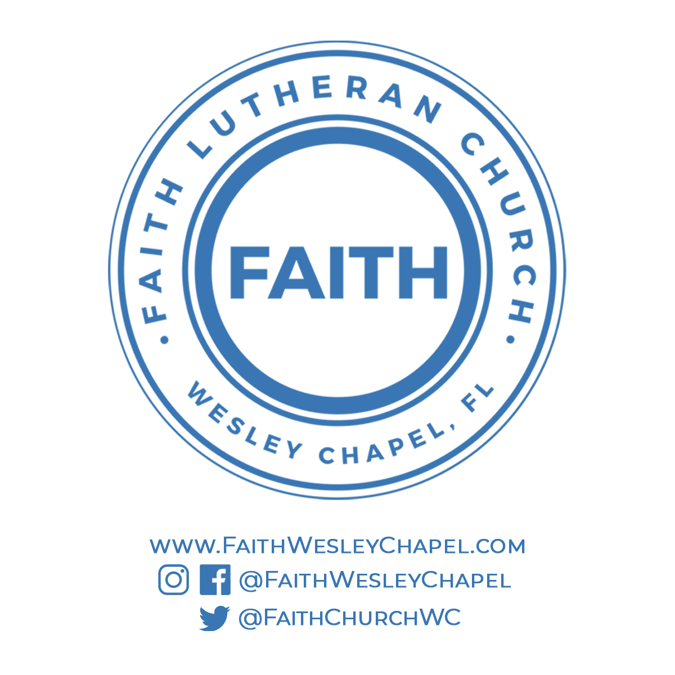**@FaithWesleyChapel**

**@FaithWesleyChapel**

**@FaithChurchWC**