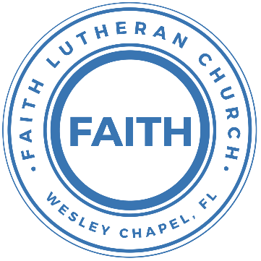

**Leading our community into a deep connection in Christ**

**Worship Service for September 12, 2021 at 11 AM**

**Welcome**

**Invocation**

**Confession and Forgiveness:**

P: As we gather, today, let us cleanse our hearts and our consciences by confessing our sin to God.

(Time of silence for reflection and confession)

C: Heavenly Father, we confess that we are sinful and unclean. We have sinned against you and against our neighbor in our thoughts, words, and actions.  We are truly sorry for our sins and sincerely repent of them. We ask for Your mercy. For the sake of Jesus Christ's bitter suffering and death, please forgive us and renew us that we may walk in Your Spirit to the glory of Your holy name.

P: The Lord has heard your confession. Therefore, as a called and ordained servant of the Lord, in the stead and by the command of my Lord, Jesus Christ, I forgive you all your sins in the name of the Father and of the Son and of the Holy Spirit.

C: Amen

**Songs of Praise and Thanksgiving – What A Friend**

Everybody has trials and temptations  
Everybody knows heart break, isolation

Pre-Chorus:  
But we can lay our burdens down, Lay our burdens down

Chorus:  
What a friend we have in Jesus.   
East to west my sins are gone  
I see grace on every horizon.   
And forever and ever His heart is my home

Verse 2:  
Everybody has fears, everybody got worries  
Everybody knows sorrow, devastation

Pre-Chorus  
Chorus

Bridge:  
No more betrayal, for He is faithful  
He fills me up and my cup runneth over  
No more betrayal, for He is faithful.  
How He has proven it over and over  
No more betrayal, for He is faithful  
He fills me up and my cup runneth over  
No more betrayal, for He is faithful  
How He has proven it over and over, over and over

Chorus 2x

Forever and ever His heart is my home

**Song - This I Believe**

Our Father everlasting the all creating One God almighty  
Through Your Holy Spirit Conceiving Christ the Son Jesus our Savior

Chorus:  
I believe in God our Father. I believe in Christ the Son  
I believe in the Holy Spirit. Our God is three in one  
I believe in the resurrection, that we will rise again.  
For I believe in the name of Jesus

Verse 2:  
Our Judge and our Defender, Suffered and crucified,  
Forgiveness is in You  
Descended into darkness You rose in glorious life, Forever seated high

Chorus

Bridge: (2x)  
I believe in You. I believe You rose again  
I believe that Jesus Christ is Lord

Chorus 2:  
I believe in life eternal. I believe in the virgin birth  
I believe in the saints' communion And in Your holy church  
I believe in the resurrection, When Jesus comes again  
For I believe in the name of Jesus. For I believe in the name of Jesus

**Old Testament Reading - Isaiah 50:4-10**

The Lord God has given me the tongue of those who are taught,  
that I may know how to sustain with a word him who is weary.  
Morning by morning he awakens;  
 he awakens my ear to hear as those who are taught.  
The Lord God has opened my ear,  
 and I was not rebellious; I turned not backward.  
I gave my back to those who strike,  
 and my cheeks to those who pull out the beard;  
I hid not my face from disgrace and spitting.

But the Lord God helps me;  
 therefore I have not been disgraced;  
therefore I have set my face like a flint,  
 and I know that I shall not be put to shame.  
He who vindicates me is near.  
Who will contend with me? Let us stand up together.  
Who is my adversary?  
 Let him come near to me. Behold, the Lord God helps me;  
 who will declare me guilty?  
Behold, all of them will wear out like a garment;  
 the moth will eat them up.

Who among you fears the Lord  
 and obeys the voice of his servant?  
Let him who walks in darkness and has no light  
trust in the name of the Lord and rely on his God.

Reader: This is the Word of the Lord.  
C: Thanks be to God.

**Epistle Reading - Jude 1:17-23**

But you must remember, beloved, the predictions of the apostles of our Lord Jesus Christ. They said to you, “In the last time there will be scoffers, following their own ungodly passions.” It is these who cause divisions, worldly people, devoid of the Spirit. But you, beloved, building yourselves up in your most holy faith and praying in the Holy Spirit, keep yourselves in the love of God, waiting for the mercy of our Lord Jesus Christ that leads to eternal life. And have mercy on those who doubt; save others by snatching them out of the fire; to others show mercy with fear, hating even the garment stained by the flesh.

Reader: This is the Word of the Lord.  
C: Thanks be to God.

**Gospel Reading - Mark 9:14–29**

And when they came to the disciples, they saw a great crowd around them, and scribes arguing with them. And immediately all the crowd, when they saw him, were greatly amazed and ran up to him and greeted him. And he asked them, “What are you arguing about with them?” And someone from the crowd answered him, “Teacher, I brought my son to you, for he has la spirit that makes him mute. And whenever it seizes him, it throws him down, and he foams and grinds his teeth and becomes rigid. So I asked your disciples to cast it out, and they were not able.” And he answered them, “O faithless generation, how long am I to be with you? How long am I to bear with you? Bring him to me.” And they brought the boy to him. And when the spirit saw him, immediately it convulsed the boy, and he fell on the ground and rolled about, foaming at the mouth. And Jesus asked his father, “How long has this been happening to him?” And he said, “From childhood. And it has often cast him into fire and into water, to destroy him. But if you can do anything, have compassion on us and help us.” And Jesus said to him, “‘If you can’! All things are possible for one who believes.” Immediately the father of the child cried out4 and said, “I believe; help my unbelief!” And when Jesus saw that a crowd came running together, he rebuked the unclean spirit, saying to it, “You mute and deaf spirit, I command you, come out of him and never enter him again.” And after crying out and convulsing him terribly, it came out, and the boy was like a corpse, so that most of them said, “He is dead.” But Jesus took him by the hand and lifted him up, and he arose. And when he had entered the house, his disciples asked him privately, “Why could we not cast it out?” And he said to them, “This kind cannot be driven out by anything but prayer.”

P: This is the Gospel of the Lord.  
C: Praise be to You, o Christ.

**Sermon Song: Cornerstone**

Verse 1:  
My hope is built on nothing less,  
Than Jesus' blood and righteousness  
I dare not trust the sweetest frame,  
But wholly trust in Jesus' name

Chorus:  
Christ alone, Cornerstone,   
Weak made strong in the Savior's love  
Through the storm  
He is Lord Lord of all

Verse 2:  
When darkness seems to hide His face,   
I rest on His unchanging grace  
In every high and stormy gale   
My anchor holds within the veil  
My anchor holds within the veil

Chorus

Bridge:  
He is Lord. Lord of all

Verse 3:  
When He shall come with trumpet sound,   
Oh may I then in Him be found  
Dressed in His righteousness alone  
Faultless, stand before the throne

**Sermon** – I Believe. Help My Unbelief.

**Prayers**

**Apostles' Creed**

I believe in God, the Father almighty, maker of heaven and earth,  
And in Jesus Christ, his only Son, our Lord,  
who was conceived by the Holy Spirit,  
born of the Virgin Mary, suffered under Pontius Pilate,  
was crucified, died and was buried. He descended into hell.  
The third day he rose again from the dead.  
He ascended into heaven and sits at the right hand of God  
the Father almighty.  
From there he will come to judge the living and the dead.  
I believe in the Holy Spirit, the holy Christian Church,  
the communion of saints, the forgiveness of sins,  
the resurrection of the body, and the life everlasting. Amen.

**The Lord's Prayer**

Our Father who art in heaven, hallowed be Thy name, Thy kingdom come, Thy will be done on earth as it is in heaven.  Give us this day our daily bread; and forgive us our trespasses as we forgive those who trespass against us; and lead us not into temptation, but deliver us from evil.  For Thine is the kingdom and the power and the glory forever and ever.  Amen

**Benediction**

**Closing Song: Praise God from Whom All Blessings Flow**

Praise God from Whom all blessings flow.  
Praise Him all creatures here below.  
Praise Him above, ye heavenly hosts.  
Praise Fat-her, Son and Holy Ghost.  
Amen

**Offering**

**Upcoming Events**

**Today, 4PM – New Members Class**Pastor Kurt’s house

**September 19, Noon – Youth Bible Study**Song and Dance

**September 20, 7 PM Council Meeting**Zoom

**September 25, TBD – Youth Event – Escape Room**TBD

**www.FaithWesleyChapel.com**

**Faith YouTube**

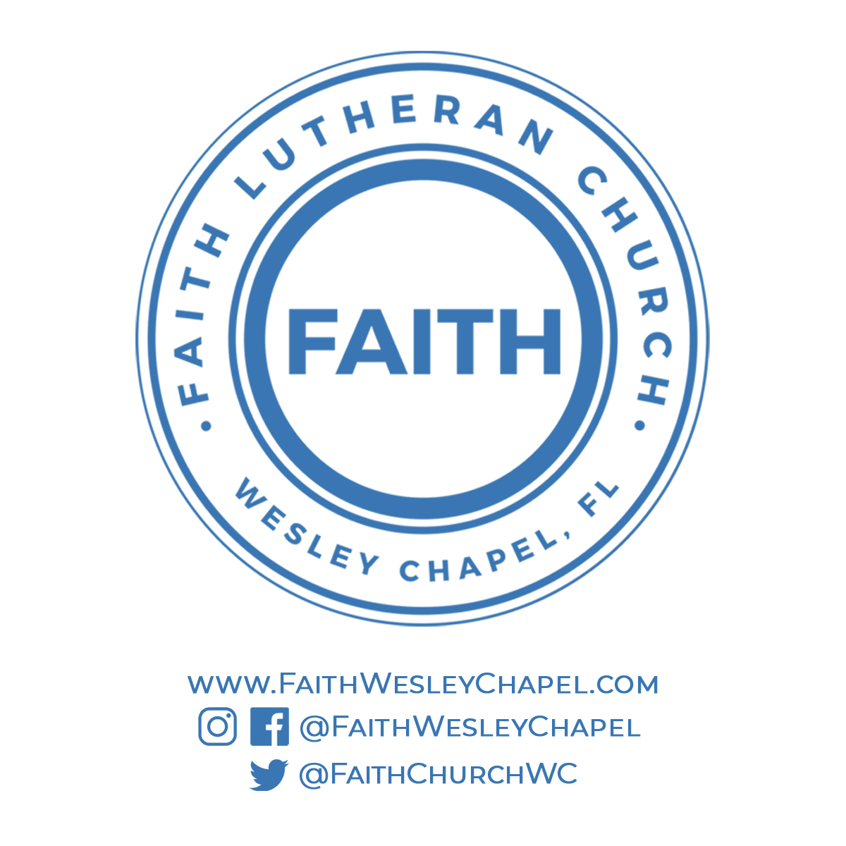**@FaithWesleyChapel**

**@FaithWesleyChapel**

**@FaithChurchWC**