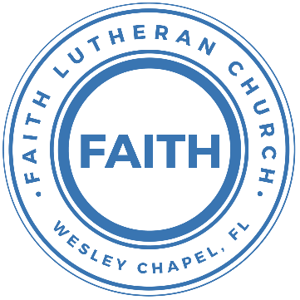

**Leading our community into a deep connection in Christ**

**Worship Service for September 19, 2021 at 11 AM**

**Welcome**

**Opening Song –** Whom Shall I Fear (God of Angel Armies)

You hear me when I call. You are my morning song  
Though darkness fills the night, It cannot hide the light  
Whom shall I fear

You crush the enemy Underneath my feetYou are my sword and shield, though troubles linger stillWhom shall I fear

Chorus:  
I know who goes before me. I know who stands behind  
The God of angel armies Is always by my side  
The One who reigns forever He is a friend of mine  
The God of angel armies Is always by my side

My strength is in Your name For You alone can save  
You will deliver me. Yours is the victory  
Whom shall I fear? Whom shall I fear?

Chorus

And nothing formed against me shall stand  
You hold the whole world in Your hands  
I'm holding on to Your promises  
You are faithful  
You are faithful   
*(Repeat)*

You are faithful

Chorus:  
I know who goes before me. I know who stands behind  
The God of angel armies Is always by my side  
The One who reigns forever He is a friend of mine  
The God of angel armies Is always by my side

(Repeat)

The God of angel armies Is always by my side

**Invocation**

**Confession and Forgiveness:**

**P:** Our Heavenly Father asks us to come into His presence.

**C:** But we are sinful and unworthy.

**P:** Yes, all have sinned and fall short of the glory of God, but Jesus Christ died on the cross that we may be forgiven and washed clean of all our sins by His blood spilled on the cross.

**C:** Lord, if You wash us, we will certainly be clean and pure.

**P:** We take a moment to bow before the His cross and silently reflect on our lives and confess our sins.

(Time of silence for reflection and confession)

**P:** Let us confess, together, our sins to God our Father.

**C:** Heavenly Father, we confess that we are sinners.  We have sinned against you and our neighbors. We have not loved you with our whole heart and we have not loved our neighbors as ourselves. We have not lived out our faith out in our community. We justly deserve Your punishment.  For the sake of Your Son, Jesus Christ, have mercy on us.  Forgive us, renew us, and lead us, so that we may delight in Your will and walk in Your ways to the glory of Your holy name.  Amen.

**P:** Almighty God in His mercy has given His Son to die for you and for His sake forgives you all your sins.  As a called and ordained servant of Christ, and by His authority, I, therefore, forgive you all your sins in the name of the Father and of the Son and of the Holy Spirit.

**C:** Amen

**Song of Praise and Thanksgiving:** O Praise the Name (Anástasis)

I cast my mind to Calvary

Where Jesus bled and died for me

I see His wounds, His hands, His feet.

My Savior on that cursed tree

His body bound and drenched in tears.

They laid Him down in Joseph's tomb

The entrance sealed by heavy stone.

Messiah still and all alone

*Chorus:*

O praise the Name of the Lord our God.

O praise His Name forevermore

For endless days, we will sing Your praise.

Oh Lord, oh Lord our God

Then on the third, at break of dawn

The Son of heaven rose a - gain

O trampled death, where is your sting.

The angels roar for Christ the King

Chorus

He shall return in robes of white.

The blazing sun shall pierce the night

And I will rise among the saints,

My gaze transfixed on Jesus' face

*Chorus:*

O praise the Name of the Lord our God.

O praise His Name forevermore

For endless days, we will sing Your praise.

Oh Lord, oh Lord our God  
(Repeat Chorus)

…Oh Lord, oh Lord our God

**Old Testament Reading -**Jeremiah 11:18-20

The Lord made it known to me and I knew;

then you showed me their deeds.

But I was like a gentle lamb

led to the slaughter.

I did not know it was against me

they devised schemes, saying,

“Let us destroy the tree with its fruit,

let us cut him off from the land of the living,

that his name be remembered no more.”

But, O Lord of hosts, who judges righteously,

who tests the heart and the mind,

let me see your vengeance upon them,

for to you have I committed my cause.

Reader: This is the Word of the Lord.  
C: Thanks be to God.

**Epistle or Gospel Reading** - James 3:13-18

Who is wise and understanding among you? By his good conduct let him show his works in the meekness of wisdom. But if you have bitter jealousy and selfish ambition in your hearts, do not boast and be false to the truth. This is not the wisdom that comes down from above, but is earthly, unspiritual, demonic. For where jealousy and selfish ambition exist, there will be disorder and every vile practice. But the wisdom from above is first pure, then peaceable, gentle, open to reason, full of mercy and good fruits, impartial and sincere. And a harvest of righteousness is sown in peace by those who make peace.

Reader: This is the Word of the Lord.  
C: Thanks be to God.

**Children's Message** *(Children dismissed to Children's Church)*

**Sermon Hymn***–*Were You There

Were you there when they crucified my Lord?  
Were you there when they crucified my Lord?  
Oh, sometimes it causes me to tremble, tremble, tremble.  
Were you there when they crucified my Lord?

Were you there when they nailed him to the tree?  
Were you there when they nailed him to the tree?  
Oh, sometimes it causes me to tremble, tremble, tremble.  
Were you there when they nailed him to the tree?

Were you there when they laid him in the tomb?  
Were you there when they laid him in the tomb?  
Oh, sometimes it causes me to tremble, tremble, tremble.  
Were you there when they laid him in the tomb?

Were you there when God raised him from the tomb?   
Were you there when God raised him from the tomb?   
Oh, sometimes it causes me to tremble, tremble, tremble.   
Were you there when God raised him from the tomb?

**Sermon** - "The Fear of Following Jesus"

Mark 9:30–37

They went on from there and passed through Galilee. And he did not want anyone to know, for he was teaching his disciples, saying to them, “The Son of Man is going to be delivered into the hands of men, and they will kill him. And when he is killed, after three days he will rise.” But they did not understand the saying, and were afraid to ask him.

And they came to Capernaum. And when he was in the house he asked them, “What were you discussing on the way?” But they kept silent, for on the way they had argued with one another about who was the greatest. And he sat down and called the twelve. And he said to them, “If anyone would be first, he must be last of all and servant of all.” And he took a child and put him in the midst of them, and taking him in his arms, he said to them, “Whoever receives one such child in my name receives me, and whoever receives me, receives not me but him who sent me.”

P: This is the Word of the Lord.  
C: Thanks be to God.

**Prayers:** *Text in prayer requests to (813) 602-1104‬*

**Nicene Creed**

I believe in one God, the Father Almighty, maker of heaven and earth and of all things visible and invisible.

And in one Lord Jesus Christ, the only-begotten Son of God, begotten of His Father before all worlds, God of God, Light of Light, very God of very God, begotten, not made, being of one substance with the Father, by whom all things were made; who for us men and for our salvation came down from heaven and was incarnate by the Holy Spirit of the virgin Mary and was made man; and was crucified also for us under Pontius Pilate. He suffered and was buried. And the third day He rose again according to the Scriptures and ascended into heaven and sits at the right hand of the Father. And He will come again with glory to judge both the living and the dead, whose kingdom will have no end.

And I believe in the Holy Spirit, the Lord and Giver of Life, who proceeds from the Father and the Son, who with the Father and the Son together is worshiped and glorified, who spoke by the prophets. And I believe in one holy Christian and apostolic Church, I acknowledge one Baptism for the remission of sins, and I look for the resurrection of the dead and the life of the world to come. Amen.

**The Lord's Prayer**

Our Father who art in heaven, hallowed be Thy name, Thy kingdom come, Thy will be done on earth as it is in heaven.  Give us this day our daily bread; and forgive us our trespasses as we forgive those who trespass against us; and lead us not into temptation, but deliver us from evil.  For Thine is the kingdom and the power and the glory forever and ever.  Amen

**Words of Institution**

**Peace**

P: The peace of the Lord be with you all.  
C: And also, with you.  
P: We greet each other in the peace of Christ.

**Distribution**

**Prayer**

**Benediction**

**Closing Song:**Stand Up, Stand Up For Jesus

Stand up, stand up for Jesus, Ye soldiers of the cross.  
Lift high His royal banner; It must not suffer loss.  
From vict'ry unto vict'ry His army He shall lead  
Till ev'ry foe is vanquished, And Christ is Lord in - deed.

Stand up, stand up for Jesus; The strife will not be long;  
This day the din of battle, The next the victor's song.  
The soldiers, overcoming, Their crown of life shall see  
And with the King of Glory Shall reign eternally.

**Offering**

**Upcoming Events**

**September 19, Noon – Youth Bible Study**  
Song and Dance

**Today, 4PM – New Members Class**Pastor Kurt’s house

**September 20, 7 PM Council Meeting**Zoom

**September 25, 1pm – Youth Event – Escape Room**$35/person  
Tampa's Escape Room  
5811 Memorial Hwy Suite #206,  
Tampa, Florida 33615

**www.FaithWesleyChapel.com**

**Faith YouTube**

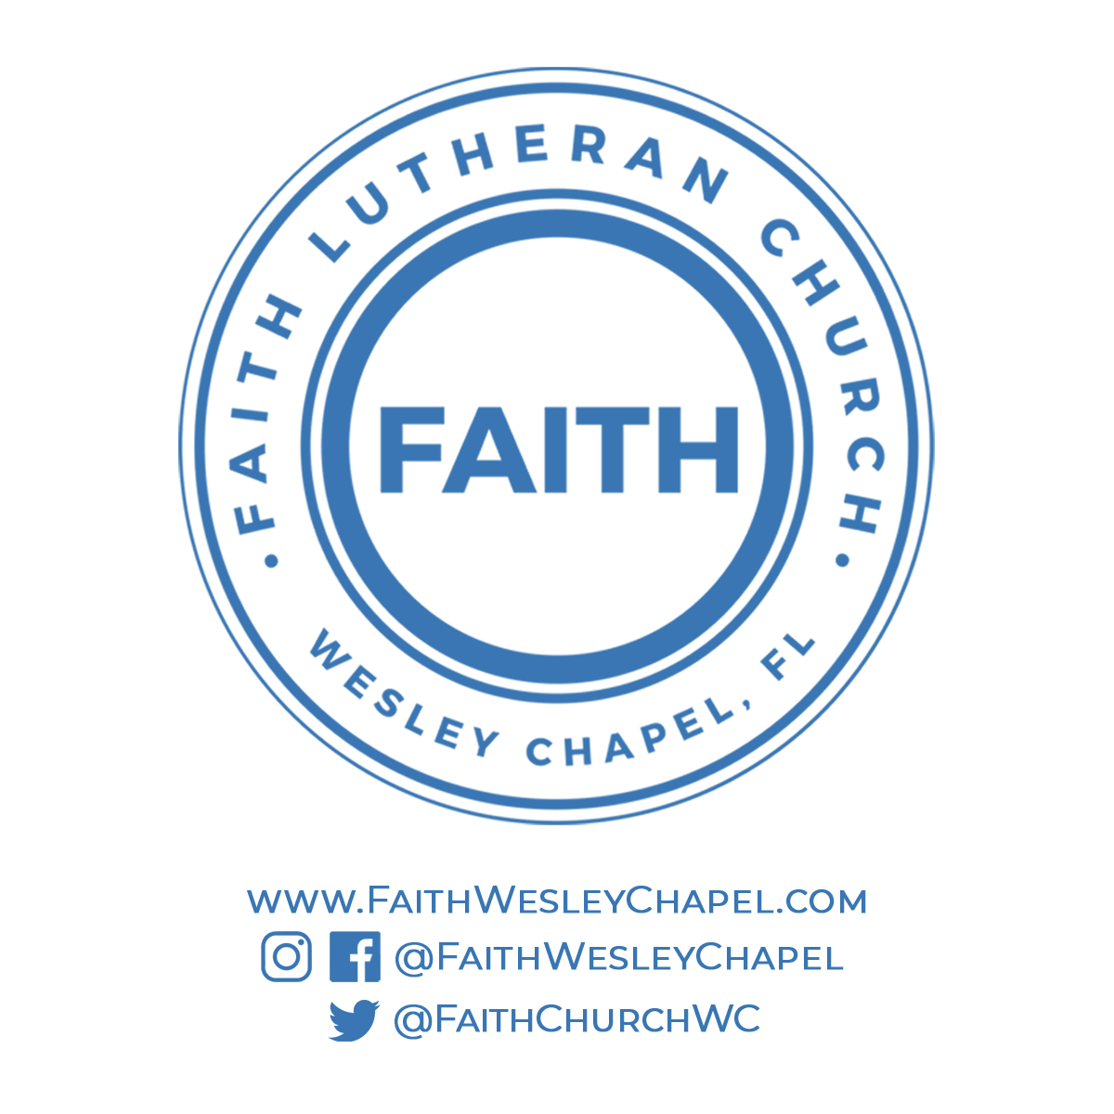**@FaithWesleyChapel**

**@FaithWesleyChapel**

**@FaithChurchWC**