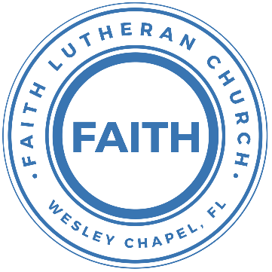

**Leading our community into a deep connection in Christ**

**Worship Service for October 17, 2021 at 11 AM**

**Welcome**

**Invocation**

**Confession and Forgiveness:**

**P:** Our Heavenly Father asks us to come into His presence.

**C:** But we are sinful and unworthy.

**P:** Yes, all have sinned and fall short of the glory of God, but Jesus Christ died on the cross that we may be forgiven and washed clean of all our sins by His blood spilled on the cross.

**C:** Lord, if You wash us, we will certainly be clean and pure.

**P:** We take a moment to bow before the His cross and silently reflect on our lives and confess our sins.

(Time of silence for reflection and confession)

**P:** Let us confess, together, our sins to God our Father.

**C:** Heavenly Father, we confess that we are sinners. We have sinned against you and our neighbors. We have not loved you with our whole heart and we have not loved our neighbors as ourselves. We have not lived out our faith out in our community. We justly deserve Your punishment.  For the sake of Your Son, Jesus Christ, have mercy on us.  Forgive us, renew us, and lead us, so that we may delight in Your will and walk in Your ways to the glory of Your holy name.  Amen.

**P:** Almighty God in His mercy has given His Son to die for you and for His sake forgives you all your sins.  As a called and ordained servant of Christ, and by His authority, I, therefore, forgive you all your sins in the name of the Father and of the Son and of the Holy Spirit.

**C:** Amen

**Song of Praise and Thanksgiving:** Christ Is Risen

Let no one caught in sin remain, Inside the lie of inward shame  
We fix our eyes upon the cross,   
And run to Him who showed great love  
And bled for us. Freely You've bled for us

Chorus:  
Christ is risen from the dead, trampling over death by death  
Come awake, come awake, come and rise up from the grave   
Christ is risen from the dead, we are one with Him again  
Come awake, come awake, come and rise up from the grave

Beneath the weight of all our sin   
You bowed to none but Heaven's will  
No scheme of Hell, no scoffer's crown,   
No burden great can hold You down  
In strength You reign. Forever let Your church pro-claim

Chorus

O death, where is your sting? O hell, where is your victory?  
O church, come stand in the light.  
The glory of God has defeated the night!   
O death, where is your sting? O hell, where is your victory?  
O church, come stand in the light.  
Our God is not dead. He is alive! He is alive!

Chorus

**Old Testament Reading: Isaiah 65:21-25**

They will build houses and dwell in them;  
 they will plant vineyards and eat their fruit.  
No longer will they build houses and others live in them,  
 or plant and others eat.  
For as the days of a tree,  
 so will be the days of my people;  
my chosen ones will long enjoy  
 the work of their hands.  
They will not labor in vain,  
 nor will they bear children doomed to misfortune;  
for they will be a people blessed by the Lord,  
 they and their descendants with them.  
Before they call I will answer;  
 while they are still speaking I will hear.

The wolf and the lamb will feed together,  
 and the lion will eat straw like the ox,  
 and dust will be the serpent’s food.  
They will neither harm nor destroy  
 on all my holy mountain,”  
says the Lord.

Reader: This is the Word of the Lord.  
C: Thanks be to God.

**Epistle Reading: Philippians 3:8-15**

Indeed, I count everything as loss because of the surpassing worth of knowing Christ Jesus my Lord. For his sake I have suffered the loss of all things and count them as rubbish, in order that I may gain Christ and be found in him, not having a righteousness of my own that comes from the law, but that which comes through faith in Christ, the righteousness from God that depends on faith — that I may know him and the power of his resurrection, and may share his sufferings, becoming like him in his death, that by any means possible I may attain the resurrection from the dead.

Not that I have already obtained this or am already perfect, but I press on to make it my own, because Christ Jesus has made me his own. Brothers, I do not consider that I have made it my own. But one thing I do: forgetting what lies behind and straining forward to what lies ahead, I press on toward the goal for the prize of the upward call of God in Christ Jesus.

Reader: This is the Word of the Lord.  
C: Thanks be to God.

**Gospel Reading: John 14:1-6**

“Do not let your hearts be troubled. You believe in God; believe also in me. My Father’s house has many rooms; if that were not so, would I have told you that I am going there to prepare a place for you? And if I go and prepare a place for you, I will come back and take you to be with me that you also may be where I am. 4 You know the way to the place where I am going.”

Thomas said to him, “Lord, we don’t know where you are going, so how can we know the way?”

Jesus answered, “I am the way and the truth and the life. No one comes to the Father except through me.

P: This is the Gospel of the Lord.  
C: Praise be to You, o Christ.

**Children's Message** *(Children dismissed to Children's Church)*

**Sermon Hymn***–*Holy, Holy, Holy

Holy, holy, holy, Lord God almighty:  
Early in the morning our song shall rise to Thee  
Holy, holy, holy, merciful and mighty  
God in three persons blessed Trinity

Holy, holy, holy, all the saints adore Thee  
Casting down their golden crowns around the glassy sea  
Cherubim and Seraphim falling down before Thee  
Which wert and art and evermore shall be.

Holy, holy, holy, though the darkness hides Thee  
Though the eye of sinful man Thy glory may not see  
Only Thou art holy there is none beside Thee  
Perfect in pow’r, in love, and purity.

Holy, holy, holy, Lord God almighty!  
All Thy works shall praise Thy name in earth and sky and sea  
Holy, holy, holy, merciful and mighty  
God in three persons blessed Trinity.  
God in three persons blessed Trinity.

**Sermon** - "What Is Heaven Like?"

**Song:** Revelation Song

Worthy is the Lamb who was slain. Holy Holy is He  
Sing a new song to him who sits on, Heaven's mercy seat

Chorus:  
Holy Holy Holy Is the Lord God Almighty, Who was and is and is to come  
With all creation I sing, Praise to the King of Kings.  
You are my everything And I will adore You...

Clothed in rainbows of living color, Flashes of lightning rolls of thunder  
Blessing and honor, strength and glory and power be  
To You the only wise King

Chorus

Filled with wonder awestruck wonder   
At the mention of your name  
Jesus your name is power,   
Breath and living water.  
Such a marvelous mystery

Chorus 2x

**Prayers:** *Text in prayer requests to (813) 602-1104‬*

**Nicene Creed**

I believe in one God, the Father Almighty, maker of heaven and earth and of all things visible and invisible.

And in one Lord Jesus Christ, the only-begotten Son of God, begotten of His Father before all worlds, God of God, Light of Light, very God of very God, begotten, not made, being of one substance with the Father, by whom all things were made; who for us men and for our salvation came down from heaven and was incarnate by the Holy Spirit of the virgin Mary and was made man; and was crucified also for us under Pontius Pilate. He suffered and was buried. And the third day He rose again according to the Scriptures and ascended into heaven and sits at the right hand of the Father. And He will come again with glory to judge both the living and the dead, whose kingdom will have no end.

And I believe in the Holy Spirit, the Lord and Giver of Life, who proceeds from the Father and the Son, who with the Father and the Son together is worshiped and glorified, who spoke by the prophets. And I believe in one holy Christian and apostolic Church, I acknowledge one Baptism for the remission of sins, and I look for the resurrection of the dead and the life of the world to come. Amen.

**The Lord's Prayer**

Our Father who art in heaven, hallowed be Thy name, Thy kingdom come, Thy will be done on earth as it is in heaven.  Give us this day our daily bread; and forgive us our trespasses as we forgive those who trespass against us; and lead us not into temptation, but deliver us from evil.  For Thine is the kingdom and the power and the glory forever and ever.  Amen

**Words of Institution**

**Peace**

P: The peace of the Lord be with you all.  
C: And also, with you.  
P: We greet each other in the peace of Christ.

**Distribution**

**Prayer**

**Benediction**

**Closing Song:**Song Title

What will it be like when my pain is gone  
And all the worries of this world just fade away?  
What will it be like when You call my name  
And that moment when I see You face to face?

Pre-Chorus 1:  
I'm waiting my whole life to hear You say

Chorus:  
Well done, well done My good and faithful one  
Welcome to the place where you belong  
Well done, well done My beloved child  
You have run the race and now you're home  
Welcome to the place where you belong

What will it be like when tears are washed away  
And every broken thing will finally be made whole?  
What will it be like when I come into Your glory  
Standing in the presence of a love so beautiful?

Pre-Chorus 2:  
I'm waiting my whole life for that day   
I will live my life to hear You say

Chorus

**Offering**

**Upcoming Events**

**Today, 1pm Bowling,** Pin Chasers – East Pasco ($16-Just bowling/shoes)

**October 18, 7 PM Council Meeting**, Zoom

**October 19, 7 PM National Youth Gathering Info Meeting,** Zoom

**October 24, Noon Budget Meeting,** Song and Dance

**4 PM Confirmation Class,** The Shuck’s Home

**November 7, 5pm Flame Concert,** Family of Christ - $10

**December 18, 6pm Christmas in the Park,** Family of Christ

**Other Announcements  
Faith Choir**

We will be starting up a choir of sorts. Because we are small and many people drive quite a distance to church, we will hold choir practice for 20 minutes immediately following the worship service each week. We are looking to add choir music to special Sundays.

**Sound Techs and Altar Guild Volunteers Needed**

We are looking for people willing to volunteer to help with the sound on Sundays as well as those willing to help set up the altar and Communion each week before the service. If you would be willing to help out, please contact Pastor Kurt or Terrell.

[**www.FaithWesleyChapel.com**](http://www.FaithWesleyChapel.com)

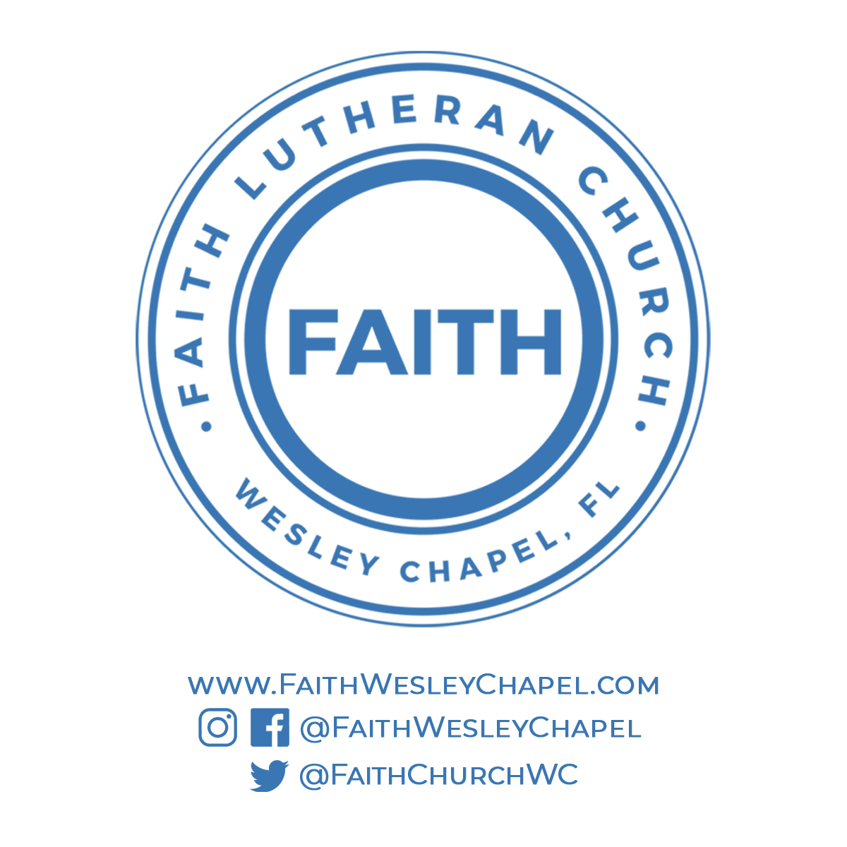**Faith YouTube**

**@FaithWesleyChapel**

**@FaithWesleyChapel**

**@FaithChurchWC**