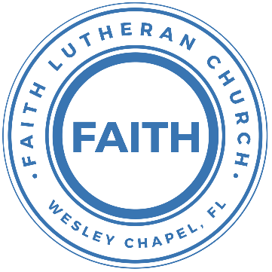

**Leading our community into a deep connection in Christ**

**Worship Service for October 24, 2021 at 11 AM**

**Welcome**

**Invocation**

**Confession and Forgiveness:**

P: Come into the presence of the Lord our God.

C: Have mercy, O Lord. If you, Lord, kept a record of sins, Lord, who could stand; but if we confess our sins, he is faithful and just to forgive us our sins and to cleanse us from all unrighteousness.

*(a time of silence to reflect and personally confess our sins)*

P: I said, "I will confess my transgressions to the LORD." And you forgave the guilt of my sin. Let us confess our sin before the Lord. Let us confess together.

C: Heavenly Father, we confess that we are sinners.  We have sinned against you and our neighbors. We have not loved you with our whole heart and we have not loved our neighbors as ourselves. We justly deserve Your punishment.  For the sake of Your Son, Jesus Christ, have mercy on us.  Forgive us, renew us, and lead us, so that we may delight in Your will and walk in Your ways to the glory of Your holy name.  Amen.

P: The Lord is gracious and merciful. He promises to forgive our sins. Therefore, upon this, your confession, as a called and ordained servant of the Lord, in the stead and by the command of my Lord, Jesus Christ, I forgive you all your sins in the name of the Father and of the Son and of the Holy Spirit.

C: Amen.

**Song of Praise and Thanksgiving - 10,000 Reasons (Bless The Lord)**

Bless the Lord, O my soul, O my soul,  
Worship His holy name.  
Sing like never before, O my soul.  
I'll worship Your holy name.

The sun comes up, it's a new day dawning;  
It's time to sing Your song again.  
Whatever may pass, and whatever lies before me,  
Let me be singing when the evening comes.

Chorus

You're rich in love, and You're slow to anger.  
Your name is great, and Your heart is kind.  
For all Your goodness, I will keep on singing;  
Ten thousand reasons for my heart to find.

Chorus

And on that day when my strength is failing,  
The end draws near, and my time has come;  
Still my soul will sing Your praise unending:  
Ten thousand years and then forevermore!   
Forevermore

Chorus

I'll worship Your holy name.   
Yes, I'll worship Your holy name.

**Baptism –**Peyton Lee Forster

**The Lord's Prayer**

Our Father who art in heaven, hallowed be Thy name, Thy kingdom come, Thy will be done on earth as it is in heaven.  Give us this day our daily bread; and forgive us our trespasses as we forgive those who trespass against us; and lead us not into temptation, but deliver us from evil.  For Thine is the kingdom and the power and the glory forever and ever.  Amen

**Old Testament - Psalm 103:1-19**

Bless the Lord, O my soul, and all that is within me,  
 bless his holy name!  
Bless the Lord, O my soul, and forget not all his benefits,  
who forgives all your iniquity, who heals all your diseases,  
who redeems your life from the pit,  
 who crowns you with steadfast love and mercy,  
who satisfies you with good  
 so that your youth is renewed like the eagle's.

The Lord works righteousness  
 and justice for all who are oppressed.  
He made known his ways to Moses,  
 his acts to the people of Israel.  
The Lord is merciful and gracious,  
 slow to anger and abounding in steadfast love.  
He will not always chide, nor will he keep his anger forever.  
He does not deal with us according to our sins,  
 nor repay us according to our iniquities.  
For as high as the heavens are above the earth,  
 so great is his steadfast love toward those who fear him;  
as far as the east is from the west,  
 so far does he remove our transgressions from us.  
As a father shows compassion to his children,  
 so the Lord shows compassion to those who fear him.  
For he knows our frame; he remembers that we are dust.

As for man, his days are like grass;  
 he flourishes like a flower of the field;  
for the wind passes over it, and it is gone,  
 and its place knows it no more.  
But the steadfast love of the Lord is from everlasting to everlasting on those who fear him,  
 and his righteousness to children's children,  
to those who keep his covenant  
 and remember to do his commandments.  
The Lord has established his throne in the heavens,  
 and his kingdom rules over all.

Reader: This is the Word of the Lord.  
C: Thanks be to God.

**Epistle Reading - 1 Timothy 6:17-19**

As for the rich in this present age, charge them not to be haughty, nor to set their hopes on the uncertainty of riches, but on God, who richly provides us with everything to enjoy. They are to do good, to be rich in good works, to be generous and ready to share, thus storing up treasure for themselves as a good foundation for the future, so that they may take hold of that which is truly life.

Reader: This is the Word of the Lord.  
C: Thanks be to God.

**Children's Message**

**Sermon Hymn - How Great Thou Art**

O Lord my God when I in awesome wonder,  
Consider all the works thy hand has made  
I see the stars, I hear the rolling thunder,   
Your power throughout the universe displayed

Chorus:  
Then sings my soul, my savior God to thee,   
How great thou art, how great thou art  
Then sings my soul, my savior God to thee,   
How great thou art, how great thou art

**Sermon -** Deeper Life: Living Below the Surface

Luke 16:19-31

“There was a rich man who was clothed in purple and fine linen and who feasted sumptuously every day. And at his gate was laid a poor man named Lazarus, covered with sores, who desired to be fed with what fell from the rich man's table. Moreover, even the dogs came and licked his sores. The poor man died and was carried by the angels to Abraham's side. The rich man also died and was buried, and in Hades, being in torment, he lifted up his eyes and saw Abraham far off and Lazarus at his side. And he called out, ‘Father Abraham, have mercy on me, and send Lazarus to dip the end of his finger in water and cool my tongue, for I am in anguish in this flame.’ But Abraham said, ‘Child, remember that you in your lifetime received your good things, and Lazarus in like manner bad things; but now he is comforted here, and you are in anguish. And besides all this, between us and you a great chasm has been fixed, in order that those who would pass from here to you may not be able, and none may cross from there to us.’ And he said, ‘Then I beg you, father, to send him to my father's house—for I have five brothers—so that he may warn them, lest they also come into this place of torment.’ But Abraham said, ‘They have Moses and the Prophets; let them hear them.’ And he said, ‘No, father Abraham, but if someone goes to them from the dead, they will repent.’ He said to him, ‘If they do not hear Moses and the Prophets, neither will they be convinced if someone should rise from the dead.’”

P: This is the Gospel of the Lord.  
C: Praise be to You, o Christ.

**Welcoming of New Members***‬*

**Prayers:** *Text in prayer requests to (813) 602-1104‬*

**Words of Institution**

**Peace**

P: The peace of the Lord be with you all.  
C: And also, with you.  
P: We greet each other in the peace of Christ.

**Distribution**

**Prayer**

**Closing Song - The Blessing**

The Lord bless you and keep you  
Make His face shine upon you and be gracious to you  
The Lord turn His face toward you And give you peace

Chorus:  
Amen. Amen. Amen.

(Repeat)

Verse

Chorus

Bridge:  
May His favor be upon you And a thousand generations  
And your family and your children  
And their children and their children

(Repeat)

Bridge 2:   
May His presence go before you and behind you and beside you  
All around you and within you. He is with you. He is with you  
In the morning, in the evening. In your coming and your going  
In your weeping and rejoicing, He is with you. He is with you  
He is for you. He is for you. He is for you. He is for you.  
He is for you He is for you

Chorus

Bridge 2

**Offering**

**Sermon Notes:**

**_______________________________________________**

**_______________________________________________**

**_______________________________________________**

**_______________________________________________**

**_______________________________________________**

**_______________________________________________**

**_______________________________________________**

**_______________________________________________**

**_______________________________________________**

**_______________________________________________**

**_______________________________________________**

**_______________________________________________**

**_______________________________________________**

**_______________________________________________**

**_______________________________________________**

**_______________________________________________**

**_______________________________________________**

**_______________________________________________**

**_______________________________________________**

**_______________________________________________**

**_______________________________________________**

**_______________________________________________**

**_______________________________________________**

**Upcoming Events**

**Today, After the Service – Budget Voter Meeting**  
Song and Dance

**Today, 4PM – Confirmation Class**  
The Shuck’s House

**November 7, 5PM Flame Concert**  
Family of Christ - $10

**November 14, After the Service - Youth Bible Study**  
Song and Dance

**December 18, 6PM Christmas in the Park**  
Wesley Chapel District Park

**Other Announcements**

**Faith Choir**

We will be starting up a choir of sorts. Because we are small and many people drive quite a distance to church, we will hold choir practice for 20 minutes immediately following the worship service each week. We are looking to add choir music to special Sundays.

**Sound Techs and Altar Guild Volunteers Needed**

We are looking for people willing to volunteer to help with the sound on Sundays as well as those willing to help set up the altar and Communion each week before the service. If you would be willing to help out, please contact Pastor Kurt or Terrell.

**www.FaithWesleyChapel.com**

**Faith YouTube**

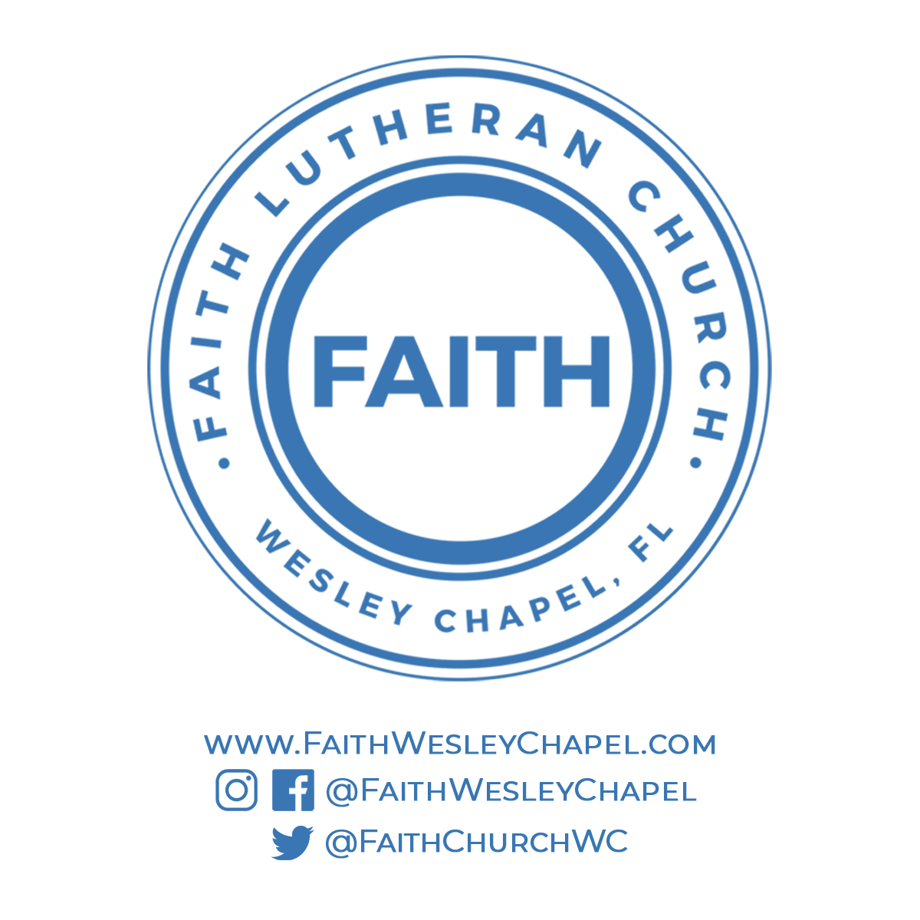**@FaithWesleyChapel**

**@FaithWesleyChapel**

**@FaithChurchWC**