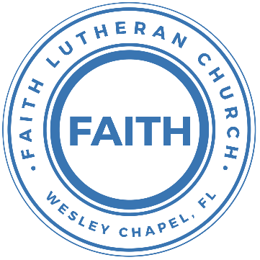

**Leading our community into a deep connection in Christ**

**Worship Service for October 31, 2021 at 11 AM**

**Welcome**

P: The grace of our Lord Jesus Christ, the love of God, and the fellowship of the Holy Spirit be with you all!

C: And also with you!

P: Let us pray together: O God, you are our refuge and our strength

C: A very present help in times of trouble, therefore we will not fear.

P: O God, you made an everlasting covenant with us.

C: Help us to be your people in this world of trial and trouble.

P: O God, too often we have sinned and have fallen short of your glory.

C: Search us, O God, and know our hearts; test us and know our thoughts. See if there is any wicked way in us, and lead us in the way everlasting.

P: O God, our mighty fortress, we have embraced the freedom you offer us.

C: We embrace the Son who makes us free.

**Opening Song:**A Mighty Fortress Is Our God

A mighty fortress is our God, a bulwark never failing;  
our helper he, amid the flood of mortal ills prevailing.  
For still our ancient foe does seek to work us woe;  
his craft and power are great, and armed with cruel hate,  
on earth is not his equal.

Did we in our own strength confide,   
our striving would be losing,  
were not the right Man on our side,   
the Man of God's own choosing.

You ask who that may be? Christ Jesus, it is he;  
Lord Sabaoth his name, from age to age the same;  
and he must win the battle.

And though this world, with devils filled,   
should threaten to undo us, we will not fear,   
for God has willed his truth to triumph through us.  
The prince of darkness grim, we tremble not for him;  
his rage we can endure, for lo! his doom is sure;  
one little word shall fell him.

That Word above all earthly powers no thanks to them abideth;  
the Spirit and the gifts are ours through him who with us sideth.  
Let goods and kindred go, this mortal life also;  
the body they may kill: God's truth abideth still;  
his kingdom is forever!

**Invocation**

**Confession and Forgiveness:**

P: Search us, O God, and know our hearts; test us and know our thoughts. See if there is any wicked way in us, and lead us in the way everlasting.

(a time of silence to reflect and personally confess our sins)

C: Heavenly Father, we confess that we have sinned against you in thought, word, and deed. We have not loved you with our whole heart and have not loved our neighbor as ourselves. We are truly sorry and we humbly repent. For the sake of your Son Jesus Christ and His suffering and death on the cross, have mercy on us and forgive us; that we may delight in your will, and walk in your ways, to the glory of your Name. Amen

P: The Lord our God is merciful and gracious, longsuffering, and abounding in goodness and truth, keeping mercy for thousands, forgiving iniquity and transgression and sin. Therefore I announce unto you the grace of our Lord Jesus Christ. In His stead and by the command of my Lord Jesus Christ, I forgive you all your sins in the name of the Father and of the Son and of the Holy Spirit.

C: Amen.

**Song of Praise and Thanksgiving -** Amazing Grace

Amazing grace,   
how sweet the sound that saved a wretch like me  
I once was lost, but now am found.   
Was blind but now I see.

T'was grace that taught my heart to fear,   
and grace my fears relieved.  
How precious did that grace appear,   
the hour I first believed.

Through many dangers, toils and snares,   
we have already come,   
T'was grace hath brought us safe thus far   
and grace will lead us home

When we've been there ten thousand years,   
bright shining as the sun  
we've no less days to sing God’s praise,  
than when we've first begun

**First Reading - Revelation 14:6-7**

Then I saw another angel flying directly overhead, with an eternal gospel to proclaim to those who dwell on earth, to every nation and tribe and language and people. And he said with a loud voice, “Fear God and give him glory, because the hour of his judgment has come, and worship him who made heaven and earth, the sea and the springs of water.”

Reader: This is the Word of the Lord.  
C: Thanks be to God.

**Gospel Reading - John 8:31–36**

So Jesus said to the Jews who had believed him, “If you abide in my word, you are truly my disciples, and you will know the truth, and the truth will set you free.” They answered him, “We are offspring of Abraham and have never been enslaved to anyone. How is it that you say, ‘You will become free’?”

Jesus answered them, “Truly, truly, I say to you, everyone who practices sin is a slave to sin. The slave does not remain in the house forever; the son remains forever. So if the Son sets you free, you will be free indeed.

P: This is the Gospel of the Lord.  
C: Praise be to You, o Christ.

**Children's Message** *(Children dismissed to Children's Church)*

**Sermon Hymn -** The Church's One Foundation

The church's one foundation is Jesus Christ, her Lord;  
she is his new creation by water and the Word:  
from heav'n he came and sought her to be his holy bride;  
with his own blood he bought her, and for her life he died.

Elect from ev’ry nation, yet one o'er all the earth,  
her charter of salvation one Lord, one faith, one birth;  
one holy name she blesses, partakes one holy food,  
and to one hope she presses, with ev'ry grace endued.

Yet she on earth hath union with God the Three in One,  
and mystic sweet communion with those whose rest is won:  
O blessed heav'nly chorus! Lord, save us by Your grace,  
that we, like saints before us, may see You face to face.

**Sermon -** "Reclaiming the Gospel"

Sermon Text - Romans 3:19-28

Now we know that whatever the law says it speaks to those who are under the law, so that every mouth may be stopped, and the whole world may be held accountable to God. For by works of the law no human being will be justified in his sight, since through the law comes knowledge of sin.

But now the righteousness of God has been manifested apart from the law, although the Law and the Prophets bear witness to it — the righteousness of God through faith in Jesus Christ for all who believe. For there is no distinction: for all have sinned and fall short of the glory of God, and are justified by his grace as a gift, through the redemption that is in Christ Jesus, whom God put forward as a propitiation by his blood, to be received by faith. This was to show God's righteousness, because in his divine forbearance he had passed over former sins. It was to show his righteousness at the present time, so that he might be just and the justifier of the one who has faith in Jesus.

Then what becomes of our boasting? It is excluded. By what kind of law? By a law of works? No, but by the law of faith. For we hold that one is justified by faith apart from works of the law.

Reader: This is the Word of the Lord.  
C: Thanks be to God.

**Offering**

**Prayers:** *Text in prayer requests to (813) 602-1104‬*

**Nicene Creed**

I believe in one God, the Father Almighty, maker of heaven and earth and of all things visible and invisible.

And in one Lord Jesus Christ, the only-begotten Son of God, begotten of His Father before all worlds, God of God, Light of Light, very God of very God, begotten, not made, being of one substance with the Father, by whom all things were made; who for us men and for our salvation came down from heaven and was incarnate by the Holy Spirit of the virgin Mary and was made man; and was crucified also for us under Pontius Pilate. He suffered and was buried. And the third day He rose again according to the Scriptures and ascended into heaven and sits at the right hand of the Father. And He will come again with glory to judge both the living and the dead, whose kingdom will have no end.

And I believe in the Holy Spirit, the Lord and Giver of Life, who proceeds from the Father and the Son, who with the Father and the Son together is worshiped and glorified, who spoke by the prophets. And I believe in one holy Christian and apostolic Church, I acknowledge one Baptism for the remission of sins, and I look for the resurrection of the dead and the life of the world to come. Amen.

**The Lord's Prayer**

Our Father who art in heaven, hallowed be Thy name, Thy kingdom come, Thy will be done on earth as it is in heaven.  Give us this day our daily bread; and forgive us our trespasses as we forgive those who trespass against us; and lead us not into temptation, but deliver us from evil.  For Thine is the kingdom and the power and the glory forever and ever.  Amen

**Words of Institution**

**Peace**

P: The peace of the Lord be with you all.  
C: And also, with you.  
P: We greet each other in the peace of Christ.

**Distribution**

**Prayer**

**Benediction**

**Closing Song -**Your Grace Is Enough

Great is Your faithfulness oh God.  
You wrestle with the sinner's restless heart  
You lead us by still waters into mercy,  
And nothing can keep us apart

Pre-chorus:  
So remember Your people. Remember Your children  
Remember Your promise, Oh God

Chorus:  
Your grace is enough. Your grace is enough  
Your grace is enough for me

Great is Your love and justice God of Jacob.  
You use the weak to lead the strong  
You lead us in the song of Your salvation  
And all Your people sing along

Pre-chorus

Chorus 2x

**Offering**

**Upcoming Events**

**November 7, 3pm Confirmation**  
The Frost’s

**November 7, 5pm Flame Concert**  
Family of Christ - $10

**November 14, After the Service - Youth Bible Study**  
Song and Dance

**December 18, 6pm Christmas in the Park**  
Wesley Chapel District Park

**Other Announcements**

**Faith Choir**

We will be starting up a choir of sorts. Because we are small and many people drive quite a distance to church, we will hold choir practice for 20 minutes immediately following the worship service each week. We are looking to add choir music to special Sundays.

**Sound Techs and Altar Guild Volunteers Needed**

We are looking for people willing to volunteer to help with the sound on Sundays as well as those willing to help set up the altar and Communion each week before the service. If you would be willing to help out, please contact Pastor Kurt or Terrell.

[**www.FaithWesleyChapel.com**](http://www.FaithWesleyChapel.com)

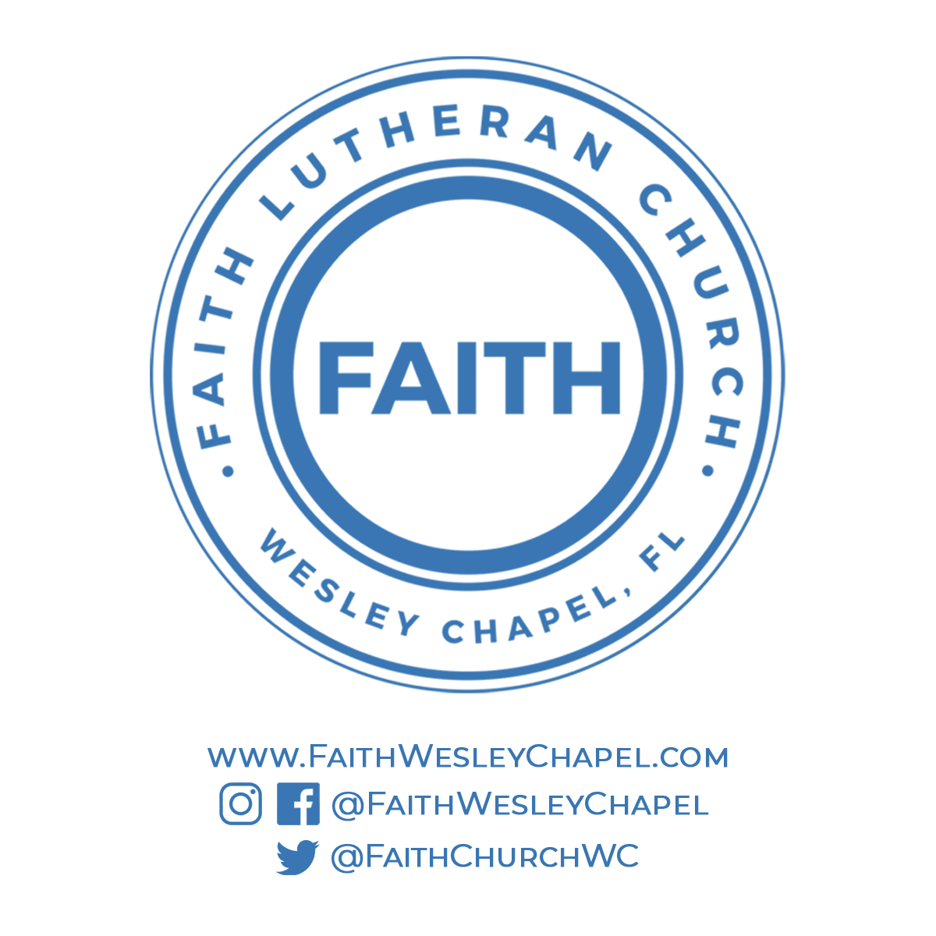**Faith YouTube**

**@FaithWesleyChapel**

**@FaithWesleyChapel**

**@FaithChurchWC**