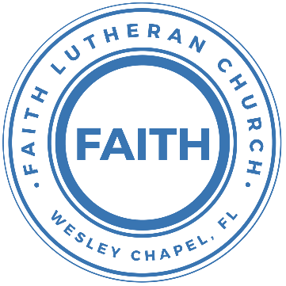

**Leading our community into a deep connection in Christ**

**Worship Service for November 14, 2021 at 11 AM**

**Welcome**

**Invocation**

**Responsive Psalm – Psalm 136**

All: Give thanks to the Lord, for he is good, for his steadfast love endures forever.  
P: Give thanks to the God of gods, for his steadfast love endures forever.  
C: Give thanks to the Lord of lords, for his steadfast love endures forever;  
P: To him who alone does great wonders, for his steadfast love endures forever;  
C: It is he who remembered us in our low estate, for his steadfast love endures forever;  
P: And rescued us from our foes, for his steadfast love endures forever;  
C: He who gives food to all flesh, for his steadfast love endures forever.  
All: Give thanks to the God of heaven, for his steadfast love endures forever.

**Confession and Forgiveness**

P: As we gather, today, let us cleanse our hearts and our consciences by confessing our sin to God.

(Time of silence for reflection and confession)

C: Heavenly Father, we confess that we are sinful and unclean. We have sinned against you and against our neighbor in our thoughts, words, and actions.  We are truly sorry for our sins and sincerely repent of them. We ask for Your mercy. For the sake of Jesus Christ's bitter suffering and death, please forgive us and renew us that we may walk in Your Spirit to the glory of Your holy name.

P: The Lord has heard your confession. Therefore, as a called and ordained servant of the Lord, in the stead and by the command of my Lord, Jesus Christ, I forgive you all your sins in the name of the Father and of the Son and of the Holy Spirit.

C: Amen

**Songs of Praise and Thanksgiving - Love Divine All Loves Excelling**

Love divine, all loves excelling, Joy of heav'n, to earth come down!  
Fix in us Thy humble dwelling, All Thy faithful mercies crown.  
Jesus, Thou art all compassion, Pure, unbounded love Thou art;  
Visit us with Thy salvation, Enter ev'ry trembling heart.

Breathe, O breathe Thy loving Spirit Into ev'ry troubled breast;  
Let us all in Thee inherit; Let us find Thy promised rest.  
Take away the love of sinning; Alpha and Omega be;  
End of faith, as its beginning, Set our hearts at liberty.

Finish then Thy new creation, Pure and spotless let us be;  
Let us see Thy great salvation Perfectly restored in Thee,  
Changed from glory into glory, Till in heav'n we take our place,  
Till we cast our crowns before Thee, Lost in wonder, love, and praise!

**Epistle Reading - 1 John 4:7-19**

Beloved, let us love one another, for love is from God, and whoever loves has been born of God and knows God. Anyone who does not love does not know God, because God is love. In this the love of God was made manifest among us, that God sent his only Son into the world, so that we might live through him. In this is love, not that we have loved God but that he loved us and sent his Son to be the propitiation for our sins. Beloved, if God so loved us, we also ought to love one another. No one has ever seen God; if we love one another, God abides in us and his love is perfected in us.

By this we know that we abide in him and he in us, because he has given us of his Spirit. And we have seen and testify that the Father has sent his Son to be the Savior of the world. Whoever confesses that Jesus is the Son of God, God abides in him, and he in God. So we have come to know and to believe the love that God has for us. God is love, and whoever abides in love abides in God, and God abides in him. By this is love perfected with us, so that we may have confidence for the day of judgment, because as he is so also are we in this world. There is no fear in love, but perfect love casts out fear. For fear has to do with punishment, and whoever fears has not been perfected in love. We love because he first loved us.

Reader: This is the Word of the Lord.  
C: Thanks be to God.

**Gospel Reading - John 15:9-14**

As the Father has loved me, so have I loved you. Abide in my love. If you keep my commandments, you will abide in my love, just as I have kept my Father's commandments and abide in his love. These things I have spoken to you, that my joy may be in you, and that your joy may be full.

“This is my commandment, that you love one another as I have loved you. Greater love has no one than this, that someone lay down his life for his friends. You are my friends if you do what I command you.

P: This is the Gospel of the Lord.  
C: Praise be to You, o Christ.

**Sermon Song** **-** **They'll Know We Are Christians By Our Love**

We are one in the Spirit, we are one in the Lord;  
We are one in the Spirit, we are one in the Lord;  
And we pray that all unity will one day be restored.

Chorus:  
And they'll know we are Christians by our love, by our love,  
yes, they'll know we are Christians by our love.

We will walk with each other, we will walk hand in hand;  
We will walk with each other, we will walk hand in hand;  
And together we'll spread the news that God is in our land.

Chorus

We Will work with each other, we will work side by side;  
We will work with each other, we will work side by side;  
And we'll guard each one's dignity and save each other's pride.

Chorus

**Sermon - "Thank You, Lord, For Love"**

**Prayers**

**Apostles' Creed**

I believe in God, the Father almighty, maker of heaven and earth,  
And in Jesus Christ, his only Son, our Lord,  
who was conceived by the Holy Spirit,  
born of the Virgin Mary, suffered under Pontius Pilate,  
was crucified, died and was buried. He descended into hell.  
The third day he rose again from the dead.  
He ascended into heaven and sits at the right hand of God  
the Father almighty.  
From there he will come to judge the living and the dead.  
I believe in the Holy Spirit, the holy Christian Church,  
the communion of saints, the forgiveness of sins,  
the resurrection of the body, and the life everlasting. Amen.

**The Lord's Prayer**

Our Father who art in heaven, hallowed be Thy name, Thy kingdom come, Thy will be done on earth as it is in heaven.  Give us this day our daily bread; and forgive us our trespasses as we forgive those who trespass against us; and lead us not into temptation, but deliver us from evil.  For Thine is the kingdom and the power and the glory forever and ever.  Amen

**Benediction**

**Closing Song: God So Loved**

Come all you weary, come all you thirsty  
Come to the well that never runs dry  
Drink of the water, come and thirst no more

Come all you sinners, come find His mercy  
Come to the table, He will satisfy  
Taste of His goodness, find what you’re looking for

Chorus 1:  
For God so loved the world that He gave us His  
One and only Son to save us  
Whoever believes in Him will live forever

Oooo, Ooooo, Ooooo

Bring all your failures, bring your addictions  
Come lay them down at the foot of the cross  
Jesus is waiting There with open arms

Chorus

Chorus 2:  
The power of Hell forever defeated   
Now it is well, I’m Walking in freedom  
For God so loved, God so loved the world

**Offering**

**Sermon Notes:**

**_______________________________________________**

**_______________________________________________**

**_______________________________________________**

**_______________________________________________**

**_______________________________________________**

**_______________________________________________**

**_______________________________________________**

**_______________________________________________**

**_______________________________________________**

**_______________________________________________**

**_______________________________________________**

**_______________________________________________**

**_______________________________________________**

**_______________________________________________**

**_______________________________________________**

**_______________________________________________**

**_______________________________________________**

**_______________________________________________**

**_______________________________________________**

**_______________________________________________**

**_______________________________________________**

**_______________________________________________**

**_______________________________________________**

**Upcoming Events**

**Today, After the Service - Youth Bible Study**  
Song and Dance

**November 15, 7pm – Church Council Meeting**  
Zoom

**November 28, 1:30pm-3:45pm – Ice Skating**  
Advent Health Center Ice  
$20/person (includes skate rental)

**December 5, 4pm Confirmation**  
The Steinbrueck’s

**December 12, 5-8pm – Open House Social**  
The Chmiel’s - 29708 Weybridge Way, Wesley Chapel, FL 33545  
Gate Code: #8419 Home Phone: 813-994-1983

**www.FaithWesleyChapel.com**

**Faith YouTube**

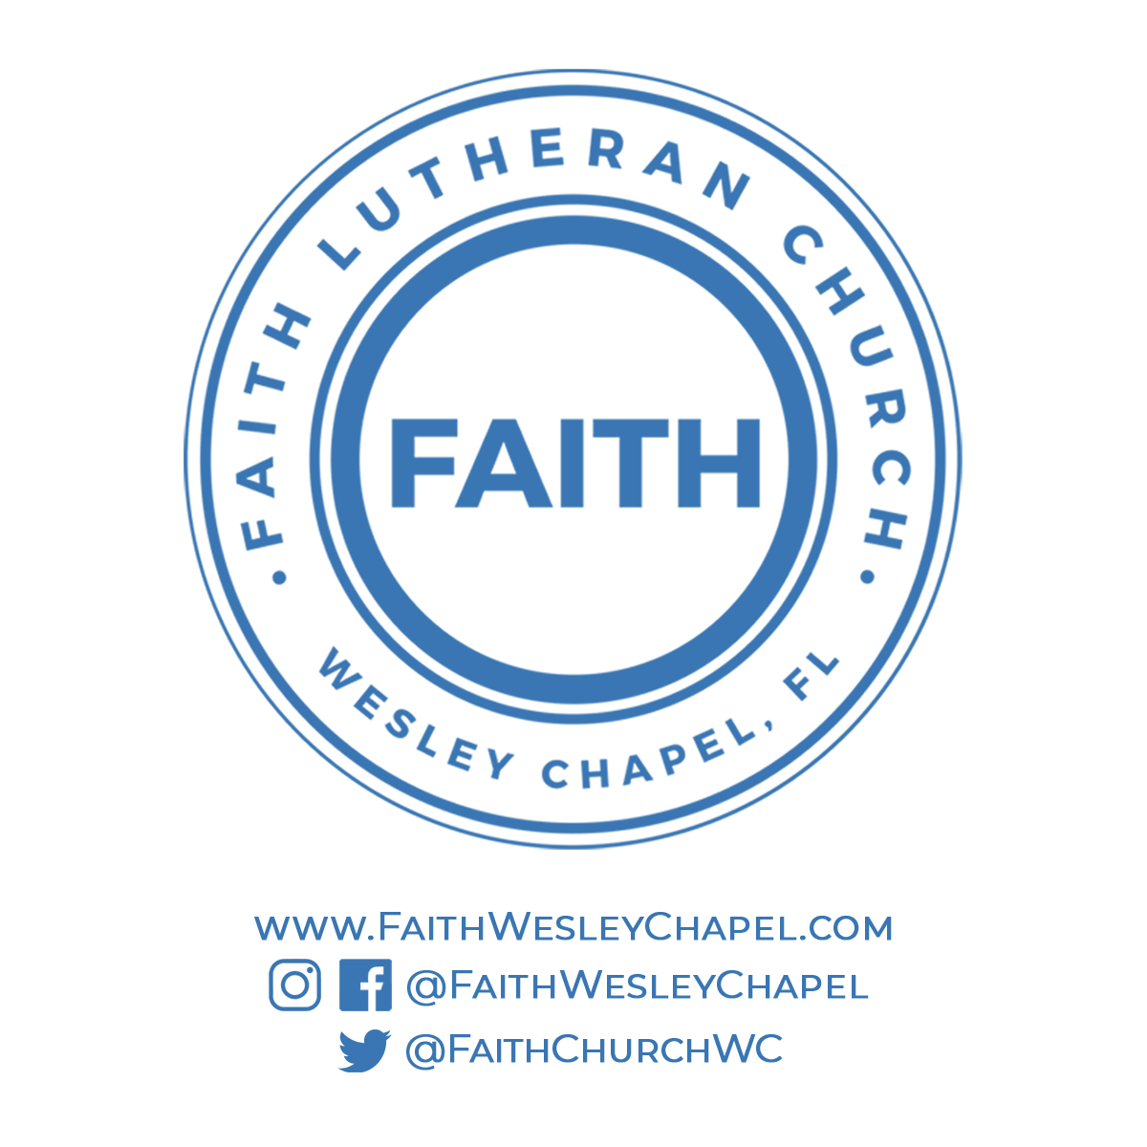**@FaithWesleyChapel**

**@FaithWesleyChapel**

**@FaithChurchWC**