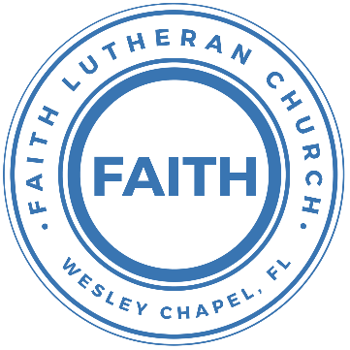

**Leading our community into a deep connection in Christ**

**Worship Service for November 21, 2021 at 11 AM**

**Welcome**

**Opening Song - Goodness of God**

I love you, Lord, for your mercy never fails me.  
All my days, I’ve been held in your hands  
From the moment that I wake up, Till I lay my head  
I will sing of the goodness of God

Chorus:  
All my life you have been faithful.   
All my life you have been so, so good  
With every breath that I am able  
I will sing of the goodness of God

I love your voice. You have led me through the fire  
In darkest night you are close like no other.  
I’ve known you as a father. I’ve known you as a friend  
I have lived in the goodness of God

Chorus

Your goodness is running after, it’s running after me  
Your goodness is running after, it’s running after me  
With my life laid down, I’m surrendered now I give you everything  
Your goodness is running after, it’s running after me

Repeat

With my life laid down, I’m surrendered now I give you everything  
Your goodness is running after, it’s running after me

Repeat

Chorus

**Invocation**

**Responsive Psalm - Psalm 118**

All: Oh give thanks to the Lord, for He is good; for His steadfast love endures forever!  
P: Out of my distress I called on the Lord;  
C: The Lord answered me and set me free.  
P: The Lord is on my side; I will not fear.  
C: What can man do to me?  
P: The Lord is on my side as my helper;  
C: I shall look in triumph on those who hate me.  
P: It is better to take refuge in the Lord than to trust in man.  
C: It is better to take refuge in the Lord than to trust in princes.  
P: You are my God, and I will give thanks to You;  
C: You are my God; I will extol You.  
All: Oh give thanks to the Lord, for He is good; for His steadfast love endures forever!

**Confession and Forgiveness:**

**P:** Our Heavenly Father asks us to come into His presence.  
**C:** But we are sinful and unworthy.

**P:** Yes, all have sinned and fall short of the glory of God, but Jesus Christ died on the cross that we may be forgiven and washed clean of all our sins by His blood spilled on the cross.

**C:** Lord, if You wash us, we will certainly be clean and pure.

**P:** We take a moment to bow before the His cross and silently reflect on our lives and confess our sins.

(Time of silence for reflection and confession)

**P:** Let us confess, together, our sins to God our Father.

**C:** Heavenly Father, we confess that we are sinners.  We have sinned against you and our neighbors. We have not loved you with our whole heart and we have not loved our neighbors as ourselves. We have not lived out our faith out in our community. We justly deserve Your punishment.  For the sake of Your Son, Jesus Christ, have mercy on us.  Forgive us, renew us, and lead us, so that we may delight in Your will and walk in Your ways to the glory of Your holy name.  Amen.

**P:** Almighty God in His mercy has given His Son to die for you and for His sake forgives you all your sins.  As a called and ordained servant of Christ, and by His authority, I, therefore, forgive you all your sins in the name of the Father and of the Son and of the Holy Spirit.

**C:** Amen

**Song of Praise and Thanksgiving: No Longer Slaves**

You unravel me, with a melody You surround me with a song  
Of deliverance, from my enemies till all my fears are gone

Chorus:  
I’m no longer a slave to fear. I am a child of God  
I’m no longer a slave to fear. I am a child of God

From my mother’s womb You have chosen me.   
Love has called my name   
I’ve been born again, into your family  
Your blood flows through my veins

Chorus

Ohhh, Ohhh...

Repeat

Bridge:  
You split the sea so I could walk right through it  
My fears are drowned in perfect love  
You rescued me and I will stand and sing.  
I am a child of God

Repeat

I am a child of God . . .

Chorus:  
I’m no longer a slave to fear. I am a child of God  
I’m no longer a slave to fear. I am a child of God

**Epistle Reading - 2 Corinthians 3:12-18**

Since we have such a hope, we are very bold, not like Moses, who would put a veil over his face so that the Israelites might not gaze at the outcome of what was being brought to an end. But their minds were hardened. For to this day, when they read the old covenant, that same veil remains unlifted, because only through Christ is it taken away. Yes, to this day whenever Moses is read a veil lies over their hearts. But when one turns to the Lord, the veil is removed. Now the Lord is the Spirit, and where the Spirit of the Lord is, there is freedom. And we all, with unveiled face, beholding the glory of the Lord, are being transformed into the same image from one degree of glory to another. For this comes from the Lord who is the Spirit.

Reader: This is the Word of the Lord.  
C: Thanks be to God.

**Gospel Reading - Luke 4:16-21**

And he came to Nazareth, where he had been brought up. And as was his custom, he went to the synagogue on the Sabbath day, and he stood up to read. And the scroll of the prophet Isaiah was given to him. He unrolled the scroll and found the place where it was written,

“The Spirit of the Lord is upon me,  
 because he has anointed me  
 to proclaim good news to the poor.

He has sent me to proclaim liberty to the captives  
 and recovering of sight to the blind,  
 to set at liberty those who are oppressed,  
to proclaim the year of the Lord's favor.”

And he rolled up the scroll and gave it back to the attendant and sat down. And the eyes of all in the synagogue were fixed on him. And he began to say to them, “Today this Scripture has been fulfilled in your hearing.”

P: This is the Gospel of the Lord.  
C: Praise be to You, o Christ.

**Children's Message** *(Children dismissed to Children's Church)*

**Songs - I’m Free**

I’m free! (echo)  
I’m free! (echo)  
I’m free to be a servant of the Lord  
Repeat

Chorus:  
He taught me how to praise Him,   
He taught me how to sing His song.  
He taught me how to L…O…V…E!  
I’m free to be a servant of the Lord.

**I Surrender All**

All to Jesus I surrender. All to Him I freely give  
I will ever love and trust Him. In His presence daily live

Chorus:  
I surrender all. I surrender all  
All to Thee my blessed Savior.  
I surrender all

All to Jesus I surrender, Humbly at His feet I bow  
Worldly pleasures all forsaken,   
Take me, Jesus, take me now

Chorus

All to Jesus I surrender. Lord, I give myself to Thee  
Fill me with Thy love and power. Let Thy blessing fall on me

Chorus 2x

**Sermon - "Thank You, Lord, For Liberty"**

**Prayers:** *Text in prayer requests to (813) 602-1104‬*

**Nicene Creed**

I believe in one God, the Father Almighty, maker of heaven and earth and of all things visible and invisible.

And in one Lord Jesus Christ, the only-begotten Son of God, begotten of His Father before all worlds, God of God, Light of Light, very God of very God, begotten, not made, being of one substance with the Father, by whom all things were made; who for us men and for our salvation came down from heaven and was incarnate by the Holy Spirit of the virgin Mary and was made man; and was crucified also for us under Pontius Pilate. He suffered and was buried. And the third day He rose again according to the Scriptures and ascended into heaven and sits at the right hand of the Father. And He will come again with glory to judge both the living and the dead, whose kingdom will have no end.

And I believe in the Holy Spirit, the Lord and Giver of Life, who proceeds from the Father and the Son, who with the Father and the Son together is worshiped and glorified, who spoke by the prophets. And I believe in one holy Christian and apostolic Church, I acknowledge one Baptism for the remission of sins, and I look for the resurrection of the dead and the life of the world to come. Amen.

**The Lord's Prayer**

Our Father who art in heaven, hallowed be Thy name, Thy kingdom come, Thy will be done on earth as it is in heaven.  Give us this day our daily bread; and forgive us our trespasses as we forgive those who trespass against us; and lead us not into temptation, but deliver us from evil.  For Thine is the kingdom and the power and the glory forever and ever.  Amen

**Words of Institution**

**Peace**

P: The peace of the Lord be with you all.  
C: And also, with you.  
P: We greet each other in the peace of Christ.

**Distribution**

**Prayer**

**Benediction**

**Closing Song - All Glory Laud and Honor**

Refrain:  
All glory, laud, and honor To You, Redeemer, King,  
To whom the lips of children Made sweet hosannas ring.

You are the King of Israel and David’s royal Son,  
Now in the Lord’s Name coming, Our King and Blessed One.

Refrain

The multitude of pilgrims with palms before You went:  
Our praise and prayers and anthems before You we present.

Refrain:  
All glory, laud, and honor To You, Redeemer, King,  
To whom the lips of children made sweet hosannas ring.

To you before Your passion they sang their hymns of praise;  
To You, now high exalted, our melody we raise.

Refrain

**Offering**

**Upcoming Events**

**November 28, 1:30pm-3:45pm – Ice Skating**  
Advent Health Center Ice  
$20/person (includes skate rental)

**December 5, 4pm Confirmation**  
The Steinbrueck’s

**December 12, 5-8pm – Open House Social**  
The Chmiel’s - 29708 Weybridge Way, Wesley Chapel, FL 33545  
Gate Code: #8419 Home Phone: 813-994-1983

**December 18, 5pm Christmas in the Park**  
Wesley Chapel District Park

[**www.FaithWesleyChapel.com**](http://www.FaithWesleyChapel.com)

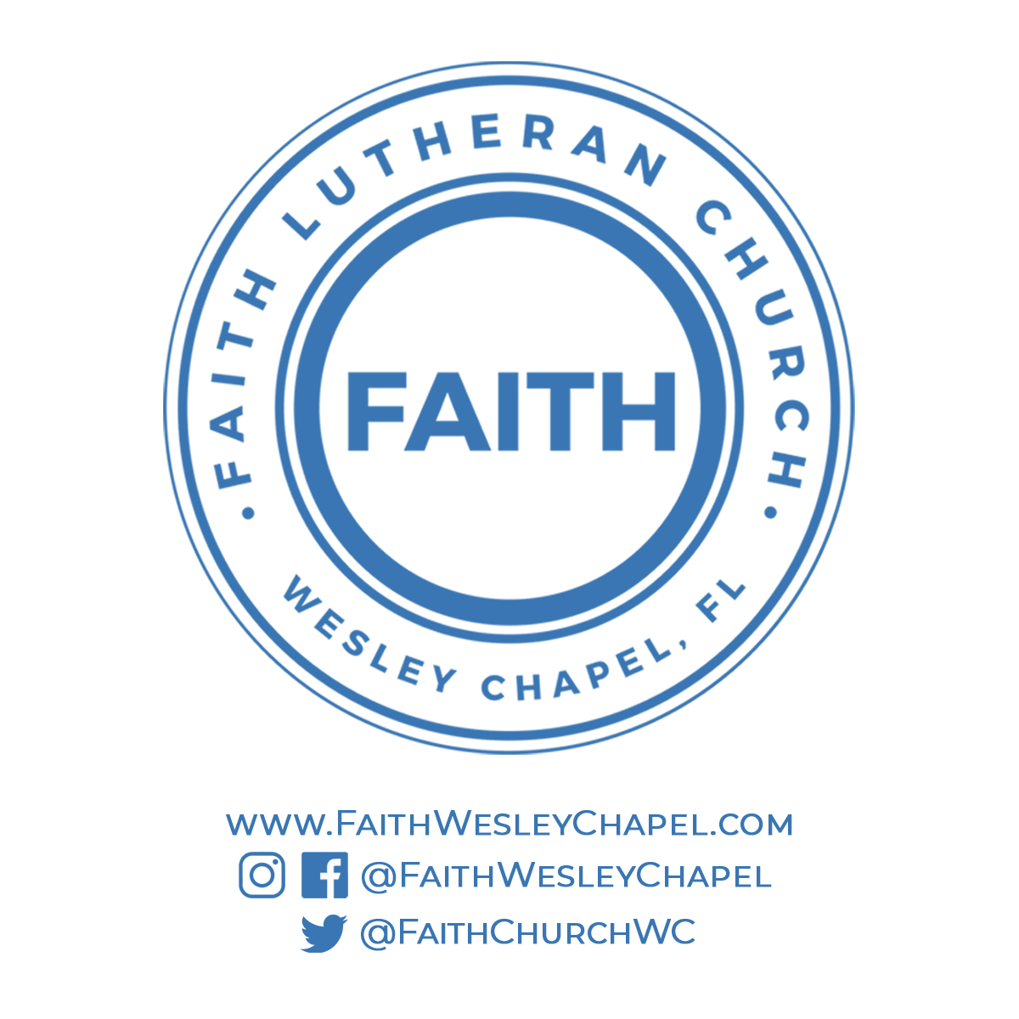**Faith YouTube**

**@FaithWesleyChapel**

**@FaithWesleyChapel**

**@FaithChurchWC**