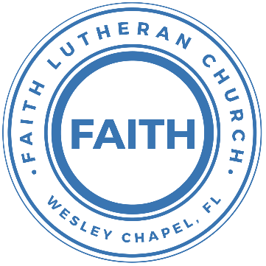

**Leading our community into a deep connection in Christ**

**Worship Service for November 28, 2021 at 11 AM**

**Welcome**

**Opening Song - Come Thou Long Expected Jesus**

Come thou long-expected Jesus, born to set thy people free  
From our fears and sins release us; let us find our rest in thee.  
Israel’s strength and consolation, hope of all the earth thou art,  
Dear desire of ev’ry nation, joy of every longing heart.

Joy to those who long to see thee, dayspring from on high appear;  
Come, thou promised Rod of Jesse, of Thy birth we long to hear!  
O’er the hills the angel’s singing news, glad tidings of a birth  
“Go to him, your praises bringing;   
Christ the Lord has come to Earth.”

Come to earth to taste our sadness,   
He whose glories knew no end;  
by His life He brings us gladness, our Redeemer, Shepherd, Friend.   
Leaving riches without number, born within a cattle stall;  
This the everlasting wonder, Christ was born the Lord of all!

Born thy people to deliver, born a child and yet a king  
born to reign in us forever, now thy gracious kingdom bring.  
By thine own eternal spirit; rule in all our hearts alone  
By thine all sufficient merit, Raise us to thy glorious throne

**Invocation**

**Confession and Forgiveness:**

P: Come into the presence of the Lord our God.

C: Have mercy, O Lord. If you, Lord, kept a record of sins, Lord, who could stand; but if we confess our sins, he is faithful and just to forgive us our sins and to cleanse us from all unrighteousness.

*(a time of silence to reflect and personally confess our sins)*

P: I said, "I will confess my transgressions to the LORD." And you forgave the guilt of my sin. Let us confess our sin before the Lord. Let us confess together.

C: Heavenly Father, we confess that we are sinners.  We have sinned against you and our neighbors. We have not loved you with our whole heart and we have not loved our neighbors as ourselves. We justly deserve Your punishment.  For the sake of Your Son, Jesus Christ, have mercy on us.  Forgive us, renew us, and lead us, so that we may delight in Your will and walk in Your ways to the glory of Your holy name.  Amen.

P: The Lord is gracious and merciful. He promises to forgive our sins. Therefore, upon this, your confession, as a called and ordained servant of the Lord, in the stead and by the command of my Lord, Jesus Christ, I forgive you all your sins in the name of the Father and of the Son and of the Holy Spirit.

C: Amen.

**Song of Praise and Thanksgiving - Sing To The King**

Sing to the King Who is coming to reign  
Glory to Jesus, the Lamb that was slain  
Life and salvation His empire shall bring  
And joy to the nations when Jesus is King

Chorus:  
Come, let us sing a song,   
A song declaring that we belong to Jesus  
He’s all we need  
Lift up a heart of praise.  
Sing now with voices raised to Jesus  
Sing to the King

For His returning we watch and we pray  
We will be ready the dawn of that day  
We'll join in singing with all the redeemed  
'Cause Satan is vanquished and Jesus is King

Chorus 2x

**Old Testament Reading - Jeremiah 23:1–6**

“Woe to the shepherds who destroy and scatter the sheep of my pasture!” declares the Lord. Therefore, thus says the Lord, the God of Israel, concerning the shepherds who care for my people: “You have scattered my flock and have driven them away, and you have not attended to them. Behold, I will attend to you for your evil deeds, declares the Lord. Then I will gather the remnant of my flock out of all the countries where I have driven them, and I will bring them back to their fold, and they shall be fruitful and multiply. I will set shepherds over them who will care for them, and they shall fear no more, nor be dismayed, neither shall any be missing, declares the Lord.

“Behold, the days are coming, declares the Lord, when I will raise up for David a righteous Branch, and he shall reign as king and deal wisely, and shall execute justice and righteousness in the land. In his days Judah will be saved, and Israel will dwell securely. And this is the name by which he will be called: ‘The Lord is our righteousness.’

Reader: This is the Word of the Lord.  
C: Thanks be to God.

**Epistle Reading - Romans 1:1–6**

Paul, a servant of Christ Jesus, called to be an apostle, set apart for the gospel of God, which he promised beforehand through his prophets in the holy Scriptures, concerning his Son, who was descended from David according to the flesh and was declared to be the Son of God in power according to the Spirit of holiness by his resurrection from the dead, Jesus Christ our Lord, through whom we have received grace and apostleship to bring about the obedience of faith for the sake of his name among all the nations, including you who are called to belong to Jesus Christ,

Reader: This is the Word of the Lord.  
C: Thanks be to God.

**Children's Message**

**Sermon Hymn - The Advent of Our King**

The advent of our King, our prayers must now employ;  
And we must hymns of welcome sing in strains of holy joy.

The everlasting Son, incarnate deigns to be;  
Himself a servant's form put on to set His servants free.

O Zion's Daughter rise to meet your lowly King;  
Nor let your faithless heart despise the peace He comes to bring.

As Judge, on clouds of light, He soon will come again  
And His true members all unite with Him in heav'n to reign.

Before the dawning day let sin's dark deeds be gone,  
The sinful self be put away the new self now put on.

All glory to the Son, who comes to set us free;  
With Father, Spirit, ever One, through all eternity.

**Sermon - "Who Is Jesus? Jesus Is the Son of David."**

Matthew 1:1–17

The book of the genealogy of Jesus Christ, the son of David, the son of Abraham.

Abraham was the father of Isaac, and Isaac the father of Jacob, and Jacob the father of Judah and his brothers, and Judah the father of Perez and Zerah by Tamar, and Perez the father of Hezron, and Hezron the father of Ram, and Ram the father of Amminadab, and Amminadab the father of Nahshon, and Nahshon the father of Salmon, and Salmon the father of Boaz by Rahab, and Boaz the father of Obed by Ruth, and Obed the father of Jesse, and Jesse the father of David the king.

And David was the father of Solomon by the wife of Uriah, and Solomon the father of Rehoboam, and Rehoboam the father of Abijah, and Abijah the father of Asaph, and Asaph the father of Jehoshaphat, and Jehoshaphat the father of Joram, and Joram the father of Uzziah, and Uzziah the father of Jotham, and Jotham the father of Ahaz, and Ahaz the father of Hezekiah, and Hezekiah the father of Manasseh, and Manasseh the father of Amos, and Amos the father of Josiah, and Josiah the father of Jechoniah and his brothers, at the time of the deportation to Babylon.

And after the deportation to Babylon: Jechoniah was the father of Shealtiel, and Shealtiel the father of Zerubbabel, and Zerubbabel the father of Abiud, and Abiud the father of Eliakim, and Eliakim the father of Azor, and Azor the father of Zadok, and Zadok the father of Achim, and Achim the father of Eliud, and Eliud the father of Eleazar, and Eleazar the father of Matthan, and Matthan the father of Jacob, and Jacob the father of Joseph the husband of Mary, of whom Jesus was born, who is called Christ.

So, all the generations from Abraham to David were fourteen generations, and from David to the deportation to Babylon fourteen generations, and from the deportation to Babylon to the Christ fourteen generations.

P: This is the Gospel of the Lord.  
C: Praise be to You, o Christ.

**Prayers:** *Text in prayer requests to (813) 602-1104‬*

**Apostles' Creed**

I believe in God, the Father almighty,  
maker of heaven and earth,

And in Jesus Christ, his only Son, our Lord,  
who was conceived by the Holy Spirit,  
born of the Virgin Mary,  
suffered under Pontius Pilate,  
was crucified, died and was buried.  
He descended into hell.  
The third day he rose again from the dead.  
He ascended into heaven and sits at the right hand of God  
the Father almighty.  
From there he will come to judge the living and the dead.

I believe in the Holy Spirit, the holy Christian Church,  
the communion of saints, the forgiveness of sins,  
the resurrection of the body, and the life everlasting. Amen.

**The Lord's Prayer**

Our Father who art in heaven, hallowed be Thy name, Thy kingdom come, Thy will be done on earth as it is in heaven.  Give us this day our daily bread; and forgive us our trespasses as we forgive those who trespass against us; and lead us not into temptation, but deliver us from evil.  For Thine is the kingdom and the power and the glory forever and ever.  Amen

**Words of Institution**

**Peace**

P: The peace of the Lord be with you all.  
C: And also, with you.  
P: We greet each other in the peace of Christ.

**Distribution**

**Prayer**

**Benediction**

**Closing Song - He Shall Reign Forevermore**

In the bleak mid-winter, all creation groans  
For a world in darkness, frozen like a stone  
Light is breaking, in a stable for a throne

Chorus:  
And He shall reign forevermore, forevermore  
And He shall reign forevermore, forevermore  
Unto us a child is born, The King of kings and Lord of lords  
And He shall reign forevermore, forevermore

If I were a wise man, I would travel far  
And if I were a shepherd, I would do my part  
But poor as I am, I will give to Him my heart

Chorus

Here within a manger lies the One who made the starry skies  
This baby born for sacrifice, Christ, the Messiah  
Into our hopes, into our fears, The Savior of the world appears  
The promise of eternal years, Christ, the Messiah

Chorus 2:   
He shall reign forevermore, forevermore  
He shall reign forevermore, forevermore  
He shall reign forevermore, forevermore  
And He shall reign forevermore, forevermore  
Unto us a child is born, The King of kings and Lord of lords  
And He shall reign forevermore, forevermore

**Upcoming Events**

**Today, 1:30pm-3:45pm – Ice Skating**  
Advent Health Center Ice  
$20/person (includes skate rental)

**December 5, After the Service – Putting Labels on Mailers**  
Song and Dance

**December 5, 4pm Confirmation**  
The Steinbrueck’s

**December 12, 5-8pm – Open House Social**  
The Chmiel’s - 29708 Weybridge Way, Wesley Chapel, FL 33545  
Gate Code: #8419 Home Phone: 813-994-1983

**December 18, 5pm Christmas in the Park**  
Wesley Chapel District Park

**www.FaithWesleyChapel.com**

**Faith YouTube**

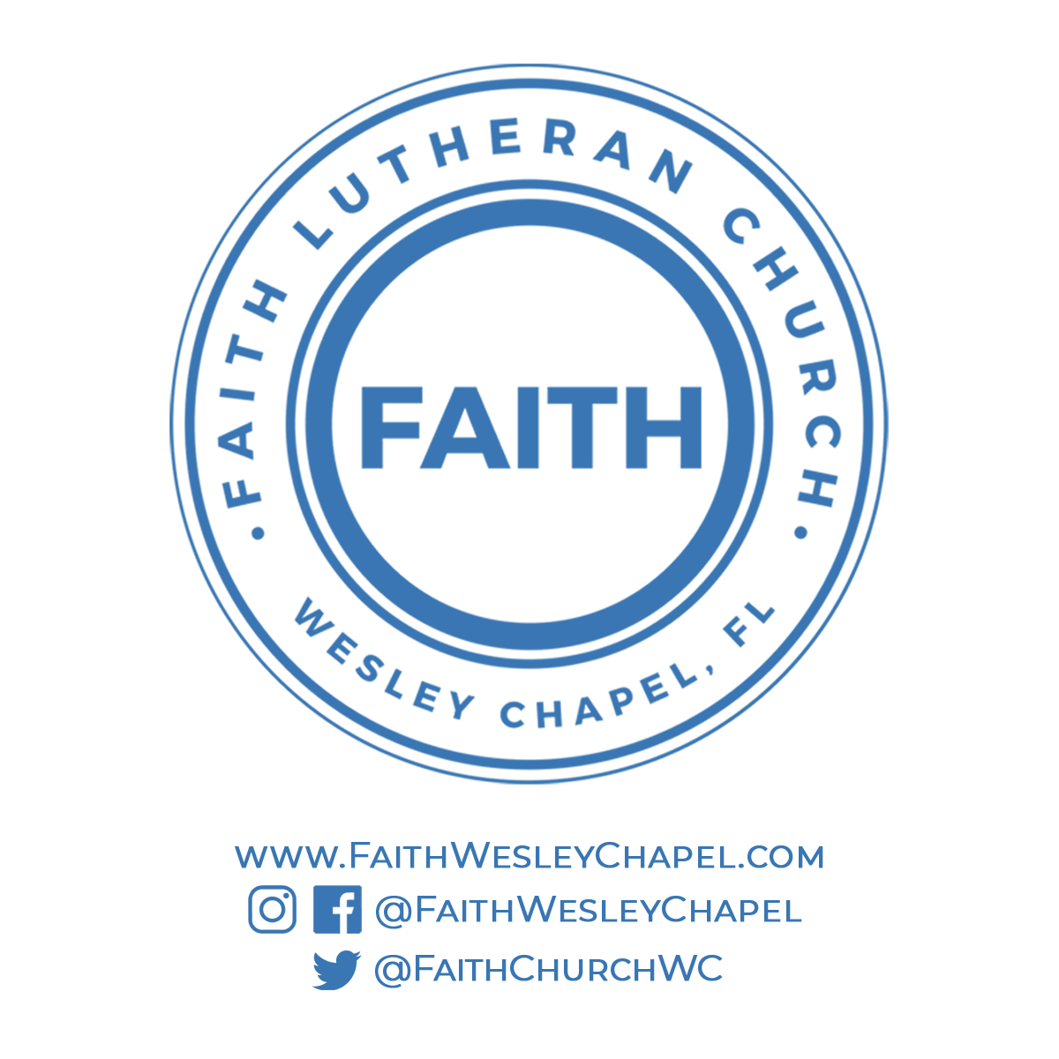**@FaithWesleyChapel**

**@FaithWesleyChapel**

**@FaithChurchWC**