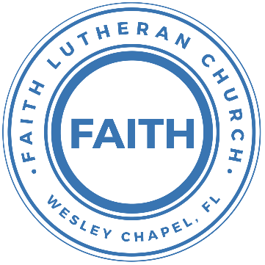

**Leading our community into a deep connection in Christ**

**Worship Service for December 5, 2021 at 11 AM**

**Welcome**

**Opening Song: Father Abraham**

Father Abraham had many sons  
Many sons had Father Abraham  
I am one of them and so are you  
So let's just praise the Lord

Right arm  
left arm  
right foot  
left foot  
Chin up  
turn around  
sit down

**Invocation**

**Confession and Forgiveness:**

P: We have come here today to worship the Lord.  In worship we hear the Word of God, we receive God's blessings, and respond with thanks and praise.  We begin by seeking God's blessing of forgiveness.  He has promised to remove the guilt and shame of our sin through the sacrifice of Jesus Christ on the cross.

P: Let us confess our sins to the Lord.

*(a time of silence to reflect and personally confess our sins)*

P: Heavenly Father,  
C: Heavenly Father,

P: I have done things that were wrong.  
C: I have done things that were wrong.  
  
P: I have been mean to others.  
C: I have been mean to others.

P: I have not obeyed my parents.  
C: I have not obeyed my parents.

P: I have not obeyed You, God.  
C: I have not obeyed You, God.

P: But I am very sorry.  
C: But I am very sorry.

P: Please forgive me.  
C: Please forgive me.

P: I love You very much.  
C: I love You very much.

P: And I know You love me, too.  
C: And I know You love me, too.

P: God has heard your apology.  He loves you very much.  God has told us that when we believe and trust in Him, He makes us His children.  As far as the east is from the west, so far does he remove our sins from us. He has told me to tell you that you are forgiven.  So, as His servant, I forgive you in the name of the Father and of the Son and of the Holy Spirit.

C: Amen.

**Song: Jesus Loves Me**

Jesus loves me this I know, for the Bible tells me so.  
Little ones to Him belong, they are weak, but He is strong.

Chorus:  
Yes, Jesus loves me, yes, Jesus loves me,  
Yes, Jesus loves me, The Bible tells me so.

Jesus loves me, He who died. Heaven's gates to open wide.  
He will wash away my sin, let His little child come in.

Chorus

Jesus loves me when I'm good, when I do the things, I should.  
Jesus loves me when I'm bad, even though it makes Him sad.

Chorus

**First Reading - Genesis 22:1–2**

After all this, God tested Abraham. God said, “Abraham!”

“Yes?” answered Abraham. “I’m listening.”

He said, “Take your dear son Isaac whom you love and go to the land of Moriah. Sacrifice him there as a burnt offering on one of the mountains that I’ll point out to you.”

Reader: This is the Word of the Lord.  
C: Thanks be to God.

**Children's Message "Willing To Give Something Precious"**

**Second Song: I Will Follow**

Intro Chorus:  
Where You go, I’ll go Where You stay, I’ll stay  
When You move, I’ll move I will follow…

All Your ways are good All Your ways are sure  
I will trust in You alone  
Higher than my sight High above my life  
I will trust in You alone

Chorus:  
Where You go, I’ll go Where You stay, I’ll stay  
When You move, I’ll move I will follow You  
Who You love, I'll love How You serve I'll serve  
If this life I lose, I will follow You, yeah.  
I will follow You

Light unto the world light unto my life  
I will live for You alone  
You're the one I seek knowing I will find  
All I need in You alone, in You alone

Chorus

In You there's life everlasting  
In You there's freedom for my soul  
In You there's joy, unending joy and I will follow

Chorus 2x

**Second Reading -   Genesis 22:12-13**

“Don’t lay a hand on that boy! Don’t touch him! Now I know how fearlessly you fear God; you didn’t hesitate to place your son, your dear son, on the altar for me.”

Abraham looked up. He saw a ram caught by its horns in the thicket. Abraham took the ram and sacrificed it as a burnt offering instead of his son.

Reader: This is the Word of the Lord.  
C: Thanks be to God.

**Children's Message "** **God Spared Isaac, But Not Jesus"**

**Epistle Reading -   Romans 8:31–34**

What then shall we say to these things? If God is for us, who can be against us? He who did not spare his own Son but gave him up for us all, how will he not also with him graciously give us all things? Who shall bring any charge against God's elect? It is God who justifies. Who is to condemn? Christ Jesus is the one who died—more than that, who was raised—who is at the right hand of God, who indeed is interceding for us.

**Sermon Hymn*–*It Is Well with My Soul (When Peace Like a River)**

When peace like a river attendeth my way,  
When sorrows like sea billows roll  
Whatever my lot, Thou has taught me to say,  
“It is well, it is well with my soul”

Chorus:  
It is well, (it is well) with my soul (with my soul)  
It is well, it is well with my soul

Though Satan should buffet tho’ trials may come,  
Let this blest assurance control  
That Christ has regarded my helpless estate  
And hath shed His own blood for my soul

Chorus

My sin, oh the bliss of this glorious thought,  
My sin not in part but in whole  
Is nailed to the cross and I bear it no more.  
Praise the Lord, praise the Lord oh my soul!

Chorus

And Lord haste the day when the faith shall be sight,  
The clouds be rolled back as a scroll  
The trump shall resound and the Lord shall descend,  
Even so it is well with my soul

Chorus 2x

**Sermon – Who Is Jesus? Jesus is the Son of Abraham**

**Prayers:** *Text in prayer requests to (813) 602-1104‬*

**The Lord's Prayer**

Our Father who art in heaven, hallowed be Thy name, Thy kingdom come, Thy will be done on earth as it is in heaven.  Give us this day our daily bread; and forgive us our trespasses as we forgive those who trespass against us; and lead us not into temptation, but deliver us from evil.  For Thine is the kingdom and the power and the glory forever and ever.  Amen

**Words of Institution**

**Peace**

P: The peace of the Lord be with you all.  
C: And also, with you.  
P: We greet each other in the peace of Christ.

**Distribution**

**Prayer**

**Benediction**

**Closing Song – Savior of the Nations, Come**

Savior of the nations, come, Virgin's Son, make here Thy home!  
Marvel now, O heaven and earth, That the Lord chose such a birth.

Not by human flesh and blood, By the Spirit of our God,  
Was the Word of God made flesh--Woman's Off-spring, pure and fresh.

From the Father forth He came and returneth to the same,  
Captive leading death and hell-- High the song of triumph swell!

Praise to God the Father sing, Praise to God the Son, our King,  
Praise to God the Spirit be Ever and eternally.

**Offering**

**Sermon Notes:**

**_______________________________________________**

**_______________________________________________**

**_______________________________________________**

**_______________________________________________**

**_______________________________________________**

**_______________________________________________**

**_______________________________________________**

**_______________________________________________**

**_______________________________________________**

**_______________________________________________**

**_______________________________________________**

**_______________________________________________**

**_______________________________________________**

**_______________________________________________**

**_______________________________________________**

**_______________________________________________**

**_______________________________________________**

**_______________________________________________**

**_______________________________________________**

**_______________________________________________**

**_______________________________________________**

**_______________________________________________**

**_______________________________________________**

**Upcoming Events**

**December 5, After the Service – Putting Labels on Mailers**  
Song and Dance

**December 5, 4pm – Confirmation**  
The Steinbrueck’s

**December 8, 7pm – Mid-Week Advent Service**  
The Larsen’s – 19107 Cypress Reach Ln. Tampa, FL 33647  
Gate Code: *1225

**December 12, 5-8pm – Open House Social**  
The Chmiel’s - 29708 Weybridge Way, Wesley Chapel, FL 33545  
Gate Code: #8419 Home Phone: 813-994-1983

**December 5, 7pm – Mid-Week Advent Service**  
The Chmiel’s - 29708 Weybridge Way, Wesley Chapel, FL 33545  
Gate Code: #8419 Home Phone: 813-994-1983

**December 18, 5pm – Christmas in the Park**  
Wesley Chapel District Park

**December 24, 6pm – Christmas Eve Service**  
Song and Dance

**www.FaithWesleyChapel.com**

**Faith YouTube**

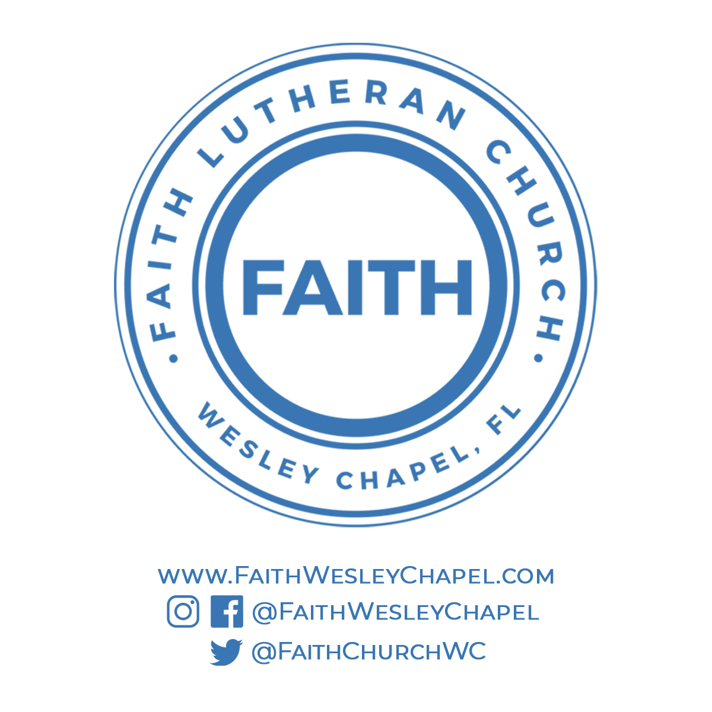**@FaithWesleyChapel**

**@FaithWesleyChapel**

**@FaithChurchWC**