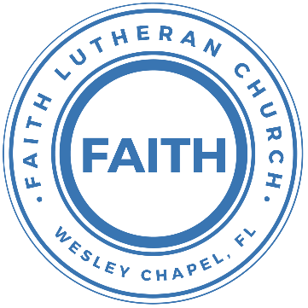

**Leading our community into a deep connection in Christ**

**Worship Service for December 12, 2021 at 11 AM**

**Welcome**

**Pray for the Food** - **People get food**

**Angels From The Realms of Glory (Emmanuel)**

Angels from the realms of glory  
Wing your flight o'er all the earth   
You who sang creation's story  
Now proclaim Messiah's birth  
Come and worship Come and worship  
Worship Christ the newborn King

Shepherds in the field abiding  
Watching o'er your flocks by night  
God with man is now residing  
Yonder shines the infant light  
Come and worship, Come and worship   
Worship Christ the newborn King

**Invocation**

**Confession and Forgiveness:**

P: As we gather, today, let us cleanse our hearts and our consciences by confessing our sin to God.

(Time of silence for reflection and confession)

C: Heavenly Father, we confess that we are sinful and unclean. We have sinned against you and against our neighbor in our thoughts, words, and actions.  We are truly sorry for our sins and sincerely repent of them. We ask for Your mercy. For the sake of Jesus Christ's bitter suffering and death, please forgive us and renew us that we may walk in Your Spirit to the glory of Your holy name.

P: The Lord has heard your confession. Therefore, as a called and ordained servant of the Lord, in the stead and by the command of my Lord, Jesus Christ, I forgive you all your sins in the name of the Father and of the Son and of the Holy Spirit.

C: Amen

**Old Testament Reading - 1 Kings 11:1–10**

Now King Solomon loved many foreign women, along with the daughter of Pharaoh: Moabite, Ammonite, Edomite, Sidonian, and Hittite women, from the nations concerning which the Lord had said to the people of Israel,“You shall not enter into marriage with them, neither shall they with you, for surely they will turn away your heart after their gods.” Solomon clung to these in love. He had 700 wives, who were princesses, and 300 concubines. And his wives turned away his heart.

For when Solomon was old his wives turned away his heart after other gods, and his heart was not wholly true to the Lord his God, as was the heart of David his father. For Solomon went after Ashtoreth the goddess of the Sidonians, and after Milcom the abomination of the Ammonites. So Solomon did what was evil in the sight of the Lord and did not wholly follow the Lord, as David his father had done.

Then Solomon built a high place for Chemosh the abomination of Moab, and for Molech the abomination of the Ammonites, on the mountain east of Jerusalem. And so he did for all his foreign wives, who made offerings and sacrificed to their gods. And the Lord was angry with Solomon, because his heart had turned away from the Lord, the God of Israel, who had appeared to him twice and had commanded him concerning this thing, that he should not go after other gods. But he did not keep what the Lord commanded.

Reader: This is the Word of the Lord.  
C: Thanks be to God.

**Epistle Reading - 2 Timothy 4:6–8**

What then shall we say to these things? If God is for us, who can be against us? He who did not spare his own Son but gave him up for us all, how will he not also with him graciously give us all things? Who shall bring any charge against God's elect? It is God who justifies. Who is to condemn? Christ Jesus is the one who died—more than that, who was raised—who is at the right hand of God, who indeed is interceding for us.

Reader: This is the Word of the Lord.  
C: Thanks be to God.

**Sermon – "Jesus is the Son of Solomon"**

Matthew 12:38–42

Then some of the scribes and Pharisees answered him, saying, “Teacher, we wish to see a sign from you.” But he answered them, “An evil and adulterous generation seeks for a sign, but no sign will be given to it except the sign of the prophet Jonah. For just as Jonah was three days and three nights in the belly of the great fish, so will the Son of Man be three days and three nights in the heart of the earth. The men of Nineveh will rise up at the judgment with this generation and condemn it, for they repented at the preaching of Jonah, and behold, something greater than Jonah is here. The queen of the South will rise up at the judgment with this generation and condemn it, for she came from the ends of the earth to hear the wisdom of Solomon, and behold, something greater than Solomon is here.

P: This is the Gospel of the Lord.  
C: Praise be to You, o Christ.

**Prayers**

**Apostles' Creed**

I believe in God, the Father almighty, maker of heaven and earth,  
And in Jesus Christ, his only Son, our Lord,  
who was conceived by the Holy Spirit,  
born of the Virgin Mary, suffered under Pontius Pilate,  
was crucified, died and was buried. He descended into hell.  
The third day he rose again from the dead.  
He ascended into heaven and sits at the right hand of God  
the Father almighty.  
From there he will come to judge the living and the dead.  
I believe in the Holy Spirit, the holy Christian Church,  
the communion of saints, the forgiveness of sins,  
the resurrection of the body, and the life everlasting. Amen.

**The Lord's Prayer**

Our Father who art in heaven, hallowed be Thy name, Thy kingdom come, Thy will be done on earth as it is in heaven.  Give us this day our daily bread; and forgive us our trespasses as we forgive those who trespass against us; and lead us not into temptation, but deliver us from evil.  For Thine is the kingdom and the power and the glory forever and ever.  Amen

**Words of Institution**

**Peace**

P: The peace of the Lord be with you all.  
C: And also, with you.  
P: We greet each other in the peace of Christ.

**Distribution**

**Prayer**

**Benediction**

**Closing Song – O Come All Ye Faithful**

Oh come all ye faithful, joyful and triumphant!  
Oh come ye oh come ye to Bethlehem;  
Come and behold him Born the King of angels  
Oh come let us adore him, Oh come let us adore him  
Oh come let us adore hi - m Christ the Lord!

Sing choirs of angels Sing in exultation,  
Sing all ye citizens of hea’en above!  
Glory to God Glory in the highest  
Oh come let us adore him, oh come let us adore him  
Oh come let us adore him Christ the Lord!

Yea Lord we greet Thee Born this happy morning;  
Jesus to Thee be glory giv’n!  
Word of the Father now in flesh appearing!  
Oh come let us adore him, Oh come let us adore him  
Oh come let us adore him Christ the Lord!

**Offering**

**What is Advent?**

* The word “advent" is from the Latin word for “coming,”
* Advent begins the church year because the church year begins where Jesus' earthly life began — in the Old Testament prophecies of his incarnation.
* The first half of the church year (approximately December through June) highlights the life of Christ. The second half (approximately June through November) highlights the teachings of Christ. The parables and miracles play a big part here. That's "the church year in a nutshell," and it should help reveal how Advent fits into "the big picture."
* Advent also points to the next advent, Christ’s 2nd coming. So, there tends to be a lot of eschatological (end times) talk.

**The Advent Candles:**

* The traditional use of Advent candles (sometimes held in a wreath) originated in eastern Germany even prior to the Reformation. As this tradition came down to us by the beginning of this century, it involved three purple or blue candles, one pink candle, and one white candle.
* The purple candles matched the purple paraments on the altar (purple for the royalty of the coming King). Many have replaced purple with blue candles to distinguish Advent from Lent. The blue represents hope. It is the color of the clear, pre-dawn sky. Day is coming! The pink candle was the third candle to be lit (not the fourth) on Gaudete Sunday, the Third Sunday of Advent. "Gaudete" means "Rejoice!" in Latin, which is taken from Phil. 4:4. ("Rejoice! ... the Lord is near"). Hence a "pink" candle was used to signify "rejoicing." Many also included a white "Christ candle" in the middle to be lit during the 12 days of Christmas (Dec. 25 to Jan. 5). White representing Christ.

**Sermon Notes:**

**_______________________________________________**

**_______________________________________________**

**_______________________________________________**

**_______________________________________________**

**_______________________________________________**

**_______________________________________________**

**_______________________________________________**

**_______________________________________________**

**_______________________________________________**

**_______________________________________________**

**_______________________________________________**

**_______________________________________________**

**_______________________________________________**

**_______________________________________________**

**_______________________________________________**

**_______________________________________________**

**_______________________________________________**

**_______________________________________________**

**_______________________________________________**

**_______________________________________________**

**_______________________________________________**

**_______________________________________________**

**_______________________________________________**

**Upcoming Events**

**December 12, 5-8pm – Open House Social**  
The Chmiel’s - 29708 Weybridge Way, Wesley Chapel, FL 33545  
Gate Code: #8419 Home Phone: 813-994-1983

**December 15, 7pm – Mid-Week Advent Service**  
The Chmiel’s - 29708 Weybridge Way, Wesley Chapel, FL 33545  
Gate Code: #8419 Home Phone: 813-994-1983

**December 18, 5pm – Christmas in the Park**  
Wesley Chapel District Park

**December 19, 12:30pm – Confirmation**  
The Shuck’s

**December 19, 3pm-6pm – Youth Christmas Party**  
Dave and Busters

**December 24, 6pm – Christmas Eve Service**  
Song and Dance

**December 26, 11am – Worship Service**  
Song and Dance

**January 2, 11am – Worship Service**  
Song and Dance

**www.FaithWesleyChapel.com**

**Faith YouTube**

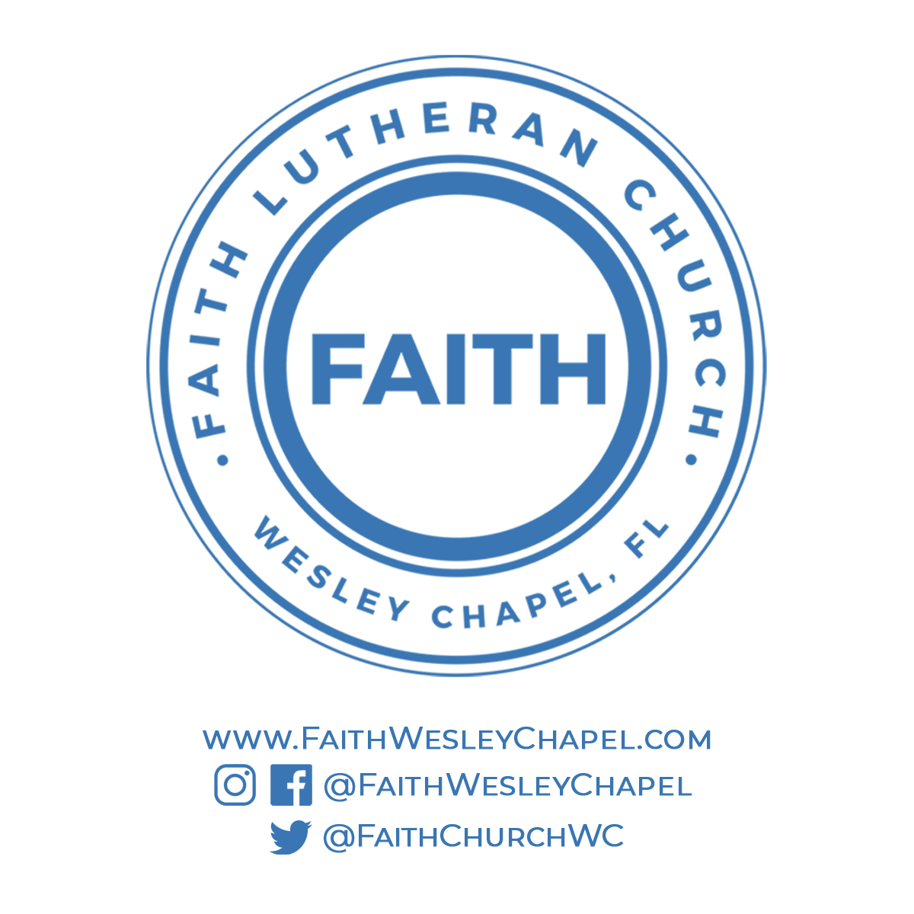**@FaithWesleyChapel**

**@FaithWesleyChapel**

**@FaithChurchWC**