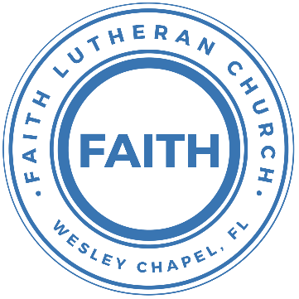

**Leading our community into a deep connection in Christ**

**Worship Service for January 16, 2021 at 11 AM**

**Welcome**

**Opening Song -** Now All The Vault Of Heaven Resounds

Now all the vault of Heav'n resounds  
In praise of love that still abound,  
Christ has triumphed, He is living!"  
Sing, choirs of angels, loud and clear,  
Repeat their song of glory here,  
Christ has triumphed, Christ has triumphed!  
Alleluia, alleluia, alleluia.

Eternal is the gift He brings,  
Therefore our heart with rapture sings,   
Christ has triumphed, He is living!"  
Now still He comes to give us life,  
And by His presence stills all strife  
Christ has triumphed! He is living!  
Alleluia, alleluia.

Adoring praises now we bring  
And with the heavenly blessed sing,  
Christ has triumphed, Alleluia!  
Be to the Father, and our Lord, To Spirit blest, most holy God,  
All the glory, never ending!  
Alleluia, alleluia, alleluia.

**Invocation**

**Confession and Forgiveness:**

**P:** Our Heavenly Father asks us to come into His presence.

**C:** But we are sinful and unworthy.

**P:** Yes, all have sinned and fall short of the glory of God, but Jesus Christ died on the cross that we may be forgiven and washed clean of all our sins by His blood spilled on the cross.

**C:** Lord, if You wash us, we will certainly be clean and pure.

**P:** We take a moment to bow before the His cross and silently reflect on our lives and confess our sins.

(Time of silence for reflection and confession)

**P:** Let us confess, together, our sins to God our Father.

**C:** Heavenly Father, we confess that we are sinners.  We have sinned against you and our neighbors. We have not loved you with our whole heart and we have not loved our neighbors as ourselves. We have not lived out our faith out in our community. We justly deserve Your punishment.  For the sake of Your Son, Jesus Christ, have mercy on us.  Forgive us, renew us, and lead us, so that we may delight in Your will and walk in Your ways to the glory of Your holy name.  Amen.

**P:** Almighty God in His mercy has given His Son to die for you and for His sake forgives you all your sins.  As a called and ordained servant of Christ, and by His authority, I, therefore, forgive you all your sins in the name of the Father and of the Son and of the Holy Spirit.

**C:** Amen

**Song of Praise and Thanksgiving:** All The People Said Amen

*Verse 1:*

You are not alone, if you are lonely

When you feel afraid, you're not the only

We are all the same, in need of mercy

To be forgiven and be free

It's all you got to lean on but thank God it's all you need

*Chorus:*

And all the people said Amen, woah

And all the people said Amen

Give thanks to the Lord for His love never ends

And all the people said Amen *(Last line repeated on last chorus)*

*Verse 2:*

If you're rich or poor, well it don't matter

Weak or strong, you know love is what we're after

We're all broken, but we're all in this together

God knows we stumble and fall

And He so loved the world, He sent His son to save us all

(Chorus)

*Bridge:*

Blessed are the poor in spirit who are torn apart

Blessed are the persecuted and the pure in heart

Blessed are the people hungry for another start

For this is the kingdom, the kingdom of God

*(Chorus 2x)*

**First Reading -**2 Corinthians 5:16-21

From now on, therefore, we regard no one according to the flesh. Even though we once regarded Christ according to the flesh, we regard him thus no longer. Therefore, if anyone is in Christ, he is a new creation. The old has passed away; behold, the new has come. All this is from God, who through Christ reconciled us to himself and gave us the ministry of reconciliation; that is, in Christ God was reconciling the world to himself, not counting their trespasses against them, and entrusting to us the message of reconciliation. Therefore, we are ambassadors for Christ, God making his appeal through us. We implore you on behalf of Christ, be reconciled to God. For our sake he made him to be sin who knew no sin, so that in him we might become the righteousness of God.

Reader: This is the Word of the Lord.  
C: Thanks be to God.

**Second Reading** - Colossians 3:12-17

Put on then, as God's chosen ones, holy and beloved, compassionate hearts, kindness, humility, meekness, and patience, bearing with one another and, if one has a complaint against another, forgiving each other; as the Lord has forgiven you, so you also must forgive. And above all these put on love, which binds everything together in perfect harmony. And let the peace of Christ rule in your hearts, to which indeed you were called in one body. And be thankful. Let the word of Christ dwell in you richly, teaching and admonishing one another in all wisdom, singing psalms and hymns and spiritual songs, with thankfulness in your hearts to God. And whatever you do, in word or deed, do everything in the name of the Lord Jesus, giving thanks to God the Father through him.

Reader: This is the Word of the Lord.  
C: Thanks be to God.

**Gospel Reading** - Luke 9:23-26

And he said to all, “If anyone would come after me, let him deny himself and take up his cross daily and follow me. For whoever would save his life will lose it, but whoever loses his life for my sake will save it. For what does it profit a man if he gains the whole world and loses or forfeits himself? For whoever is ashamed of me and of my words, of him will the Son of Man be ashamed when he comes in his glory and the glory of the Father and of the holy angels.

P: This is the Gospel of the Lord.  
C: Praise be to You, o Christ.

**Children's Message** *(Children dismissed to Children's Church)*

**Sermon Hymn**Love Divine All Loves Excelling

Love divine, all loves excelling, Joy of heav'n, to earth come down!  
Fix in us Thy humble dwelling, All Thy faithful mercies crown.  
Jesus, Thou art all compassion, Pure, unbounded love Thou art;  
Visit us with Thy salvation, Enter ev'ry trembling heart.

Breathe, O breathe Thy loving Spirit Into ev'ry troubled breast;  
Let us all in Thee inherit; Let us find Thy promised rest.  
Take away the love of sinning; Alpha and Omega be;  
End of faith, as its beginning, Set our hearts at liberty.

Finish then Thy new creation, Pure and spotless let us be;  
Let us see Thy great salvation Perfectly restored in Thee,  
Changed from glory into glory, Till in heav'n we take our place,  
Till we cast our crowns before Thee, Lost in wonder, love, and praise!

**Sermon** - Series: Breaking Down the Barriers to a Deeper Faith Life  
 Week 2: "Relationships"

**Prayers:** *Text in prayer requests to (813) 602-1104‬*

**Nicene Creed**

I believe in one God, the Father Almighty, maker of heaven and earth and of all things visible and invisible.

And in one Lord Jesus Christ, the only-begotten Son of God, begotten of His Father before all worlds, God of God, Light of Light, very God of very God, begotten, not made, being of one substance with the Father, by whom all things were made; who for us men and for our salvation came down from heaven and was incarnate by the Holy Spirit of the virgin Mary and was made man; and was crucified also for us under Pontius Pilate. He suffered and was buried. And the third day He rose again according to the Scriptures and ascended into heaven and sits at the right hand of the Father. And He will come again with glory to judge both the living and the dead, whose kingdom will have no end.

And I believe in the Holy Spirit, the Lord and Giver of Life, who proceeds from the Father and the Son, who with the Father and the Son together is worshiped and glorified, who spoke by the prophets. And I believe in one holy Christian and apostolic Church, I acknowledge one Baptism for the remission of sins, and I look for the resurrection of the dead and the life of the world to come. Amen.

**The Lord's Prayer**

Our Father who art in heaven, hallowed be Thy name, Thy kingdom come, Thy will be done on earth as it is in heaven.  Give us this day our daily bread; and forgive us our trespasses as we forgive those who trespass against us; and lead us not into temptation, but deliver us from evil.  For Thine is the kingdom and the power and the glory forever and ever.  Amen

**Words of Institution**

**Peace**

P: The peace of the Lord be with you all.  
C: And also, with you.  
P: We greet each other in the peace of Christ.

**Distribution**

**Prayer**

**Benediction**

**Closing Song:**Lifesong

Empty hands held high. Such small sacrifice  
If not joined with my life, I sing in vain tonight

Pre-Chorus:  
May the words I say and the things I do  
Make my lifesong sing. Bring a smile to You

Chorus:  
Let my lifesong sing to You. Let my lifesong sing to You  
I want to sign Your name to the end of this day  
Knowing that my heart was true.  
Let my lifesong sing to You

Lord I give my life, A living sacrifice  
To reach a world in need, To be Your hands and feet

Pre-Chorus

Chorus

Bridge:  
Hallelujah! Hallelujah!  
Let my lifesong sing to You

Repeat bridge 3x)

Chorus

**Offering**

**Sermon Notes:**

**_______________________________________________**

**_______________________________________________**

**_______________________________________________**

**_______________________________________________**

**_______________________________________________**

**Upcoming Events**

**January 16, 4:30pm – Confirmation**Location – The Shucks

**January 17, 7 PM – Council Meeting**  
Zoom

**February 5, 10 AM - 2 PM – Spiritual Conversations (Free)**  
“*How to Have More Meaningful Spiritual Conversations*”  
Presented by Lutheran Hour Ministries  
Messiah Lutheran Church – 14920 Hutchison Rd. Tampa, FL 33625  
(Lunch provided) – Register at LHM.org/SCDATampa

**www.FaithWesleyChapel.com**

**Faith YouTube**

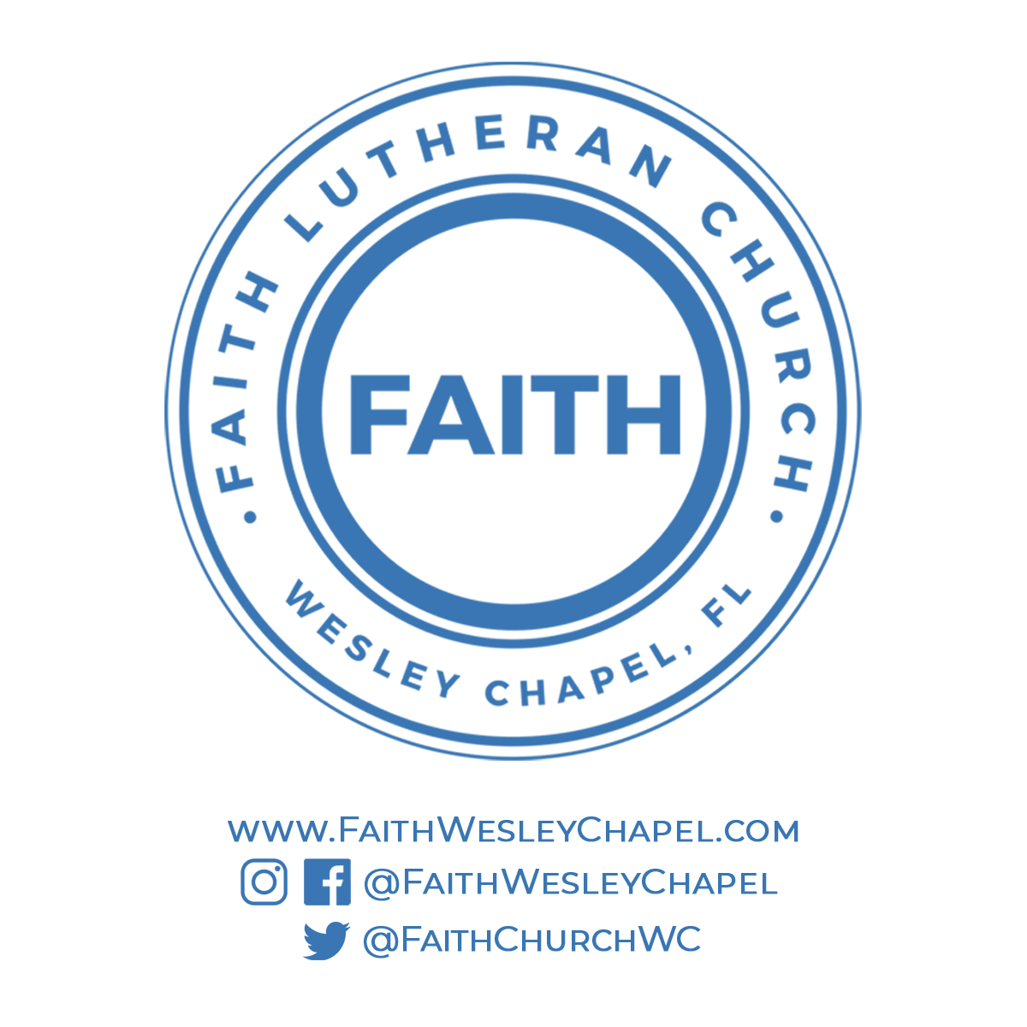**@FaithWesleyChapel**

**@FaithWesleyChapel**

**@FaithChurchWC**