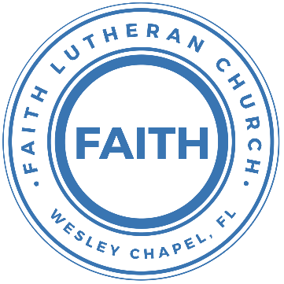

**Leading our community into a deep connection in Christ**

**Worship Service for February 13, 2022 at 11 AM**

**Welcome**

**Invocation**

**Confession and Forgiveness:**

P: As we gather, today, let us cleanse our hearts and our consciences by confessing our sin to God.

(Time of silence for reflection and confession)

C: Heavenly Father, we confess that we are sinful and unclean. We have sinned against you and against our neighbor in our thoughts, words, and actions.  We are truly sorry for our sins and sincerely repent of them. We ask for Your mercy. For the sake of Jesus Christ's bitter suffering and death, please forgive us and renew us that we may walk in Your Spirit to the glory of Your holy name.

P: The Lord has heard your confession. Therefore, as a called and ordained servant of the Lord, in the stead and by the command of my Lord, Jesus Christ, I forgive you all your sins in the name of the Father and of the Son and of the Holy Spirit.

C: Amen

**Songs of Praise and Thanksgiving:** Canvas And Clay

Verse 1:

In my mother’s womb You formed me with Your hands

Known and loved by You Before I took a breath

Pre-Chorus 1:

When I doubt it, Lord, remind me I’m wonderfully made

You’re an artist and a potter I’m the canvas and the clay

Chorus:

You make all things work together For my future and for my good

You make all things work together

For Your glory and for Your name

Verse 2:

There’s a healing light Just beyond the clouds

Though I’ve walked through fire I see clearly now

Pre-Chorus 2:

I know nothing has been wasted No failure or mistake

You’re an artist and a potter I’m the canvas and the clay

Chorus

Bridge:

When I doubt it, Lord, remind me I’m wonderfully made

You’re an artist and a potter I’m the canvas and the clay

I know nothing has been wasted No failure or mistake

You’re an artist and a potter I’m the canvas and the clay

Chorus (x2)

**Old Testament Reading:**Deuteronomy 7:6-10a

“For you are a people holy to the Lord your God. The Lord your God has chosen you to be a people for his treasured possession, out of all the peoples who are on the face of the earth. It was not because you were more in number than any other people that the Lord set his love on you and chose you, for you were the fewest of all peoples, but it is because the Lord loves you and is keeping the oath that he swore to your fathers, that the Lord has brought you out with a mighty hand and redeemed you from the house of slavery, from the hand of Pharaoh king of Egypt. Know therefore that the Lord your God is God, the faithful God who keeps covenant and steadfast love with those who love him and keep his commandments, to a thousand generations, and repays to their face those who hate him, by destroying them.

Reader: This is the Word of the Lord.  
C: Thanks be to God.

**Epistle Reading:**Galatians 2:17-21

But if, in our endeavor to be justified in Christ, we too were found to be sinners, is Christ then a servant of sin? Certainly not! For if I rebuild what I tore down, I prove myself to be a transgressor. For through the law I died to the law, so that I might live to God. I have been crucified with Christ. It is no longer I who live, but Christ who lives in me. And the life I now live in the flesh I live by faith in the Son of God, who loved me and gave himself for me. I do not nullify the grace of God, for if righteousness were through the law, then Christ died for no purpose.

Reader: This is the Word of the Lord.  
C: Thanks be to God.

**Gospel Reading:**John 17:14-21

I have given them your word, and the world has hated them because they are not of the world, just as I am not of the world. I do not ask that you take them out of the world, but that you keep them from the evil one. They are not of the world, just as I am not of the world. Sanctify them in the truth; your word is truth. As you sent me into the world, so I have sent them into the world. And for their sake I consecrate myself, that they also may be sanctified in truth.

“I do not ask for these only, but also for those who will believe in me through their word, that they may all be one, just as you, Father, are in me, and I in you, that they also may be in us, so that the world may believe that you have sent me.

P: This is the Gospel of the Lord.  
C: Praise be to You, o Christ.

**Sermon Song:** Who You Say I Am

Who am I that the highest King / Would welcome me  
I was lost but He brought me in / Oh His love for me  
Oh His love for me

Chorus 1:  
Who the Son sets free, oh is free indeed  
I'm a child of God, yes, I am

Free at last He has ransomed me / His grace runs deep  
While I was a slave to sin / Jesus died for me  
Yes He died for me

Chorus 2:  
Who the Son sets free, oh is free indeed  
I'm a child of God, yes, I am  
In my Father's house, there’s a place for me  
I'm a child of God, yes, I am

I am chosen / Not forsaken I am who You say I am  
You are for me / Not against me I am who You say I am

I am who You say I am

Chorus 2

**Sermon** – Series: Breaking Down the Barriers to a Deeper Faith Life  
 Week 6: "How I See Myself"

**Prayers:**

**Apostles' Creed**

I believe in God, the Father almighty, maker of heaven and earth,  
And in Jesus Christ, his only Son, our Lord,  
who was conceived by the Holy Spirit,  
born of the Virgin Mary, suffered under Pontius Pilate,  
was crucified, died and was buried. He descended into hell.  
The third day he rose again from the dead.  
He ascended into heaven and sits at the right hand of God  
the Father almighty.  
From there he will come to judge the living and the dead.  
I believe in the Holy Spirit, the holy Christian Church,  
the communion of saints, the forgiveness of sins,  
the resurrection of the body, and the life everlasting. Amen.

**The Lord's Prayer**

Our Father who art in heaven, hallowed be Thy name, Thy kingdom come, Thy will be done on earth as it is in heaven.  Give us this day our daily bread; and forgive us our trespasses as we forgive those who trespass against us; and lead us not into temptation, but deliver us from evil.  For Thine is the kingdom and the power and the glory forever and ever.  Amen

**Benediction**

**Closing Song:** Praise God from Whom All Blessings Flow

Praise God from Whom all blessings flow.  
Praise Him all creatures here below.  
Praise Him above, ye heavenly hosts.  
Praise Father, Son and Holy Ghost.  
Amen

**Offering**

**Sermon Notes:**

**_______________________________________________**

**_______________________________________________**

**_______________________________________________**

**_______________________________________________**

**_______________________________________________**

**_______________________________________________**

**_______________________________________________**

**_______________________________________________**

**_______________________________________________**

**_______________________________________________**

**_______________________________________________**

**_______________________________________________**

**_______________________________________________**

**_______________________________________________**

**_______________________________________________**

**_______________________________________________**

**_______________________________________________**

**_______________________________________________**

**_______________________________________________**

**_______________________________________________**

**_______________________________________________**

**_______________________________________________**

**_______________________________________________**

**Upcoming Events**

**February 21, 7 PM Council Meeting**  
Zoom

**February 24, 4:30-7 PM Spaghetti Dinner Fundraiser**  
Song and Dance

**www.FaithWesleyChapel.com**

**Faith YouTube**

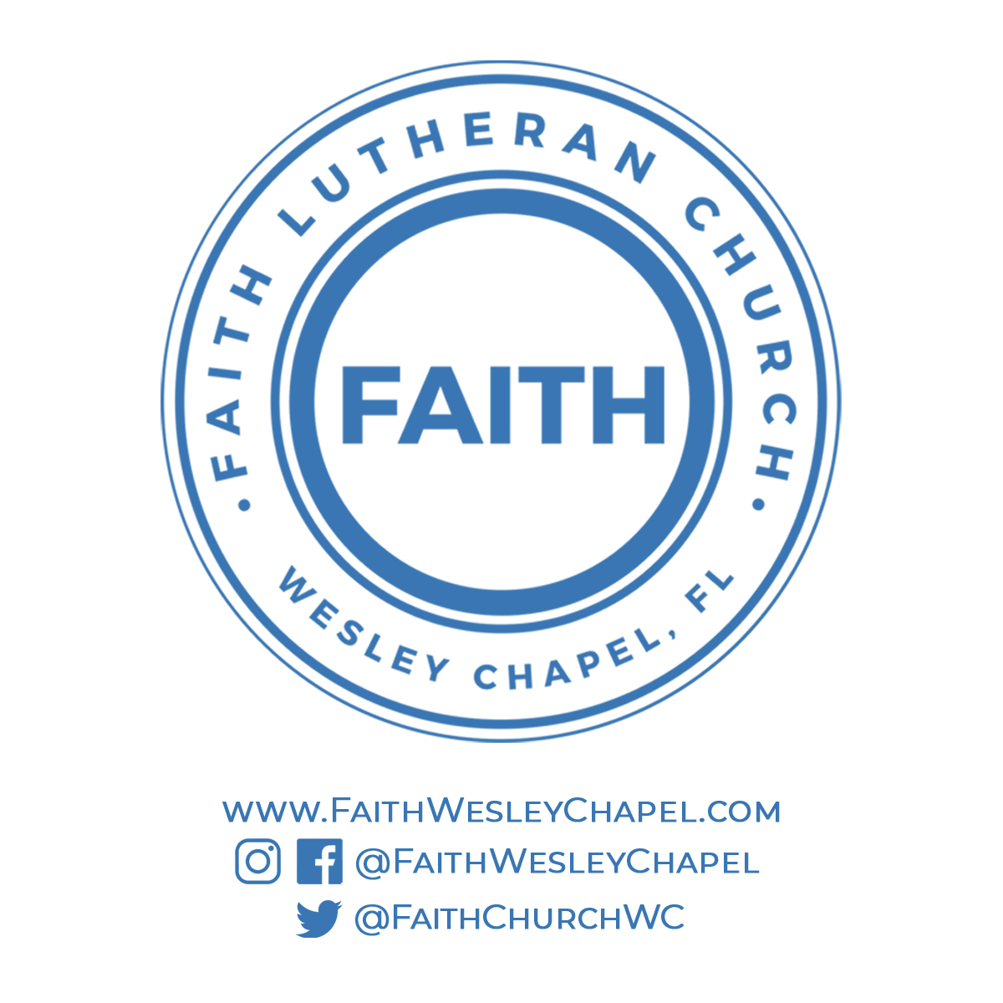**@FaithWesleyChapel**

**@FaithWesleyChapel**

**@FaithChurchWC**