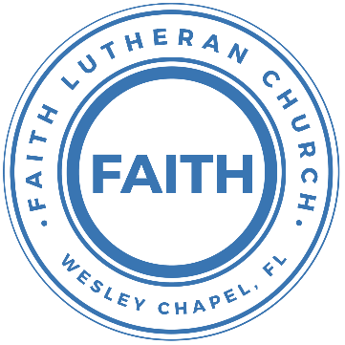

**Leading our community into a deep connection in Christ**

**Worship Service for February 20, 2022 at 11 AM**

**Welcome**

**Opening Song -** Canvas and Clay

Verse 1:

In my mother’s womb You formed me with Your hands

Known and loved by You Before I took a breath

Pre-Chorus 1:

When I doubt it, Lord, remind me I’m wonderfully made

You’re an artist and a potter I’m the canvas and the clay

Chorus:

You make all things work together For my future and for my good

You make all things work together

For Your glory and for Your name

Verse 2:

There’s a healing light Just beyond the clouds

Though I’ve walked through fire I see clearly now

Pre-Chorus 2:

I know nothing has been wasted No failure or mistake

You’re an artist and a potter I’m the canvas and the clay

Chorus (x2)

**Invocation**

**Confession and Forgiveness:**

**P:** Our Heavenly Father asks us to come into His presence.

**C:** But we are sinful and unworthy.

**P:** Yes, all have sinned and fall short of the glory of God, but Jesus Christ died on the cross that we may be forgiven and washed clean of all our sins by His blood spilled on the cross.

**C:** Lord, if You wash us, we will certainly be clean and pure.

**P:** We take a moment to bow before the His cross and silently reflect on our lives and confess our sins.

(Time of silence for reflection and confession)

**P:** Let us confess, together, our sins to God our Father.

**C:** Heavenly Father, we confess that we are sinners.  We have sinned against you and our neighbors. We have not loved you with our whole heart and we have not loved our neighbors as ourselves. We have not lived out our faith out in our community. We justly deserve Your punishment.  For the sake of Your Son, Jesus Christ, have mercy on us.  Forgive us, renew us, and lead us, so that we may delight in Your will and walk in Your ways to the glory of Your holy name.  Amen.

**P:** Almighty God in His mercy has given His Son to die for you and for His sake forgives you all your sins.  As a called and ordained servant of Christ, and by His authority, I, therefore, forgive you all your sins in the name of the Father and of the Son and of the Holy Spirit.

**C:** Amen

**Song of Praise and Thanksgiving:** Give Thanks

Verse:

Give thanks with a grateful heart. Give thanks to the holy one

Give thanks because he's given Jesus Christ, His son.

(repeat)

Chorus:

And now let the weak say I am strong

Let the poor say I am rich.

Because of what the Lord has done for us

(repeat)

Ending: Give thanks. Give thanks. We give thanks.

**Old Testament Reading –**Leviticus 19:9-10

“When you reap the harvest of your land, you shall not reap your field right up to its edge, neither shall you gather the gleanings after your harvest. And you shall not strip your vineyard bare, neither shall you gather the fallen grapes of your vineyard. You shall leave them for the poor and for the sojourner: I am the Lord your God."

Reader: This is the Word of the Lord.  
C: Thanks be to God.

**Epistle Reading** – Philippians 4:10-19ence

I rejoiced in the Lord greatly that now at length you have revived your concern for me. You were indeed concerned for me, but you had no opportunity. Not that I am speaking of being in need, for I have learned in whatever situation I am to be content. I know how to be brought low, and I know how to abound. In any and every circumstance, I have learned the secret of facing plenty and hunger, abundance and need. I can do all things through him who strengthens me.

Reader: This is the Word of the Lord.  
C: Thanks be to God.

**Children's Message** *(Children dismissed to Children's Church)*

**Gospel Reading** – Matthew 6:19-25

“Do not lay up for yourselves treasures on earth, where moth and rust destroy and where thieves break in and steal, but lay up for yourselves treasures in heaven, where neither moth nor rust destroys and where thieves do not break in and steal. For where your treasure is, there your heart will be also.

“The eye is the lamp of the body. So, if your eye is healthy, your whole body will be full of light, but if your eye is bad, your whole body will be full of darkness. If then the light in you is darkness, how great is the darkness!

“No one can serve two masters, for either he will hate the one and love the other, or he will be devoted to the one and despise the other. You cannot serve God and money.

P: This is the Gospel of the Lord.  
C: Praise be to You, o Christ.

**Sermon Hymn***–*What Is The World To Me

Verse 1:

What is the world to me With all its vaunted pleasure

When You, and You alone, Lord Jesus, are my Treasure!

You only, dearest Lord, My soul's Delight shall be;

You are my Peace, my Rest, What is the world to me!

Verse 3:

The world seeks after wealth And all that Mammon offers,

Yet never is content Though gold should fill it coffers.

I have a higher good, Content with it I'll be:

My Jesus is my Wealth, What is the world to me!

Verse 4:

What is the world to me! My Jesus is my Treasure,

My Life, my Health, my Wealth, My Friend, my Love, my Pleasure,

My Joy, my Crown, my All, My Bliss eternally.

Once more, then, I declare: What is the world to me!

**Sermon** – Series: Breaking Down the Barriers to a Deeper Faith Life  
 Week 6: "Our Stuff"

**Prayers:** *Text in prayer requests to (813) 602-1104‬*

**Nicene Creed**

I believe in one God, the Father Almighty, maker of heaven and earth and of all things visible and invisible.

And in one Lord Jesus Christ, the only-begotten Son of God, begotten of His Father before all worlds, God of God, Light of Light, very God of very God, begotten, not made, being of one substance with the Father, by whom all things were made; who for us men and for our salvation came down from heaven and was incarnate by the Holy Spirit of the virgin Mary and was made man; and was crucified also for us under Pontius Pilate. He suffered and was buried. And the third day He rose again according to the Scriptures and ascended into heaven and sits at the right hand of the Father. And He will come again with glory to judge both the living and the dead, whose kingdom will have no end.

And I believe in the Holy Spirit, the Lord and Giver of Life, who proceeds from the Father and the Son, who with the Father and the Son together is worshiped and glorified, who spoke by the prophets. And I believe in one holy Christian and apostolic Church, I acknowledge one Baptism for the remission of sins, and I look for the resurrection of the dead and the life of the world to come. Amen.

**The Lord's Prayer**

Our Father who art in heaven, hallowed be Thy name, Thy kingdom come, Thy will be done on earth as it is in heaven.  Give us this day our daily bread; and forgive us our trespasses as we forgive those who trespass against us; and lead us not into temptation, but deliver us from evil.  For Thine is the kingdom and the power and the glory forever and ever.  Amen

**Words of Institution**

**Peace**

P: The peace of the Lord be with you all.  
C: And also, with you.  
P: We greet each other in the peace of Christ.

**Distribution**

**Prayer**

**Benediction**

**Closing Song:**The Wonderful Cross

Verse 1:

When I survey the wondrous cross,

On which the prince of glory died,

My richest gain I count but loss,

And pour contempt on all my pride.

Verse 2:

Forbid it, Lord, that I should boast,

Save in the death of Christ my God.

All the vain things that charm me most,

I sacrifice them to His blood

Chorus:

O the wonderful cross, O the wonderful cross

Bids me come and die and find that I may truly live.

O the wonderful cross, O the wonderful cross

All who gather here By grace draw near and bless your name.

Verse 3:

See from his head, His hands, His feet,

Sorrow and love flow mingled down.

Did e’er such love and sorrow meet,

Or thorns compose so rich a crown

(Chorus)

Verse 4:

Were the whole realm of nature mine,

That were an present far too small

Love so amazing so divine, Demands my soul, my life, my all.

(Chorus)

**Offering**

**Upcoming Events**

**February 21, 7 PM Council Meeting**  
Zoom

**February 24, 4:30-7 PM Spaghetti Dinner Fundraiser**  
Song and Dance

**From the LCMS**

Do you know any young man who would make a great pastor? How about someone who would be a great Lutheran school teacher, deaconess or DCE? Jesus gives His church people who work full time in service to the Gospel. He told us to pray for such workers. The LCMS continues to pray, and has begun [Set Apart to Serve](https://www.lcms.org/set-apart-to-serve) (SAS), an intentional effort to encourage young people to consider church work as their career. Your opinion can help improve SAS. Please fill out a brief survey at [lcms.org/set-apart-to-serve-survey](https://lcms.org/set-apart-to-serve-survey) by March 15, and let us know how you think SAS can be beneficial to your congregation. Thank you.

[**www.FaithWesleyChapel.com**](http://www.FaithWesleyChapel.com)

 **Faith YouTube**

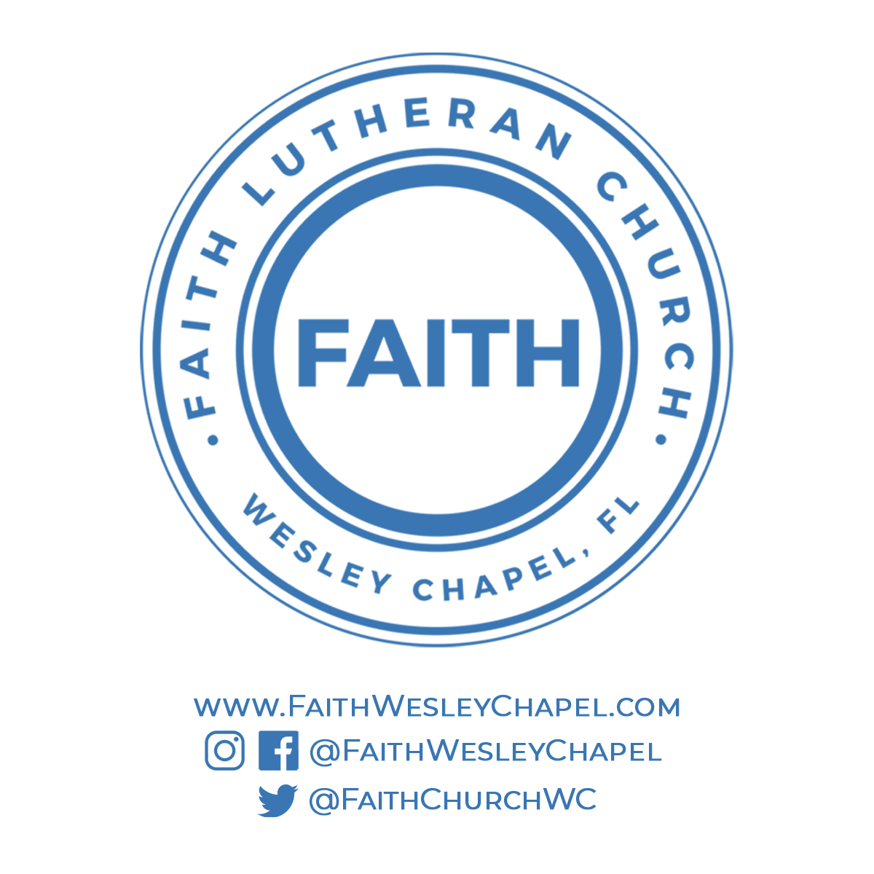**@FaithWesleyChapel**

**@FaithWesleyChapel**

**@FaithChurchWC**