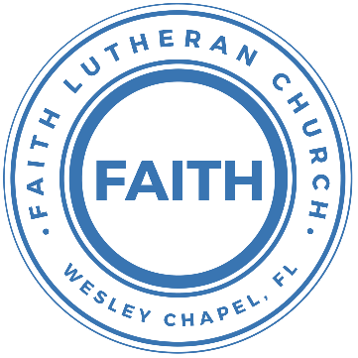

**Leading our community into a deep connection in Christ**

**Worship Service for February 27, 2022 at 11 AM**

**Welcome**

**Invocation**

**Psalm 99**

P: The Lord reigns; let the peoples tremble!

C: He sits enthroned upon the cherubim; let the earth quake!

P: The Lord is great in Zion; he is exalted over all the peoples.

C: Let them praise your great and awesome name!

All: Holy is he!

P: The King in his might loves justice.

Men: You have established equity;

Women: you have executed justice and righteousness in Jacob.

P: Exalt the Lord our God; worship at his footstool!

All: Holy is he!

P: Moses and Aaron were among his priests,

Men: Samuel also was among those who called upon his name.

Women: They called to the Lord, and he answered them.

P: In the pillar of the cloud he spoke to them;

C: they kept his testimonies and the statute that he gave them.

P: O Lord our God, you answered them;

Men: you were a forgiving God to them,

Women: but an avenger of their wrongdoings.

P: Exalt the Lord our God, and worship at his holy mountain;

All: for the Lord our God is holy!

**Confession and Forgiveness:**

P: When we come into the presence of God we cannot help but see our sinfulness. God does not require us to cleanse our own sin and be perfect of our own power for, surely, we could never achieve this. Instead, He tells us to come as we are and receive His great mercy.

**Song:** Come As You Are

Verse 1:

Come out of sadness, From wherever you've been

Come broken hearted, Let rescue begin

Come find your mercy, Oh sinner come kneel

Earth has no sorrow that Heaven can't heal

Earth has no sorrow that Heaven can't heal

Chorus:

So lay down your burdens, Lay down your shame

All who are broken, Lift up your face

Oh wanderer come home, You're not too far

So lay down your hurt, Lay down your heart,

Come as you are

Verse 2:

There's hope for the hopeless, and all those who've strayed

Come sit at the table, Come taste of the grace

There's rest for the weary, rest that endures

Earth has no sorrow that Heaven can't cure

Chorus

Bridge:

Come as you are. Fall in his arms. Come as you are.

*(a time of silence to reflect and personally confess our sins)*

C: Heavenly Father, we confess that we have sinned against you and each other. We are truly sorry and we humbly repent. For the sake of your Son Jesus Christ and His suffering and death on the cross, please forgive us and help us to live according to Your ways. Amen

Verse 3:

There's joy for the morning, Oh sinner be still

Earth has no sorrow that Heaven can't heal

Earth has no sorrow that Heaven can't heal

Chorus

P: The Lord our God is merciful and gracious, longsuffering, and abounding in goodness and truth, keeping mercy for thousands, forgiving iniquity and transgression and sin. Therefore I announce unto you the grace of our Lord Jesus Christ. In His stead and by the command of my Lord Jesus Christ, I forgive you all your sins in the name of the Father and of the Son and of the Holy Spirit.

C: Amen.

**Song of Praise and Thanksgiving -** Beautiful Savior

Beautiful Savior, King of creation,  
Son of God and Son of man.  
Truly I’d love Thee, Truly I’d serve Thee  
Light of my soul, my joy, my crown.

Fair are the meadows. Fair is the woodlands  
Robed in the flow’rs of blooming spring  
Jesus is fairer. Jesus is purer.   
He makes our sorrowing spirit sing

Beautiful Savior, Lord of the nations,  
Son of God and Son of man.  
Glory and honor, praise adoration,  
Now and forever more be Thine!

**Old Testament Reading -**Deuteronomy 34:1–12

Then Moses went up from the plains of Moab to Mount Nebo, to the top of Pisgah, which is opposite Jericho. And the Lord showed him all the land, Gilead as far as Dan, all Naphtali, the land of Ephraim and Manasseh, all the land of Judah as far as the western sea, the Negeb, and the Plain, that is, the Valley of Jericho the city of palm trees, as far as Zoar. And the Lord said to him, “This is the land of which I swore to Abraham, to Isaac, and to Jacob, ‘I will give it to your offspring.’ I have let you see it with your eyes, but you shall not go over there.” So Moses the servant of the Lord died there in the land of Moab, according to the word of the Lord, and he buried him in the valley in the land of Moab opposite Beth-peor; but no one knows the place of his burial to this day. Moses was 120 years old when he died. His eye was undimmed, and his vigor unabated. And the people of Israel wept for Moses in the plains of Moab thirty days. Then the days of weeping and mourning for Moses were ended.

And Joshua the son of Nun was full of the spirit of wisdom, for Moses had laid his hands on him. So the people of Israel obeyed him and did as the Lord had commanded Moses. And there has not arisen a prophet since in Israel like Moses, whom the Lord knew face to face, none like him for all the signs and the wonders that the Lord sent him to do in the land of Egypt, to Pharaoh and to all his servants and to all his land, and for all the mighty power and all the great deeds of terror that Moses did in the sight of all Israel.

Reader: This is the Word of the Lord.  
C: Thanks be to God.

**Epistle Reading -** Hebrews 3:1-6

Therefore, holy brothers, you who share in a heavenly calling, consider Jesus, the apostle and high priest of our confession, who was faithful to him who appointed him, just as Moses also was faithful in all God's house. For Jesus has been counted worthy of more glory than Moses—as much more glory as the builder of a house has more honor than the house itself. (For every house is built by someone, but the builder of all things is God.) Now Moses was faithful in all God's house as a servant, to testify to the things that were to be spoken later, but Christ is faithful over God's house as a son. And we are his house, if indeed we hold fast our confidence and our boasting in our hope.

Reader: This is the Word of the Lord.  
C: Thanks be to God.

**Children's Message**

**Gospel Reading -** Luke 9:28–36

Now about eight days after these sayings he took with him Peter and John and James and went up on the mountain to pray. And as he was praying, the appearance of his face was altered, and his clothing became dazzling white. And behold, two men were talking with him, Moses and Elijah, who appeared in glory and spoke of his departure, which he was about to accomplish at Jerusalem. Now Peter and those who were with him were heavy with sleep, but when they became fully awake they saw his glory and the two men who stood with him. And as the men were parting from him, Peter said to Jesus, “Master, it is good that we are here. Let us make three tents, one for you and one for Moses and one for Elijah”—not knowing what he said. As he was saying these things, a cloud came and overshadowed them, and they were afraid as they entered the cloud. And a voice came out of the cloud, saying, “This is my Son, my Chosen One; listen to him!” And when the voice had spoken, Jesus was found alone. And they kept silent and told no one in those days anything of what they had seen.

P: This is the Gospel of the Lord.  
C: Praise be to You, o Christ.

**Sermon Hymn -** Amazing Grace

Amazing grace,   
how sweet the sound that saved a wretch like me  
I once was lost, but now am found.   
Was blind but now I see.

T'was grace that taught my heart to fear,   
and grace my fears relieved.  
How precious did that grace appear,   
the hour I first believed.

Through many dangers, toils and snares,   
we have already come,   
T'was grace hath brought us safe thus far   
and grace will lead us home

When we've been there ten thousand years,   
bright shining as the sun  
we've no less days to sing God’s praise,  
than when we've first begun

**Sermon -** Series: Breaking Down the Barriers to a Deeper Faith Life  
 Week 8: Our Standing Before God

**Prayers:** *Text in prayer requests to (813) 602-1104‬*

**Apostles' Creed**

I believe in God, the Father almighty,  
maker of heaven and earth,

And in Jesus Christ, his only Son, our Lord,  
who was conceived by the Holy Spirit, born of the Virgin Mary,  
suffered under Pontius Pilate, was crucified, died and was buried.  
He descended into hell.  
The third day he rose again from the dead.  
He ascended into heaven and sits at the right hand of God  
the Father almighty.  
From there he will come to judge the living and the dead.

I believe in the Holy Spirit, the holy Christian Church,  
the communion of saints, the forgiveness of sins,  
the resurrection of the body, and the life everlasting. Amen.

**The Lord's Prayer**

Our Father who art in heaven, hallowed be Thy name, Thy kingdom come, Thy will be done on earth as it is in heaven.  Give us this day our daily bread; and forgive us our trespasses as we forgive those who trespass against us; and lead us not into temptation, but deliver us from evil.  For Thine is the kingdom and the power and the glory forever and ever.  Amen

**Words of Institution**

**Peace**

P: The peace of the Lord be with you all.  
C: And also, with you.  
P: We greet each other in the peace of Christ.

**Distribution**

**Prayer**

**Benediction**

**Closing Song -**Great Is Thy Faithfulness

Great is Thy faithfulness, O God my Father.  
There is no shadow of turning with Thee  
Thou changest not, Thy compassions they fail not.  
As Thou hast been, Thou forever wilt be.

Chorus:  
Great is Thy faithfulness! Great is Thy faithfulness!  
Morning by morning new mercies I see  
All I have needed Thy hand has provided.  
Great is Thy faithfulness, Lord unto me.

Summer and winter and springtime and harvest,  
Sun, moon and stars in their courses above  
Join with all nature in manifold witness  
To Thy great faithfulness mercy and love.

Chorus

Pardon for sin and a peace that endureth,  
Thine own dear presence to cheer and to guide;  
Strength for today and bright hope for tomorrow,  
Blessings all mine, with ten thousand beside.

Chorus:  
Great is Thy faithfulness! Great is Thy faithfulness!  
Morning by morning new mercies I see  
All I have needed Thy hand has provided.  
Great is Thy faithfulness, Lord unto me.

**Upcoming Events**

**March 2, 7 PM Ash Wednesday Service**  
Pastor Kurt’s Home  
4414 Crystal Downs Ct. Wesley Chapel, FL 33543

**March 21, 7 PM Council Meeting**  
Zoom

**March 27, Noon “Build Our Faith” Launch Dinner**  
Song and Dance

**From the LCMS**

Do you know any young man who would make a great pastor? How about someone who would be a great Lutheran school teacher, deaconess or DCE? Jesus gives His church people who work full time in service to the Gospel. He told us to pray for such workers. The LCMS continues to pray, and has begun [Set Apart to Serve](https://www.lcms.org/set-apart-to-serve) (SAS), an intentional effort to encourage young people to consider church work as their career. Your opinion can help improve SAS. Please fill out a brief survey at [lcms.org/set-apart-to-serve-survey](https://lcms.org/set-apart-to-serve-survey) by March 15, and let us know how you think SAS can be beneficial to your congregation. Thank you.

[**www.FaithWesleyChapel.com**](http://www.FaithWesleyChapel.com)

 **Faith YouTube**

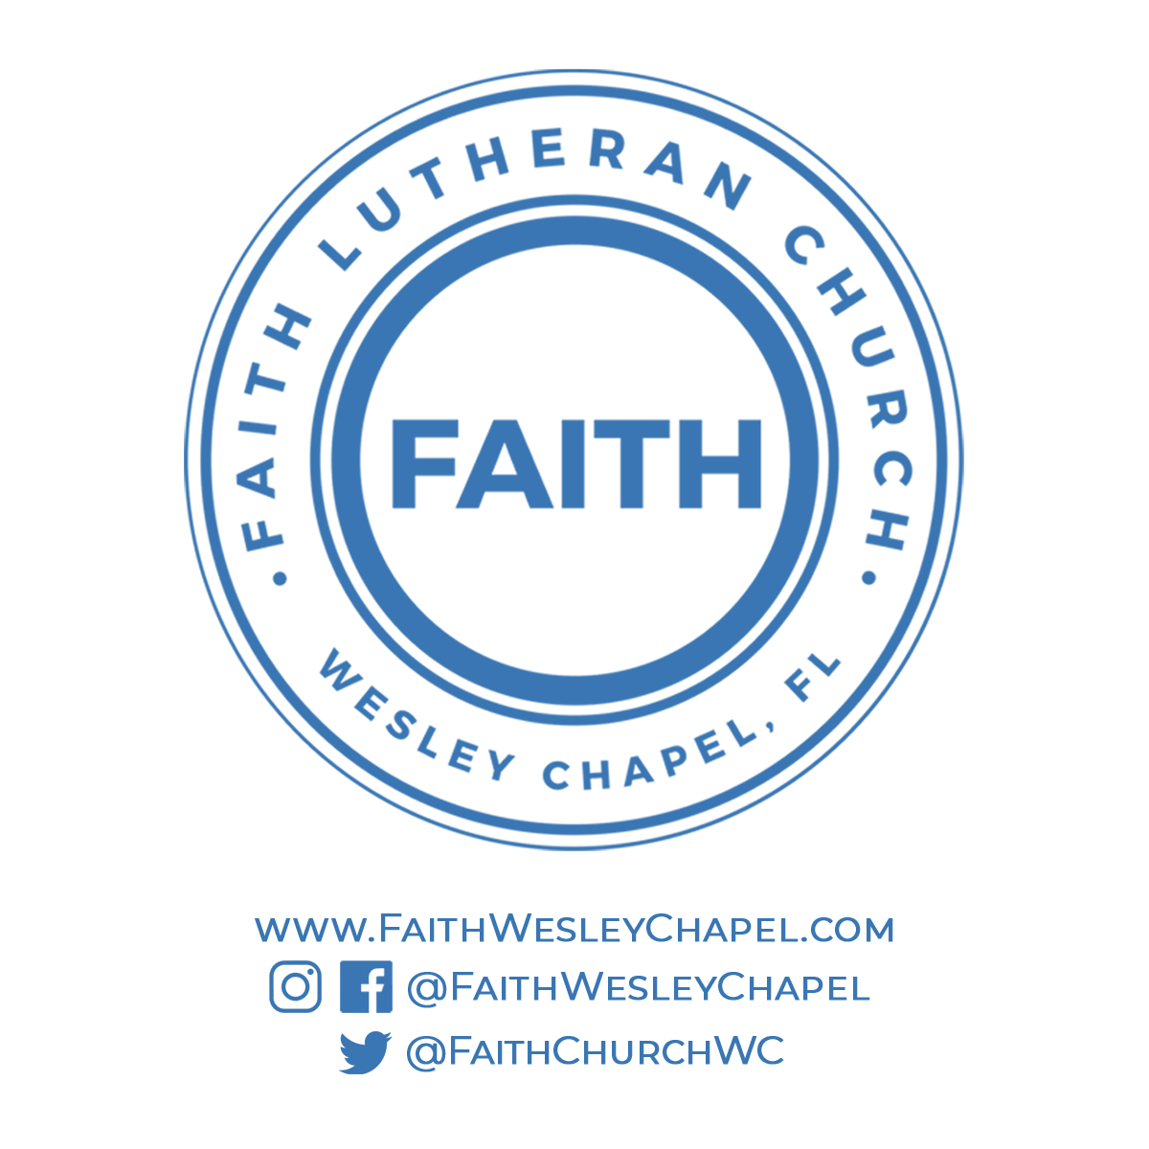**@FaithWesleyChapel**

**@FaithWesleyChapel**

**@FaithChurchWC**