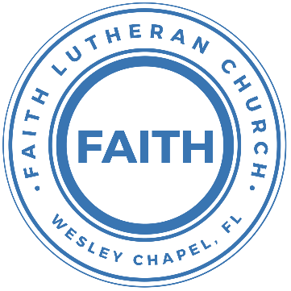

**Leading our community into a deep connection in Christ**

**Worship Service for April 3, 2022 at 11 AM**

**Welcome**

**Opening Song:**I Am a C-H-R-I-S-T-I-A-N

I am

I am C-H

I am C-H-R-I-S-T-I-A-N

And I have C-H-R-I-S-T

In my H-E-A-R-T

And I will L-I-V-E-E-T-E-R-N-A-L-L-Y

**Invocation**

**Confession and Forgiveness:**

P: We have come here today to worship the Lord.  In worship we hear the Word of God, we receive God's blessings, and respond with thanks and praise.  We begin by seeking God's blessing of forgiveness.  He has promised to remove the guilt and shame of our sin through the sacrifice of Jesus Christ on the cross.

P: Let us confess our sins to the Lord.

*(a time of silence to reflect and personally confess our sins)*

P: Heavenly Father,  
C: Heavenly Father,

P: I have done things that were wrong.  
C: I have done things that were wrong.  
  
P: I have been mean to others.  
C: I have been mean to others.

P: I have not obeyed my parents.  
C: I have not obeyed my parents.

P: I have not obeyed You, God.  
C: I have not obeyed You, God.

P: But I am very sorry.  
C: But I am very sorry.

P: Please forgive me.  
C: Please forgive me.

P: I love You very much.  
C: I love You very much.

P: And I know You love me, too.  
C: And I know You love me, too.

P: God has heard your apology.  He loves you very much.  God has told us that when we believe and trust in Him, He makes us His children.  As far as the east is from the west, so far does he remove our sins from us. He has told me to tell you that you are forgiven.  So, as His servant, I forgive you in the name of the Father and of the Son and of the Holy Spirit.

C: Amen.

**Song:**Jesus Loves Me

Jesus loves me this I know, For the Bible tells me so.

Little ones to Him belong, They are weak, but He is strong.

Chorus:

Yes, Jesus loves me, Yes, Jesus loves me,

Yes, Jesus loves me, The Bible tells me so.

Jesus loves me, He who died. Heaven's gates to open wide.

He will wash away my sin, Let His little child come in.

Chorus

**First Reading -**Luke 23:35-36a

The people stood there watching everything. The Jewish leaders laughed at Jesus. They said, “If he is God’s Chosen One, the Messiah, then let him save himself. He saved others, didn’t he?” Even the soldiers laughed at Jesus and made fun of him.

P: This is the Gospel of the Lord.  
C: Praise be to You, o Christ.

**Children's Message**"Hearing the Good over the Bad"

**Second Song:**I See You

God of love, God of all glory, every day I see new mercy  
Great is Your faithfulness  
God of love, God of my story, You never fail.   
You never forsake me  
Great is Your faithfulness

Chorus:  
I see You in the morning light. I feel You in the fire by night  
I hear You say, “Child, I am with you. Everything will be alright.”  
I see You in the tears that run. I feel You when the healing comes  
I hear You say, “Beloved one, I am with you.”   
Every moment of my life  
I see You. I see You. I see You. God, I see You

God of love, God of new vision, Every blessing You have given  
Great is Your faithfulness! Oh, how great is Your faithfulness

Chorus

I will worship through the storm,   
Through the storm, Through the storm  
All my hope is in You Lord, In You Lord, In You Lord   
I see You in the morning light  
I feel You in the fire by night  
I hear You say, “Child, I am with you.  
Everything will be alright.”

Chorus  
I see You in the morning light. I feel You in the fire by night  
I hear You say, “Child, I am with you. Everything will be alright.”  
I see You in the tears that run. I feel You when the healing comes  
I hear You say, “Beloved one, I am with you.”   
Every moment of my life  
I see You. I see You. I see You. God, I see You

**Second Reading -**Luke 23:39-43

One of the criminals hanging there began to shout insults at Jesus: “Aren’t you the Messiah, God's Chosen One? Then save yourself, and save us too!...if you can.”

But the other criminal stopped him. He said, “You should fear God. All of us will die soon. You and I are guilty. We deserve to die because we did wrong. But this man has done nothing wrong.” Then he said, “Jesus, remember me when you begin ruling as king!”

Then Jesus said to him, “I promise you, today you will be with me in paradise.”

P: This is the Gospel of the Lord.  
C: Praise be to You, o Christ.

**Children's Message**"You Never Know Who or When Someone Will Believe"

**Sermon Hymn*–***The King Shall Come When Morning Dawns

The King shall come when morning dawns

and light triumphant breaks,

When beauty gilds the eastern hills and life to joy awakes

Not as of old a little child to bear, and fight, and die,

but crowned with glory like the sun that lights the morning sky.

Oh, brighter than the rising morn when Christ, victorious, rose

and left the lonesome place of death despite the rage of foes

Oh, brighter than that glorious morn shall dawn upon our race

the day when Christ in splendor comes and we shall see his face.

The King shall come when morning dawns

and light and beauty brings;

Hail, Christ the Lord! Your people pray:

come quickly, King of kings!

**Sermon –**“Today and the Day to Come”

Sermon Text - Luke 23:26-43

And as they led him away, they seized one Simon of Cyrene, who was coming in from the country, and laid on him the cross, to carry it behind Jesus. And there followed him a great multitude of the people and of women who were mourning and lamenting for him. But turning to them Jesus said, “Daughters of Jerusalem, do not weep for me, but weep for yourselves and for your children. For behold, the days are coming when they will say, ‘Blessed are the barren and the wombs that never bore and the breasts that never nursed!’ Then they will begin to say to the mountains, ‘Fall on us,’ and to the hills, ‘Cover us.’ For if they do these things when the wood is green, what will happen when it is dry?”

Two others, who were criminals, were led away to be put to death with him. And when they came to the place that is called The Skull, there they crucified him, and the criminals, one on his right and one on his left. And Jesus said, “Father, forgive them, for they know not what they do.” And they cast lots to divide his garments. And the people stood by, watching, but the rulers scoffed at him, saying, “He saved others; let him save himself, if he is the Christ of God, his Chosen One!” The soldiers also mocked him, coming up and offering him sour wine and saying, “If you are the King of the Jews, save yourself!” There was also an inscription over him, “This is the King of the Jews.”

One of the criminals who were hanged railed at him, saying, “Are you not the Christ? Save yourself and us!” But the other rebuked him, saying, “Do you not fear God, since you are under the same sentence of condemnation? And we indeed justly, for we are receiving the due reward of our deeds; but this man has done nothing wrong.” And he said, “Jesus, remember me when you come into your kingdom.” And he said to him, “Truly, I say to you, today you will be with me in paradise.”

**Prayers:** *Text in prayer requests to (813) 602-1104‬*

**The Lord's Prayer**

Our Father who art in heaven, hallowed be Thy name, Thy kingdom come, Thy will be done on earth as it is in heaven.  Give us this day our daily bread; and forgive us our trespasses as we forgive those who trespass against us; and lead us not into temptation, but deliver us from evil.  For Thine is the kingdom and the power and the glory forever and ever.  Amen

**Words of Institution**

**Peace**

P: The peace of the Lord be with you all.  
C: And also, with you.  
P: We greet each other in the peace of Christ.

**Distribution**

**Prayer**

**Benediction**

**Closing Song –**What A Beautiful Name

You were the Word at the beginning   
One With God the Lord Most High  
Your hidden glory in creation  
Now revealed in You Our Christ

Chorus 1:  
What a beautiful Name it is, What a beautiful Name it is  
The Name of Jesus Christ my King  
What a beautiful Name it is, Nothing compares to this  
What a beautiful Name it is, The Name of Jesus

You didn't want heaven without us  
So Jesus You brought heaven Down  
My sin was great, Your love was greater  
What could separate us now

Chorus 2:  
What a wonderful Name it is, What a wonderful Name it is  
The Name of Jesus Christ my King  
What a wonderful Name it is, Nothing compares to this  
What a wonderful Name it is, The Name of Jesus  
What a wonderful Name it is, The Name of Jesus

Bridge:  
Death could not hold you, The veil tore before You   
You silenced the boast of sin and grave   
The heavens are roaring, the praise of Your glory   
For you are raised to life again   
You have no rival, You have no Equal   
Now and forever God You reign   
Yours is the Kingdom, Yours is the glory   
Yours is the Name above all names

Chorus 3:  
What a powerful Name it is, what a powerful Name it is  
The Name of Jesus Christ my King  
What a powerful Name it is, nothing can stand against  
What a powerful Name it is, The Name of Jesus  
What a powerful Name it is, The Name of Jesus  
What a powerful Name it is, The Name of Jesus

**Offering**

**Upcoming Events**

**April 3 - Youth Raffle Fundraiser Begins**Online

**April 3 – Confirmation**The Frosts

**April 10, After the Service – Bake Sale**  
Song and Dance

**April 14, 7 PM - Maundy Thursday Worship Service**  
The Chmiel’s Home

**April 15, 7 PM - Good Friday Worship Service**  
Song and Dance

**April 17, 11 AM – Easter Worship Service**  
Song and Dance

**April 24, After the Service – Voters’ Meeting**  
Song and Dance

**May 1 - Youth Raffle Fundraiser Drawing**Online

**www.FaithWesleyChapel.com**

**Faith YouTube**

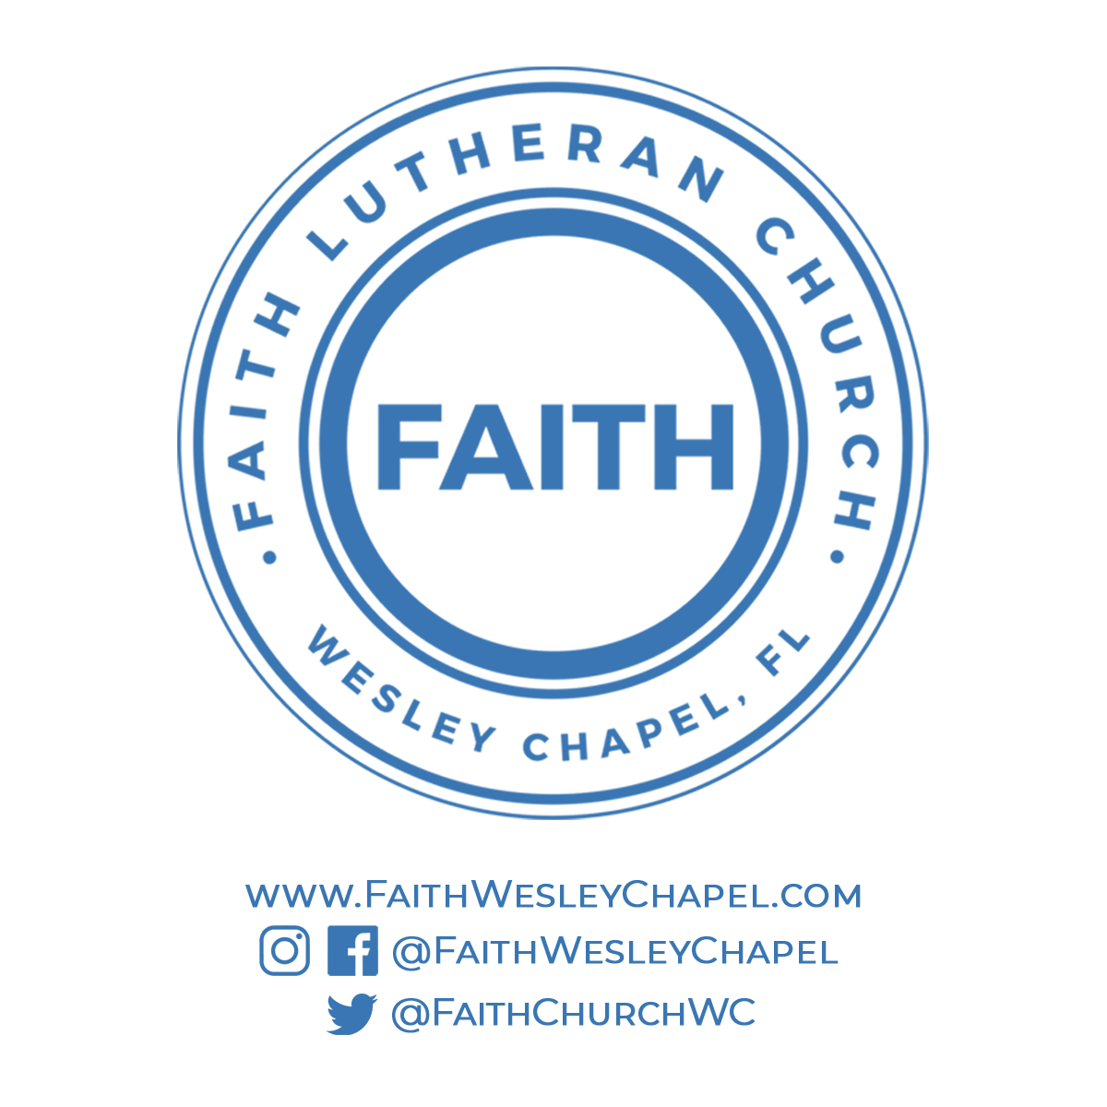**@FaithWesleyChapel**

**@FaithWesleyChapel**

**@FaithChurchWC**