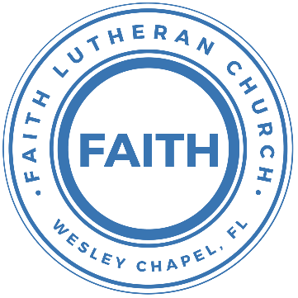

**Leading our community into a deep connection in Christ**

**Easter Worship Service for April 17, 2022, at 11:00 AM**

**Welcome**

P: He is risen!

**C: He is risen, indeed! Hallelujah!**

**Opening Song:**Jesus Christ is Risen, Today

Verse 1:

Jesus Christ is ris'n today, Alleluia!

Our triumphant holy day, Alleluia!

Who did once upon the cross, Alleluia!

Suffer to redeem our loss, Alleluia!

Verse 2:

Hymns of praise then let us sing, Alleluia!

Unto Christ, our heav'nly king, Alleluia!

Who endured the cross and grave, Alleluia!

Sinners to redeem and save, Alleluia!

Verse 3:

But the pains which He endured, Alleluia!

Our salvation have procured; Alleluia!

Now above the sky He’s king, Alleluia!

Where the angels ever sing, Alleluia!

Verse 4:

Sing we to our God above, Alleluia!

Praise eternal as His love; Alleluia!

Praise Him, all ye heav'nly host, Alleluia!

Father, Son, and Holy Ghost. Alleluia!

**Invocation**

**Confession and Forgiveness:**

**P:** Blessed be the Holy Trinity, the Father, Son, and Holy Spirit, one God, whose rising from the empty tomb brings to us the promise of life eternal. And so, we confess together in the presence of the living God,

**C:** We confess that we set our minds towards things of this dying world, and not on the life that is revealed in Christ. We have sinned against you and our neighbors. We have not loved you with our whole heart and we have not loved our neighbors as ourselves. We justly deserve Your punishment.  For the sake of Your Son, Jesus Christ, have mercy on us.  Forgive us, renew us, and lead us, so that we may delight in Your will and walk in Your ways to the glory of Your holy name.  Amen.

**P:** Our Lord and Savior Jesus Christ proclaims, “Do not be afraid!” Know that you are washed anew in his rising, and your sins are forgiven. Be at peace, and live in the everlasting love of God. Amen!

**C:** Amen

**Song of Praise and Thanksgiving:** Christ Is Risen

Let no one caught in sin remain Inside the lie of inward shame  
We fix our eyes upon the cross and run to Him who showed great love  
And bled for us. Freely You've bled for us

Chorus:  
Christ is risen from the dead, trampling over death by death  
Come awake, come awake, come and rise up from the grave  
Christ is risen from the dead, we are one with Him again  
Come awake, come awake, come and rise up from the grave

Beneath the weight of all our sin You bowed to none but Heaven's will  
No scheme of Hell, no scoffer's crown,   
No burden great can hold You down  
In strength, You reign. Forever let Your church proclaim

(Chorus)

O death, where is your sting? O hell, where is your victory?  
O church, come stand in the light.  
The glory of God has defeated the night!  
O death, where is your sting? O hell, where is your victory?  
O church, come stand in the light.  
Our God is not dead. He is alive! He is alive!

(Chorus)

**Old Testament Reading –**Genesis 12:1-4

Now the Lord said to Abram, “Go from your country and your kindred and your father's house to the land that I will show you. And I will make of you a great nation, and I will bless you and make your name great, so that you will be a blessing. I will bless those who bless you, and him who dishonors you I will curse, and in you all the families of the earth shall be blessed.”

So Abram went, as the Lord had told him, and Lot went with him. Abram was seventy-five years old when he departed from Haran.

**Reader:** This is the Word of the Lord. **C:** Thanks be to God.

**Epistle Reading –**2 Corinthians 1:18-20

As surely as God is faithful, our word to you has not been Yes and No. For the Son of God, Jesus Christ, whom we proclaimed among you, Silvanus and Timothy and I, was not Yes and No, but in him it is always Yes. For all the promises of God find their Yes in him. That is why it is through him that we utter our Amen to God for his glory.

**Reader:** This is the Word of the Lord. **C:** Thanks be to God.

**Children's Message**

**Gospel Reading** – Luke 24:1-12

But on the first day of the week, at early dawn, they went to the tomb, taking the spices they had prepared. And they found the stone rolled away from the tomb, but when they went in they did not find the body of the Lord Jesus. While they were perplexed about this, behold, two men stood by them in dazzling apparel. And as they were frightened and bowed their faces to the ground, the men said to them, “Why do you seek the living among the dead? He is not here, but has risen. Remember how he told you, while he was still in Galilee, that the Son of Man must be delivered into the hands of sinful men and be crucified and on the third day rise.” And they remembered his words, and returning from the tomb they told all these things to the eleven and to all the rest. Now it was Mary Magdalene and Joanna and Mary the mother of James and the other women with them who told these things to the apostles, but these words seemed to them an idle tale, and they did not believe them. But Peter rose and ran to the tomb; stooping and looking in, he saw the linen cloths by themselves; and he went home marveling at what had happened.

**P:** This is the Gospel of the Lord.  
**C:** Praise be to You, o Christ.

**Sermon Hymn**: Mighty To Save

Verse 1:

Everyone needs compassion, A Love that's never failing

Let mercy fall on me

Everyone needs forgiveness, The kindness of a savior,

The hope of nations

Chorus:

Savior, he can move the mountains,

My God is mighty to save. He is mighty to save

Forever, author of salvation

He rose and conquered the grave. Jesus conquered the grave

Verse 2:

So take me as you find me, All my fears and failures

And fill my life again

I give my life to follow Everything I believe in.

Now I surrender (I surrender)

(Chorus)

Bridge:

Shine your light and let the whole world see singing,

For the glory of the risen king, Jesus

Shine your light and let the whole world see singing,

For the glory of the risen king

(Chorus2x)

**Sermon** – “The Power of the Easter Promise”

**Prayers:** *Text in prayer requests to (813) 602-1104‬*

**Nicene Creed**

I believe in one God, the Father Almighty, maker of heaven and earth and of all things visible and invisible.

And in one Lord Jesus Christ, the only-begotten Son of God, begotten of His Father before all worlds, God of God, Light of Light, very God of very God, begotten, not made, being of one substance with the Father, by whom all things were made; who for us men and for our salvation came down from heaven and was incarnate by the Holy Spirit of the virgin Mary and was made man; and was crucified also for us under Pontius Pilate. He suffered and was buried. And the third day He rose again according to the Scriptures and ascended into heaven and sits at the right hand of the Father. And He will come again with glory to judge both the living and the dead, whose kingdom will have no end.

And I believe in the Holy Spirit, the Lord and Giver of Life, who proceeds from the Father and the Son, who with the Father and the Son together is worshiped and glorified, who spoke by the prophets. And I believe in one holy Christian and apostolic Church, I acknowledge one Baptism for the remission of sins, and I look for the resurrection of the dead and the life of the world to come. Amen.

**The Lord's Prayer**

Our Father who art in heaven, hallowed be Thy name, Thy kingdom come, Thy will be done on earth as it is in heaven.  Give us this day our daily bread; and forgive us our trespasses as we forgive those who trespass against us; and lead us not into temptation, but deliver us from evil.  For Thine is the kingdom and the power and the glory forever and ever.  Amen

**Words of Institution**

**Peace**

P: The peace of the Lord be with you all.  
C: And also, with you.  
P: We greet each other in the peace of Christ.

**Distribution**

**Prayer**

**Benediction**

**Closing Song:**Our God/All Hail the Power of Jesus Christ

Our God -Verse1:

Water You turned into wine, Opened the eyes of the blind

There's no one like You, None like You

Our God -Verse2:

Into the darkness You shine, Out of the ashes we rise

There's no one like You, None like You

Our God - Chorus:

Our God is greater. Our God is stronger.

God, You are higher than any other

Our God is healer, Awesome in power, Our God, Our God

Crown Him -Verse1:

All hail the pow'r of Je- sus' name! Let angels prostrate fall;

Bring forth the royal diadem And crown Him Lord of all

Bring forth the royal diadem And crown Him Lord of all

Crown Him -Verse3:

Ye seed of Israel's chosen race, Ye ransomed from the fall,

Hail Him who saves you by His grace And crown Him Lord of all

Hail Him who saves you by His grace And crown Him Lord of all

(Our God -Verse2)

(Our God -Chorus1x)

**Offering**

**Upcoming Events**

**April 18, 11 AM – Council Meeting**  
Zoom

**April 24, After the Service – Voters’ Meeting**  
Song and Dance

**April 24, After the Service – Bake Sale**  
Song and Dance  
More info at: FaithWesleyChapel.com/bake-sale/

**April 24, 4 PM – Confirmation**The Shucks (lessons 20, 21, & 22)

**May 1 - Youth Raffle Fundraiser Drawing**Online  
More info at: FaithWesleyChapel.com/youth-raffle/

**www.FaithWesleyChapel.com**

**Faith YouTube**

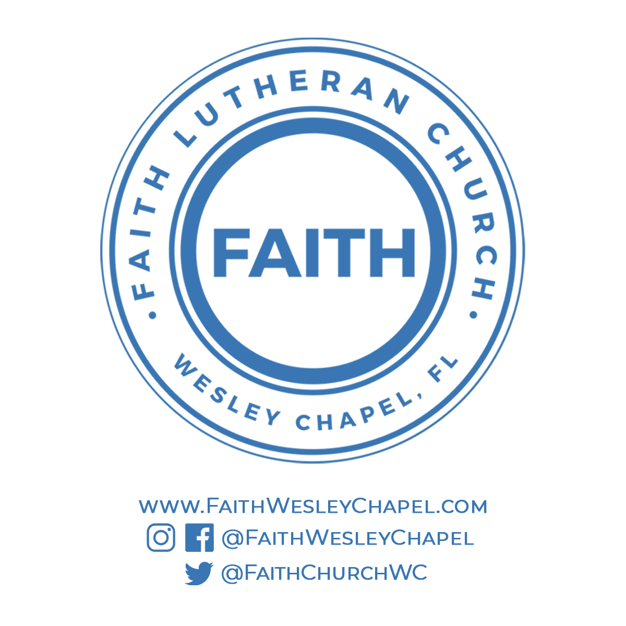**@FaithWesleyChapel**

**@FaithWesleyChapel**

**@FaithChurchWC**