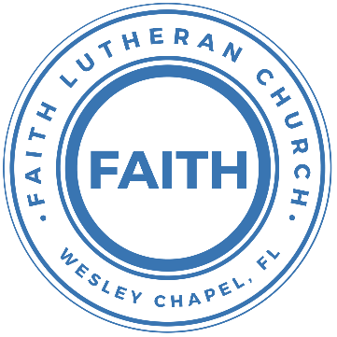

**Leading our community into a deep connection in Christ**

**Worship Service for May 22, 2022 at 11 AM**

**Welcome**

**Invocation**

**Confession and Forgiveness:**

**P:** Come into the presence of the Lord our God.

**C:** Have mercy, O Lord. If you, Lord, kept a record of sins, Lord, who could stand; but if we confess our sins, he is faithful and just to forgive us our sins and to cleanse us from all unrighteousness.

*(a time of silence to reflect and personally confess our sins)*

**P:** I said, "I will confess my transgressions to the LORD." And you forgave the guilt of my sin. Let us confess our sin before the Lord. Let us confess together.

**C:** Heavenly Father, we confess that we are sinners.  We have sinned against you and our neighbors. We have not loved you with our whole heart and we have not loved our neighbors as ourselves. We justly deserve Your punishment.  For the sake of Your Son, Jesus Christ, have mercy on us.  Forgive us, renew us, and lead us, so that we may delight in Your will and walk in Your ways to the glory of Your holy name.  Amen.

**P:** Almighty God in His mercy has given His Son to die for you and for His sake forgives you all your sins.  Here the good news of Jesus Christ. If we confess our sins, He is faithful and just to forgive our sins and cleanse us of all unrighteousness. Therefore, upon your confession, I announce to you that your sins and forgiven.

**C:** Amen

**Song of Praise and Thanksgiving –** Great Is Thy Faithfulness

Verse 1:

Great is Thy faithfulness, O God my Father.

There is no shadow of turning with Thee

Thou changest not, Thy compassions they fail not.

As Thou hast been, Thou forever wilt be.

Chorus:

Great is Thy faithfulness! Great is Thy faithfulness!

Morning by morning new mercies I see

All I have needed Thy hand has provided.

Great is Thy faithfulness, Lord unto me.

Verse 2:

Summer and winter and springtime and harvest,

Sun, moon and stars in their courses above

Join with all nature in manifold witness

To Thy great faithfulness mercy and love.

(Chorus)

Verse 3:

Pardon for sin and a peace that endureth,

Thine own dear presence to cheer and to guide;

Strength for today and bright hope for tomorrow,

Blessings all mine, with ten thousand beside.

(Chorus)

**First Reading –**Acts 16:9-15

And a vision appeared to Paul in the night: a man of Macedonia was standing there, urging him and saying, “Come over to Macedonia and help us.” And when Paul had seen the vision, immediately we sought to go on into Macedonia, concluding that God had called us to preach the gospel to them.

So, setting sail from Troas, we made a direct voyage to Samothrace, and the following day to Neapolis, and from there to Philippi, which is a leading city of the district of Macedonia and a Roman colony. We remained in this city some days. And on the Sabbath day we went outside the gate to the riverside, where we supposed there was a place of prayer, and we sat down and spoke to the women who had come together. One who heard us was a woman named Lydia, from the city of Thyatira, a seller of purple goods, who was a worshiper of God. The Lord opened her heart to pay attention to what was said by Paul. And after she was baptized, and her household as well, she urged us, saying, “If you have judged me to be faithful to the Lord, come to my house and stay.” And she prevailed upon us.

**Reader:** This is the Word of the Lord.  
**C:** Thanks be to God.

**Second Reading –**Revelation 21:9-14,21-27

Then came one of the seven angels who had the seven bowls full of the seven last plagues and spoke to me, saying, “Come, I will show you the Bride, the wife of the Lamb.” And he carried me away in the Spirit to a great, high mountain, and showed me the holy city Jerusalem coming down out of heaven from God, having the glory of God, its radiance like a most rare jewel, like a jasper, clear as crystal. It had a great, high wall, with twelve gates, and at the gates twelve angels, and on the gates the names of the twelve tribes of the sons of Israel were inscribed— on the east three gates, on the north three gates, on the south three gates, and on the west three gates. And the wall of the city had twelve foundations, and on them were the twelve names of the twelve apostles of the Lamb...

...And the twelve gates were twelve pearls, each of the gates made of a single pearl, and the street of the city was pure gold, like transparent glass.

And I saw no temple in the city, for its temple is the Lord God the Almighty and the Lamb. And the city has no need of sun or moon to shine on it, for the glory of God gives it light, and its lamp is the Lamb. By its light will the nations walk, and the kings of the earth will bring their glory into it, and its gates will never be shut by day—and there will be no night there. They will bring into it the glory and the honor of the nations. But nothing unclean will ever enter it, nor anyone who does what is detestable or false, but only those who are written in the Lamb's book of life.

**Reader:** This is the Word of the Lord.  
**C:** Thanks be to God.

**Gospel Reading –** John 5:1-17

After this there was a feast of the Jews, and Jesus went up to Jerusalem. Now there is in Jerusalem by the Sheep Gate a pool, in Aramaic called Bethesda, which has five roofed colonnades. In these lay a multitude of invalids—blind, lame, and paralyzed. One man was there who had been an invalid for thirty-eight years. When Jesus saw him lying there and knew that he had already been there a long time, he said to him, “Do you want to be healed?” The sick man answered him, “Sir, I have no one to put me into the pool when the water is stirred up, and while I am going another steps down before me.” Jesus said to him, “Get up, take up your bed, and walk.” And at once the man was healed, and he took up his bed and walked.

Now that day was the Sabbath. So the Jews said to the man who had been healed, “It is the Sabbath, and it is not lawful for you to take up your bed.” But he answered them, “The man who healed me, that man said to me, ‘Take up your bed, and walk.’” They asked him, “Who is the man who said to you, ‘Take up your bed and walk’?” Now the man who had been healed did not know who it was, for Jesus had withdrawn, as there was a crowd in the place. Afterward Jesus found him in the temple and said to him, “See, you are well! Sin no more, that nothing worse may happen to you.” The man went away and told the Jews that it was Jesus who had healed him. And this was why the Jews were persecuting Jesus, because he was doing these things on the Sabbath. But Jesus answered them, “My Father is working until now, and I am working.”

**P:** This is the Gospel of the Lord.  
**C:** Praise be to You, o Christ.

**Children's Message**

**Sermon Hymn –** Beautiful Savior

Beautiful Savior, King of creation,

Son of God and Son of man.

Truly I’d love Thee, Truly I’d serve Thee

Light of my soul, my joy, my crown.

Fair are the meadows. Fair is the woodlands

Robed in the flow’rs of blooming spring

Jesus is fairer. Jesus is purer.

He makes our sorrowing spirit sing

Beautiful Savior, Lord of the nations,

Son of God and Son of man.

Glory and honor, praise adoration,

Now and forevermore be Thine!

**Sermon -** "Jesus Still Healed Him"

**Prayers:** *Text in prayer requests to (813) 602-1104‬*

**Apostles' Creed**

I believe in God, the Father almighty,  
maker of heaven and earth,

And in Jesus Christ, his only Son, our Lord,  
who was conceived by the Holy Spirit,  
born of the Virgin Mary,  
suffered under Pontius Pilate,  
was crucified, died and was buried.  
He descended into hell.  
The third day he rose again from the dead.  
He ascended into heaven and sits at the right hand of God  
the Father almighty.  
From there he will come to judge the living and the dead.

I believe in the Holy Spirit,  
the holy Christian Church,  
the communion of saints,  
the forgiveness of sins,  
the resurrection of the body,  
and the life everlasting. Amen.

**The Lord's Prayer**

Our Father who art in heaven, hallowed be Thy name, Thy kingdom come, Thy will be done on earth as it is in heaven.  Give us this day our daily bread; and forgive us our trespasses as we forgive those who trespass against us; and lead us not into temptation, but deliver us from evil.  For Thine is the kingdom and the power and the glory forever and ever.  Amen

**Benediction**

The Lord bless you and keep you

The Lord make His face to shine upon you and be gracious to you

The Lord look upon you with His favor and give you peace.

Amen.

**Closing Song –**Go My Children With My Blessing

Verse 1:

Go, My children, with My blessing, Never alone.

Waking, sleeping, I am with you; You are My own.

In My love’s baptismal river I have made you Mine forever.

Go, My children, with My blessing, You are My own.

Verse 2:

Go, My children, sins forgiven, At peace and pure.

Here you learned how much I love you, What I can cure.

Here you heard My dear Son’s story;  
Here you touched Him, saw His glory.

Go, My children, sins forgiven, At peace and pure.

Verse 3: (Piano only)

Go, My children, fed and nourished, Closer to Me;

Grow in love and love by serving, Joyful and free.

Here My Spirit’s power-filled you;  
Here His tender comfort stilled you.

Go, My children, fed and nourished, Joyful and free.

**Offering**

**Upcoming Events**

**Today, 4 PM, Confirmation**Zoom (lessons 23, 24, & 25)

**May 25, 7 PM Special Council Meeting**  
Zoom

**Social Media**

Do you have any pictures or videos of past events at Faith? Please send them to Aaron so he can post them to our social media accounts. [ashuck77@gmail.com](mailto:ashuck77@gmail.com) Thanks!

**--------------------------- Faith’s Financial Update ---------------------------**

May's Budgeted Expenses: $6,615

May's General Fund Gifts and Offerings to Date: $2,400

**----------------------------------------------------------------------------------------**

[**www.FaithWesleyChapel.com**](http://www.FaithWesleyChapel.com)

 **Faith YouTube**

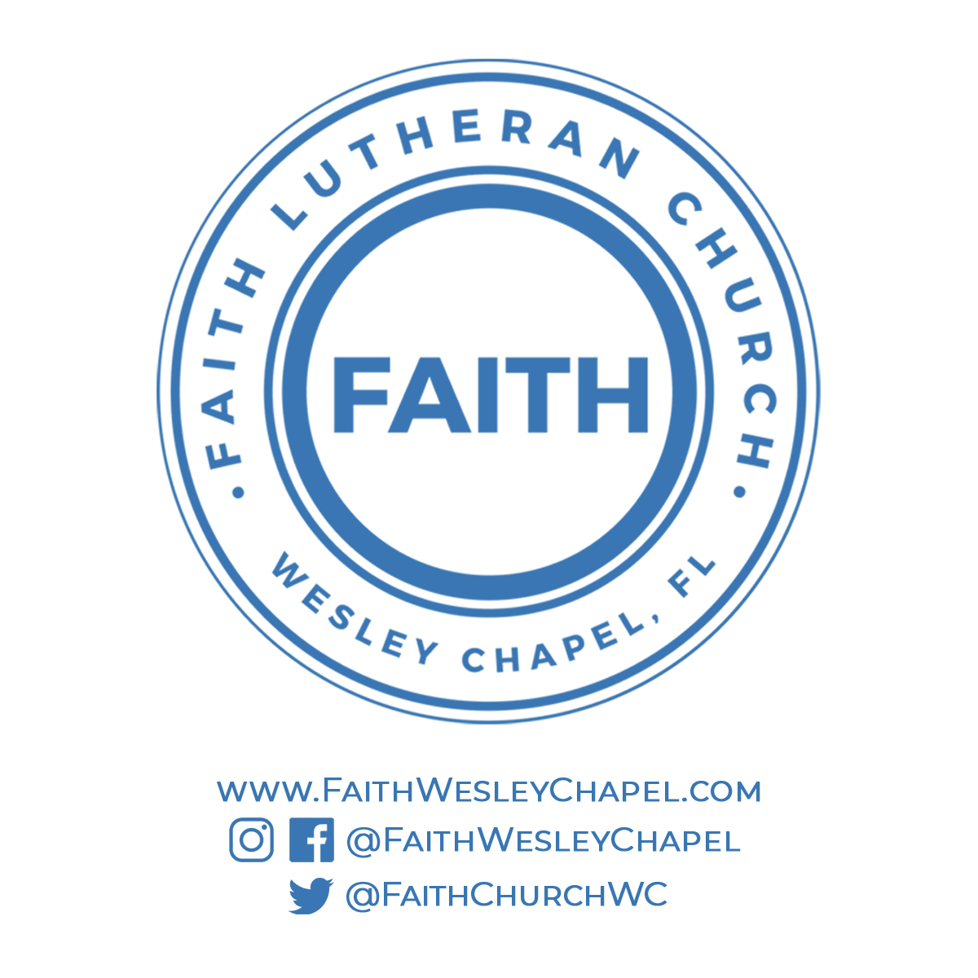**@FaithWesleyChapel**

**@FaithWesleyChapel**

**@FaithChurchWC**