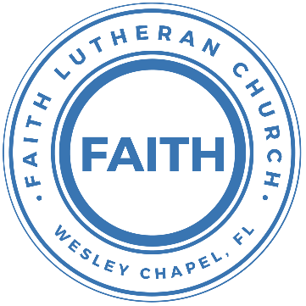

**Leading our community into a deep connection in Christ**

**Worship Service for May 29, 2022 at 11 AM**

**Ascension Sunday**

**Welcome**

**Invocation**

**Confession and Forgiveness:**

**P:** As we gather, today, let us cleanse our hearts and our consciences by confessing our sin to God.

*(Time of silence for reflection and confession)*

**P:** Today, we confess our sins by singing the song, “Lord, I Need You.”

**Song of Confession:** Lord, I Need You

Lord I come, I confess. Bowing here I find my rest  
Without You, I fall apart. You're the one that guides my heart

Chorus:  
Lord, I need You, oh I need You. Every hour I need You  
My one defense, my righteousness, Oh God, how I need You

Where sin runs deep, Your grace is more.  
Where grace is found is where You are  
And where You are Lord I am free. Holiness is Christ in me

Chorus:  
Lord, I need You, oh I need You. Every hour I need You  
My one defense, my righteousness, Oh God, how I need You

So teach my song to rise to You When temptation comes my way  
And when I cannot stand I'll fall on You.   
Jesus You're my hope and stay

Chorus

Lord, I need You, oh I need You. Every hour I need You  
My one defense, my righteousness, Oh God, how I need You  
My one defense, my righteousness, Oh God, how I need You  
My one defense, my righteousness, Oh God, how I need You

**P:** The Lord has heard your confession. Therefore, as a called and ordained servant of the Lord, in the stead and by the command of my Lord, Jesus Christ, I forgive you all your sins in the name of the Father and of the Son and of the Holy Spirit.

**C:** Amen

**Song of Praise and Thanksgiving –** All The People Said Amen

Verse 1:

You are not alone, if you are lonely

When you feel afraid, you're not the only

We are all the same, in need of mercy

To be forgiven and be free

It's all you got to lean on but thank God it's all you need

Chorus:

And all the people said Amen, woah

And all the people said Amen

Give thanks to the Lord for His love never ends

And all the people said Amen (Last line repeated on last chorus)

Verse 2:

If you're rich or poor, well it don't matter

Weak or strong, you know love is what we're after

We're all broken, but we're all in this together

God knows we stumble and fall

And He so loved the world, He sent His son to save us all

(Chorus)

Bridge:

Blessed are the poor in spirit who are torn apart

Blessed are the persecuted and the pure in heart

Blessed are the people hungry for another start

For this is the kingdom, the kingdom of God

(Chorus 2x)

**Baptism –** Luke William Strasheim

**The Lord's Prayer**

Our Father who art in heaven, hallowed be Thy name, Thy kingdom come, Thy will be done on earth as it is in heaven.  Give us this day our daily bread; and forgive us our trespasses as we forgive those who trespass against us; and lead us not into temptation, but deliver us from evil.  For Thine is the kingdom and the power and the glory forever and ever.  Amen

**First Reading –**Acts 1:1-11

In the first book, O Theophilus, I have dealt with all that Jesus began to do and teach, until the day when he was taken up, after he had given commands through the Holy Spirit to the apostles whom he had chosen. He presented himself alive to them after his suffering by many proofs, appearing to them during forty days and speaking about the kingdom of God.

And while staying with them he ordered them not to depart from Jerusalem, but to wait for the promise of the Father, which, he said, “you heard from me; for John baptized with water, but you will be baptized with the Holy Spirit not many days from now.”

So when they had come together, they asked him, “Lord, will you at this time restore the kingdom to Israel?” He said to them, “It is not for you to know times or seasons that the Father has fixed by his own authority. But you will receive power when the Holy Spirit has come upon you, and you will be my witnesses in Jerusalem and in all Judea and Samaria, and to the end of the earth.” And when he had said these things, as they were looking on, he was lifted up, and a cloud took him out of their sight. And while they were gazing into heaven as he went, behold, two men stood by them in white robes, and said, “Men of Galilee, why do you stand looking into heaven? This Jesus, who was taken up from you into heaven, will come in the same way as you saw him go into heaven.”

**Reader:** This is the Word of the Lord.  
**C:** Thanks be to God.

**Second Reading –**Ephesians 1:15-23

For this reason, because I have heard of your faith in the Lord Jesus and your love toward all the saints, I do not cease to give thanks for you, remembering you in my prayers, that the God of our Lord Jesus Christ, the Father of glory, may give you the Spirit of wisdom and of revelation in the knowledge of him, having the eyes of your hearts enlightened, that you may know what is the hope to which he has called you, what are the riches of his glorious inheritance in the saints, and what is the immeasurable greatness of his power toward us who believe, according to the working of his great might that he worked in Christ when he raised him from the dead and seated him at his right hand in the heavenly places, far above all rule and authority and power and dominion, and above every name that is named, not only in this age but also in the one to come. And he put all things under his feet and gave him as head over all things to the church, which is his body, the fullness of him who fills all in all.

**Reader:** This is the Word of the Lord.  
**C:** Thanks be to God.

**Children's Message** *(Children dismissed to Children's Church)*

**Gospel Reading –** Luke 24:44-53

Then he said to them, “These are my words that I spoke to you while I was still with you, that everything written about me in the Law of Moses and the Prophets and the Psalms must be fulfilled.” Then he opened their minds to understand the Scriptures, and said to them, “Thus it is written, that the Christ should suffer and on the third day rise from the dead, and that repentance for the forgiveness of sins should be proclaimed in his name to all nations, beginning from Jerusalem. You are witnesses of these things. And behold, I am sending the promise of my Father upon you. But stay in the city until you are clothed with power from on high.”

And he led them out as far as Bethany, and lifting up his hands he blessed them. While he blessed them, he parted from them and was carried up into heaven. And they worshiped him and returned to Jerusalem with great joy, and were continually in the temple blessing God.

**P:** This is the Gospel of the Lord.  
**C:** Praise be to You, o Christ.

**Sermon Hymn –** The Church’s One Foundation

Verse 1:

The church's one foundation is Jesus Christ, her Lord;

she is his new creation by water and the Word:

from heav'n he came and sought her to be his holy bride;

with his own blood he bought her, and for her life he died.

Verse 2:

Elect from ev'-ry nation, yet one o'er all the earth,

her charter of salvation one Lord, one faith, one birth;

one holy name she blesses, partakes one holy food,

and to one hope she presses, with ev'ry grace endued.

Verse 5:

Yet she on earth hath union with God the Three in One,

and mystic sweet communion with those whose rest is won:

O blessed heav'nly chorus! Lord, save us by Your grace,

that we, like saints before us, may see You face to face.

**Sermon -** "Stepping Into Something New"

**Prayers:** *Text in prayer requests to (813) 602-1104‬*

**Apostles' Creed**

I believe in God, the Father almighty, maker of heaven and earth,

And in Jesus Christ, his only Son, our Lord,  
who was conceived by the Holy Spirit, born of the Virgin Mary,  
suffered under Pontius Pilate, was crucified, died and was buried.  
He descended into hell.  
The third day he rose again from the dead.  
He ascended into heaven and sits at the right hand of God  
the Father almighty.  
From there he will come to judge the living and the dead.

I believe in the Holy Spirit, the holy Christian Church,  
the communion of saints, the forgiveness of sins,  
the resurrection of the body, and the life everlasting. Amen.

**Words of Institution**

**Peace**

P: The peace of the Lord be with you all.  
C: And also, with you.  
P: We greet each other in the peace of Christ.

**Distribution**

**Prayer**

**Benediction**

**Closing Song –**I Will Follow

Where You go, I’ll go Where You stay, I’ll stay

When You move, I’ll move I will follow...

Verse 1:

All Your ways are good All Your ways are sure

I will trust in You alone

Higher than my sight High above my life

I will trust in You alone

Chorus:

Where You go, I’ll go Where You stay, I’ll stay

When You move, I’ll move I will follow You

Who You love, I'll love How You serve I'll serve

If this life I lose, I will follow You, Yeah.

I will follow You

Verse 2:

Light unto the world Light unto my life

I will live for You alone

You're the one I seek Knowing I will find

All I need in You alone, in You alone

Chorus

Bridge:

In You there's life everlasting

In You there's freedom for my soul

In You there's joy, unending joy

and I will follow

Chorus 2x

**Offering**

**Sermon Notes:**

**_______________________________________________**

**_______________________________________________**

**_______________________________________________**

**_______________________________________________**

**Upcoming Events**

**June 5, 4 PM, Confirmation**The Frosts (lessons 26 and 27)

**June 12, After Worship, Congregational Game Day**  
Song and Dance

**June 12, 7 PM, MS/HS Youth Bible Study**  
Zoom

**June 14, 2 PM, Farm / Petting Zoo**  
Bushel and a Peck Acres – 26525 Dayflower Blvd – $5/person

**Date/Time TBD, Youth Game Night**  
Location TBD

**--------------------------- Faith’s Financial Update ---------------------------**

May's Budgeted Expenses: $6,615

May's General Fund Gifts and Offerings to Date: $2,796.80

**----------------------------------------------------------------------------------------**

[**www.FaithWesleyChapel.com**](http://www.FaithWesleyChapel.com)

 **Faith YouTube**

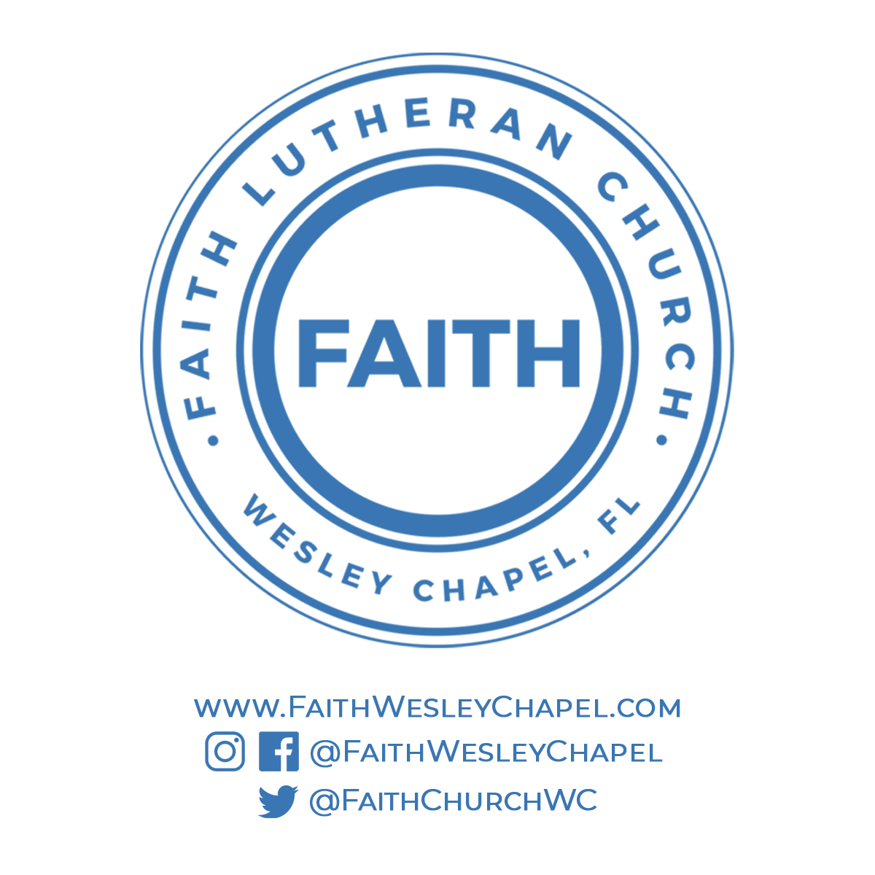**@FaithWesleyChapel**

**@FaithWesleyChapel**

**@FaithChurchWC**