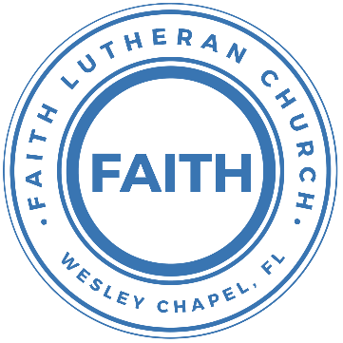

**Leading our community into a deep connection in Christ**

**Worship Service for June 19, 2022 at 11 AM**

**Welcome**

**Opening Song –** Now All the Vault of Heaven Resounds

Now all the vault of Heav'n resounds

In praise of love that still abound,

Christ has triumphed, He is living!"

Sing, choirs of angels, loud and clear,

Repeat their song of glory here,

Christ has triumphed, Christ has triumphed!

Alleluia, alleluia, alleluia.

Eternal is the gift He brings,

Therefore, our heart with rapture sings,

Christ has triumphed, He is living!"

Now, still, He comes to give us life,

And by His presence stills all strife

Christ has triumphed! He is living!

Alleluia, alleluia, alleluia.

Adoring praises now we bring

And with the heavenly blessed sing,

Christ has triumphed, Alleluia!

Be to the Father, and our Lord,

To Spirit blest, most holy God,

All the glory, never-ending!

Alleluia, alleluia, alleluia.

**Invocation**

**Confession and Forgiveness:**

**P:** Our Heavenly Father asks us to come into His presence.

**C:** But we are sinful and unworthy.

**P:** Yes, all have sinned and fall short of the glory of God, but Jesus Christ died on the cross that we may be forgiven and washed clean of all our sins by His blood spilled on the cross.

**C:** Lord, if You wash us, we will certainly be clean and pure.

**P:** We take a moment to bow before the cross and silently reflect on our lives and confess our sins.

*(Time of silence for reflection and confession)*

**P:** Let us confess, together, our sins to God our Father.

**C:** Heavenly Father, we confess that we are sinners.  We have sinned against you and our neighbors. We have not loved you with our whole heart and we have not loved our neighbors as ourselves. We have not lived out our faith in our community. We justly deserve Your punishment.  For the sake of Your Son, Jesus Christ, have mercy on us.  Forgive us, renew us, and lead us, so that we may delight in Your will and walk in Your ways to the glory of Your holy name.  Amen.

**P:** Almighty God in His mercy has given His Son to die for you and for His sake forgives you all your sins.  As a called and ordained servant of Christ, and by His authority, I, therefore, forgive you all your sins in the name of the Father and of the Son and of the Holy Spirit.

**C:** Amen

**Song of Praise and Thanksgiving:** Praise To The Lord The Almighty

Praise to the Lord The Almighty, the King of creation

O my soul, praise Him for He is your health and salvation

Let all who hear, now to His temple draw near

Joining in glad adoration

Praise to the Lord Who o’er all things is wondrously reigning

And as on wings of an eagle, uplifting, sustaining

Have you not seen, all that is needful has been

Sent by His gracious ordaining?

Praise to the Lord! O let all that is in me adore Him

All that has life and breath come now with praises before Him

Let the amen sound from His people again  
Gladly forever adore Him

**Old Testament Reading –**Isaiah 25:6-9

On this mountain the Lord of hosts will make for all peoples a feast of rich food, a feast of well-aged wine, of rich food full of marrow, of aged wine well refined. And he will swallow up on this mountain the covering that is cast over all peoples, the veil that is spread over all nations. He will swallow up death forever; and the Lord God will wipe away tears from all faces, and the reproach of his people he will take away from all the earth, for the Lord has spoken. It will be said on that day, “Behold, this is our God; we have waited for him, that he might save us. This is the Lord; we have waited for him; let us be glad and rejoice in his salvation.”

**Reader:** This is the Word of the Lord.  
**C:** Thanks be to God.

**Gospel Reading** – John 16:12-22

“I still have many things to say to you, but you cannot bear them now. When the Spirit of truth comes, he will guide you into all the truth, for he will not speak on his own authority, but whatever he hears he will speak, and he will declare to you the things that are to come. He will glorify me, for he will take what is mine and declare it to you. All that the Father has is mine; therefore I said that he will take what is mine and declare it to you.

“A little while, and you will see me no longer; and again a little while, and you will see me.” So some of his disciples said to one another, “What is this that he says to us, ‘A little while, and you will not see me, and again a little while, and you will see me’; and, ‘because I am going to the Father’?” So they were saying, “What does he mean by ‘a little while’? We do not know what he is talking about.” Jesus knew that they wanted to ask him, so he said to them, “Is this what you are asking yourselves, what I meant by saying, ‘A little while and you will not see me, and again a little while and you will see me’? Truly, truly, I say to you, you will weep and lament, but the world will rejoice. You will be sorrowful, but your sorrow will turn into joy. When a woman is giving birth, she has sorrow because her hour has come, but when she has delivered the baby, she no longer remembers the anguish, for joy that a human being has been born into the world. So also you have sorrow now, but I will see you again, and your hearts will rejoice, and no one will take your joy from you.

**P:** This is the Gospel of the Lord.  
**C:** Praise be to You, o Christ.

**Children's Message** *(Children dismissed to Children's Church)*

**Sermon Hymn***–*Revelation Song

Verse 1:

Worthy is the Lamb who was slain. Holy Holy is He

Sing a new song to him who sits on, Heaven's mercy seat

Chorus:

Holy Holy Holy Is the Lord God Almighty,  
Who was and is and is to come

With all creation I sing, Praise to the King of Kings.

You are my everything And I will adore You...

Verse 2:

Clothed in rainbows of living color,

Flashes of lightning rolls of thunder

Blessing and honor, strength and glory and power be

To You the only wise King

(Chorus)

Verse 3:

Filled with wonder awestruck wonder At the mention of your name

Jesus your name is power, Breath and living water.

Such a marvelous mystery

(Chorus 2x)

**Sermon** - "Home"

**Sermon text** – Revelation 21:7

Then I saw a new heaven and a new earth, for the first heaven and the first earth had passed away, and the sea was no more. And I saw the holy city, new Jerusalem, coming down out of heaven from God, prepared as a bride adorned for her husband. And I heard a loud voice from the throne saying, “Behold, the dwelling place of God is with man. He will dwell with them, and they will be his people, and God himself will be with them as their God. He will wipe away every tear from their eyes, and death shall be no more, neither shall there be mourning, nor crying, nor pain anymore, for the former things have passed away.”

And he who was seated on the throne said, “Behold, I am making all things new.” Also he said, “Write this down, for these words are trustworthy and true.” And he said to me, “It is done! I am the Alpha and the Omega, the beginning and the end. To the thirsty I will give from the spring of the water of life without payment. The one who conquers will have this heritage, and I will be his God and he will be my son.

**P:** This is the Word of the Lord.  
**C:** Thanks be to God.

**Prayers:** *Text in prayer requests to (813) 602-1104‬*

**Nicene Creed**

I believe in one God, the Father Almighty, maker of heaven and earth and of all things visible and invisible.

And in one Lord Jesus Christ, the only-begotten Son of God, begotten of His Father before all worlds, God of God, Light of Light, very God of very God, begotten, not made, being of one substance with the Father, by whom all things were made; who for us men and for our salvation came down from heaven and was incarnate by the Holy Spirit of the virgin Mary and was made man; and was crucified also for us under Pontius Pilate. He suffered and was buried. And the third day He rose again according to the Scriptures and ascended into heaven and sits at the right hand of the Father. And He will come again with glory to judge both the living and the dead, whose kingdom will have no end.

And I believe in the Holy Spirit, the Lord and Giver of Life, who proceeds from the Father and the Son, who with the Father and the Son together is worshiped and glorified, who spoke by the prophets. And I believe in one holy Christian and apostolic Church, I acknowledge one Baptism for the remission of sins, and I look for the resurrection of the dead and the life of the world to come. Amen.

**The Lord's Prayer**

Our Father who art in heaven, hallowed be Thy name, Thy kingdom come, Thy will be done on earth as it is in heaven.  Give us this day our daily bread; and forgive us our trespasses as we forgive those who trespass against us; and lead us not into temptation, but deliver us from evil.  For Thine is the kingdom and the power and the glory forever and ever.  Amen.

**Words of Institution**

**Peace**

P: The peace of the Lord be with you all.  
C: And also, with you.  
P: We greet each other in the peace of Christ.

**Distribution**

**Prayer**

**Benediction**

**Closing Song:**Well Done

Verse 1:

What will it be like when my pain is gone

And all the worries of this world just fade away?

What will it be like when You call my name

And that moment when I see You face to face?

Pre-Chorus 1:

I'm waiting my whole life to hear You say

Chorus:

Well done, well done My good and faithful one

Welcome to the place where you belong

Well done, well done My beloved child

You have run the race and now you're home

Welcome to the place where you belong

Verse 2:

What will it be like when tears are washed away

And every broken thing will finally be made whole?

What will it be like when I come into Your glory

Standing in the presence of a love so beautiful?

Pre-Chorus 2:

I'm waiting my whole life for that day  
I will live my life to hear You say

Chorus:

Well done, well done My good and faithful one

Welcome to the place where you belong

Well done, well done My beloved child

You have run the race and now you're home

Welcome to the place where you belong

Bridge:

What will it be like when I hear that sound?

All of heaven's angels crying out:

Singing holy, holy, holy are You, Lord *(Repeat 2x)*

Pre-Chorus 3:

Waiting my whole life for that day.  
Until then I'll live to hear You say

(Chorus) Outro: Well done

**Sermon Notes:**

**__________________________________________________________________________**

**__________________________________________________________________________**

**__________________________________________________________________________**

**__________________________________________________________________________**

**__________________________________________________________________________**

**__________________________________________________________________________**

**__________________________________________________________________________**

**__________________________________________________________________________**

**__________________________________________________________________________**

**__________________________________________________________________________**

**__________________________________________________________________________**

**__________________________________________________________________________**

**__________________________________________________________________________**

**__________________________________________________________________________**

**__________________________________________________________________________**

**Upcoming Events**

**June 20, 7 PM, Council Meeting**  
The Chmiels

**June 25, 5-8 PM, Youth Pizza and Game Night**  
The Steinbruecks

**June 26, 4 PM, Confirmation**The Shucks (lessons 28 – 29, and Party)

**July 2, 7 PM, MS/HS Youth Bible Study**  
Zoom

**--------------------------- Faith’s Financial Update ---------------------------**

June's Budgeted Expenses: $6,575

June's General Fund Gifts and Offerings to Date: $1801.80

**----------------------------------------------------------------------------------------**

[**www.FaithWesleyChapel.com**](http://www.FaithWesleyChapel.com)

 **Faith YouTube**

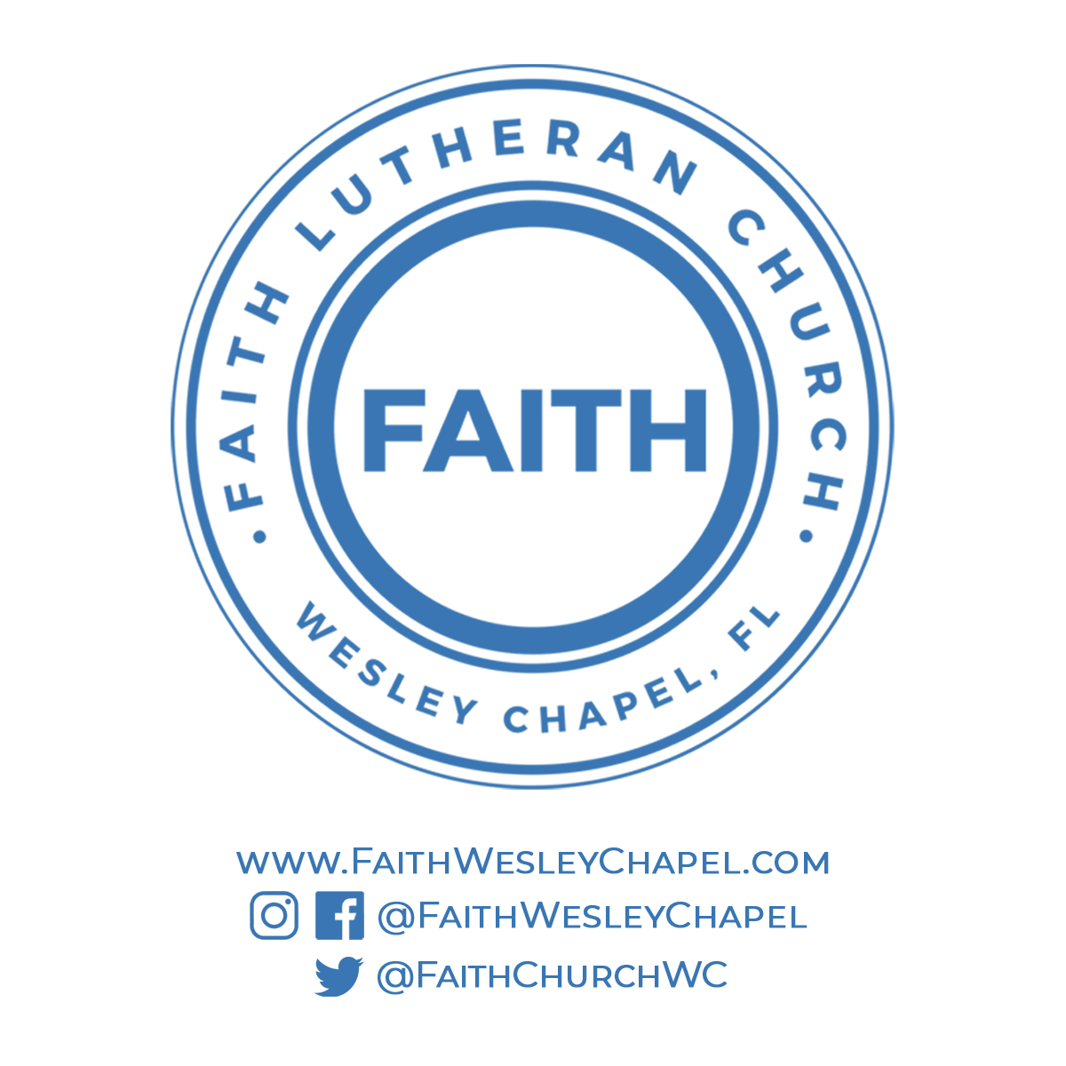**@FaithWesleyChapel**

**@FaithWesleyChapel**

**@FaithChurchWC**