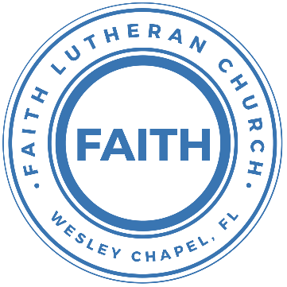

**Leading our community into a deep connection in Christ**

**Worship Service for August 7, 2022 at 11 AM**

**Prelude**

**Welcome**

**Invocation**

**Confession and Forgiveness:**

**P:** We have come here today to worship the Lord.  In worship we hear the Word of God, we receive God's blessings, and respond with thanks and praise.  We begin by seeking God's blessing of forgiveness.  He has promised to remove the guilt and shame of our sin through the sacrifice of Jesus Christ on the cross.

*(a time of silence to reflect and personally confess our sins)*

**P:** Let us confess our sins to the Lord.

**P:** Heavenly Father,  
**C:** Heavenly Father,

**P:** I have done things that were wrong.  
**C:** I have done things that were wrong.  
  
**P:** I have been mean to others.  
**C:** I have been mean to others.

**P:** I have not obeyed my parents.  
**C:** I have not obeyed my parents.

**P:** I have not obeyed You, God.  
**C:** I have not obeyed You, God.

**P:** But I am very sorry.  
**C:** But I am very sorry.

**P:** Please forgive me.  
**C:** Please forgive me.

**P:** I love You very much.  
**C:** I love You very much.

**P:** And I know You love me, too.  
**C:** And I know You love me, too.

**P:** God has heard your apology.  He loves you very much.  God has told us that when we believe and trust in Him, He makes us His children.  As far as the east is from the west, so far does he remove our sins from us. He has told me to tell you that you are forgiven.  So, as His servant, I forgive you in the name of the Father and of the Son and of the Holy Spirit.

**C:** Amen.

**Song:**Jesus Loves Me

Verse 1:

Jesus loves me this I know, For the Bible tells me so.

Little ones to Him belong, They are weak, but He is strong.

Chorus:

Yes, Jesus loves me, Yes, Jesus loves me,

Yes, Jesus loves me, The Bible tells me so.

Verse 2:

Jesus loves me, He who died. Heaven's gates to open wide.

He will wash away my sin, Let His little child come in.

**First Reading –**Colossians 1:18a

He is the head of the body, which is the church.

**Reader:** This is the Word of the Lord.  
**C:** Thanks be to God.

**Children's Message**"It’s Jesus’ Church"

**First NYG Youth Testimonial**

**Song:**Amazing Grace

Amazing grace, how sweet the sound that saved a wretch like me

I once was lost, but now am found. Was blind but now I see.

When we've been there ten thousand years,  
bright shining as the sun

we've no less days to sing God’s praise,  
than when we've first begun

**Second Reading –**Colossians 1:18b

And he is the first among all who will be raised from death.

**Reader:** This is the Word of the Lord.  
**C:** Thanks be to God.

**Children's Message**"Because Jesus Was Raise, So Will You Be Raised"

**Second NYG Youth Testimonial**

**Third NYG Youth Testimonial**

**Song:**Living Hope

Verse 1:

How great the chasm that lay between us

How high the mountain I could not climb

In desperation, I turned to heaven  
And spoke Your name into the night

Then through the darkness Your loving kindness

Tore through the shadows of my soul

The work is finished, the end is written,  
Jesus Christ, my Living Hope

Verse 2:

Who could imagine so great a mercy

What heart could fathom such boundless grace

The God of ages stepped down from glory  
To wear my sin and bear my shame

The cross has spoken, I am forgiven

The King of Kings calls me His own

Beautiful Savior I’m Yours forever, Jesus Christ, my Living Hope

Chorus:

Hallelujah, praise the one who set me free

Hallelujah, death has lost its grip on me

You have broken every chain, there’s salvation in Your Name

Jesus Christ, my Living Hope

(Repeat)

Verse 3:

Then came the morning that sealed the promise

Your buried body began to breathe

Out of the silence the roaring Lion

Declared the grave has no claim on me

(Repeat)

Jesus, Yours is the victory

(Chorus 2x)

**Fourth NYG Youth Testimonial**

**National Youth Gathering Slideshow Video**

**Fifth NYG Testimonial**

**Reading –**Colossians 1:15-20

He is the image of the invisible God, the firstborn of all creation. 16 For by him all things were created, in heaven and on earth, visible and invisible, whether thrones or dominions or rulers or authorities—all things were created through him and for him. 17 And he is before all things, and in him all things hold together. 18 And he is the head of the body, the church. He is the beginning, the firstborn from the dead, that in everything he might be preeminent. 19 For in him all the fullness of God was pleased to dwell, 20 and through him to reconcile to himself all things, whether on earth or in heaven, making peace by the blood of his cross.

**P:** This is the Gospel of the Lord.  
**C:** Praise be to You, o Christ.

**Pastor Kurt’s NYG Testimonial / Message**

**Prayers:** *Text in prayer requests to (813) 602-1104‬*

**The Lord's Prayer**

Our Father who art in heaven, hallowed be Thy name, Thy kingdom come, Thy will be done on earth as it is in heaven.  Give us this day our daily bread; and forgive us our trespasses as we forgive those who trespass against us; and lead us not into temptation, but deliver us from evil.  For Thine is the kingdom and the power and the glory forever and ever.  Amen

**Words of Institution**

**Peace**

**P:** The peace of the Lord be with you all.  
**C:** And also, with you.  
**P:** We greet each other in the peace of Christ.

**Distribution**

**Prayer**

**Benediction**

**Closing Song:**Echo

Verse 1:

When night has fallen When fear is common

Still You're calling me When faith is lost

And my hope exhausted You will be my strength

Pre-Chorus:

When my mind says I'm not good enough  
God, You're enough for me

I've decided I'm not giving up 'Cause You won't give up on me

You won't give up on me

Chorus:

Your love is holding on And it won't let go

I feel it breaking out like an echo Your love is holding on

And it won't let go I feel it breaking out like an echo

Post-Chorus:

Echo in my so-o-o-o-oul So-o-o-o-oul.

Echo in my so-o-o-o-oul So-o-o-o-oul.

Verse 2:

In every season You keep repeating promises to me

Now there's no stopping What you have started

Until it is complete

(Pre-Chorus)

(Chorus)

(Post-Chorus 2x)

**Offering**

**Sermon Notes:**

**_______________________________________________**

**_______________________________________________**

**_______________________________________________**

**_______________________________________________**

**_______________________________________________**

**_______________________________________________**

**_______________________________________________**

**_______________________________________________**

**_______________________________________________**

**_______________________________________________**

**_______________________________________________**

**_______________________________________________**

**_______________________________________________**

**_______________________________________________**

**_______________________________________________**

**_______________________________________________**

**_______________________________________________**

**_______________________________________________**

**_______________________________________________**

**_______________________________________________**

**_______________________________________________**

**_______________________________________________**

**_______________________________________________**

**Hey Youth!!**Do you know any worship songs you’d like to sing as part of our youth service? Let Pastor Kurt know.

Do you want to sing or play an instrument? Let Pastor Kurt know.

We want you to be a part of the service.

**Upcoming Events**

**August 16, 7 PM Council Meeting**  
Zoom

**www.FaithWesleyChapel.com**

**Faith YouTube**

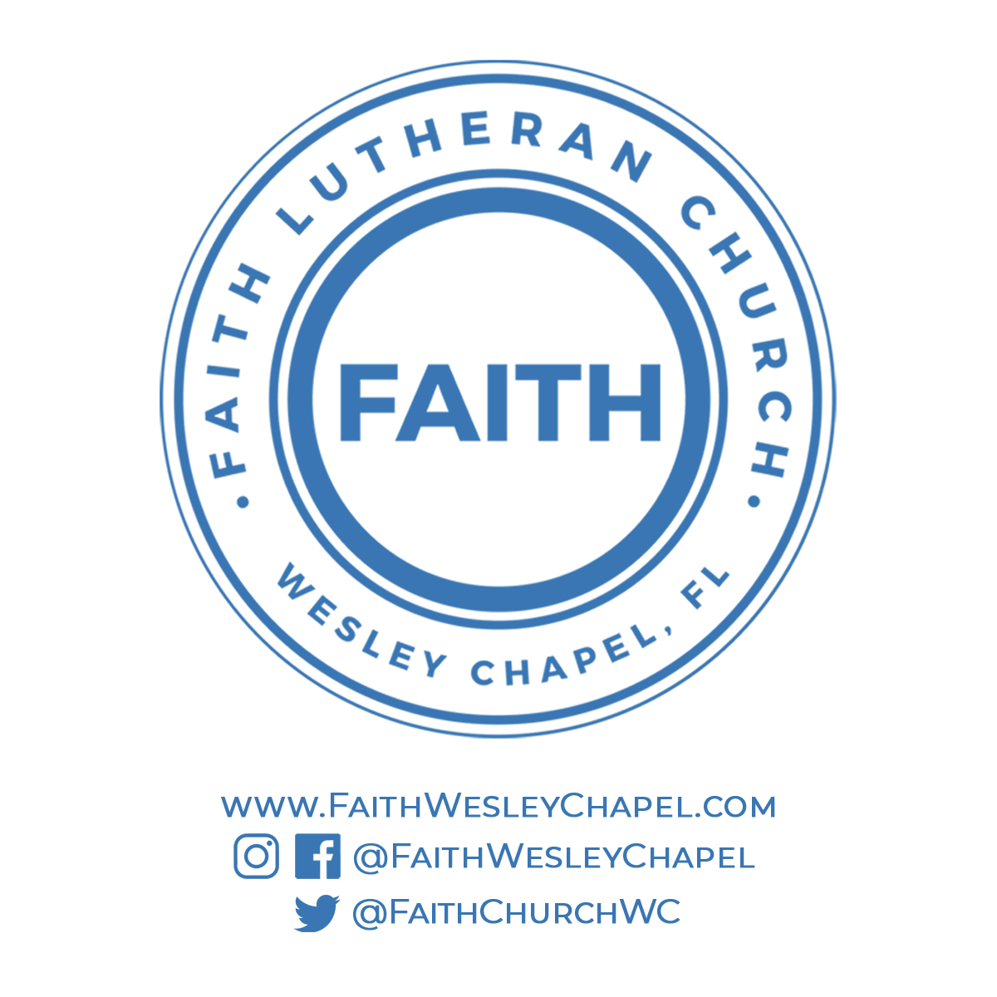**@FaithWesleyChapel**

**@FaithWesleyChapel**

**@FaithChurchWC**