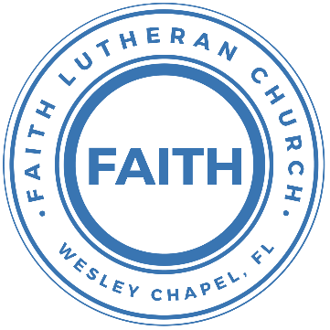

**Leading our community into a deep connection in Christ**

**Worship Service for September 4, 2022, at 11 AM**

**Welcome**

**Opening Song:**The Hippopotamus Song

In the beginning, God made the sea

(make a wave motion)

And the forest filled with trees

(wave your hands)

He made the mountains up so high

(making a point with your hands)

Above it all He placed the sky

(Motion like you are throwing the sky up)

God's fingerprints are everywhere

(touch things with your fingers)

Just to show how much He cares

(hug yourself)

Along the way He had some fun

(swoop your fist in front of you)

He made a hippo that weighed a ton

(when you say "ton," put your arms away from your sides making something

look big)

Hip-Hip-Hippopotamus

(using the same thing

**Invocation**

**Confession and Forgiveness:**

**P:** We have come here today to worship the Lord.  In worship we hear the Word of God, we receive God's blessings, and respond with thanks and praise.  We begin by seeking God's blessing of forgiveness.  He has promised to remove the guilt and shame of our sin through the sacrifice of Jesus Christ on the cross.

*(a time of silence to reflect and personally confess our sins)*

**P:** Let us confess our sins to the Lord.

**P:** Heavenly Father,  
**C:** Heavenly Father,

**P:** I have done things that were wrong.  
**C:** I have done things that were wrong.  
  
**P:** I have been mean to others.  
**C:** I have been mean to others.

**P:** I have not obeyed my parents.  
**C:** I have not obeyed my parents.

**P:** I have not obeyed You, God.  
**C:** I have not obeyed You, God.

**P:** But I am very sorry.  
**C:** But I am very sorry.

**P:** Please forgive me.  
**C:** Please forgive me.

**P:** I love You very much.  
**C:** I love You very much.

**P:** And I know You love me, too.  
**C:** And I know You love me, too.

**P:** God has heard your apology.  He loves you very much.  God has told us that when we believe and trust in Him, He makes us His children.  As far as the east is from the west, so far does he remove our sins from us. He has told me to tell you that you are forgiven.  So, as His servant, I forgive you in the name of the Father and of the Son and of the Holy Spirit.

**C:** Amen.

**Song:**Jesus Loves Me

Verse 1:

Jesus loves me this I know, For the Bible tells me so.

Little ones to Him belong, They are weak, but He is strong.

Chorus:

Yes, Jesus loves me, Yes, Jesus loves me,

Yes, Jesus loves me, The Bible tells me so.

Verse 2:

Jesus loves me, He who died. Heaven's gates to open wide.

He will wash away my sin, Let His little child come in.

Chorus

Verse 3:

Jesus loves me when I'm good, When I do the things I should.

Jesus loves me when I'm bad, Even though it makes Him sad.

Chorus

**First Reading –**Genesis 1:1-3

In the beginning, God created the heavens and the earth. The earth was without form and void, and darkness was over the face of the deep. And the Spirit of God was hovering over the face of the waters. And God said, “Let there be light,” and there was light.

**Reader:** This is the Word of the Lord.  
**C:** Thanks be to God.

**Children's Message**"God Created All Things Just by Speaking!!"

**Song:**God of Wonders

Verse 1:

Lord of all creation Of water, earth, and sky

The heavens are You tabernacle Glory to the Lord on high

Chorus 1:

God of wonders beyond our galaxy You are holy, holy

The universe declares Your majesty You are holy, holy

Lord of heaven and earth Lord of heaven and earth

Verse 2:

Early in the morning, I will celebrate the light.

When I stumble in the darkness, I will call Your Name by night.

Chorus

Bridge:

Hallelujah To the Lord of heaven and earth... (3x)

You are holy, holy.

You are holy, holy, holy, holy

Chorus 2:

God of wonders beyond our galaxy You are holy, holy

Precious Lord, reveal your heart to me You are holy, holy.

The universe declares Your majesty You are holy, holy

Lord of heaven and earth Lord of heaven and earth

**Second Reading –**Genesis 2:1-3

Thus the heavens and the earth were finished, and all the host of them. And on the seventh day God finished his work that he had done, and he rested on the seventh day from all his work that he had done. So God blessed the seventh day and made it holy, because on it God rested from all his work that he had done in creation.

**Reader:** This is the Word of the Lord.  
**C:** Thanks be to God.

**Children's Message**"God Created All Things for Rest"

**Gospel Reading –**John 1:1-3

In the beginning was the Word, and the Word was with God, and the Word was God. He was in the beginning with God. All things were made through him, and without him was not any thing made that was made.

**P:** This is the Gospel of the Lord.  
**C:** Praise be to You, o Christ.

**Sermon Hymn:**Canvas And Clay

Verse 1:

In my mother’s womb You formed me with Your hands

Known and loved by You Before I took a breath

Pre-Chorus 1:

When I doubt it, Lord, remind me I’m wonderfully made

You’re an artist and a potter I’m the canvas and the clay

Chorus:

You make all things work together For my future and for my good

You make all things work together For Your glory and for Your name

Verse 2:

There’s a healing light Just beyond the clouds

Though I’ve walked through fire I see clearly now

Pre-Chorus 2:

I know nothing has been wasted No failure or mistake

You’re an artist and a potter I’m the canvas and the clay

**Sermon –**Series: Navigating God's Plan

Week 1: "God's Good Creation"

**Prayers:** *Text in prayer requests to (813) 326-5255*

**The Lord's Prayer**

Our Father who art in heaven, hallowed be Thy name, Thy kingdom come, Thy will be done on earth as it is in heaven.  Give us this day our daily bread; and forgive us our trespasses as we forgive those who trespass against us; and lead us not into temptation, but deliver us from evil.  For Thine is the kingdom and the power and the glory forever and ever.  Amen

**Words of Institution**

**Peace**

**P:** The peace of the Lord be with you all.  
**C:** And also, with you.  
**P:** We greet each other in the peace of Christ.

**Distribution**

**Prayer**

**Benediction**

**Closing Song:**I See You

Verse 1:

God of love, God of all glory, Every day I see new mercy

Great is Your faithfulness

Verse 2:

God of love, God of my story, You never fail. You never forsake me

Great is Your faithfulness

Chorus:

I see You in the morning light. I feel You in the fire by night

I hear You say, “Child, I am with you. Everything will be alright.”

I see You in the tears that run. I feel You when the healing comes

I hear You say, “Beloved one, I am with you.” Every moment of my life

I see You. I see You. I see You. God, I see You

Verse 3:

God of love, God of new vision, Every blessing You have given

Great is Your faithfulness! Oh how great is Your faithfulness

(Chorus)

Bridge:

I will worship through the storm, Through the storm, Through the storm

All my hope is in You Lord, In You Lord, In You Lord

I see You in the morning light

I feel You in the fire by night

I hear You say, “Child, I am with you.

Everything will be alright.”

**Offering**

**Sermon Notes:**

**_______________________________________________**

**_______________________________________________**

**_______________________________________________**

**_______________________________________________**

**_______________________________________________**

**_______________________________________________**

**_______________________________________________**

**_______________________________________________**

**_______________________________________________**

**_______________________________________________**

**_______________________________________________**

**_______________________________________________**

**_______________________________________________**

**_______________________________________________**

**_______________________________________________**

**_______________________________________________**

**_______________________________________________**

**_______________________________________________**

**_______________________________________________**

**_______________________________________________**

**_______________________________________________**

**_______________________________________________**

**_______________________________________________**

**_______________________________________________**

**Hey Youth!!**Do you know any worship songs you’d like to sing as part of our youth service? Let Pastor Kurt know.

Do you want to sing or play an instrument? Let Pastor Kurt know.

We want you to be a part of the service.

**Upcoming Events**

**September 8, 7pm, Grow Watch Party**Zoom

**September 11, After the Worship Service – Youth Group**  
Song and Dance

**September 13, 7pm, Growth Group Bible Study**Location – TBD

**www.FaithWesleyChapel.com**

**Faith YouTube**

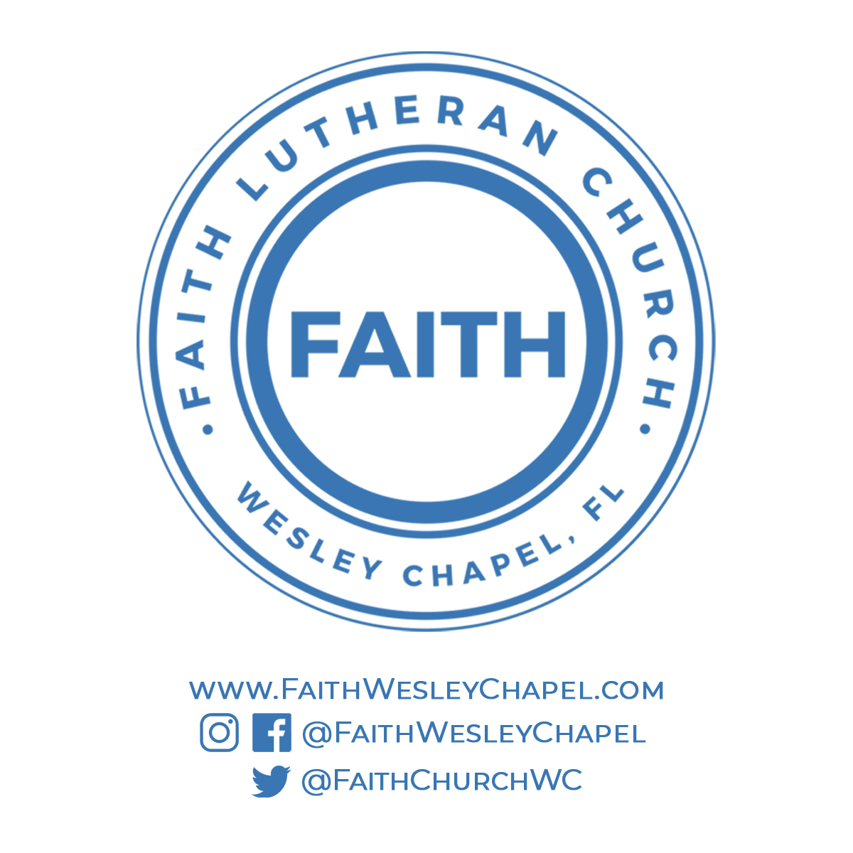**@FaithWesleyChapel**

**@FaithWesleyChapel**

**@FaithChurchWC**