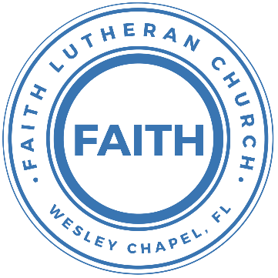

**Leading our community into a deep connection in Christ**

**Worship Service for September 11, 2022, at 11 AM**

**Welcome**

**Pray for the Food** - **People get food**

**Invocation**

**Confession and Forgiveness:**

P: As we gather, today, let us cleanse our hearts and our consciences by confessing our sin to God.

(Time of silence for reflection and confession)

C: Heavenly Father, we confess that we are sinful and unclean. We have sinned against you and against our neighbor in our thoughts, words, and actions.  We are truly sorry for our sins and sincerely repent of them. We ask for Your mercy. For the sake of Jesus Christ's bitter suffering and death, please forgive us and renew us that we may walk in Your Spirit to the glory of Your holy name.

P: The Lord has heard your confession. Therefore, as a called and ordained servant of the Lord, in the stead and by the command of my Lord, Jesus Christ, I forgive you all your sins in the name of the Father and of the Son and of the Holy Spirit.

C: Amen

**Song of Praise and Thanksgiving –** Beautiful Savior

Beautiful Savior, King of creation,

Son of God and Son of man.

Truly I’d love Thee, Truly I’d serve Thee

Light of my soul, my joy, my crown.

Fair are the meadows. Fair is the woodlands

Robed in the flow’rs of blooming spring

Jesus is fairer. Jesus is purer.

He makes our sorrowing spirit sing

Acapella??

Beautiful Savior, Lord of the nations,

Son of God and Son of man.

Glory and honor, praise adoration,

Now and forever more be Thine!

**Epistle Reading:**Romans 5:12-21

Therefore, just as sin came into the world through one man, and death through sin, and so death spread to all men because all sinned—for sin indeed was in the world before the law was given, but sin is not counted where there is no law. Yet death reigned from Adam to Moses, even over those whose sinning was not like the transgression of Adam, who was a type of the one who was to come.

But the free gift is not like the trespass. For if many died through one man's trespass, much more have the grace of God and the free gift by the grace of that one man Jesus Christ abounded for many. And the free gift is not like the result of that one man's sin. For the judgment following one trespass brought condemnation, but the free gift following many trespasses brought justification. For if, because of one man's trespass, death reigned through that one man, much more will those who receive the abundance of grace and the free gift of righteousness reign in life through the one man Jesus Christ.

Therefore, as one trespass led to condemnation for all men, so one act of righteousness leads to justification and life for all men. For as by the one man's disobedience the many were made sinners, so by the one man's obedience the many will be made righteous. Now the law came in to increase the trespass, but where sin increased, grace abounded all the more, so that, as sin reigned in death, grace also might reign through righteousness leading to eternal life through Jesus Christ our Lord.

Reader: This is the Word of the Lord.  
C: Thanks be to God.

**Gospel Reading:**John 3:16-17

“For God so loved the world, that he gave his only Son, that whoever believes in him should not perish but have eternal life. For God did not send his Son into the world to condemn the world, but in order that the world might be saved through him.

P: This is the Gospel of the Lord.  
C: Praise be to You, o Christ.

**Sermon Song-** Chief Of Sinners Though I Be

Verse 1:

Chief of sinners though I be, Jesus shed His blood for me.

Died that I might live on high, Lived that I might never die.

As the branch is to the vine, I am His and He is mine.

Verse 2:

Oh, the height of Jesus' love, Higher than the heav'ns above,

Deeper than the depths of sea, Lasting as eternity!

Love that found me wondrous thought! Found me when I sought Him not.

Verse 3:

Only Jesus can impart, Balm to heal the wounded heart,

Peace that flows from sin forgiv'n, Joy that lifts the soul to heav'n.

Faith and hope to walk with God, In the way that Enoch trod.

**Sermon** – The Fall: Our Needs for a Savior

Genesis 3:1-24

Now the serpent was more crafty than any other beast of the field that the Lord God had made.

He said to the woman, “Did God actually say, ‘You shall not eat of any tree in the garden’?” And the woman said to the serpent, “We may eat of the fruit of the trees in the garden, but God said, ‘You shall not eat of the fruit of the tree that is in the midst of the garden, neither shall you touch it, lest you die.’” But the serpent said to the woman, “You will not surely die. For God knows that when you eat of it your eyes will be opened, and you will be like God, knowing good and evil.” So when the woman saw that the tree was good for food, and that it was a delight to the eyes, and that the tree was to be desired to make one wise, she took of its fruit and ate, and she also gave some to her husband who was with her, and he ate. Then the eyes of both were opened, and they knew that they were naked. And they sewed fig leaves together and made themselves loincloths.

And they heard the sound of the Lord God walking in the garden in the cool of the day, and the man and his wife hid themselves from the presence of the Lord God among the trees of the garden. But the Lord God called to the man and said to him, “Where are you?” And he said, “I heard the sound of you in the garden, and I was afraid, because I was naked, and I hid myself.” He said, “Who told you that you were naked? Have you eaten of the tree of which I commanded you not to eat?” The man said, “The woman whom you gave to be with me, she gave me fruit of the tree, and I ate.” Then the Lord God said to the woman, “What is this that you have done?” The woman said, “The serpent deceived me, and I ate.”

The Lord God said to the serpent,

“Because you have done this,

cursed are you above all livestock

and above all beasts of the field;

on your belly you shall go,

and dust you shall eat

all the days of your life.

I will put enmity between you and the woman,

and between your offspring and her offspring;

he shall bruise your head,

and you shall bruise his heel.”

To the woman he said,

“I will surely multiply your pain in childbearing;

in pain you shall bring forth children.

Your desire shall be contrary to your husband,

but he shall rule over you.”

And to Adam he said,

“Because you have listened to the voice of your wife

and have eaten of the tree

of which I commanded you,

‘You shall not eat of it,’

cursed is the ground because of you;

in pain you shall eat of it all the days of your life;

thorns and thistles it shall bring forth for you;

and you shall eat the plants of the field.

By the sweat of your face

you shall eat bread,

till you return to the ground,

for out of it you were taken;

for you are dust,

and to dust you shall return.”

The man called his wife's name Eve, because she was the mother of all living. And the Lord God made for Adam and for his wife garments of skins and clothed them.

Then the Lord God said, “Behold, the man has become like one of us in knowing good and evil. Now, lest he reach out his hand and take also of the tree of life and eat, and live forever—”therefore the Lord God sent him out from the garden of Eden to work the ground from which he was taken. He drove out the man, and at the east of the garden of Eden he placed the cherubim and a flaming sword that turned every way to guard the way to the tree of life.

Reader: This is the Word of the Lord.  
C: Thanks be to God.

**Offering**

**Prayers:**

**Apostles' Creed**

I believe in God, the Father almighty, maker of heaven and earth,  
And in Jesus Christ, his only Son, our Lord,  
who was conceived by the Holy Spirit,  
born of the Virgin Mary, suffered under Pontius Pilate,  
was crucified, died and was buried. He descended into hell.  
The third day he rose again from the dead.  
He ascended into heaven and sits at the right hand of God  
the Father almighty.  
From there he will come to judge the living and the dead.  
I believe in the Holy Spirit, the holy Christian Church,  
the communion of saints, the forgiveness of sins,  
the resurrection of the body, and the life everlasting. Amen.

**The Lord's Prayer**

Our Father who art in heaven, hallowed be Thy name, Thy kingdom come, Thy will be done on earth as it is in heaven.  Give us this day our daily bread; and forgive us our trespasses as we forgive those who trespass against us; and lead us not into temptation, but deliver us from evil.  For Thine is the kingdom and the power and the glory forever and ever.  Amen

**Words of Institution**

**Distribution**

**Prayer**

**Benediction**

**Closing Song:** Praise God From Whom All Blessings Flow

Praise God from Whom all blessings flow.  
Praise Him all creatures here below.  
Praise Him above, ye heavenly hosts.  
Praise Father, Son and Holy Ghost.  
Amen

**Sermon Notes:**

**_______________________________________________**

**_______________________________________________**

**_______________________________________________**

**_______________________________________________**

**_______________________________________________**

**_______________________________________________**

**_______________________________________________**

**_______________________________________________**

**_______________________________________________**

**_______________________________________________**

**_______________________________________________**

**_______________________________________________**

**_______________________________________________**

**_______________________________________________**

**_______________________________________________**

**_______________________________________________**

**_______________________________________________**

**_______________________________________________**

**_______________________________________________**

**_______________________________________________**

**_______________________________________________**

**_______________________________________________**

**_______________________________________________**

**_______________________________________________**

**_______________________________________________**

**_______________________________________________**

**_______________________________________________**

**_______________________________________________**

**_______________________________________________**

**Upcoming Events**

**September 15, 7pm, Grow Watch Party**Zoom

**September 25, 1:30pm – Greek Restaurant and Arcade**  
Replay Museum

**September 13, 7pm, Growth Group Bible Study**Location - TBD

**www.FaithWesleyChapel.com**

**Faith YouTube**

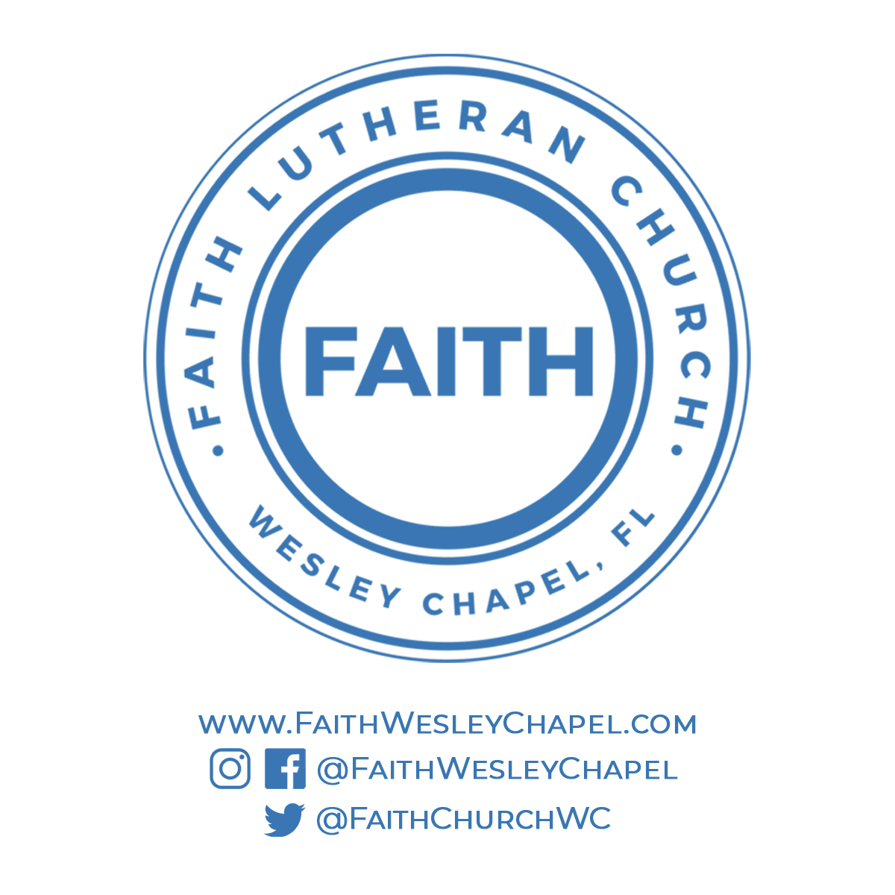**@FaithWesleyChapel**

**@FaithWesleyChapel**

**@FaithChurchWC**