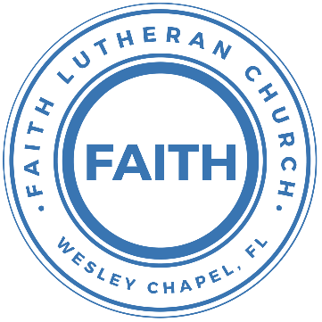

**Leading our community into a deep connection in Christ**

**Worship Service for September 18, 2022, at 11 AM**

**Welcome**

**Invocation**

**Confession and Forgiveness:**

**P:** When we come into the presence of God we cannot help but see our sinfulness. God does not require us to cleanse our own sin and be perfect of our own power for, surely, we could never achieve this. Instead, He tells us to come just as we are and receive His great mercy.

**Song:** Just As I Am

Just as I am, without one plea,  
But that Thy blood was shed for me,  
And that Thou bidd'st me come to Thee,   
O Lamb of God, I come! I come!

Just as I am, and waiting not,  
To rid my soul of one dark blot,  
To Thee whose blood can cleanse each spot,  
O Lamb of God, I come! I come!

Just as I am, though tossed about,  
With many a conflict, many a doubt,  
Fightings and fears within, without,  
Lamb of God, I come! I come!

*(a time of silence to reflect and personally confess our sins)*

**C:** Heavenly Father, we confess that we have sinned against you and each other. We are truly sorry and we humbly repent. For the sake of your Son Jesus Christ and His suffering and death on the cross, please forgive us and help us to live according to Your ways. Amen

**Just As I Am Verse 4:**Just as I am, Thou wilt receive,  
Wilt welcome, pardon, cleanse, relieve,  
Because Thy promise I believe,  
O Lamb of God, I come! I come!

**P:** The Lord our God is merciful and gracious, longsuffering, and abounding in goodness and truth, keeping mercy for thousands, forgiving iniquity and transgression and sin. Therefore I announce unto you the grace of our Lord Jesus Christ. In His stead and by the command of my Lord Jesus Christ, I forgive you all your sins in the name of the Father and of the Son and of the Holy Spirit.

**C:** Amen.

**Song of Praise and Thanksgiving:** Because He Lived (Amen)

Verse 1:

I believe in the Son. I believe in the risen One

I believe I overcome. By the power of His blood

Chorus:

Amen, - men. I’m alive, I’m alive because He lives

Amen, - men. Let my song join the one that never ends

Because He lives

Verse 2:

I was dead in the grave. I was covered in sin and shame

I heard mercy call my name. He rolled the stone away

Chorus

Bridge:

Because He lives, I can face tomorrow

Because He lives, Every fear is gone

I know He holds my life my future in His hands

Final Chorus:

Amen, - men. I’m alive, I’m alive because He lives

Amen, - men. Let my song join the one that never ends

Amen, - men. I’m alive, I’m alive because He lives

Amen, - men. Let my song join the one that never ends

Because He lives

Because He lives

**Epistle Reading -**1 Peter 3:20-21

because they formerly did not obey, when God's patience waited in the days of Noah, while the ark was being prepared, in which a few, that is, eight persons, were brought safely through water. Baptism, which corresponds to this, now saves you, not as a removal of dirt from the body but as an appeal to God for a good conscience, through the resurrection of Jesus Christ,

Reader: This is the Word of the Lord.  
C: Thanks be to God.

**Gospel Reading** – Luke 17:26-27

Just as it was in the days of Noah, so will it be in the days of the Son of Man. They were eating and drinking and marrying and being given in marriage, until the day when Noah entered the ark, and the flood came and destroyed them all.

P: This is the Gospel of the Lord.  
C: Praise be to You, o Christ.

**Children's Message** *(Children dismissed to Children's Church)*

**Sermon Hymn***–*How Deep The Father’s Love For Us

Verse 1:

How deep the Father's love for us, how vast beyond all measure

That He should give His only Son, to make a wretch His treasure

How great the pain of searing loss, the Father turned His face away

As wounds which mar the Chosen One, bring many sons to glory

Verse 2:

Behold the Man upon a cross, my sin upon His shoulders

Ashamed, I hear my mocking voice call out among the scoffers

It was my sin that held Him there until it was accomplished

His dying breath has brought me life; I know that it is finished

Verse 3:

I will not boast in anything: no gifts, no power, no wisdom

But I will boast in Je - sus Christ; his death and resurrection

Why should I gain from His reward? I cannot give an answer

But this I know with all my heart: His wounds have paid my ransom

But this I know with all my heart: His wounds have paid my ransom

**Sermon** - "The Flood: Death and Life"

Genesis 6:5-22, 7:11, 7:17-24, 8:1-5, 8:13-22

The Lord saw that the wickedness of man was great in the earth, and that every intention of the thoughts of his heart was only evil continually. And the Lord regretted that he had made man on the earth, and it grieved him to his heart. So the Lord said, “I will blot out man whom I have created from the face of the land, man and animals and creeping things and birds of the heavens, for I am sorry that I have made them.” But Noah found favor in the eyes of the Lord.

These are the generations of Noah. Noah was a righteous man, blameless in his generation. Noah walked with God. And Noah had three sons, Shem, Ham, and Japheth.

Now the earth was corrupt in God's sight, and the earth was filled with violence. And God saw the earth, and behold, it was corrupt, for all flesh had corrupted their way on the earth. And God said to Noah, “I have determined to make an end of all flesh, for the earth is filled with violence through them. Behold, I will destroy them with the earth. Make yourself an ark of gopher wood. Make rooms in the ark, and cover it inside and out with pitch. This is how you are to make it: the length of the ark 300 cubits, its breadth 50 cubits, and its height 30 cubits. Make a roof for the ark, and finish it to a cubit above, and set the door of the ark in its side. Make it with lower, second, and third decks. For behold, I will bring a flood of waters upon the earth to destroy all flesh in which is the breath of life under heaven. Everything that is on the earth shall die. But I will establish my covenant with you, and you shall come into the ark, you, your sons, your wife, and your sons' wives with you. And of every living thing of all flesh, you shall bring two of every sort into the ark to keep them alive with you. They shall be male and female. Of the birds according to their kinds, and of the animals according to their kinds, of every creeping thing of the ground, according to its kind, two of every sort shall come in to you to keep them alive. Also take with you every sort of food that is eaten, and store it up. It shall serve as food for you and for them.” Noah did this; he did all that God commanded him...

...six hundredth year of Noah's life, in the second month, on the seventeenth day of the month, on that day all the fountains of the great deep burst forth, and the windows of the heavens were opened...

...The flood continued forty days on the earth. The waters increased and bore up the ark, and it rose high above the earth. The waters prevailed and increased greatly on the earth, and the ark floated on the face of the waters. And the waters prevailed so mightily on the earth that all the high mountains under the whole heaven were covered. The waters prevailed above the mountains, covering them fifteen cubits deep. And all flesh died that moved on the earth, birds, livestock, beasts, all swarming creatures that swarm on the earth, and all mankind. Everything on the dry land in whose nostrils was the breath of life died. He blotted out every living thing that was on the face of the ground, man and animals and creeping things and birds of the heavens. They were blotted out from the earth. Only Noah was left, and those who were with him in the ark. And the waters prevailed on the earth 150 days...

...But God remembered Noah and all the beasts and all the livestock that were with him in the ark. And God made a wind blow over the earth, and the waters subsided. The fountains of the deep and the windows of the heavens were closed, the rain from the heavens was restrained, and the waters receded from the earth continually. At the end of 150 days the waters had abated, and in the seventh month, on the seventeenth day of the month, the ark came to rest on the mountains of Ararat. And the waters continued to abate until the tenth month; in the tenth month, on the first day of the month, the tops of the mountains were seen...

...In the six hundred and first year, in the first month, the first day of the month, the waters were dried from off the earth. And Noah removed the covering of the ark and looked, and behold, the face of the ground was dry. In the second month, on the twenty-seventh day of the month, the earth had dried out. Then God said to Noah, “Go out from the ark, you and your wife, and your sons and your sons' wives with you. Bring out with you every living thing that is with you of all flesh—birds and animals and every creeping thing that creeps on the earth—that they may swarm on the earth, and be fruitful and multiply on the earth.” So Noah went out, and his sons and his wife and his sons' wives with him. Every beast, every creeping thing, and every bird, everything that moves on the earth, went out by families from the ark.

Then Noah built an altar to the Lord and took some of every clean animal and some of every clean bird and offered burnt offerings on the altar. And when the Lord smelled the pleasing aroma, the Lord said in his heart, “I will never again curse the ground because of man, for the intention of man's heart is evil from his youth. Neither will I ever again strike down every living creature as I have done. While the earth remains, seedtime and harvest, cold and heat, summer and winter, day and night, shall not cease.”

P: This is the Word of the Lord.  
C: Thanks be to God.

**Prayers:** *Text in prayer requests to (813) 326-5255*

**Nicene Creed**

I believe in one God, the Father Almighty, maker of heaven and earth and of all things visible and invisible.

And in one Lord Jesus Christ, the only-begotten Son of God, begotten of His Father before all worlds, God of God, Light of Light, very God of very God, begotten, not made, being of one substance with the Father, by whom all things were made; who for us men and for our salvation came down from heaven and was incarnate by the Holy Spirit of the virgin Mary and was made man; and was crucified also for us under Pontius Pilate. He suffered and was buried. And the third day He rose again according to the Scriptures and ascended into heaven and sits at the right hand of the Father. And He will come again with glory to judge both the living and the dead, whose kingdom will have no end.

And I believe in the Holy Spirit, the Lord and Giver of Life, who proceeds from the Father and the Son, who with the Father and the Son together is worshiped and glorified, who spoke by the prophets. And I believe in one holy Christian and apostolic Church, I acknowledge one Baptism for the remission of sins, and I look for the resurrection of the dead and the life of the world to come. Amen.

**The Lord's Prayer**

Our Father who art in heaven, hallowed be Thy name, Thy kingdom come, Thy will be done on earth as it is in heaven.  Give us this day our daily bread; and forgive us our trespasses as we forgive those who trespass against us; and lead us not into temptation, but deliver us from evil.  For Thine is the kingdom and the power and the glory forever and ever.  Amen

**Words of Institution**

**Peace**

P: The peace of the Lord be with you all.  
C: And also, with you.  
P: We greet each other in the peace of Christ.

**Distribution**

**Prayer**

**Benediction**

**Closing Song:**Children Of The Heavenly Father

Verse 1:

Children of the Heavenly Father Safely in His bosom gather;

Nestling bird nor star in heaven Such a refuge e’er was given.

Verse 2:

God His own doth tend and nourish; In His holy courts they flourish.

From all evil things He spares them; In His mighty arms He bears them.

Chorus:

Precious children, You have called us. Making us heirs with Your Son.

“Abba Father”, now we call You. In Your presence, now we come.

Verse 3:

Neither life nor death shall ever From the Lord His children sever;

Unto them His grace He showeth, And their sorrows all he knoweth.

Chorus

Verse 4:

Though he giveth or He taketh, God His children ne’er forsaketh;

His the loving purpose solely To preserve them pure and holy.

**Offering**

**Sermon Notes:**

**_______________________________________________**

**_______________________________________________**

**_______________________________________________**

**_______________________________________________**

**_______________________________________________**

**_______________________________________________**

**_______________________________________________**

**_______________________________________________**

**_______________________________________________**

**_______________________________________________**

**_______________________________________________**

**_______________________________________________**

**_______________________________________________**

**_______________________________________________**

**_______________________________________________**

**_______________________________________________**

**_______________________________________________**

**_______________________________________________**

**_______________________________________________**

**_______________________________________________**

**_______________________________________________**

**_______________________________________________**

**_______________________________________________**

**Upcoming Events**

**September 20, 7 PM Council Meeting**  
Zoom

**September 22, 7pm, Grow Watch Party**Zoom

**September 25, 1:30pm, Greek Restaurant and Arcade**Location – The Limani Restaurant and Replay Museum

**www.FaithWesleyChapel.com**

**Faith YouTube**

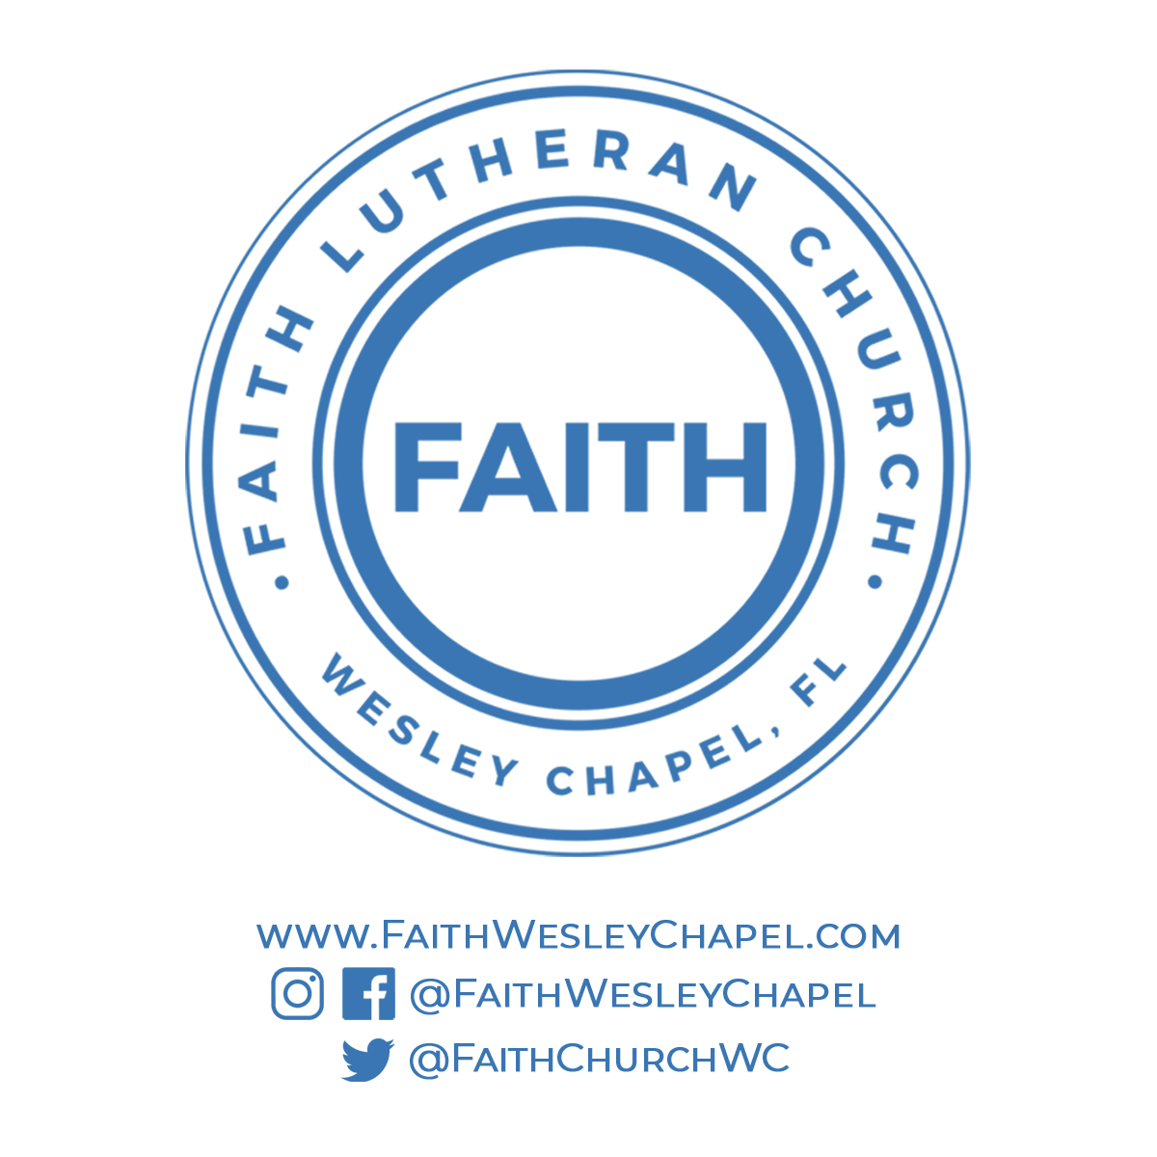**@FaithWesleyChapel**

**@FaithWesleyChapel**

**@FaithChurchWC**