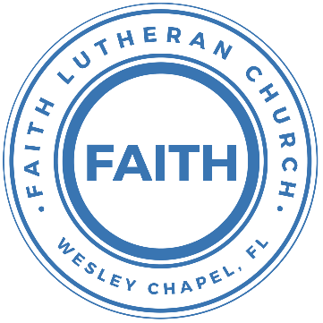

**Leading our community into a deep connection in Christ**

**Worship Service for October 2, 2022, at 11 AM**

**Welcome**

**Opening Song:**Praise Ye The Lord, Hallelujah

Side 1: Hallelu, hallelu, hallelu, hallelujah,

Side 2: Praise ye the Lord.

Side 1: Hallelu, hallelu, hallelu, hallelujah,

Side 2: Praise ye the Lord.

Side 2: Praise ye the Lord.

Side 1: Hallelujah,

Side 2: Praise ye the Lord.

Side 1: Hallelujah,

Side 2: Praise ye the Lord.

Side 1: Hallelujah,

All: Praise ye the Lord.

(Repeat all)

**Invocation**

**Confession and Forgiveness:**

**P:** We have come here today to worship the Lord.  In worship we hear the Word of God, we receive God's blessings, and respond with thanks and praise.  We begin by seeking God's blessing of forgiveness.  He has promised to remove the guilt and shame of our sin through the sacrifice of Jesus Christ on the cross.

*(a time of silence to reflect and personally confess our sins)*

**P:** Let us confess our sins to the Lord.

**P:** Heavenly Father,  
**C:** Heavenly Father,

**P:** I have done things that were wrong.  
**C:** I have done things that were wrong.  
  
**P:** I have been mean to others.  
**C:** I have been mean to others.

**P:** I have not obeyed my parents.  
**C:** I have not obeyed my parents.

**P:** I have not obeyed You, God.  
**C:** I have not obeyed You, God.

**P:** But I am very sorry.  
**C:** But I am very sorry.

**P:** Please forgive me.  
**C:** Please forgive me.

**P:** I love You very much.  
**C:** I love You very much.

**P:** And I know You love me, too.  
**C:** And I know You love me, too.

**P:** God has heard your apology.  He loves you very much.  God has told us that when we believe and trust in Him, He makes us His children.  As far as the east is from the west, so far does he remove our sins from us. He has told me to tell you that you are forgiven.  So, as His servant, I forgive you in the name of the Father and of the Son and of the Holy Spirit.

**C:** Amen.

**Song:**Jesus Loves Me

Verse 1:

Jesus loves me this I know, For the Bible tells me so.

Little ones to Him belong, They are weak, but He is strong.

Chorus:

Yes, Jesus loves me, Yes, Jesus loves me,

Yes, Jesus loves me, The Bible tells me so.

Verse 2:

Jesus loves me, He who died. Heaven's gates to open wide.

He will wash away my sin, Let His little child come in.

**First Reading –**Genesis 37:2-5, 28

Joseph was a young man, 17 years old. His job was to take care of the sheep and the goats. Joseph did this work with his brothers,..Joseph told his father about the bad things that his brothers did.

His father loved him more than he loved his other sons. Jacob gave him a special coat, which was long and very beautiful. When Joseph’s brothers saw that their father loved Joseph more than he loved them, they hated their brother because of this. They refused to say nice things to him. One time Joseph had a special dream. Later, he told his brothers about this dream, and after that his brothers hated him even more...

...When the Midianite traders came by, the brothers took Joseph out of the well and sold him to the traders for 20 pieces of silver. The traders took him to Egypt.**Reader:** This is the Word of the Lord.  
**C:** Thanks be to God.

**Children's Message**

**Need volunteers:**- Jacob

- Joseph

- Siblings (at least 2)

- Trader(s)

**Song:**Way Maker

Verse 1:

You are here Moving in our midst. I worship you. I worship you

You are here Moving in this place. I worship you. I worship you

You are here Moving in our midst. I worship you. I worship you

You are here Moving in this place. I worship you. I worship you

Chorus:

Way maker, miracle worker

Promise keeper, light in the darkness,

My God, that is who you are

(Repeat)

Verse 2:

You are here Touching every heart. I worship you. I worship you

You are here Healing every heart. I worship you. I worship you

You are here Turning lives around. I worship you. I worship you

You are here Mending every heart. I worship you. I worship you

(Chorus)

Tag:

That is who You are. That is who You are.

That is who You are. That is who You are.

Bridge:

Even when I don't see it, You're working

Even when I don't feel it, You're working

You never stop, You never stop working

You never stop, You never stop working

(Repeat)

(Chorus)

**Second Reading –**Genesis 39:1-2, 7,14, 41:1,8,14,25The traders who bought Joseph took him down to Egypt. They sold him to the captain of Pharaoh’s guard, Potiphar. The Lord helped Joseph become a successful man...

...After some time, the wife of Joseph’s master began to pay special attention to him....

...She called to the men outside and said, “Look! This Hebrew slave was brought here to make fun of us. He came in and tried to attack me, but I screamed...

...The Lord was with Joseph and continued to show his kindness to him, so the commander of the prison guards began to like Joseph...

...Two years later Pharaoh dreamed...Pharaoh told these men the dreams, but none of them could explain the dreams...

...So Pharaoh called Joseph from the prison...Then Joseph said to Pharaoh, “Both of these dreams have the same meaning. God is telling you what will happen soon.

**Reader:** This is the Word of the Lord.  
**C:** Thanks be to God.

**Children's Message**  
- Potipher

- Wife

- Joseph

- Prison Commander

- Pharaoh

- Wine Taster

**Sermon Song:**Canvas and Clay   
  
Verse 1:

In my mother’s womb You formed me with Your hands

Known and loved by You Before I took a breath

Pre-Chorus 1:

When I doubt it, Lord, remind me I’m wonderfully made

You’re an artist and a potter I’m the canvas and the clay

Chorus:

You make all things work together For my future and for my good

You make all things work together For Your glory and for Your name

Verse 2:

There’s a healing light Just beyond the clouds

Though I’ve walked through fire I see clearly now

Pre-Chorus 2:

I know nothing has been wasted No failure or mistake

You’re an artist and a potter I’m the canvas and the clay

**Sermon –**“Navigating the Plan: Genesis to Jesus”

Sermon Text: Genesis 41:39-40,45:4b-8a, 16-21a

Then Pharaoh said to Joseph, “Since God has shown you all this, there is none so discerning and wise as you are. You shall be over my house, and all my people shall order themselves as you command. Only as regards the throne will I be greater than you.”...

...And he said, “I am your brother, Joseph, whom you sold into Egypt. And now do not be distressed or angry with yourselves because you sold me here, for God sent me before you to preserve life. For the famine has been in the land these two years, and there are yet five years in which there will be neither plowing nor harvest. And God sent me before you to preserve for you a remnant on earth, and to keep alive for you many survivors. So it was not you who sent me here, but God...

...When the report was heard in Pharaoh's house, “Joseph's brothers have come,” it pleased Pharaoh and his servants. And Pharaoh said to Joseph, “Say to your brothers, ‘Do this: load your beasts and go back to the land of Canaan, and take your father and your households, and come to me, and I will give you the best of the land of Egypt, and you shall eat the fat of the land.’ And you, Joseph, are commanded to say, ‘Do this: take wagons from the land of Egypt for your little ones and for your wives, and bring your father, and come. Have no concern for[a] your goods, for the best of all the land of Egypt is yours.’” The sons of Israel did so:

**Prayers:** *Text in prayer requests to (813) 602-1104‬*

**The Lord's Prayer**

Our Father who art in heaven, hallowed be Thy name, Thy kingdom come, Thy will be done on earth as it is in heaven.  Give us this day our daily bread; and forgive us our trespasses as we forgive those who trespass against us; and lead us not into temptation, but deliver us from evil.  For Thine is the kingdom and the power and the glory forever and ever.  Amen

**Offering**

**Words of Institution**

**Peace**

**P:** The peace of the Lord be with you all.  
**C:** And also, with you.  
**P:** We greet each other in the peace of Christ.

**Distribution**

**Prayer**

**Benediction**

**Closing Song:**Blessed Be Your Name

Verse 1:

Blessed be Your name in the land that is plentiful

Where Your streams of abundance flow blessed be Your name

Blessed be Your name when I'm found in the desert place

Though I walk through the wilderness blessed be Your name

Pre-Chorus:

Every blessing You pour out I'll turn back to praise

When the darkness closes in, Lord still I will say

Chorus:

Blessed be the name of the Lord

Blessed be Your name

Blessed be the name of the Lord

Blessed be Your glorious name

Verse 2:

Blessed be Your name when the sun's shining down on me

When the world's, "all as it should be" blessed be Your name

Blessed be Your name on the road marked with suffering

Though there's pain in the offering blessed be Your name

(Pre-Chorus)

(Chorus)

Bridge:

You give and take away

You give and take away

My heart will choose to say

Lord, blessed be Your name

(Pre-Chorus)

(Chorus)

**Hey Youth!!**Do you know any worship songs you’d like to sing as part of our youth service? Let Pastor Kurt know.

Do you want to sing or play an instrument? Let Pastor Kurt know.

We want you to be a part of the service.

**Upcoming Events**

**Third Monday, 7 PM Council Meeting**  
Zoom

**www.FaithWesleyChapel.com**

**Faith YouTube**

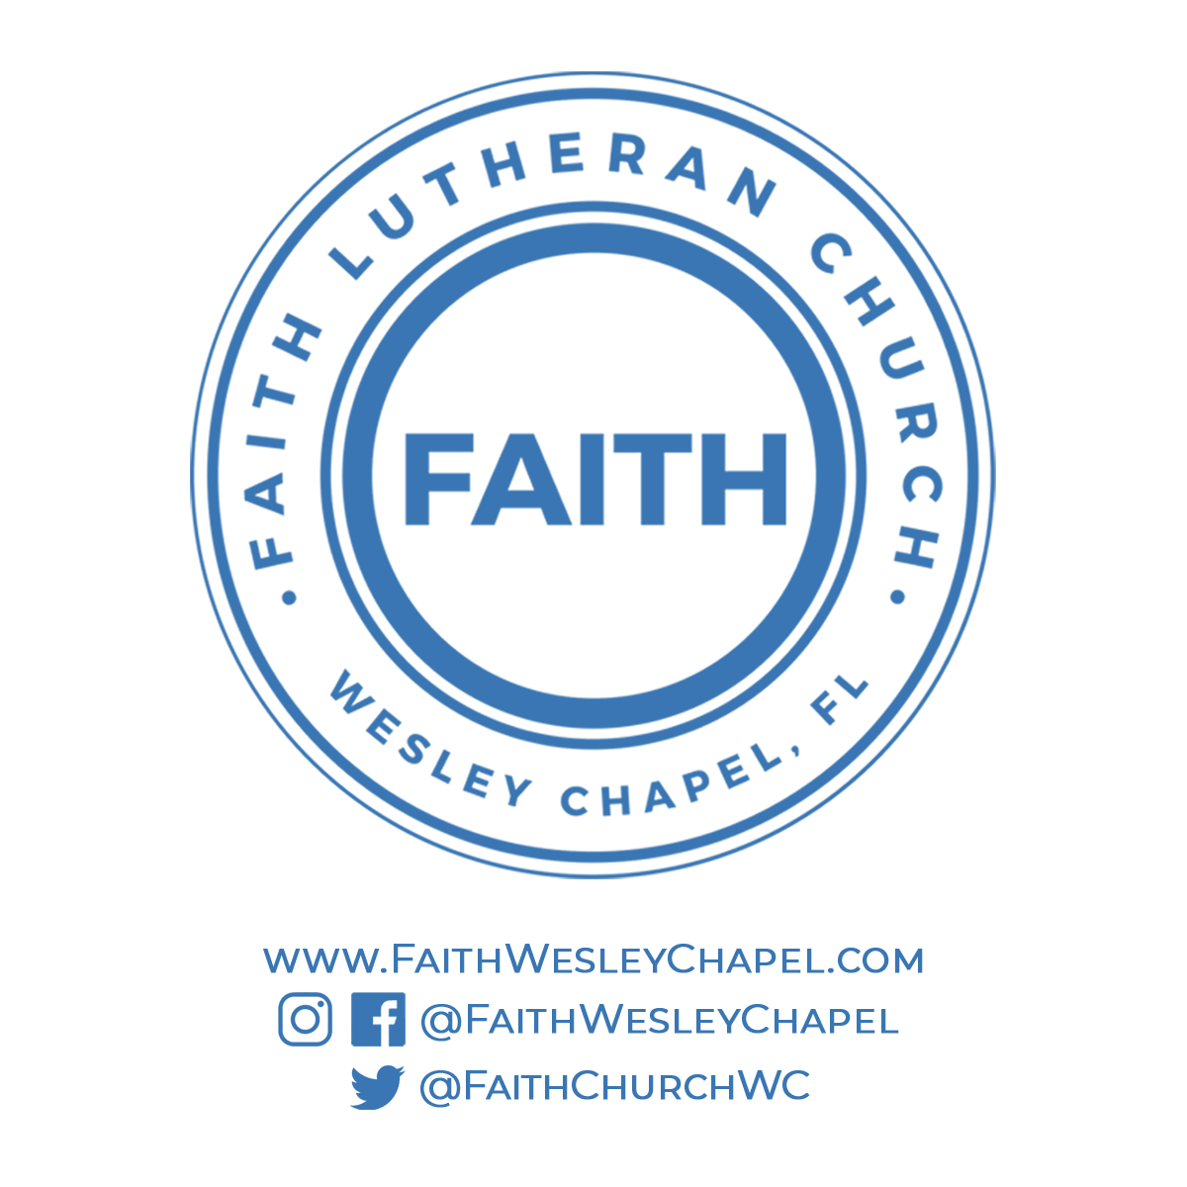**@FaithWesleyChapel**

**@FaithWesleyChapel**

**@FaithChurchWC**