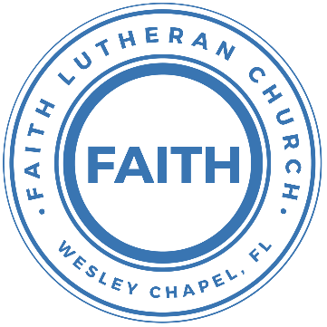

**Leading our community into a deep connection in Christ**

**Worship Service for October 9, 2022, at 11 AM**

**Welcome**

**Invocation**

**Confession and Forgiveness:**

P: As we gather, today, let us cleanse our hearts and our consciences by confessing our sin to God.

(Time of silence for reflection and confession)

C: Heavenly Father, we confess that we are sinful and unclean. We have sinned against you and against our neighbor in our thoughts, words, and actions.  We are truly sorry for our sins and sincerely repent of them. We ask for Your mercy. For the sake of Jesus Christ's bitter suffering and death, please forgive us and renew us that we may walk in Your Spirit to the glory of Your holy name.

P: The Lord has heard your confession. Therefore, as a called and ordained servant of the Lord, in the stead and by the command of my Lord, Jesus Christ, I forgive you all your sins in the name of the Father and of the Son and of the Holy Spirit.

C: Amen

**Song of Praise and Thanksgiving – At The Cross**

Verse 1:

There’s a place, where mercy reigns and never dies

There’s a place, where streams of grace flows deep and wide

Pre-Chorus:

All the love, I’ve ever found

Comes like a flood, comes flowing down

Chorus:

At the cross, at the cross, I surrender my life

I’m in awe of you; I’m in awe of you

Where your love ran red, and my sins washed white

I owe all to you, I owe all to you, (Go to bridge here on 2nd chorus)

Jesus (Repeat "Jesus" once at end)

Verse 2:

There’s a place, where sin and shame are powerless

Where my heart has peace with God, and forgiveness

Pre-Chorus

Chorus

Bridge:

Here my hope is found, here on holy ground

Here I bow down, here I bow down

Here arms open wide, here you saved my life

Here I bow down, here I bow

Chorus**New Testament Reading:**Revelation 5:6-14

And between the throne and the four living creatures and among the elders I saw a Lamb standing, as though it had been slain, with seven horns and with seven eyes, which are the seven spirits of God sent out into all the earth. And he went and took the scroll from the right hand of him who was seated on the throne. And when he had taken the scroll, the four living creatures and the twenty-four elders fell down before the Lamb, each holding a harp, and golden bowls full of incense, which are the prayers of the saints. And they sang a new song, saying,

“Worthy are you to take the scroll

and to open its seals,

for you were slain, and by your blood you ransomed people for God

from every tribe and language and people and nation,

and you have made them a kingdom and priests to our God,

and they shall reign on the earth.”

Then I looked, and I heard around the throne and the living creatures and the elders the voice of many angels, numbering myriads of myriads and thousands of thousands, saying with a loud voice,

“Worthy is the Lamb who was slain,

to receive power and wealth and wisdom and might

and honor and glory and blessing!”

And I heard every creature in heaven and on earth and under the earth and in the sea, and all that is in them, saying,

“To him who sits on the throne and to the Lamb

be blessing and honor and glory and might forever and ever!”

And the four living creatures said, “Amen!” and the elders fell down and worshiped.  
Reader: This is the Word of the Lord.  
C: Thanks be to God.

**Gospel Reading:**John 1:29-34

The next day he saw Jesus coming toward him, and said, “Behold, the Lamb of God, who takes away the sin of the world! This is he of whom I said, ‘After me comes a man who ranks before me, because he was before me.’ I myself did not know him, but for this purpose I came baptizing with water, that he might be revealed to Israel.” And John bore witness: “I saw the Spirit descend from heaven like a dove, and it remained on him. I myself did not know him, but he who sent me to baptize with water said to me, ‘He on whom you see the Spirit descend and remain, this is he who baptizes with the Holy Spirit.’ And I have seen and have borne witness that this is the Son of God.”

P: This is the Gospel of the Lord.  
C: Praise be to You, o Christ.

**Sermon** – Revelation Song

Verse 1:

Worthy is the Lamb who was slain. Holy Holy is He

Sing a new song to him who sits on, Heaven's mercy seat

Chorus:

Holy Holy Holy Is the Lord God Almighty, Who was and is and is to come

With all creation I sing, Praise to the King of Kings.

You are my everything And I will adore You...

Verse 2:

Clothed in rainbows of living color,

Flashes of lightning rolls of thunder

Blessing and honor, strength and glory and power be

To You the only wise King

(Chorus)

Verse 3:

Filled with wonder awestruck wonder At the mention of your name

Jesus your name is power, Breath and living water.

Such a marvelous mystery

(Chorus 2x)

Series - Navigating the Plan: Genesis to Jesus

Week 6 - "Moses: The Blood of the Lamb"

Sermon Text Exodus 12:1-12

The Lord said to Moses and Aaron in Egypt, “This month is to be for you the first month, the first month of your year. Tell the whole community of Israel that on the tenth day of this month each man is to take a lamb for his family, one for each household. If any household is too small for a whole lamb, they must share one with their nearest neighbor, having taken into account the number of people there are. You are to determine the amount of lamb needed in accordance with what each person will eat. The animals you choose must be year-old males without defect, and you may take them from the sheep or the goats. Take care of them until the fourteenth day of the month, when all the members of the community of Israel must slaughter them at twilight. Then they are to take some of the blood and put it on the sides and tops of the doorframes of the houses where they eat the lambs. That same night they are to eat the meat roasted over the fire, along with bitter herbs, and bread made without yeast. Do not eat the meat raw or boiled in water, but roast it over a fire—with the head, legs and internal organs. Do not leave any of it till morning; if some is left till morning, you must burn it. This is how you are to eat it: with your cloak tucked into your belt, your sandals on your feet and your staff in your hand. Eat it in haste; it is the Lord’s Passover.

“On that same night I will pass through Egypt and strike down every firstborn of both people and animals, and I will bring judgment on all the gods of Egypt.

Reader: This is the Word of the Lord.  
C: Thanks be to God.

**Prayers:**

**Apostles' Creed**

I believe in God, the Father almighty, maker of heaven and earth,  
And in Jesus Christ, his only Son, our Lord,  
who was conceived by the Holy Spirit,  
born of the Virgin Mary, suffered under Pontius Pilate,  
was crucified, died and was buried. He descended into hell.  
The third day he rose again from the dead.  
He ascended into heaven and sits at the right hand of God  
the Father almighty.  
From there he will come to judge the living and the dead.  
I believe in the Holy Spirit, the holy Christian Church,  
the communion of saints, the forgiveness of sins,  
the resurrection of the body, and the life everlasting. Amen.

**The Lord's Prayer**

Our Father who art in heaven, hallowed be Thy name, Thy kingdom come, Thy will be done on earth as it is in heaven.  Give us this day our daily bread; and forgive us our trespasses as we forgive those who trespass against us; and lead us not into temptation, but deliver us from evil.  For Thine is the kingdom and the power and the glory forever and ever.  Amen

**Offering**

**Benediction**

**Closing Song:** Praise God From Whom All Blessings Flow

Praise God from Whom all blessings flow.  
Praise Him all creatures here below.  
Praise Him above, ye heavenly hosts.  
Praise Father, Son and Holy Ghost.  
Amen

**Sermon Notes:**

**_______________________________________________**

**_______________________________________________**

**_______________________________________________**

**_______________________________________________**

**_______________________________________________**

**_______________________________________________**

**_______________________________________________**

**_______________________________________________**

**_______________________________________________**

**_______________________________________________**

**_______________________________________________**

**_______________________________________________**

**_______________________________________________**

**_______________________________________________**

**_______________________________________________**

**_________________________________________________**

**_______________________________________________**

**_______________________________________________**

**_______________________________________________**

**_______________________________________________**

**_______________________________________________**

**_______________________________________________**

**_________________________________________________**

**_______________________________________________**

**_______________________________________________**

**_______________________________________________**

**_______________________________________________**

**Upcoming Events**

**Today, After the Worship Service – Youth Group**  
Song and Dance

**Today, After the Worship Service – Service/Outreach Planning Meeting**  
Song and Dance

**October 12, 7pm, Growth Group Bible Study**Location - TBD

**October 13, 7pm, Grow Watch Party**Zoom

**October 18, 7pm, Council Meeting**The Shucks

**October 23, 7pm, Budget Voter’s Meeting / Pastor’s Call Change Voter’s Meeting**Song and Dance

**www.FaithWesleyChapel.com**

**Faith YouTube**

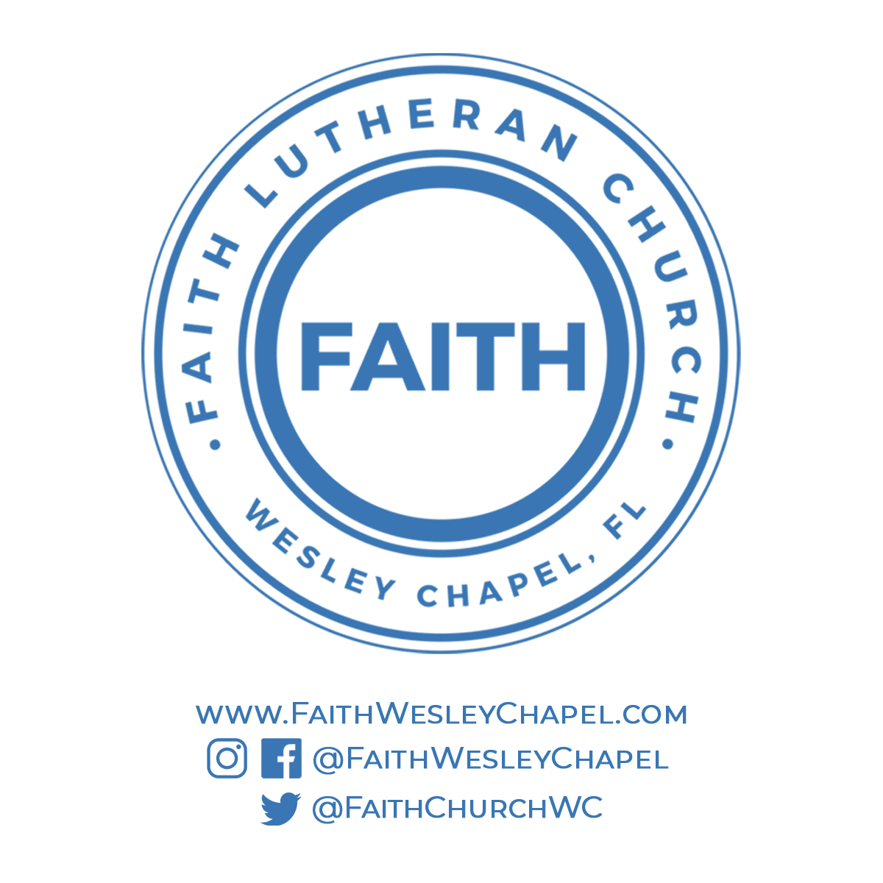**@FaithWesleyChapel**

**@FaithWesleyChapel**

**@FaithChurchWC**