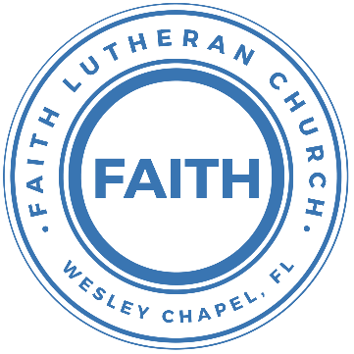

**Leading our community into a deep connection in Christ**

**Worship Service for October 16, 2022, at 11 AM**

**Welcome**

**Faith: This Is Who We Are:** Our Values

“Come On In”

**Opening Song -** Forever

Verse 1:

The moon and stars they wept. The morning sun was dead

The Savior of the world was fallen.

His body on the cross. His blood poured out for us.

The weight of every curse upon Him

Verse 2:

One final breath He gave, As Heaven looked away

The Son of God was laid in darkness.

A battle in the grave. The war on death was waged.

The power of hell forever broken

Pre-Chorus:

The ground began to shake. The stone was rolled away

His perfect love could not be overcome

Now death where is your sting. Our resurrected King

Has rendered you defeated

Chorus:

Forever, He is glorified. Forever, He is lifted high

Forever, He is risen. He is alive; He is alive!

Pre-Chorus

Chorus

Instrumental (chorus):

Bridge:

We sing hallelujah. We sing hallelujah

We sing hallelujah. The Lamb has overcome

Chorus (2x)

**Invocation**

**Confession and Forgiveness:**

**P:** Our Heavenly Father asks us to come into His presence.

**C:** But we are sinful and unworthy.

**P:** Yes, all have sinned and fall short of the glory of God, but Jesus Christ died on the cross that we may be forgiven and washed clean of all our sins by His blood spilled on the cross.

**C:** Lord, if You wash us, we will certainly be clean and pure.

**P:** We take a moment to bow before the His cross and silently reflect on our lives and confess our sins.

(Time of silence for reflection and confession)

**P:** Let us confess, together, our sins to God our Father.

**C:** Heavenly Father, we confess that we are sinners.  We have sinned against you and our neighbors. We have not loved you with our whole heart and we have not loved our neighbors as ourselves. We have not lived out our faith in our community. We justly deserve Your punishment.  For the sake of Your Son, Jesus Christ, have mercy on us.  Forgive us, renew us, and lead us, so that we may delight in Your will and walk in Your ways to the glory of Your holy name.  Amen.

**P:** Almighty God in His mercy has given His Son to die for you and for His sake forgives you all your sins.  As a called and ordained servant of Christ, and by His authority, I, therefore, forgive you all your sins in the name of the Father and of the Son and of the Holy Spirit.

**C:** Amen

**Song of Praise and Thanksgiving:** Great Is Thy Faithfulness

Verse 1:

Great is Thy faithfulness, O God my Father.

There is no shadow of turning with Thee

Thou changest not, Thy compassions they fail not.

As Thou hast been, Thou forever wilt be.

Chorus:

Great is Thy faithfulness! Great is Thy faithfulness!

Morning by morning new mercies I see

All I have needed Thy hand has provided.

Great is Thy faithfulness, Lord unto me.

Verse 2:

Summer and winter and springtime and harvest,

Sun, moon and stars in their courses above

Join with all nature in manifold witness

To Thy great faithfulness mercy and love.

(Chorus)

Verse 3:

Pardon for sin and a peace that endureth,

Thine own dear presence to cheer and to guide;

Strength for today and bright hope for tomorrow,

Blessings all mine, with ten thousand beside.

(Chorus)

**Old Testament Reading –**Deuteronomy 8:7-15

For the Lord your God is bringing you into a good land, a land of brooks of water, of fountains and springs, flowing out in the valleys and hills, a land of wheat and barley, of vines and fig trees and pomegranates, a land of olive trees and honey, a land in which you will eat bread without scarcity, in which you will lack nothing, a land whose stones are iron, and out of whose hills you can dig copper. And you shall eat and be full, and you shall bless the Lord your God for the good land he has given you.

“Take care lest you forget the Lord your God by not keeping his commandments and his rules and his statutes, which I command you today, lest, when you have eaten and are full and have built good houses and live in them, and when your herds and flocks multiply and your silver and gold is multiplied and all that you have is multiplied, then your heart be lifted up, and you forget the Lord your God, who brought you out of the land of Egypt, out of the house of slavery,

Reader: This is the Word of the Lord.  
C: Thanks be to God.

**Epistle Reading** – Hebrews 4:7-11

again he appoints a certain day, “Today,” saying through David so long afterward, in the words already quoted,

“Today, if you hear his voice,

do not harden your hearts.”

For if Joshua had given them rest, God would not have spoken of another day later on. So then, there remains a Sabbath rest for the people of God, for whoever has entered God's rest has also rested from his works as God did from his.

Let us therefore strive to enter that rest, so that no one may fall by the same sort of disobedience.

Reader: This is the Word of the Lord.  
C: Thanks be to God.

**Gospel Reading** – Matthew 18:1-6

At that time the disciples came to Jesus, saying, “Who is the greatest in the kingdom of heaven?” And calling to him a child, he put him in the midst of them and said, “Truly, I say to you, unless you turn and become like children, you will never enter the kingdom of heaven. Whoever humbles himself like this child is the greatest in the kingdom of heaven.

“Whoever receives one such child in my name receives me, but whoever causes one of these little ones who believe in me to sin, it would be better for him to have a great millstone fastened around his neck and to be drowned in the depth of the sea.

P: This is the Gospel of the Lord.  
C: Praise be to You, o Christ.

**Children's Message** *(Children dismissed to Children's Church)*

**Sermon Hymn***–*Whom Shall I Fear

You hear me when I call. You are my morning song

Though darkness fills the night, It cannot hide the light

Whom shall I fear

You crush the enemy Underneath my feet

You are my sword and shield, Though troubles linger still

Whom shall I fear

Chorus:

I know who goes before me. I know who stands behind

The God of angel armies Is always by my side

The One who reigns forever He is a friend of mine

The God of angel armies Is always by my side

My strength is in Your name For You alone can save

You will deliver me. Yours is the victory

Whom shall I fear? Whom shall I fear

Chorus

Bridge:

And nothing formed against me shall stand

You hold the whole world in Your hands

I'm holding on to Your promises

You are faithful

You are faithful

You are faithful

**Sermon** – Navigating the Plan  
Week # - "Joshua: The Promise Land"

Joshua 24:14-24

“Now therefore fear the Lord and serve him in sincerity and in faithfulness. Put away the gods that your fathers served beyond the River and in Egypt, and serve the Lord. And if it is evil in your eyes to serve the Lord, choose this day whom you will serve, whether the gods your fathers served in the region beyond the River, or the gods of the Amorites in whose land you dwell. But as for me and my house, we will serve the Lord.”

Then the people answered, “Far be it from us that we should forsake the Lord to serve other gods, for it is the Lord our God who brought us and our fathers up from the land of Egypt, out of the house of slavery, and who did those great signs in our sight and preserved us in all the way that we went, and among all the peoples through whom we passed. And the Lord drove out before us all the peoples, the Amorites who lived in the land. Therefore we also will serve the Lord, for he is our God.”

But Joshua said to the people, “You are not able to serve the Lord, for he is a holy God. He is a jealous God; he will not forgive your transgressions or your sins. If you forsake the Lord and serve foreign gods, then he will turn and do you harm and consume you, after having done you good.” And the people said to Joshua, “No, but we will serve the Lord.” Then Joshua said to the people, “You are witnesses against yourselves that you have chosen the Lord, to serve him.” And they said, “We are witnesses.” He said, “Then put away the foreign gods that are among you, and incline your heart to the Lord, the God of Israel.” And the people said to Joshua, “The Lord our God we will serve, and his voice we will obey.”

**Reader:** This is the Word of the Lord.  
**C:** Thanks be to God.

**Prayers:** *Text in prayer requests to (813) 326-5255*

**Nicene Creed**

I believe in one God, the Father Almighty, maker of heaven and earth and of all things visible and invisible.

And in one Lord Jesus Christ, the only-begotten Son of God, begotten of His Father before all worlds, God of God, Light of Light, very God of very God, begotten, not made, being of one substance with the Father, by whom all things were made; who for us men and for our salvation came down from heaven and was incarnate by the Holy Spirit of the virgin Mary and was made man; and was crucified also for us under Pontius Pilate. He suffered and was buried. And the third day He rose again according to the Scriptures and ascended into heaven and sits at the right hand of the Father. And He will come again with glory to judge both the living and the dead, whose kingdom will have no end.

And I believe in the Holy Spirit, the Lord and Giver of Life, who proceeds from the Father and the Son, who with the Father and the Son together is worshiped and glorified, who spoke by the prophets. And I believe in one holy Christian and apostolic Church, I acknowledge one Baptism for the remission of sins, and I look for the resurrection of the dead and the life of the world to come. Amen.

**The Lord's Prayer**

Our Father who art in heaven, hallowed be Thy name, Thy kingdom come, Thy will be done on earth as it is in heaven.  Give us this day our daily bread; and forgive us our trespasses as we forgive those who trespass against us; and lead us not into temptation, but deliver us from evil.  For Thine is the kingdom and the power and the glory forever and ever.  Amen

**Offering**

**Words of Institution**

**Peace**

P: The peace of the Lord be with you all.  
C: And also, with you.  
P: We greet each other in the peace of Christ.

**Distribution**

**Prayer**

**Benediction**

**Closing Song:**As For Me & My House

Verse 1:

Let our foundation be Built on your majesty

Let every word you speak Fill this home

Jesus our cornerstone. The anchor for our souls

Your glory will be shown By our love

Chorus:

As for me and my house, As for me and my house

We will serve you. We will serve you

As for me and my house, As for me and my house

We will serve you. We will serve you

Verse 2:

We stand on Holy Ground. This is where lost get found

Your goodness all around, It’s pouring out

Your presence is new wine. The old is left behind

There’s nothing but new life To be found

(Chorus)

Bridge:

This is a house where idols fall

This is a house where dead man walk

This is a house where freedoms calls

Can you hear it now, hear it now

(Repeat)

(Chorus 2x)

**Sermon Notes:**

**_______________________________________________**

**_______________________________________________**

**_______________________________________________**

**_______________________________________________**

**_______________________________________________**

**_______________________________________________**

**_______________________________________________**

**_______________________________________________**

**_______________________________________________**

**_______________________________________________**

**_______________________________________________**

**_______________________________________________**

**_______________________________________________**

**_______________________________________________**

**_______________________________________________**

**_______________________________________________**

**_______________________________________________**

**_______________________________________________**

**_______________________________________________**

**_______________________________________________**

**_______________________________________________**

**_______________________________________________**

**_______________________________________________**

**Upcoming Events**

**October 18, 7 PM - Council Meeting**  
The Shucks

**October 23, After the Worship Service, Budget Voter’s Meeting / Pastor’s Call Change Voter’s Meeting**Song and Dance

**October 25, 7 PM - Growth Group Bible Study**Location - TBD

*(Remove Financials in Online Bulletin)*

**--------------------------- Faith’s Financial Update ---------------------------**

October's Budgeted Expenses: $6,815

October's General Fund Gifts and Offerings to Date: $???

**----------------------------------------------------------------------------------------**

**www.FaithWesleyChapel.com**

**Faith YouTube**

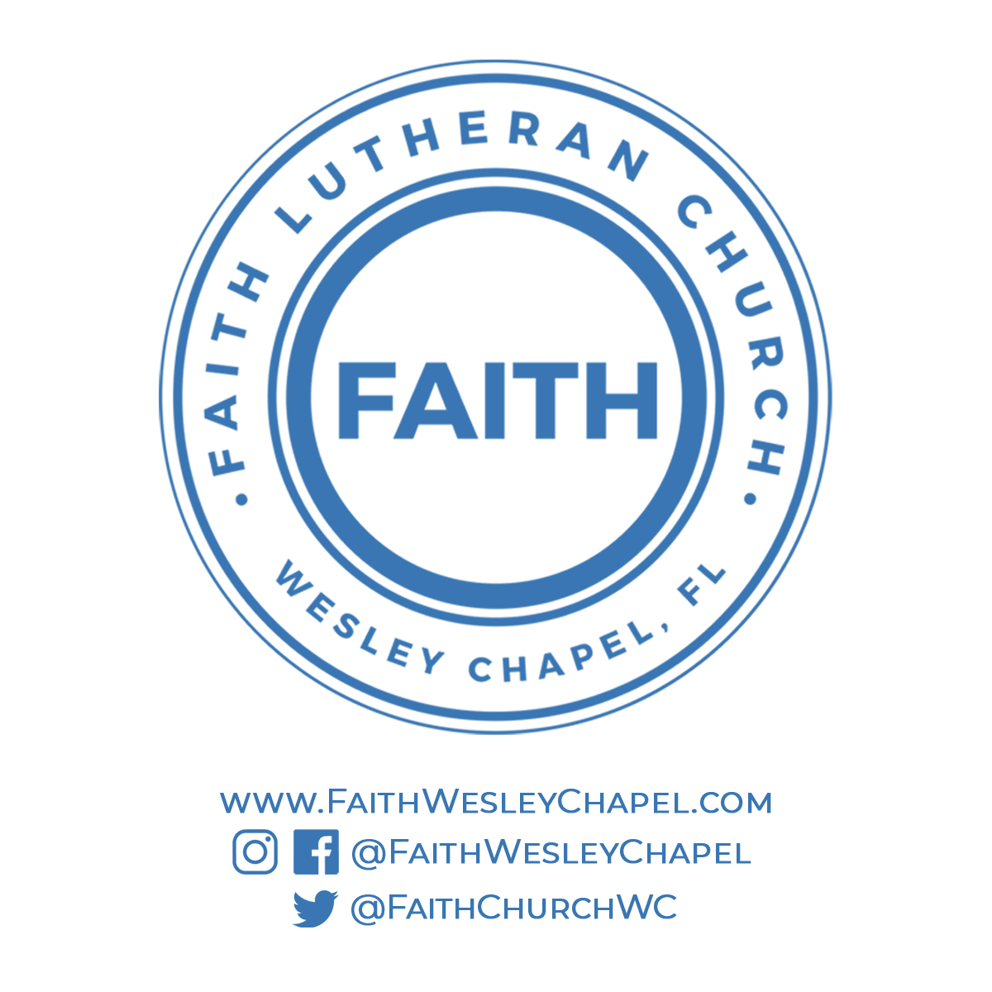**@FaithWesleyChapel**

**@FaithWesleyChapel**

**@FaithChurchWC**