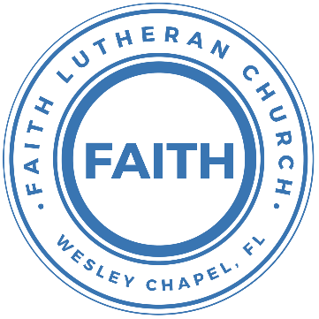

**Leading our community into a deep connection in Christ**

**Worship Service for October 23, 2022, at 11 AM**

**Welcome**

**Faith: This Is Who We Are:** Our Values

“Know Your Neighbor”

**Invocation**

**Responsive Reading** (*Judges - Selected Passages)*

**All:** When God gave the Promised Land to Israel, He told them to kill or drive out all the former inhabitants of the land, lest they lead the Children of Israel away from God.

**P:** Manasseh did not drive out the inhabitants of Beth-shean and its villages, or Taanach and its villages, or the inhabitants of Dor and its villages, or the inhabitants of Ibleam and its villages, or the inhabitants of Megiddo and its villages, for the Canaanites persisted in dwelling in that land. When Israel grew strong, they put the Canaanites to forced labor, but did not drive them out completely.

**Men:** The Angel of the Lord said, "I brought you up from Egypt and brought you into the land that I swore to give to your fathers. I said, ‘I will never break my covenant with you, and you shall make no covenant with the inhabitants of this land; you shall break down their altars.’

**Women:** But you have not obeyed my voice. What is this you have done? So now I say, I will not drive them out before you, but they shall become thorns in your sides, and their gods shall be a snare to you.”

**P:** And the people of Israel did what was evil in the sight of the Lord and served the Baals.

**Men:** And they abandoned the Lord, the God of their fathers, who had brought them out of the land of Egypt.

**Women:** They went after other gods, from among the gods of the peoples who were around them, and bowed down to them.

**P:** And they provoked the Lord to anger.

**Men:** They abandoned the Lord and served the Baals and the Ashtaroth.

**Women:** So the anger of the Lord was kindled against Israel, and he gave them over to plunderers, who plundered them.

P: Then the Lord raised up judges, who saved them out of the hand of those who plundered them.

**Men:** Yet they did not listen to their judges

**Women:** whenever the judge died, they turned back and were more corrupt than their fathers,

**All:** In those days there was no king in Israel. Everyone did what was right in his own eyes.

**Confession and Forgiveness:**

**Confession and Forgiveness:**

**P:** The truth is that we often live as though we have no King. We ignore God’s commands and do what is right in our own eyes. As we gather, today, let us cleanse our hearts and our consciences by confessing our sin to God.

(Time of silence for reflection and confession)

**P:** Today, we confess our sins by singing the song, “Lord, I Need You.”

**Song of Confession:** Lord, I Need You

Lord I come, I confess. Bowing here I find my rest  
Without You, I fall apart. You're the one that guides my heart

Chorus:  
Lord, I need You, oh I need You. Every hour I need You  
My one defense, my righteousness, Oh God, how I need You

Where sin runs deep, Your grace is more.  
Where grace is found is where You are  
And where You are Lord I am free. Holiness is Christ in me

Chorus:  
Lord, I need You, oh I need You. Every hour I need You  
My one defense, my righteousness, Oh God, how I need You

So teach my song to rise to You When temptation comes my way  
And when I cannot stand I'll fall on You.   
Jesus You're my hope and stay

Chorus

Lord, I need You, oh I need You. Every hour I need You  
My one defense, my righteousness, Oh God, how I need You  
My one defense, my righteousness, Oh God, how I need You  
My one defense, my righteousness, Oh God, how I need You

**P:** The Father has raised up the ultimate Judge, Jesus Christ, who saves us from the hand of the devil and our own sinfulness. He who died once for our sin, was raised and will never die again. The Lord has heard your confession. Therefore, as a called and ordained servant of the Lord, in the stead and by the command of my Lord, Jesus Christ, I forgive you all your sins in the name of the Father and of the Son and of the Holy Spirit.

**C:** Amen

**Song of Praise and Thanksgiving –** Living Hope

Verse 1:

How great the chasm that lay between us

How high the mountain I could not climb

In desperation, I turned to heaven And spoke Your name into the night

Then through the darkness Your loving kindness

Tore through the shadows of my soul

The work is finished, the end is written, Jesus Christ, my Living Hope

Verse 2:

Who could imagine so great a mercy

What heart could fathom such boundless grace

The God of ages stepped down from glory To wear my sin and bear my shame

The cross has spoken, I am forgiven

The King of Kings calls me His own

Beautiful Savior I’m Yours forever, Jesus Christ, my Living Hope

Chorus:

Hallelujah, praise the one who set me free

Hallelujah, death has lost its grip on me

You have broken every chain, there’s salvation in Your Name

Jesus Christ, my Living Hope

(Repeat)

**Epistle Reading –** Romans 3:21-26

But now the righteousness of God has been manifested apart from the law, although the Law and the Prophets bear witness to it—the righteousness of God through faith in Jesus Christ for all who believe. For there is no distinction: for all have sinned and fall short of the glory of God, and are justified by his grace as a gift, through the redemption that is in Christ Jesus, whom God put forward as a propitiation by his blood, to be received by faith. This was to show God's righteousness, because in his divine forbearance he had passed over former sins. It was to show his righteousness at the present time, so that he might be just and the justifier of the one who has faith in Jesus.  
**Reader:** This is the Word of the Lord.  
**C:** Thanks be to God.

**Gospel Reading -**John 8:31-36

So Jesus said to the Jews who had believed him, “If you abide in my word, you are truly my disciples, and you will know the truth, and the truth will set you free.” They answered him, “We are offspring of Abraham and have never been enslaved to anyone. How is it that you say, ‘You will become free’?” Jesus answered them, “Truly, truly, I say to you, everyone who practices sin is a slave to sin. The slave does not remain in the house forever; the son remains forever. So if the Son sets you free, you will be free indeed.  
**P:** This is the Gospel of the Lord.  
**C:** Praise be to You, o Christ.

**Children's Message**

**Sermon Hymn –** Chief Of Sinners Though I Be

Verse 1:

Chief of sinners though I be, Jesus shed His blood for me.

Died that I might live on high, Lived that I might never die.

As the branch is to the vine, I am His and He is mine.

Verse 2:

Oh, the height of Jesus' love, Higher than the heav'ns above,

Deeper than the depths of sea, Lasting as eternity!

Love that found me wondrous thought! Found me when I sought Him not.

Verse 3:

Only Jesus can impart, Balm to heal the wounded heart,

Peace that flows from sin forgiv'n, Joy that lifts the soul to heav'n.

Faith and hope to walk with God, In the way that Enoch trod.

Verse 5:

O my Savior, help afford, By Your Spirit and Your Word!

When my wayward heart would stray, Keep me in the narrow way;

Grace in time of need supply, While I live and when I die.

**Sermon** – Series: Navigating the Plan: Genesis to Jesus   
Week # - "The Judges: Unending Mercy"

Sermon text Judges 2:11-12, 16-19

And the people of Israel did what was evil in the sight of the Lord and served the Baals. And they abandoned the Lord, the God of their fathers, who had brought them out of the land of Egypt...

...Then the Lord raised up judges, who saved them out of the hand of those who plundered them. Yet they did not listen to their judges, for they whored after other gods and bowed down to them. They soon turned aside from the way in which their fathers had walked, who had obeyed the commandments of the Lord, and they did not do so. Whenever the Lord raised up judges for them, the Lord was with the judge, and he saved them from the hand of their enemies all the days of the judge. For the Lord was moved to pity by their groaning because of those who afflicted and oppressed them. But whenever the judge died, they turned back and were more corrupt than their fathers, going after other gods, serving them and bowing down to them.  
**Reader:** This is the Word of the Lord.  
**C:** Thanks be to God.

**Prayers:** *Text in prayer requests to (813) 326-5255*

**Apostles' Creed**

I believe in God, the Father almighty,  
maker of heaven and earth,

And in Jesus Christ, his only Son, our Lord,  
who was conceived by the Holy Spirit,  
born of the Virgin Mary,  
suffered under Pontius Pilate,  
was crucified, died and was buried.  
He descended into hell.  
The third day he rose again from the dead.  
He ascended into heaven and sits at the right hand of God  
the Father almighty.  
From there he will come to judge the living and the dead.

I believe in the Holy Spirit,  
the holy Christian Church,  
the communion of saints,  
the forgiveness of sins,  
the resurrection of the body,

and the life everlasting. Amen.

**The Lord's Prayer**

Our Father who art in heaven, hallowed be Thy name, Thy kingdom come, Thy will be done on earth as it is in heaven.  Give us this day our daily bread; and forgive us our trespasses as we forgive those who trespass against us; and lead us not into temptation, but deliver us from evil.  For Thine is the kingdom and the power and the glory forever and ever.  Amen

**Offering**

**Words of Institution**

**Peace**

P: The peace of the Lord be with you all.  
C: And also, with you.  
P: We greet each other in the peace of Christ.

**Distribution**

**Prayer**

**Benediction**

**Closing Song –**How Deep The Father’s Love For Us

Verse 1:

How deep the Father's love for us, how vast beyond all measure

That He should give His only Son, to make a wretch His treasure

How great the pain of searing loss, the Father turned His face away

As wounds which mar the Chosen One, bring many sons to glory

Verse 2:

Behold the Man upon a cross, my sin upon His shoulders

Ashamed, I hear my mocking voice call out among the scoffers

It was my sin that held Him there until it was accomplished

His dying breath has brought me life; I know that it is finished

Verse 3:

I will not boast in anything: no gifts, no power, no wisdom

But I will boast in Jesus Christ; his death and resurrection

Why should I gain from His reward? I cannot give an answer

But this I know with all my heart: His wounds have paid my ransom

But this I know with all my heart: His wounds have paid my ransom

**Sermon Notes:**

**_______________________________________________**

**_______________________________________________**

**_______________________________________________**

**_______________________________________________**

**_______________________________________________**

**_______________________________________________**

**_______________________________________________**

**_______________________________________________**

**_______________________________________________**

**_______________________________________________**

**_______________________________________________**

**_______________________________________________**

**_______________________________________________**

**_______________________________________________**

**_______________________________________________**

**_______________________________________________**

**_______________________________________________**

**_______________________________________________**

**_______________________________________________**

**_______________________________________________**

**_______________________________________________**

**_______________________________________________**

**_______________________________________________**

**Upcoming Events**

**Today, After the Worship Service, Budget Voter’s Meeting / Pastor’s Call Change Voter’s Meeting**Song and Dance

**October 25, 7 PM - Growth Group Bible Study**Location - TBD

*(Remove Financials in Online Bulletin)*

**--------------------------- Faith’s Financial Update ---------------------------**

October's Budgeted Expenses: $6,815

October's General Fund Gifts and Offerings to Date: $???

**----------------------------------------------------------------------------------------**

**www.FaithWesleyChapel.com**

**Faith YouTube**

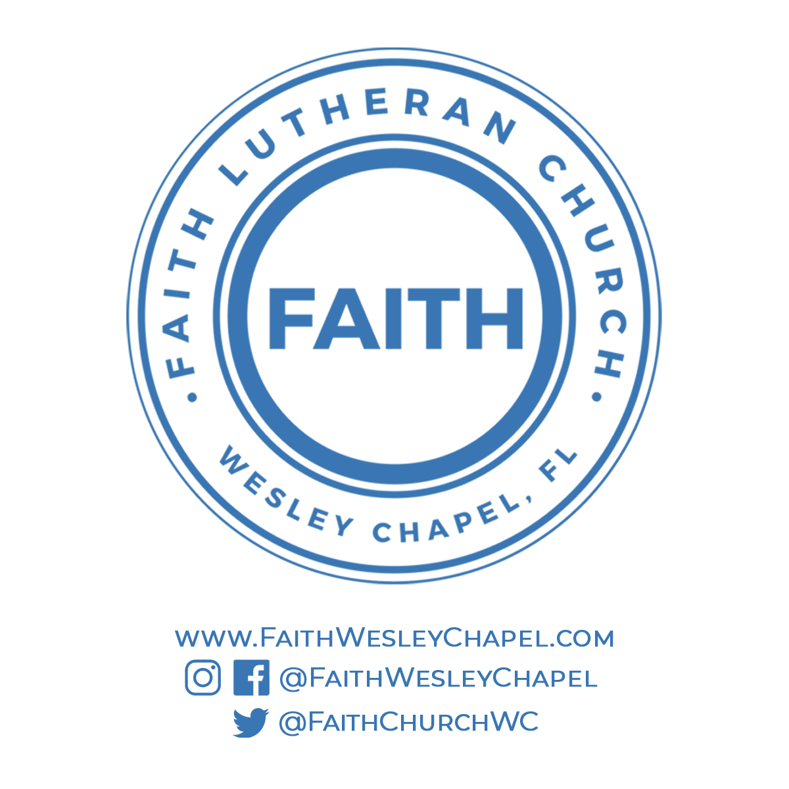**@FaithWesleyChapel**

**@FaithWesleyChapel**

**@FaithChurchWC**