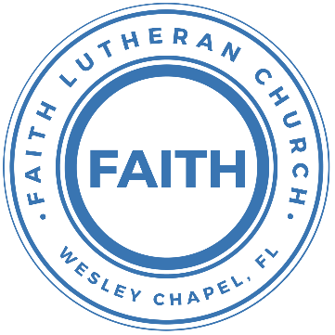

**Leading our community into a deep connection in Christ**

**Worship Service for November 6, 2022, at 11 AM**

**Welcome**

**Faith: This Is Who We Are:**Our Values

“Go The Distance”

**Opening Song:**I Just Wanna Be A Sheep

Chorus:I just wanna be a sheep, baa baa baa baa.

I just wanna be a sheep, baa baa baa baa.

I pray the Lord my soul to keep, I just wanna be a sheep, baa baa baa baa.

Verse: 1

Don't wanna be a goat...nope! Don't wanna be a goat...nope!

Haven't got any hope...nope! Don't wanna be a goat...nope!

Verse: 4

Don't wanna be a Sadducee. Don't wanna be a Sadducee

'Cause they're so sad you see. Don't wanna be a Sadducee

Chorus

Verse: 5

Just wanna be a child of God. Just wanna be a child of God

Walkin' the same path He trod. Just wanna be a child of God

Chorus

**Invocation**

**Confession and Forgiveness:**

**P:** We have come here today to worship the Lord.  In worship we hear the Word of God, we receive God's blessings, and respond with thanks and praise.  We begin by seeking God's blessing of forgiveness.  He has promised to remove the guilt and shame of our sin through the sacrifice of Jesus Christ on the cross.

*(a time of silence to reflect and personally confess our sins)*

**P:** Let us confess our sins to the Lord.

**P:** Heavenly Father,  
**C:** Heavenly Father,

**P:** I have done things that were wrong.  
**C:** I have done things that were wrong.  
 **P:** I have been mean to others.  
**C:** I have been mean to others.

**P:** I have not obeyed my parents.  
**C:** I have not obeyed my parents.

**P:** I have not obeyed You, God.  
**C:** I have not obeyed You, God.

**P:** But I am very sorry.  
**C:** But I am very sorry.

**P:** Please forgive me.  
**C:** Please forgive me.

**P:** I love You very much.  
**C:** I love You very much.

**P:** And I know You love me, too.  
**C:** And I know You love me, too.

**P:** God has heard your apology.  He loves you very much.  God has told us that when we believe and trust in Him, He makes us His children.  As far as the east is from the west, so far does he remove our sins from us. He has told me to tell you that you are forgiven.  So, as His servant, I forgive you in the name of the Father and of the Son and of the Holy Spirit.

**C:** Amen.

**Song:**Jesus Loves Me

Verse 1:

Jesus loves me this I know, For the Bible tells me so.

Little ones to Him belong, They are weak, but He is strong.

Chorus:

Yes, Jesus loves me, Yes, Jesus loves me,

Yes, Jesus loves me, The Bible tells me so.

Verse 2:

Jesus loves me, He who died. Heaven's gates to open wide.

He will wash away my sin, Let His little child come in.

**First Reading –**Matthew 11:25-30

Then Jesus said, “I praise you, Father, Lord of heaven and earth. I am thankful that you have hidden these things from those who are so wise and so smart. But you have shown them to people who are like little children. Yes, Father, you did this because it’s what you really wanted to do.

“My Father has given me everything. No one knows the Son—only the Father knows the Son. And no one knows the Father—only the Son knows the Father. And the only people who will know about the Father are those the Son chooses to tell.

“Come to me all of you who are tired from the heavy burden you have been forced to carry. I will give you rest. Accept my teaching. Learn from me. I am gentle and humble in spirit. And you will be able to get some rest. Yes, the teaching that I ask you to accept is easy. The load I give you to carry is light.”  
  
**Reader:** This is the Gospel of the Lord.  
**C:** Praise be to You, o Christ.

**Children's Message**"Like Little Children!"

**Song:**Echo

Verse 1:

When night has fallen When fear is common

Still You're calling me When faith is lost

And my hope exhausted You will be my strength

Pre-Chorus:

When my mind says I'm not good enough God, You're enough for me

I've decided I'm not giving up 'Cause You won't give up on me

You won't give up on me

Chorus:

Your love is holding on And it won't let go

I feel it breaking out like an echo Your love is holding on

And it won't let go I feel it breaking out like an echo

Post-Chorus:

Echo in my so-o-o-o-oul So-o-o-o-oul.

Echo in my so-o-o-o-oul So-o-o-o-oul.

Verse 2:

In every season You keep repeating promises to me

Now there's no stopping What you have started

Until it is complete

(Pre-Chorus)

(Chorus)

(Post-Chorus 2x)

**Second Reading –**Romans 3:21-22

But God has a way to make people right, and it has nothing to do with the law. He has now shown us that new way, which the law and the prophets told us about. God makes people right through their faith in Jesus Christ. He does this for all who believe in Christ. Everyone is the same.

**Reader:** This is the Word of the Lord.  
**C:** Thanks be to God.

**Children's Message**"We Are Right With God By Faith In Jesus"

**Sermon Hymn:**The Church’s One Foundation

Verse 1:

The church's one foundation is Jesus Christ, her Lord;

she is his new creation by water and the Word:

from heav'n he came and sought her to be his holy bride;

with his own blood he bought her, and for her life he died.

Verse 2:

Elect from ev’ry nation, yet one o'er all the earth,

her charter of salvation one Lord, one faith, one birth;

one holy name she blesses, partakes one holy food,

and to one hope she presses, with ev'ry grace endued.

Verse 5:

Yet she on earth hath union with God the Three in One,

and mystic sweet communion with those whose rest is won:

O blessed heav'nly chorus! Lord, save us by Your grace,

that we, like saints before us, may see You face to face.

**Sermon –**“Genesis to Jesus”  
Series - Navigating the Plan: Genesis to Jesus

This Week - "Hezekiah: The God of Reformation"

Sermon Reading: 2 Kings 18:1-8

In the third year of Hoshea son of Elah, king of Israel, Hezekiah the son of Ahaz, king of Judah, began to reign. He was twenty-five years old when he began to reign, and he reigned twenty-nine years in Jerusalem. His mother's name was Abi the daughter of Zechariah. And he did what was right in the eyes of the Lord, according to all that David his father had done. He removed the high places and broke the pillars and cut down the Asherah. And he broke in pieces the bronze serpent that Moses had made, for until those days the people of Israel had made offerings to it (it was called Nehushtan). He trusted in the Lord, the God of Israel, so that there was none like him among all the kings of Judah after him, nor among those who were before him. For he held fast to the Lord. He did not depart from following him, but kept the commandments that the Lord commanded Moses. And the Lord was with him; wherever he went out, he prospered. He rebelled against the king of Assyria and would not serve him. He struck down the Philistines as far as Gaza and its territory, from watchtower to fortified city.  
  
**Prayers:** *Text in prayer requests to (813) 326-5255*

**The Lord's Prayer**

Our Father who art in heaven, hallowed be Thy name, Thy kingdom come, Thy will be done on earth as it is in heaven.  Give us this day our daily bread; and forgive us our trespasses as we forgive those who trespass against us; and lead us not into temptation, but deliver us from evil.  For Thine is the kingdom and the power and the glory forever and ever.  Amen

**Offering**

**Words of Institution**

**Peace**

**P:** The peace of the Lord be with you all.  
**C:** And also, with you.  
**P:** We greet each other in the peace of Christ.

**Distribution**

**Prayer**

**Benediction**

**Closing Song:**A Mighty Fortress Is Our God

Verse 1:

A mighty fortress is our God, a bulwark never failing;

our helper he, a - mid the flood of mortal ills prevailing.

For still our ancient foe does seek to work us woe;

his craft and power are great, and armed with cruel hate,

on earth is not his equal.

Verse 2:

Did we in our own strength confide, our striving would be losing,

were not the right Man on our side, the Man of God's own choosing.

You ask who that may be? Christ Jesus, it is he;

Lord Sabaoth his name, from age to age the same;

and he must win the battle.

Verse 3:

And though this world, with devils filled, should threaten to undo us,

we will not fear, for God has willed his truth to triumph through us.

The prince of darkness grim, we tremble not for him;

his rage we can endure, for lo! his doom is sure;

one little word shall fell him.

Verse 4:

That Word above all earthly powers no thanks to them abideth;

the Spirit and the gifts are ours through him who with us sideth.

Let goods and kindred go, this mortal life also;

the body they may kill: God's truth abideth still;

his kingdom is forever

**Sermon Notes:**

**_______________________________________________**

**_______________________________________________**

**_______________________________________________**

**_______________________________________________**

**_______________________________________________**

**_______________________________________________**

**_______________________________________________**

**_______________________________________________**

**_______________________________________________**

**_______________________________________________**

**_______________________________________________**

**_______________________________________________**

**_______________________________________________**

**_______________________________________________**

**_______________________________________________**

**_______________________________________________**

**_______________________________________________**

**_______________________________________________**

**_______________________________________________**

**_______________________________________________**

**_______________________________________________**

**_______________________________________________**

**_______________________________________________**

**_______________________________________________**

**_______________________________________________**

**_______________________________________________**

**_______________________________________________**

**Hey Youth!!**Do you know any worship songs you’d like to sing as part of our youth service? Let Pastor Kurt know.

Do you want to sing or play an instrument? Let Pastor Kurt know.

We want you to be a part of the service.

**Upcoming Events**

**Date, time, title**Location

**Third Monday, 7 PM Council Meeting**  
Zoom

**www.FaithWesleyChapel.com**

**Faith YouTube**

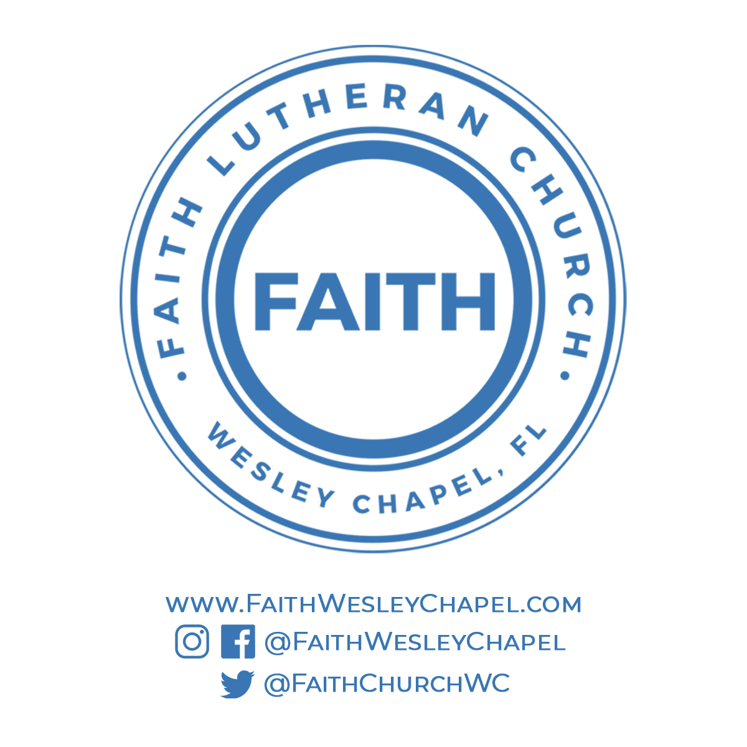**@FaithWesleyChapel**

**@FaithWesleyChapel**

**@FaithChurchWC**