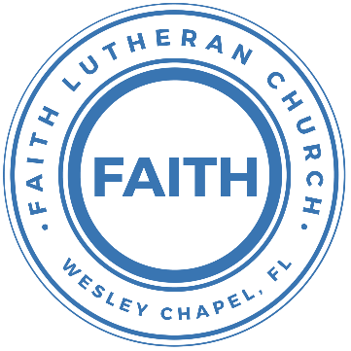

**Leading our community into a deep connection in Christ**

**Worship Service for November 13, 2022, at 11 AM**

**Welcome**

**Faith: This Is Who We Are:**Our Values

“Pass It On”

**Invocation**

**Confession and Forgiveness:**

P: As we gather, today, let us cleanse our hearts and our consciences by confessing our sin to God.

(Time of silence for reflection and confession)

C: Heavenly Father, we confess that we are sinful and unclean. We have sinned against you and against our neighbor in our thoughts, words, and actions.  We are truly sorry for our sins and sincerely repent of them. We ask for Your mercy. For the sake of Jesus Christ's bitter suffering and death, please forgive us and renew us that we may walk in Your Spirit to the glory of Your holy name.

P: The Lord has heard your confession. Therefore, as a called and ordained servant of the Lord, in the stead and by the command of my Lord, Jesus Christ, I forgive you all your sins in the name of the Father and of the Son and of the Holy Spirit.

C: Amen

**Song of Praise and Thanksgiving – Joy of The Lord**

Though the tears may fall my song will rise,

my song will rise to You

Though my heart may fail my song will rise,

my song will rise to You

While there's breath in my lungs, I will praise You Lord

In the dead of night I’ll lift my eyes, I’ll lift my eyes to You

Though the waters rise I’ll lift my eyes, I’ll lift my eyes to You

While there's hope in this heart, I will praise You Lord

Chorus:

The joy of the Lord is my strength. The joy of the Lord is my strength

In the darkness I’ll dance, in the shadows I’ll sing

The joy of the Lord is my strength

Verse 2:

When I cannot see You with my eyes, let faith arise to You

When I cannot feel Your hand in mine, let faith arise to You

God of mercy and love, I will praise You Lord

How You shine with glory Lord of light, I feel alive with You

In Your presence now I come alive, I am alive with You

There is strength when I say "I will praise You Lord"

When sorrow comes my way, You are the shield around me

Always You remain my courage in the fight

I hear You call my name, Jesus I am coming

Walking on the waves, reaching for Your light

**Gospel Reading:**John 16:25-33

“I have said these things to you in figures of speech. The hour is coming when I will no longer speak to you in figures of speech but will tell you plainly about the Father. In that day you will ask in my name, and I do not say to you that I will ask the Father on your behalf; for the Father himself loves you, because you have loved me and have believed that I came from God. I came from the Father and have come into the world, and now I am leaving the world and going to the Father.”

His disciples said, “Ah, now you are speaking plainly and not using figurative speech! Now we know that you know all things and do not need anyone to question you; this is why we believe that you came from God.” Jesus answered them, “Do you now believe? Behold, the hour is coming, indeed it has come, when you will be scattered, each to his own home, and will leave me alone. Yet I am not alone, for the Father is with me. I have said these things to you, that in me you may have peace. In the world you will have tribulation. But take heart; I have overcome the world.”  
P: This is the Gospel of the Lord.  
C: Praise be to You, o Christ.

**Sermon Hymn – It Is Well with My Soul**

Verse 1:

When peace like a river attendeth my way,

When sorrows like sea billows roll

Whatever my lot, Thou has taught me to say,

“It is well, it is well with my soul”

Chorus:

It is well, (it is well) with my soul (with my soul)

It is well, it is well with my soul

Verse 2:

Though Satan should buffet tho’ trials may come,

Let this blest assurance control

That Christ has regarded my helpless estate

And hath shed His own blood for my soul

Chorus

Verse 3:

My sin, oh the bliss of this glorious thought,

My sin not in part but in whole

Is nailed to the cross and I bear it no more.

Praise the Lord, praise the Lord oh my soul!

Chorus

Verse 4:

And Lord haste the day when the faith shall be sight,

The clouds be rolled back as a scroll

The trump shall resound and the Lord shall descend,

Even so it is well with my soul

**Sermon** – Series - Navigating the Plan: Genesis to Jesus  
This Week - "Daniel: Present in Exile"

Sermon Text: Daniel 1:1-7

In the third year of the reign of Jehoiakim king of Judah, Nebuchadnezzar king of Babylon came to Jerusalem and besieged it. And the Lord gave Jehoiakim king of Judah into his hand, with some of the vessels of the house of God. And he brought them to the land of Shinar, to the house of his god, and placed the vessels in the treasury of his god. Then the king commanded Ashpenaz, his chief eunuch, to bring some of the people of Israel, both of the royal family and of the nobility, youths without blemish, of good appearance and skillful in all wisdom, endowed with knowledge, understanding learning, and competent to stand in the king's palace, and to teach them the literature and language of the Chaldeans. The king assigned them a daily portion of the food that the king ate, and of the wine that he drank. They were to be educated for three years, and at the end of that time they were to stand before the king. Among these were Daniel, Hananiah, Mishael, and Azariah of the tribe of Judah. And the chief of the eunuchs gave them names: Daniel he called Belteshazzar, Hananiah he called Shadrach, Mishael he called Meshach, and Azariah he called Abednego.  
Reader: This is the Word of the Lord.  
C: Thanks be to God.

**Prayers:**

**Apostles' Creed**

I believe in God, the Father almighty, maker of heaven and earth,  
And in Jesus Christ, his only Son, our Lord,  
who was conceived by the Holy Spirit,  
born of the Virgin Mary, suffered under Pontius Pilate,  
was crucified, died and was buried. He descended into hell.  
The third day he rose again from the dead.  
He ascended into heaven and sits at the right hand of God  
the Father almighty.  
From there he will come to judge the living and the dead.  
I believe in the Holy Spirit, the holy Christian Church,  
the communion of saints, the forgiveness of sins,  
the resurrection of the body, and the life everlasting. Amen.

**The Lord's Prayer**

Our Father who art in heaven, hallowed be Thy name, Thy kingdom come, Thy will be done on earth as it is in heaven.  Give us this day our daily bread; and forgive us our trespasses as we forgive those who trespass against us; and lead us not into temptation, but deliver us from evil.  For Thine is the kingdom and the power and the glory forever and ever.  Amen

**Offering**

**Benediction**

**Closing Song:** Praise God From Whom All Blessings Flow

Praise God from Whom all blessings flow.  
Praise Him all creatures here below.  
Praise Him above, ye heavenly hosts.  
Praise Father, Son and Holy Ghost.  
Amen

**Sermon Notes:**

**_______________________________________________**

**_______________________________________________**

**_______________________________________________**

**_______________________________________________**

**_______________________________________________**

**_______________________________________________**

**_______________________________________________**

**_______________________________________________**

**_______________________________________________**

**_______________________________________________**

**_______________________________________________**

**_______________________________________________**

**_______________________________________________**

**_______________________________________________**

**_______________________________________________**

**_______________________________________________**

**_______________________________________________**

**_______________________________________________**

**_______________________________________________**

**_______________________________________________**

**_______________________________________________**

**_______________________________________________**

**_______________________________________________**

**Upcoming Events**

**Date, time, title**Location

**Third Monday, 7 PM Council Meeting**  
Zoom

**www.FaithWesleyChapel.com**

**Faith YouTube**

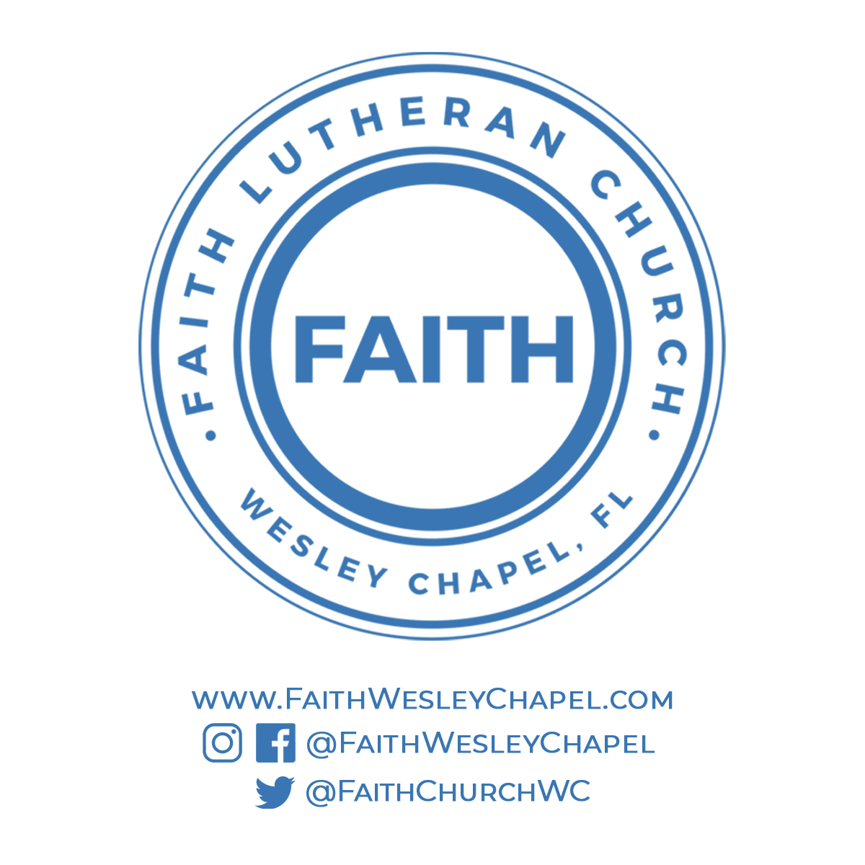**@FaithWesleyChapel**

**@FaithWesleyChapel**

**@FaithChurchWC**